Part 1:

Linear regression:

Learning rate = 0.001 epoch = 100

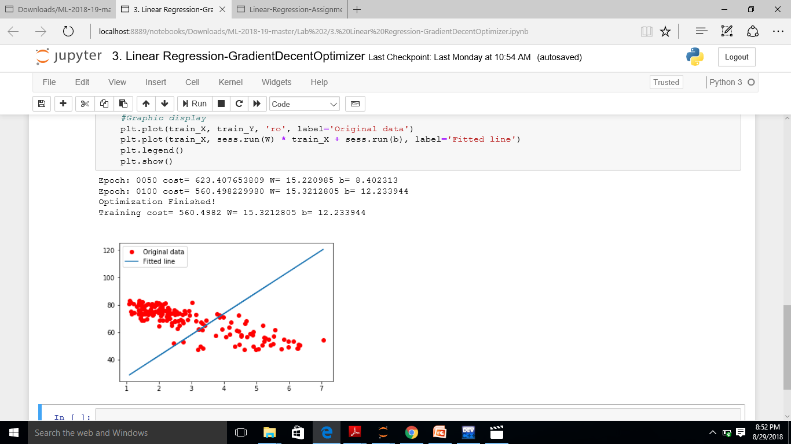

Learning rate = 0.005 and epoch = 500

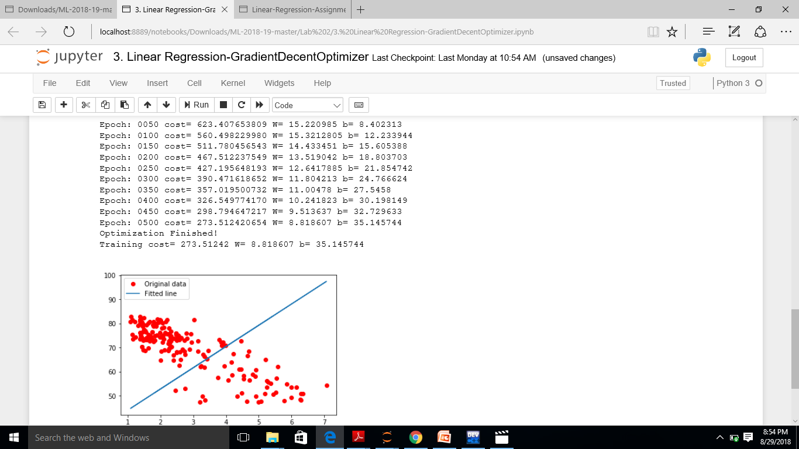

Learning rate =0.005 and epoch = 1000

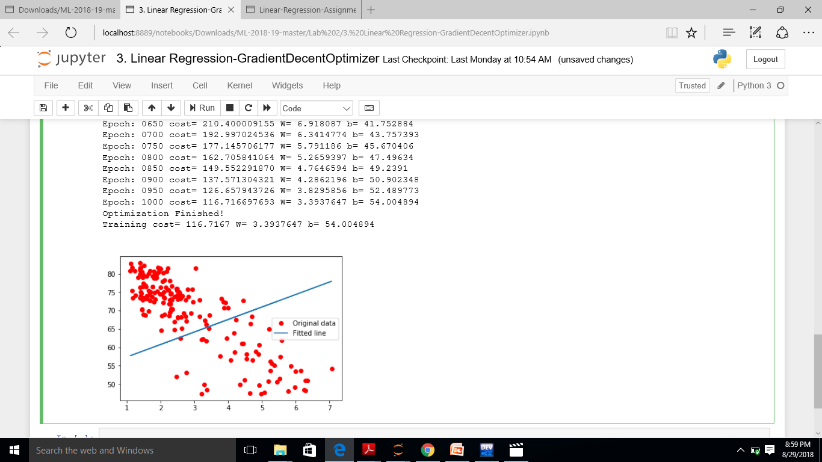

Learning rate = 0.005 and epoch = 10000

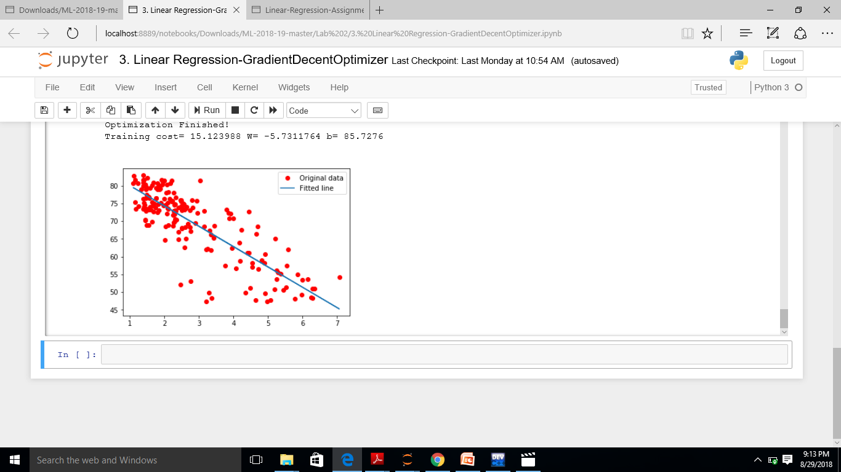

Learning rate = 0.05 and epoch = 10000

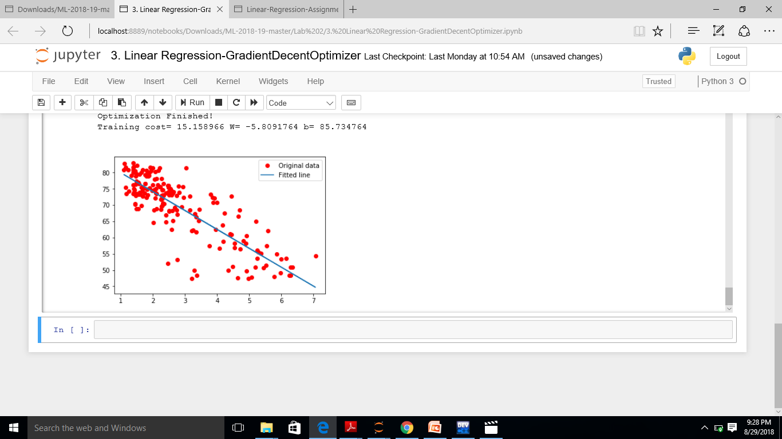

Part 2:

Time complexity:

Time consumed for learning rate = 0.05 and epoch = 10000:

10m 35sec

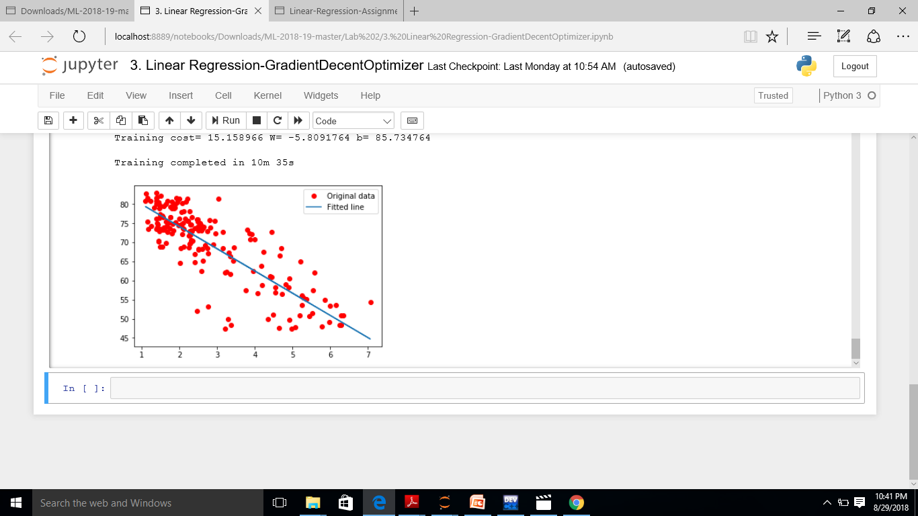

Conclusion:

1. The time to get the minimum cost function decreases with decrease in learning rate.
2. We get the better fit line as we increase the number of epochs.

Part 3:

1. Optimization:

It can be increased by increasing the number of epochs and decreasing the learning rate.

1. Cost Function:

Quadratic cost

CMST(W,B,Sr,Er)=0.5∑j(aLj−Erj)2