Input array=1960x1960x3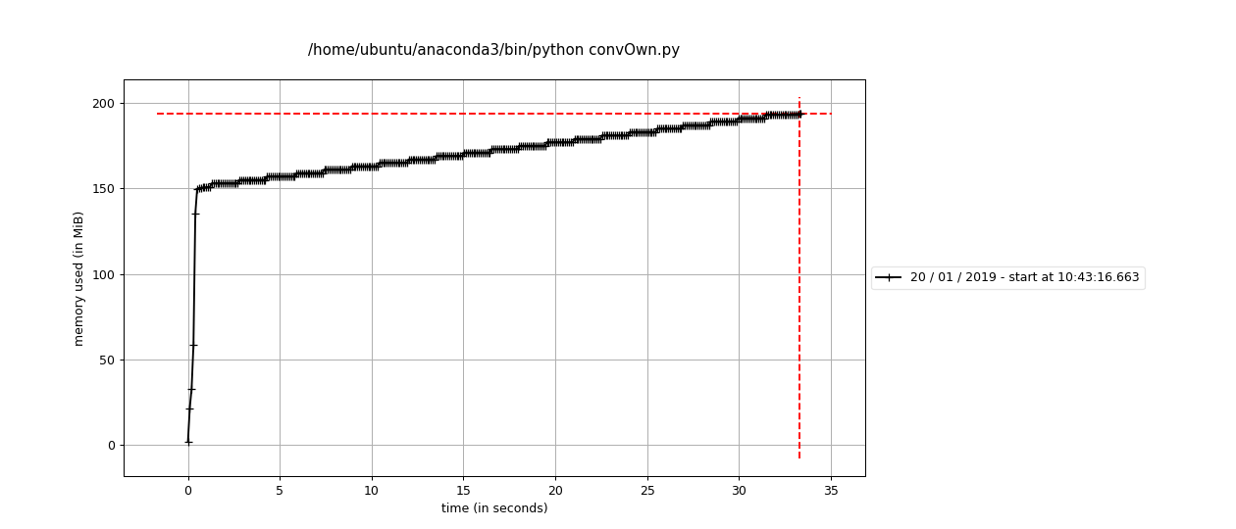

Output array=979x1958x3

Stride along w=1

Stride along h=2

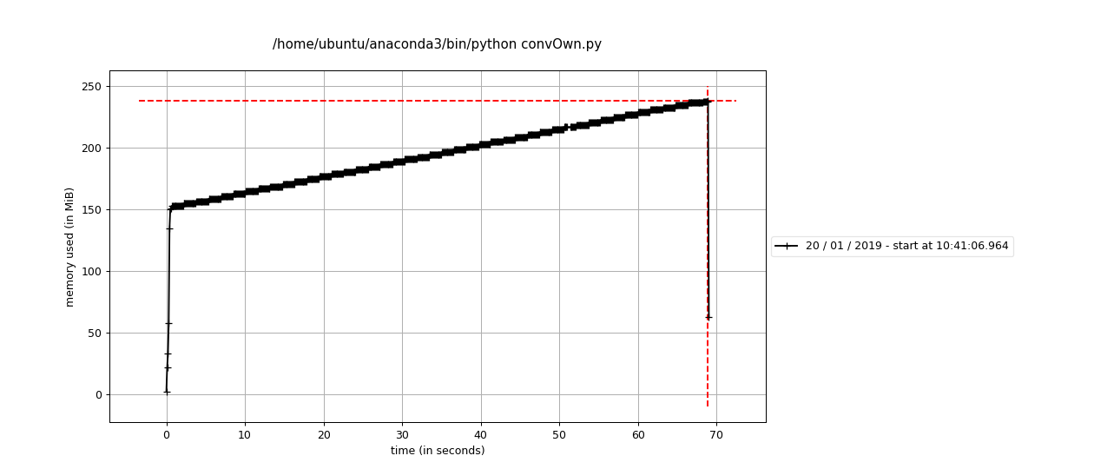

Input array=1960x1960x3

Output array=1958x1958x3

Stride along w=1

Stride along h=1

Input array=300x300x3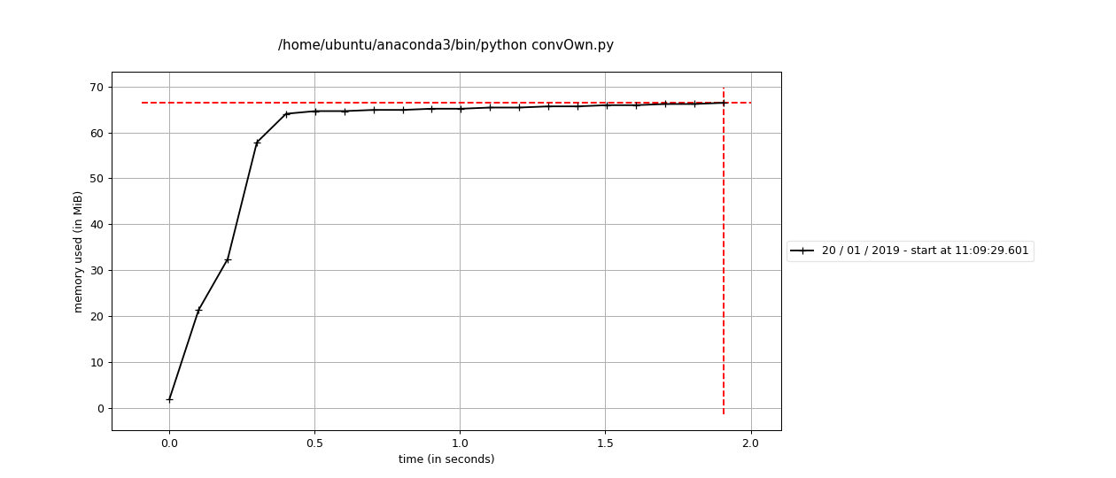

Output array=298x298x3

Stride along w=1

Stride along h=1