Assignment #3

1.)

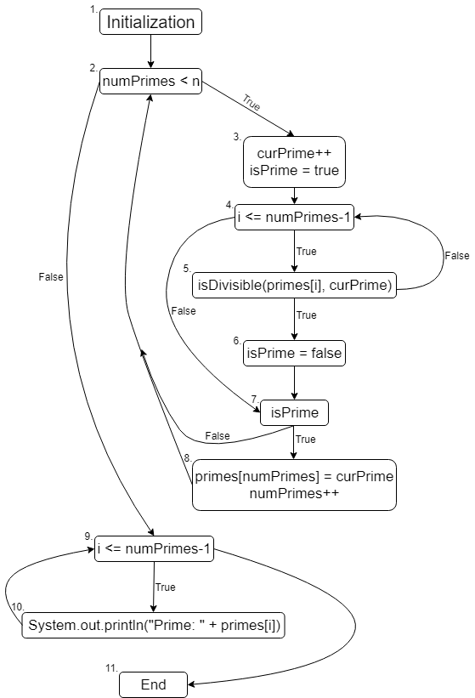

2.)

Any test case in which n <=1

3.)

[(1, 2), (2, 3), (3, 4), (4, 5), (5, 6), (6, 7), (7, 8), (8, 2), (2, 9), (9, 10), (10, 9), (9, 11)]

[(1, 2), (2, 3), (3, 4), (4, 5), (5, 4), (4, 7), (7, 2), (2, 9), (9, 11)]