Homework 9 20516287-Leung Ko Tsun

Q1

The value of the forward contract is the spot price of the underlying asset minus the present value of the forward price, while the forward price is the strike price at which the present value of the forward contract is zero.

Q2

$Put=e^{-rT}E\left[{\left(K-S_{T}\right)}^{+}\right]=e^{-rT}E\left[{\left(K-S_{0}e^{\left(r-\frac{σ^{2}}{2}\right)T+σ\sqrt{T}z}\right)}^{+}\right]$

We note that $K≥S_{T}$ implies $K-S_{0}e^{\left(r-\frac{σ^{2}}{2}\right)T+σ\sqrt{T}z}≥0$ or $z≤\frac{\ln\left(\frac{K}{S_{0}}\right)-\left(r-\frac{σ^{2}}{2}\right)T}{σ\sqrt{T}}$

Or $z≤-d_{2}$.

$P_{0}=e^{-rT}\int_{-∞}^{-d_{2}}{\left(K-S_{0}e^{\left(r-\frac{σ^{2}}{2}\right)T+σ\sqrt{T}x}\right)}\frac{1}{\sqrt{2π}}e^{-\frac{x^{2}}{2}}dx$

$=Ke^{-rT}\int_{-∞}^{{-d}_{2}}{\frac{1}{\sqrt{2π}}e^{-\frac{x^{2}}{2}}dx}-e^{-rT}\int_{-∞}^{-d_{2}}{S_{0}e^{\left(r-\frac{σ^{2}}{2}\right)T+σ\sqrt{T}x}}\frac{1}{\sqrt{2π}}e^{-\frac{x^{2}}{2}}dx$

$=Ke^{-rT}Φ\left({-d}_{2}\right)-S_{0}e^{-rT}\int_{-∞}^{-d_{2}}{e^{\left(r-\frac{σ^{2}}{2}\right)T+σ\sqrt{T}x-\frac{x^{2}}{2}}dx}$

$=Ke^{-rT}Φ\left({-d}_{2}\right)-S_{0}e^{-rT}\int_{-∞}^{-d_{2}}{e^{rT-\frac{{(x-σ\sqrt{T})}^{2}}{2}}dx}$

$=Ke^{-rT}Φ\left({-d}_{2}\right)-S_{0}\int_{-∞}^{-d_{2}}{e^{-\frac{{(x-σ\sqrt{T})}^{2}}{2}}dx}$

$=Ke^{-rT}Φ\left({-d}_{2}\right)-S_{0}\int_{-∞}^{-d_{2}-σ\sqrt{T}}{e^{-\frac{y^{2}}{2}}dy}$

$=Ke^{-rT}Φ\left({-d}_{2}\right)-S_{0}\int_{-∞}^{-d_{1}}{e^{-\frac{y^{2}}{2}}dy}$

$=Ke^{-rT}Φ\left({-d}_{2}\right)-S_{0}Φ\left({-d}_{1}\right)$

Also, $\frac{dP_{0}}{dS_{0}}=\frac{d}{dS_{0}}Ke^{-rT}Φ\left({-d}_{2}\right)-\frac{d}{dS_{0}}S_{0}Φ\left({-d}_{1}\right)$

$=Ke^{-rT}\frac{d}{dS_{0}}Φ\left({-d}_{2}\right)-Φ\left({-d}_{1}\right)-S_{0}\frac{d}{dS_{0}}Φ\left({-d}_{1}\right)$

$=-Φ\left({-d}_{1}\right)-Ke^{-rT}\frac{1}{\sqrt{2π}}e^{-\frac{{d_{2}}^{2}}{2}}\frac{d}{dS_{0}}d_{2}+S_{0}\frac{1}{\sqrt{2π}}e^{-\frac{{d_{1}}^{2}}{2}}\frac{d}{dS_{0}}d_{1}$

$=-Φ\left({-d}_{1}\right)-\frac{\frac{K}{S_{0}}e^{-\frac{{d_{2}}^{2}}{2}-rT}-e^{-\frac{{d_{1}}^{2}}{2}}}{S_{0}σ\sqrt{T}\sqrt{2π}}$

$\frac{K}{S_{0}}e^{-\frac{{d_{2}}^{2}}{2}-rT}=e^{-\frac{{d_{2}}^{2}}{2}-rT+ln⁡(\frac{K}{S_{0}})}=e^{-rT+\ln\left(\frac{K}{S_{0}}\right)-\frac{{(ln⁡(\frac{S_{0}}{K}))}^{2}+r^{2}T^{2}+\frac{σ^{4}T^{2}}{4}+2\ln\left(\frac{S_{0}}{K}\right)rT-σ^{2}\operatorname{Tln}\left(\frac{S_{0}}{K}\right)-rσT^{\frac{3}{2}}}{2σ^{2}T}}$

$=e^{-\frac{{(ln⁡(\frac{S_{0}}{K}))}^{2}+r^{2}T^{2}+\frac{σ^{4}T^{2}}{4}+2\ln\left(\frac{S_{0}}{K}\right)rT-σ^{2}\operatorname{Tln}\left(\frac{S_{0}}{K}\right)-rσ^{2}T^{2}+2rσ^{2}T^{2}-2σ^{2}T\ln\left(\frac{K}{S_{0}}\right)}{2σ^{2}T}}$

$=e^{-\frac{{(ln⁡(\frac{S_{0}}{K}))}^{2}+r^{2}T^{2}+\frac{σ^{4}T^{2}}{4}+2\ln\left(\frac{S_{0}}{K}\right)rT-σ^{2}\operatorname{Tln}\left(\frac{S_{0}}{K}\right)+rσ^{2}T^{2}+2σ^{2}T\ln\left(\frac{S_{0}}{K}\right)}{2σ^{2}T}}$

$=e^{-\frac{{(ln⁡(\frac{S_{0}}{K}))}^{2}+r^{2}T^{2}+\frac{σ^{4}T^{2}}{4}+2\ln\left(\frac{S_{0}}{K}\right)rT+σ^{2}\operatorname{Tln}\left(\frac{S_{0}}{K}\right)+rσ^{2}T^{2}}{2σ^{2}T}}=e^{-\frac{{d_{1}}^{2}}{2}}$

Therefore, we have

$\frac{dP_{0}}{dS_{0}}=-Φ\left({-d}_{1}\right)-\frac{\frac{K}{S_{0}}e^{-\frac{{d_{2}}^{2}}{2}-rT}-e^{-\frac{{d_{1}}^{2}}{2}}}{S_{0}σ\sqrt{T}\sqrt{2π}}=-Φ\left({-d}_{1}\right)-\frac{e^{-\frac{{d_{1}}^{2}}{2}}-e^{-\frac{{d_{1}}^{2}}{2}}}{S_{0}σ\sqrt{T}\sqrt{2π}}=-Φ\left({-d}_{1}\right)$

Q3

From the equation, we have $d_{1}=\frac{\ln\left(\frac{S_{0}}{K}\right)+rT}{σ\sqrt{T}}+\frac{1}{2}σ\sqrt{T}=0.252021277$

$d_{2}=\frac{\ln\left(\frac{S_{0}}{K}\right)+rT}{σ\sqrt{T}}-\frac{1}{2}σ\sqrt{T}=-0.217978723$

$C_{0}=S_{0}Φ\left(d_{1}\right)-Ke^{-rT}Φ\left(d_{2}\right)=32.32950372$

$P_{0}={-S}_{0}Φ\left(-d_{1}\right)+Ke^{-rT}Φ\left({-d}_{2}\right)=30.96696115$

$S_{0}-Ke^{-rT}=1.362542563$

Therefore $C_{0}-P_{0}=S_{0}-Ke^{-rT}$

Q4

Using the following code, we can plot two graphs of call and put options across strikes:

sig=0.47;F=100; T=1;  
  
dK=5;  
K=50:dK:150;  
CP=zeros(size(K));  
DCF=0.98;  
for i=1:length(K)  
Ki=K(i);  
CP(i)=call2(F,Ki,T,sig,DCF);  
end  
plot(K,CP)  
  
  
for i=1:length(K)  
Ki=K(i);  
PP(i)=put2(F,Ki,T,sig,DCF);  
end  
plot(K,PP)  
  
function x=call2(F,K,T,sig,DCF)  
if T\*sig == 0  
x=max(F-K,0); return;  
end  
d1=log(F/K)+0.5\*(sig^2)\*T;  
d1=d1/(sig\*sqrt(T));  
d2=d1-sig\*sqrt(T);  
nd1=0.5\*(1+erf(d1/sqrt(2)));  
nd2=0.5\*(1+erf(d2/sqrt(2)));  
x=F\*nd1-DCF\*K\*nd2;  
return;  
end  
function x=put2(F,K,T,sig,DCF)  
if T\*sig == 0  
x=max(K-F,0);  
return;  
end  
d1=log(F/K)+0.5\*(sig^2)\*T;  
d1=d1/(sig\*sqrt(T));  
d2=d1-sig\*sqrt(T);  
nd1=0.5\*(1+erf(-d1/sqrt(2)));  
nd2=0.5\*(1+erf(-d2/sqrt(2)));  
x=DCF\*K\*nd2-F\*nd1;  
return  
end

Call:

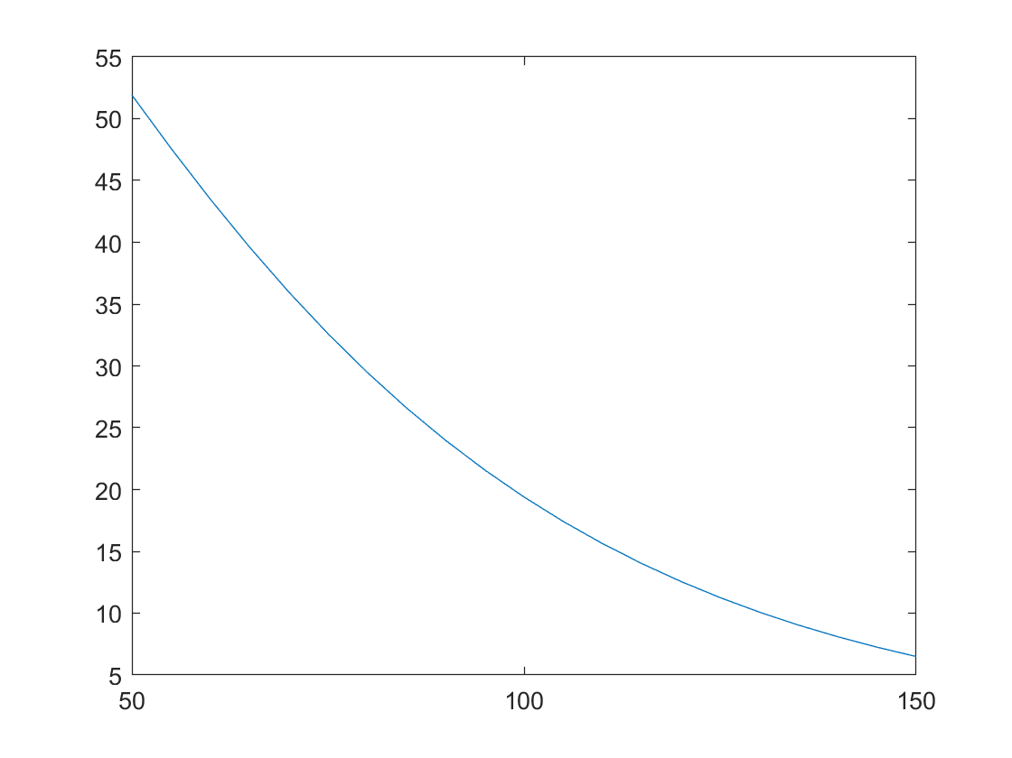

Put

