**PhD candidate’s authorship statement, Wageningen University**

**Aim of the authorship statement**

The authorship statement is sent with the thesis manuscript to the opponents to help them judge the candidate’s contribution to (chapters in) the thesis. A PhD study is a learning process, so the candidate is not supposed to have it done all by her/himself.

The promotor may have come up with the research question, for example, or suggested text improvements. Perhaps an MSc student did an experiment under the candidate’s guidance.

**The authorship statement should focus on the candidate’s own contribution**

While it may be needed to mention what others did, in particular when the candidate is not the first author of a chapter, the statement should focus on the candidate’s own contribution. Therefore, the text is written in the first person.

The text must be concise, maximum 1 page A4, about 500 words. If there are authorship statements on chapters that were already submitted or published as paper, these may be re-used in this authorship statement.

Items to address in the research chapters are usually: research question, methodology, research and data collection, data analysis, text and graphs, and the final discussion. For other chapters or for other types of research, the items to address may differ.

**Example of an authorship statement**

PhD candidate’s name : xx xxxxx  
First promotor : xxxx xx. Xx xxxxxxxxxxx  
Title of PhD thesis : xxx xxx xxxx xx xxxxx xxxxxx   
Date of public defence: xx-xx-xxxx xx:xx

*Chapter 1 General introduction.* The general research question and its general scientific and social perspective were proposed by my promotor. I delineated the research question, described how it fits in the current scientific literature and described its potential social impact. I revised the text two times, after comments of my co-promotor.

*Chapter 2 . . .*

*Chapter 3* . . .

*Chapter 4 . . .*

*Chapter 5 . . .*

*Chapter 6 General discussion*. I wrote the first draft of the text after just one discussion with my co-promotor on the subjects and arguments to be included. I revised the text once, after comments of my promotor and co-promotor.

Date  
Signature PhD candidate  
Signature promotor for agreement

**Authorship statement**

PhD candidate’s name: Koen Leuveld

First promotor: Maarten Voors

Title of PhD thesis: Risks and opportunities to development in Africa: A local perspective

Date of public defence: 30-11-2022

**Chapter 1. Introduction**

I wrote the introduction, with feedback from my promotor.

**Chapter 2: Conflict Exposure and Competitiveness**

I worked on this paper with my co-authors from inception to finalization. Together we developed the research protocol and implemented the data collection in Sierra Leone. A co-author prepared the first draft, which I edited, and added one section to. I assisted in data analysis, and re-did all data analysis to ensure no mistakes were left.

**Chapter 3: Input Subsidies to Increase Food Security**

I joined the project of which this paper is an output right before the baseline data collection. I designed and implemented the baseline (and preceding census) with help from other project members and partners. A co-author wrote the first draft of the paper, which I helped edit. After comments by reviewer, we decided to redo the analysis, for which I created all the code and tables. A co-author rewrote the paper, which other co-authors and I edited.

**Chapter 4: Markets and the determinants of sending behaviour in an Investment Game**

Together with my co-author I designed and implemented the field work. Together we wrote a first draft of the paper. I then adapted the draft and changed the focus to examine the role of markets. I received comments on the draft from my promotor which I implemented.

**Chapter 5: Sexual violence, conflict, and female empowerment**

I wrote the paper on my own; I collected the data (with help from my daily supervisor and research assistants), analysed the data and wrote the paper. My promotor provided feedback, which I implemented.

**Chapter 6: Conclusion**

I wrote the conclusion by myself.

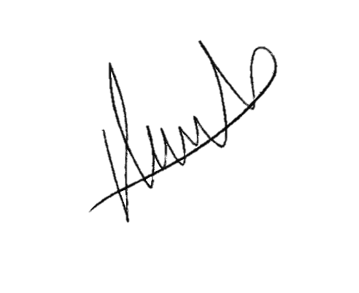Date: 15-08-2022

Signature PhD candidate

Signature promotor for agreement

