Step 5: Sketch Designs
Project Theme: Patient Management System
Group Members: Juela Kadriu, Klevis Kadriu
Team Captain: Juela Kadriu

Requirements:
This step is just an exercise in exploring different Design approaches to your app. Your team will put together at least three different designs for app, perhaps showing different moods or targeting different audiences. These are meant to be very rough designs that only cover the most basic functionality of your app. That is, just one or two screens, and those should only show the major GUI elements.

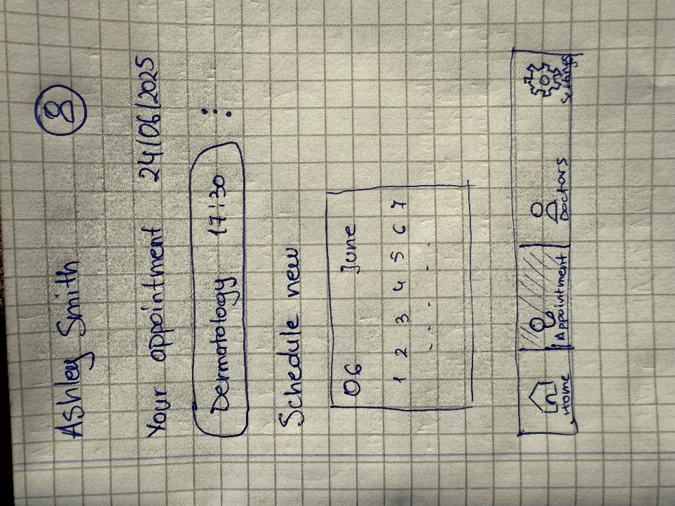
This screen is a patient-facing dashboard that displays upcoming appointment details and allows the user to schedule a new one.
Key Elements:
- User Info: Displays the patient's name (Ashley Smith).
- Appointment Details: Shows a scheduled dermatology appointment for June 24, 2025, at 17:30.
- Schedule New Appointment: Includes a simple calendar UI for the first week of June to pick a new appointment date.
- Navigation Bar: Bottom menu includes:
  - Home
  - Appointment (highlighted)
  - Doctors
  - Settings

This view is intended for doctors or administrative staff to manage daily patient appointments and access management features.
Key Elements:
- Daily Schedule View: Displays scheduled patients per day (June 7–9), including:
  - Ashley Smith (10:00 AM)
  - Rick Sanchez (12:00 PM)
  - Morty Chel (1:00 PM)
- Management Section:
  - My Patients: 10 waiting
  - Medicine: 30 available
  - Doctors: 3 available
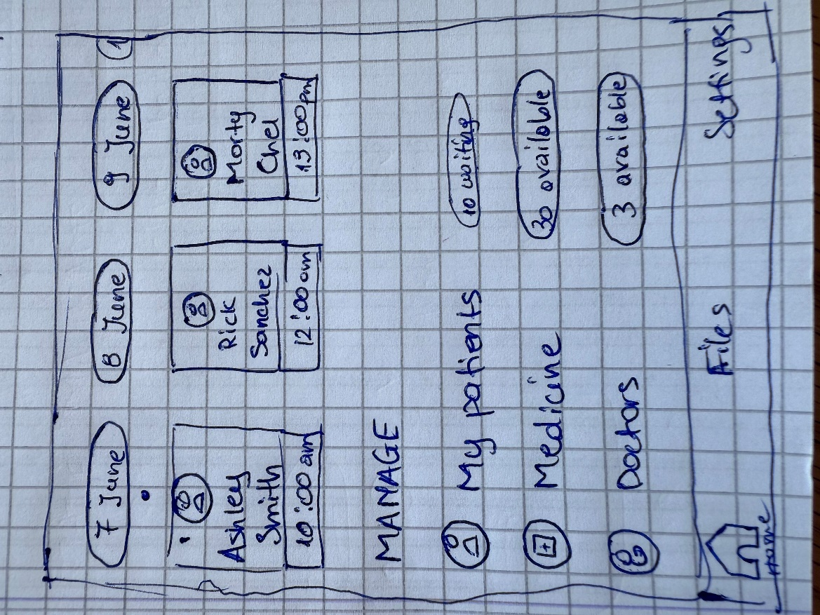
- Navigation Bar: Includes Home, Files, and Settings

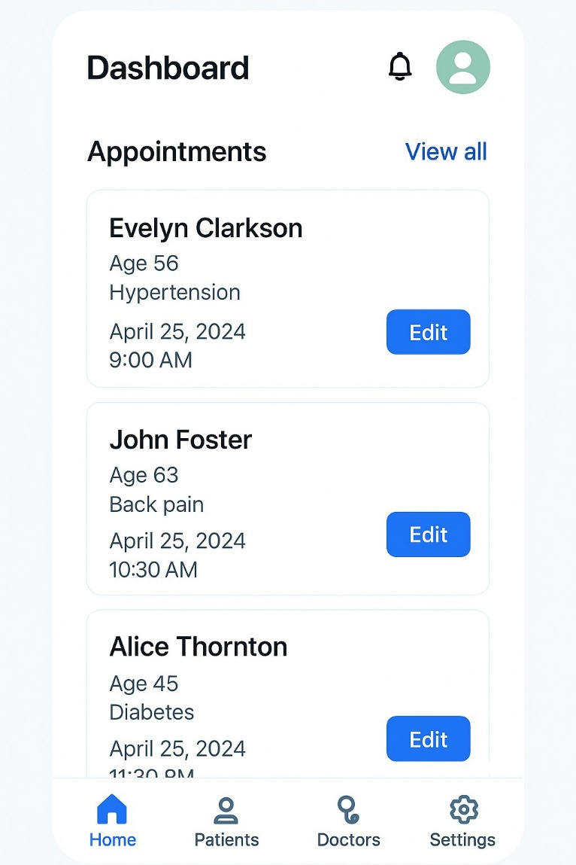
This is a high-fidelity digital mockup showing a refined dashboard interface for the app.
Key Elements:
- Dashboard Title: Clear heading for user context.
- Appointments List:
  - Patient cards with:
    - Name
    - Age
    - Health condition
    - Appointment date & time
    - Edit button
- Navigation Bar: Modern icons for:
  - Home (active)
  - Patients
  - Doctors
  - Settings
Purpose:
This represents the polished user interface using Tailwind CSS, giving a glimpse into the final design of the application. It reflects a clean and responsive layout suitable for both patients and medical staff.

