Step 6: Detailed Designs
Project Theme: Patient Management System
Group Members: Juela Kadriu, Klevis Kadriu
Team Captain: Juela Kadriu

Page 1: User Registration Page (Welcome to MedicPlus)
Purpose:
To allow new users to register for the MedicPlus platform.
Key Functionalities:
- Full Name, Email, Phone Number Inputs: Fields where the user can enter their basic personal details.
- Icons next to input fields visually guide the user on what information to enter.
- "Get Started" Button: Submits the registration information and likely navigates to the next step of onboarding.
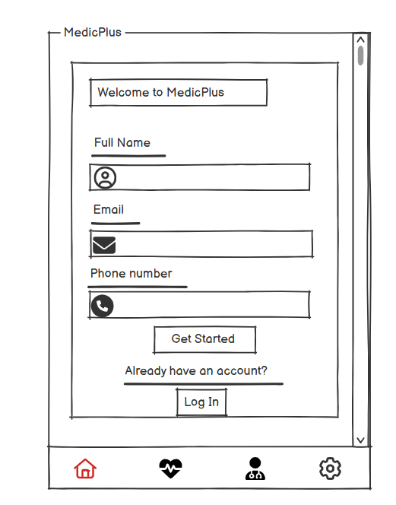
- "Already have an account?" Link + Log In Button: Redirects users to the login page if they already have an existing account.
- Bottom Navigation Bar: Provides quick access to Home, Appointments, Doctors, and Settings.

Page 2: Appointment Dashboard Page
Purpose:
To manage current and future appointments, and help the user find the clinic's location.
Key Functionalities:
- Upcoming Appointments Section: Displays existing appointment details (date, time, department).
- "Schedule New Appointment" Calendar: Lets users select a date to book a new appointment.
- "Our Location" Section: Integrates a map view to show the physical location of the clinic.
- User Profile Icon: Provides access to account settings or user information.
- Bottom Navigation Bar: Same as Page 1.
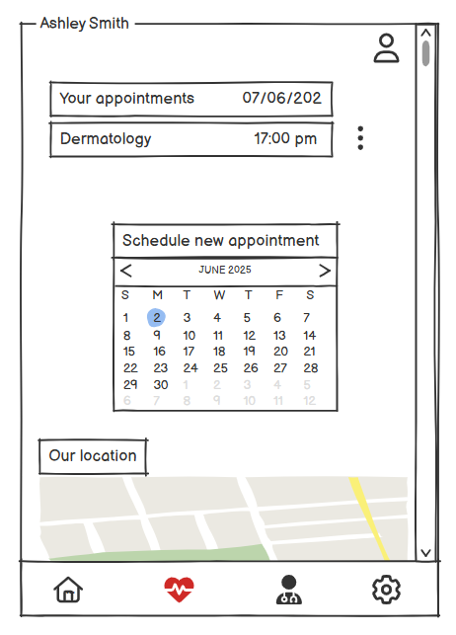

Page 3: Doctor Directory Page
Purpose:
To help users browse and view information about available doctors.
Key Functionalities:
- Doctor Cards: Each doctor is represented with an image, name, and specialization (e.g., Cardiologist, Ophthalmologist).
- "More Info" Button: Likely provides additional details such as availability, experience, or the ability to book an appointment with that doctor.
- Top Banner with User Name: Indicates the logged-in user.
- Bottom Navigation Bar: Remains consistent for easy navigation.
