Step 2: Personal Log
Project Theme: Patient Management System
Group Members: Juela Kadriu, Klevis Kadriu
Team Captain: Juela Kadriu
- Each member must maintain a personal weekly log.
- Logs should be detailed and specific.
- Entries must be in reverse chronological order.
- Include what technologies were explored and personal contributions.
Logs are visible to all team members.
Week 2:
- As a group, we set up Visual Studio Code for development, ensuring all members had a consistent environment.
- We installed and configured Tailwind CSS, successfully integrating it and testing its responsiveness with a simple layout.
- We also designed the main page of the Patient Management System in Figma. The layout includes sections for patient records, a navigation menu, and a color palette aligned with healthcare standards.
- Analysis: Early configuration of tools like VS Code and Tailwind ensures a smooth workflow and prevents future integration issues. The Figma prototype provides a visual foundation, helping align the team's vision and improving efficiency when implementing the front-end.

Use Case Diagram
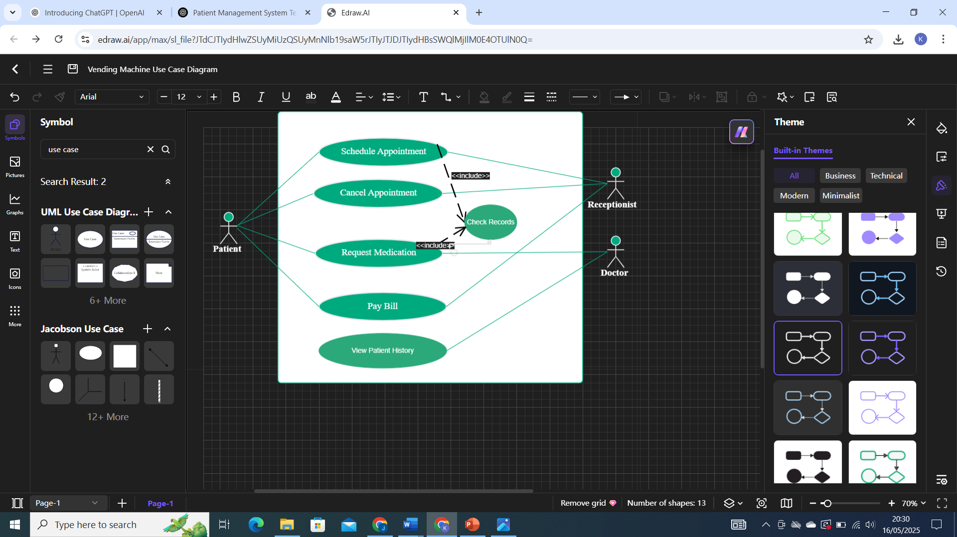

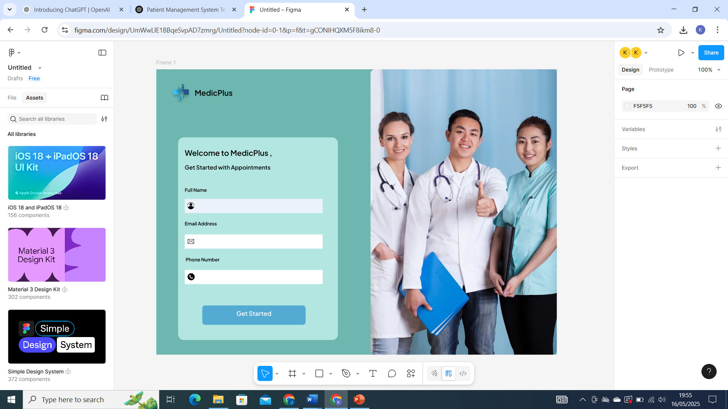
Main Page Design

