Homework 5

Klevis Tefa

Part A

Question A.1

1. 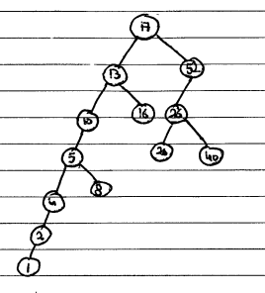
2. 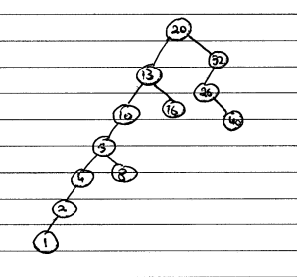
3. 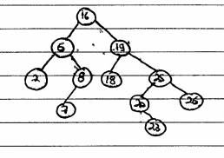
4. (2, 7, 8, 6, 18, 23, 20, 26, 25, 19, 16)
5. 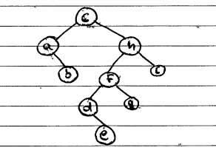

Question A.2

Using this patter: We can use DeMorgan’s law: i ^ ii ^ iii ^ iv = - (-i v –ii v –iii v –iv). Each would translate in the pattern form as: “([^0-9]+ | [^a-z]\* | [^A-Z]+ |[^\S]+){0}”.

Question A.3

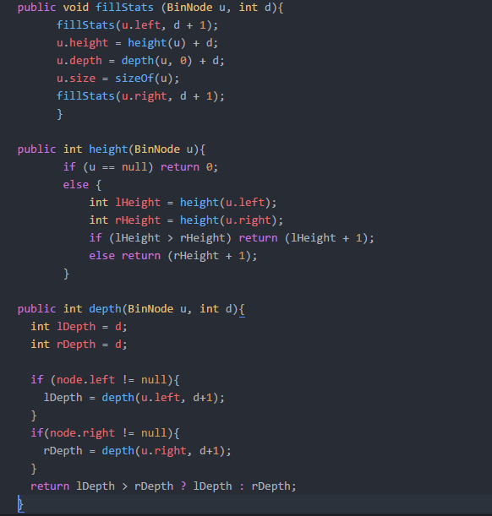

Question A.4

All the methods and the code is located at src/sqew/Sqew.java.