**Klevu LINK Integration**

Version 21.1.0



Table of Contents

1. Overview 2-2

1.1 Compatibility 2-3

1.2 Supported Locales 2-3

2. Integration Components 2-3

2.1 Components 2-3

2.2 Adding the cartridge in SFCC UX Studio 2-3

2.3 Business Manager Configurations 2-3

2.3.1 Activating the cartridge in Business Manager 2-4

2.3.2 Importing Metadata 2-4

2.3.3 Type Extensions 2-5

2.3.4 HTTP Service 2-9

3. Testing 3-9

3.1 Business Manager features – Export jobs 3-9

3.2 Storefront features 3-10

4. Operations, Maintenance 4-11

4.1 Availability 4-11

4.2 Support 4-12

5. Known Issues 5-12

5.1 Plain use of SFTPClient.connect() 5-12

6. Release History 6-12

# Overview

This document describes the technical integration of Klevu LINK cartridge.

**Klevu Smart Search** is a powerful and extensible eCommerce search solution that delivers search results based on shopper intentions and behavior, in real-time. It combines the power of machine learning and natural language processing to deliver the most relevant results to the shopper.

**Klevu Smart Category Merchandising** is a combination of world class AI and Merchandiser-friendly controls. Klevu dynamically ranks ordering of products on category pages and also provides well designed visual merchandising capabilities to tune category pages, with AI still remaining a backbone.

## Compatibility

This Cartridge works best with the SFRA version of 5.5.0 and compatibility mode 21.2

## Supported Locales

This Cartridge supports all Locales. Currently it supports single locale (default locale) per site. That said, no support for multiple locales in the same site.

# Integration Components

## Components

Klevu Integration has the following cartridges.

* **int_klevu_sfra -** This cartridge has controllers and other script files necessary for integration on SFRA site.
* **bm_klevu -** Business Manager extension cartridge for data export features.
* **int_klevu_core -** This cartridge has script files which are used by scripts in both int_klevu_sfra and bm_klevu cartridges.

## Adding the cartridge in SFCC UX Studio

To upload the cartridges into the SFCC server, first need to add the cartridges in SFCC UX Studio. In order to do this, follow these instructions.

1. In UX Studio, select in the menu File > Import.
2. In the import dialog, select General > Existing Projects in the workspace and click on 'Next'.
3. Ensure 'Select archive file' is selected and select the compressed cartridge file by clicking on the 'Browse' button.
4. Click on 'Finish' button to import the cartridges.
5. Studio will now ask you if you want to link the cartridge to your active DigitalServer connection. Click on yes or manually link the cartridge to your server by checking the project under project references in the server connection properties.

## Business Manager Configurations

For the Klevu integration to work, the following needs to be configured in the Business manager.

### Activating the cartridge in Business Manager

Before the Klevu functionality can become available to Site, the cartridges have to be added to the cartridge path of the Site. In order to do this, follow the following instructions:

1. Log into Business Manager.
2. Navigate to Administration > Sites > Manage Sites.
3. Click on the site name and on the next page go to the 'Settings' tab.
4. In the 'Cartridges' input field add 'int_klevu_sfra:int_klevu_core' in front of base cartridge.
5. Click on 'Apply' button.
6. To activate the cartridge for the Sandbox/Development/Production instances repeat steps 4 and 5 after selecting the appropriate instance from the 'Instance Type' dropdown menu.
7. Repeat steps 3 to 6 for each site that is to use Klevu.
8. Go to 'Manage the Business Manager site'.
9. In the Cartridges input field add ‘bm_klevu:int_klevu_core’
10. Click on 'Apply' button.

### Importing Metadata

For the Klevu integration to work, the following object structures (metadata) needs to be imported and configured in the Business manager. Follow the below steps:

1. In the cartridge bundle find **metadata/klevu-meta-import** folder.
2. Find the **libraries** folder and inside it, find **RefArchSharedLibrary** folder.
3. Rename this **RefArchSharedLibrary** folder to the ID of your site. If you have multiple sites to which these meta has to be imported, then copy and paste this **RefArchSharedLibrary** folder to replicate for other sites. Renames those folders with ID of corresponding sites.
4. Find library.xml inside the **RefArchSharedLibrary** folder. Open it in any basic text editing application. In second line find below XML tag:

<library xmlns="http://www.demandware.com/xml/impex/library/2006-10-31" library-id="RefArchSharedLibrary">

Repeat this step for all the site’s folders inside the libraries folder.

1. In the cartridge bundle, inside **metadata** folder compress klevu-meta-import folder to generate **klevu-meta-import.zip** file.
2. Go to Business Manager Menu > Administration > Site Development > Site Import & Export
3. Under Import: Upload Archive: Ensure that the radio button with label **Local** is enabled (Else click on the radio button to enable it)
4. Click on Choose File input field, select the klevu-meta-import.zip file from open dialog box and click on upload button
5. After finishing the upload, from the Archives list click the radio button corresponding to **klevu-meta-import.zip** and click on Import button
6. Click on OK button of the confirmation box asking, “Are you sure that you want to import the selected archive?”

### Type Extensions

#### 2.3.3.1 Custom Site Preferences

**After the successful metadata import following attributes should have been created:**

In Business Manager, navigate to the Merchant Tools > Site Preferences > Custom Preferences. Custom site preference groups with the ID ‘Klevu’ will be available after the successful import of metadata. Please select it and edit the attributes according to your Klevu account data.

For each site, set the values for your site preferences.

**Group ID: Klevu**

1. **Enable Klevu Storefront** (ID - enableKlevuStorefront, Type - Boolean) - To enable or disable Klevu’s functionality on storefront.
2. **Enable Klevu Category Page** (ID - enableKlevuCategoryPage, Type - Boolean) – Enable or disable Klevu’s functionality only on category landing page
3. **Storefront Search URL** (ID - klevuStorefrontSearchURL, Type - String) – Klevu’s API End Point for storefront search feature
4. **API Key** (ID - klevuAPIKey, Type - String) – Klevu API key
5. **Rest Key** (ID - klevuRestKey, Type - String) – Klevu Rest key
6. **Number of Products in Single File** (ID - klevuProductsInSingleFile, Type - Integer) – Number of Master or Simple products in a single XML file of Product Export jobs
7. **Storefront Item Search Limit** (ID - klevuItemSearchLimit, Type - Integer) – The maximum number of products that searched on Klevu API for storefront search feature, in a single API call
8. **Product Attributes Mapping Mandatory** (ID - klevuMandatoryProductAttributes, Type - Text) – Klevu to SFCC mapping of Klevu’s mandatory attributes to be exported to Klevu.

This is mandatory working JSON example.

where *klevu_id* will be attribute to Klevu side.

*sfcc_id* this will be SFCC’s system or custom object type representing products.

*sfcc_type* Type of object whether system or custom

Example: [

{

"klevu_id": "id",

"sfcc_id": "ID",

"sfcc_type": "system"

},

{

"klevu_id": "title",

"sfcc_id": "name",

"sfcc_type": "system"

}

]

1. **Product Attributes Mapping Optional** (ID - klevuOptionalProductAttributes, Type - Text) – The following are the additional attributes about items should be indexed if you would like to be searchable for your item. This content will be indexed for search.

Example: [

{

"klevu_id": "keywords",

"sfcc_id": "pageKeywords",

"sfcc_type": "system"

},

{

"klevu_id": "brand",

"sfcc_id": "brand",

"sfcc_type": "system"

},

{

"klevu_id": "short_description",

"sfcc_id": "shortDescription",

"sfcc_type": "system"

},

{

"klevu_id": "description",

"sfcc_id": "longDescription",

"sfcc_type": "system"

},

{

"klevu_id": "mpn",

"sfcc_id": "manufacturerSKU",

"sfcc_type": "system"

},

{

"klevu_id": "gtin",

"sfcc_id": "UPC",

"sfcc_type": "system"

},

{

"klevu_id": "boosting_score",

"sfcc_id": "boostingScore",

"sfcc_type": "custom"

},

{

"klevu_id": "swatch_color",

"sfcc_id": "color",

"sfcc_type": "custom"

},

{

"klevu_id": "swatch_label",

"sfcc_id": "refinementColor",

"sfcc_type": "custom"

},

{

"klevu_id": "swatch_size",

"sfcc_id": "size",

"sfcc_type": "custom"

},

{

"klevu_id": "size",

"sfcc_id": "size",

"sfcc_type": "custom"

}

]

1. **Product Attributes Dynamic** (ID - klevuDynamicProductAttributes, Type - Text) –

The following are additional attributes about your item which you may freely define. You can specify multiple values for each attribute and also whether it should be searchable and/or treated as a facet.

*sfcc_id* will be system or custom object type of Products.

*is_facet* <is_facet/> is false by default. If you specify an attribute with <is_facet/> true, it will automatically be searchable. A facet attribute will always be searchable.

*is_searchable* If you want an attribute to be searchable but not a facet, specify

<is_facet/> false. <is_searchable/> is true by default so no need to specify.

*is_return* If you want an attribute to be returned in the search response data, but neither searchable nor a facet, then you can specify <is_facet/> and <is_searchable/> as false and <is_return/> as true.

Example:

[

{

"sfcc_id": "rating",

"is_facet": true

},

{

"sfcc_id": "tabDetails",

"is_return": false

},

{

"sfcc_id": "discountText",

"is_return": true,

"is_facet": false,

"is_searchable": false

}

]

Note: Following Klevu attributes are directly handled by the cartridge without explicitly mentioning them on Site Preferences

* item_group_id
* item_type
* sku
* link
* availability
* categories
* price
* sale_price
* image_link
* additional_image_link

#### 2.3.3.2 Content Assets

In Business Manager, navigate to the Merchant Tools > Content > Content Assets and search for the text ‘Klevu’ to find all below 4 Content Assets as part of this integration. These content assets are to serve some browser side code snippets for customizing Quick Search Box and for providing ability to send analytics to Klevu.

1. klevu-quick-search-css (Quick Search Box Implementation: CSS)
2. klevu-quick-search-js (Quick Search Box Implementation: JS)
3. klevu-quick-search-templates (Quick Search Box Implementation: Templates)
4. klevu-analytics-snippet (Storefront Analytics Snippet)

#### 2.3.3.3 Export Jobs

On the Business Manager go to Menu > Administration > Operations > Jobs and find following jobs

Following is the Full synchronizing job which is supposed to be executed once just after finishing the integration in order to export all the existing data to Klevu. This job is not required to schedule for triggering in recurring interval.

* KlevuExport01Full
* Export Products, Categories, Content assets in Full sync mode. Data is needed to be synchronized with Klevu’s database, in order to provide Klevu’s AI based search offerings in Merchant’s storefront.

Following jobs are for sending delta/differential data to Klevu in recurring interval. The recurring interval has to be set by the merchant. Default value is set as 6 Hours.

* KlevuExport02DeltaProducts
* Export the Products from SFCC to Klevu in Delta mode
* KlevuExport03DeltaCategories
* Export the Categories from SFCC to Klevu in Delta mode
* KlevuExport04DeltaContentAssets
* Export the Content assets from SFCC to Klevu in Delta mode
* KlevuExport05DeletedProducts
* Export the Products to Klevu which are deleted in SFCC
* KlevuExport06DeletedCategories
* Export the Categories to Klevu which are deleted in SFCC
* KlevuExport07DeletedContentAssets
* Export the Content assets to Klevu which are deleted in SFCC
* KlevuExport08Order
* Export the newly created orders into Klevu API. Klevu uses items from order to identify popular products and rank them for search results.
* KlevuExport09DeltaPrice
* Export pricebook data of the products to Klevu.

### HTTP Service

Under Administration > Operations > Services,

check that services with following names are created:

* klevu.http.storefront
* klevu.http.backkoffice
* klevu.http.analytics

Check the Service Credential objects under Administration > Operations > Services > Service Credentials. Get appropriate URLs from Klevu and configure under URL field of each Service Credential object.

Note that there is a string /{api_key}/ under the URL field of Service Credential object with name klevu.http.backoffice.credentials. This must be kept intact since cartridge code will automatically substitute this value with actual API Key that is configured on appropriate field under custom site preferences.

# Testing

## Business Manager features – Export jobs

On the Business Manager go to Menu > Administration > Operations > Jobs and find following jobs

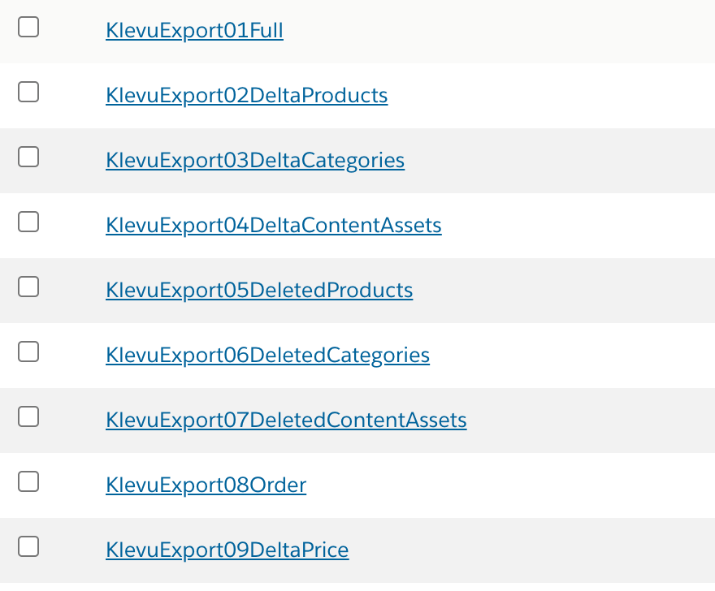

* Execute Job **KlevuExport01Full** and get job status OK
* Make some changes on any attribute of some products, categories and content assets, execute the jobs **KlevuExport02DeltaProducts**, **KlevuExport03DeltaCategories** and **KlevuExport04DeltaContentAssets** and get job status OK
* Delete (or make offline) some products, categories and content assets, execute the jobs **KlevuExport05DeletedProducts**, **KlevuExport06DeletedCategories**, **KlevuExport07DeletedContentAssets** and get job status OK
* On storefront place some dummy orders, execute job **KlevuExport08Order** and get job status OK
* Execute Job **KlevuExport09DeltaPrice** and get job status OK

## Storefront features

On Business Manager go to Menu > Merchant Tools > Site Preferences > Custom Preferences > Klevu: ‘Enable Klevu Storefront’ and change its selection value as ‘Yes’

Open storefront and use quick search option to see Klevu’s smart search result user interface

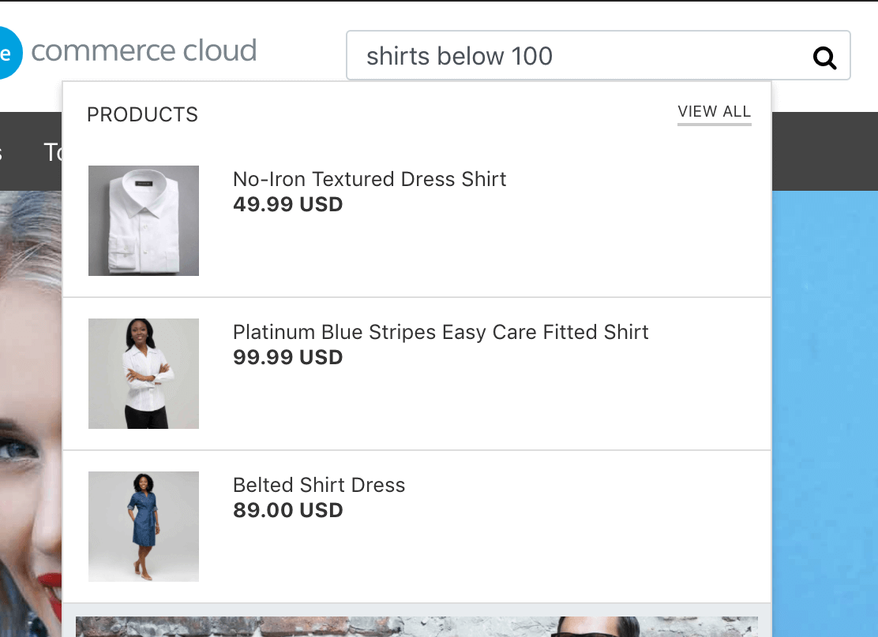

Enter the search query and land on search result page to see the Klevu’s smart search result

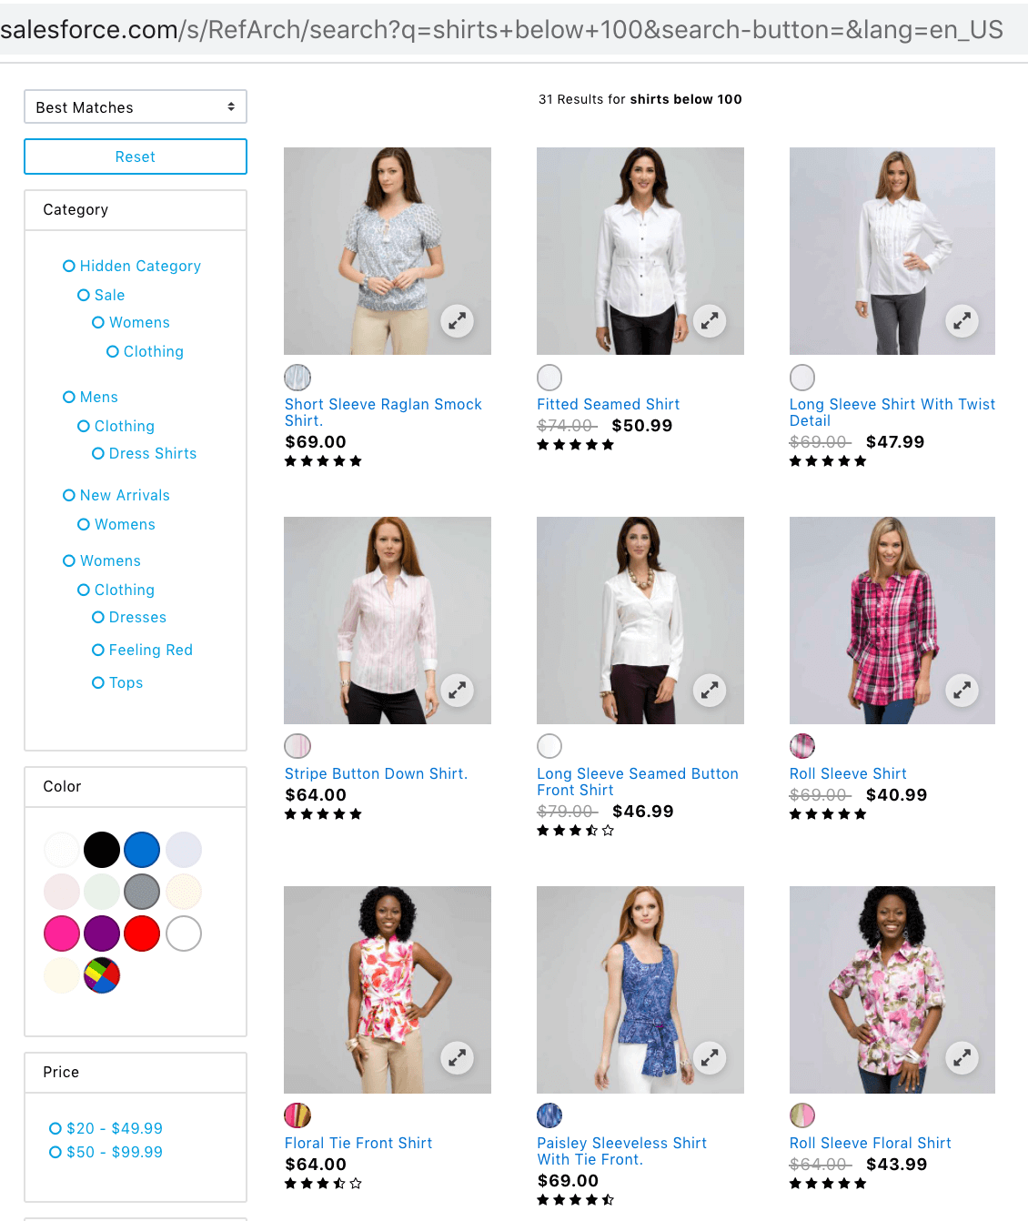

Similar to search landing page, category landing page is also configured in such a way that the product list is fetched from the Klevu’s database

# Operations, Maintenance

## Availability

If Klevu API service is down, then it could be identified by below points. In such contexts contact the Klevu’s Support team. Details are in Support section (4.1).

* Business Manager export jobs – Every XML export job has a special job step **KlevuAPIAvailabilityCheck** which will end up on ERROR and the whole job also
* Storefront search features – Customer will get a message as shown in the below screenshot



When a technical problem occurs like shown above then Merchants can disable the

cartridge in Business Manager.

Go to Menu > Merchant Tools > Site Preferences > Custom Preferences > Klevu:

‘Enable Klevu Storefront’ and change its selection value as ‘No’. Once this is done then

the storefront loads in default mode without any issues.

Klevu has numerous levels of redundancy built in, including multiple data centres,

distributed search endpoints via CDN and a very active support team. If you do

encounter an issue, please contact Klevu Support (support@klevu.com) who will be able

to investigate for you.

However, in the unlikely event that Klevu service remains unavailable after contacting

support, you have the option to disable Klevu by changing the value of "Enable Klevu

Storefront" to No, and your native search functionality will resume. Once the Klevu

service becomes available again, switch this flag back to Yes.

## Support

For technical support, visit our [Help Center](https://support.klevu.com/) OR email us at [support@klevu.com](mailto:support@klevu.com)

# Known Issues

## Plain use of SFTPClient.connect()

In the cartridge there is use of SFTPClient.connect() method without using SFCC’s relevant service object. This is because the requirement related to this feature is that to get SFTP login credentials from Klevu’s API and to use it for dynamic SFTP connection. For connecting to SFTP server through service object insists the use of static SFTP login credential that need to be set on the service credential objects which is not possible on this requirement.

# Release History

|  |  |  |
| --- | --- | --- |
| **Version** | **Date** | **Changes** |
| 21.1.0 | 12-May-2021 | Initial release |