SUPPLEMENTARY INFORMATION

Analytical and Statistical Details

An 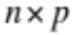 matrix of observations of phenotypic values, 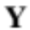, has the following linear model,

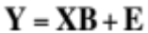, | (1)
where 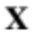is an 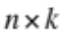 design matrix, 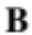is an 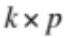 matrix of for the 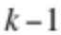 model coefficients plus an intercept (vector of 1s), and 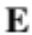is an matrix of residuals (Rencher, 2008). Model coefficients are estimated via generalized least squares as,

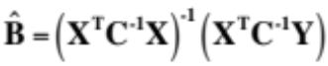, | (2)
where the subscripts ^{T} and ⁻¹ indicate matrix transposition and inversion, respectively, and 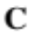is an positive-definite covariance matrix that expresses the hypothesized or estimated correlations among the observations (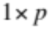 vectors of phenotypic values), if they are not independent (e.g., if observations are from siblings of the same families). In the case that observations are independent, both and 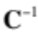 are identity matrices (Martins and Hansen, 1997).

By extension of equation 1, the estimated residuals from the linear model is the matrix,

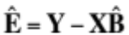, | (3)

and the 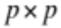 matrix of sum of squares and cross-products for the error is found as,

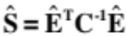. | (4)

The residual sum of squared error, RSS, can be calculated as the trace of .

In order to calculate for the independent variables of the model, a comparison between for two models is required: one model with model variables, including the intercept, and one model with only the intercept. If these models have design matrices 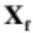 and 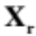 to indicate “full” and “reduced” models, respectively – the full design matrix with columns and the design matrix a single vector of 1s – the matrix of sums of squares and cross-products is found as,

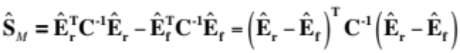, | (5)

where the subscript, _{M}, simply refers to effect of the model coefficients under consideration (Rencher, 2008). Likewise, the trace of 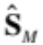 can be used to estimate the sum of squares for the model effect.

In the interest of hypothesis testing, the covariance matrix of the model effect can be estimated as

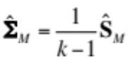, | (6)
and the trace of this matrix has an expected value of 0 under the null hypothesis (indicating that the additional parameters of the full design matrix do not contribute to a reduction in error). Either traces of or 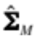, sum of squares (SS) or mean squares (MS), respectively, or a calculation of a coefficient of determination as,

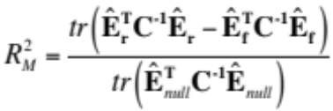, | (7)

or an F-value (McArdle and Anderson, 2001) as,

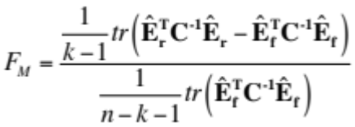, | (8)

can be used as adequate test statistics for a hypothesis test, using a resampling experiment to generate probability distributions (Adams and Collyer, 2007; Adams and Collyer, 2009; Collyer and Adams, 2007; Collyer and Adams, 2013; Collyer et al, 2007; Turner et al, 2010). In the denominator in equation 7, the subscript, _{null}, indicates that the model only contains an intercept, even if the reduced model is not a null model (see below).

The most appropriate resampling experiment is the randomized residual permutation procedure (Anderson and Robinson, 2001; Freedman and Lane, 1983), because it produces random versions of 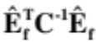, holding 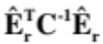 constant, thus assuring that the rank order of random versions of , , 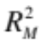, and 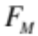 calculated from the same random permutations would be exactly the same. (I.e., the ranks of the statistics are perfectly correlated, as each one is a linear or non-linear transformation of any other.) RRPP randomly shuffles the vectors of residuals in 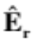, producing 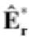. By adding these randomized residuals to the predicted values of the reduced model,

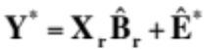, | (9)

pseudorandom values of Y are produced, which hold constant the effects of the reduced model. In the case that the reduced model contains only an intercept (the null model), 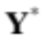 is simply a randomized version of Y. If the squared Euclidean distances of residuals from their predictions are not normally distributed, it might be of interest to modify residuals (Davison and Hinkley, 1997). Modified residuals are calculated as

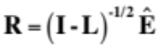, | (10)

where I is a n x n identity matrix and L is a diagonal matrix whose diagonal elements are leverage values, and are the same as the diagonal elements of the hat matrix,

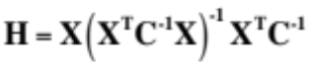. | (11)

In each random permutation of RRPP, steps 2-5 are repeated for the full model, replacing for Y, and one or all of the test statistics in steps 5-8 are calculated, creating sampling distributions from which P-values can be estimated as the percentiles of the observed statistic in the distribution.

Additionally, the effect size of any statistic can be estimated from a sampling distribution generated by a resampling experiment, by finding (e.g., for 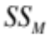),

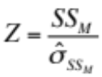, | (12)
where 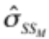 is the standard deviation of the sampling distribution of (Collyer and Adams, 2013). The benefit of calculating the effect size, which measures the standard deviation of the observed effect from an expected value of 0, relative to the standard deviation of hypothetical random outcomes, is that it facilitates comparisons of different effects, both within the same study and across studies.

Multiple model effects

For models with multiple effects, like factorial models or models with both (categorical) factors and (continuous) covariates, the same approach can be used. For example, let the full model contain the number of parameters 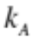 plus 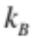 in addition to an intercept to model effects A and B. Step 5 can be performed using this full model, and a reduced model that has an intercept and either or parameters. Calculating , as in step 5, indicates the change in error associated with the parameters added to the reduced model (or subtracted from the full model). Rejection of the null hypothesis, 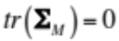, indicates that the parameters that differ between full and reduced models are important, as they explain a significant amount of multivariate variation. When performed on the parameters that differ between models, effect A can be evaluated. When performed on the parameters that differ between models, effect B can be evaluated. The method of introducing or subtracting model effects is the basis for calculating sums of squares and cross-products matrices (Shaw and Mitchell-Olds, 1993).

However, the method to generate sampling distributions for multiple test statistics is not trivial, and requires further consideration. For the purpose of example, we use Type I (sequential) sums of squares and cross-products, in which the order of model effects is important. For m model effects, there are m + 1 iterations of steps 2-4 and m +1 resulting sums of squares and cross-products matrices calculated in step 5. For example, assuming effects A and B indicate a preferred order of consideration 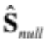 is calculated for a null model (containing only an intercept), which is the matrix of “total” sums of squares and cross-products. Subsequently, 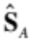 and 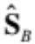 are calculated by adding then parameters to the model, iteratively, as in step 5. Using the trace of these matrices is the simplest statistic for a hypothesis test (or statistics in 6-8 could be used).

For m added model effects, there are m hypothesis tests to perform. However, performing the RRPP m times, once for each sums of squares and cross-products matrix calculation is not preferred, as the separate sampling distributions would not contain the same random permutations. Rather, the residuals matrices can be concatenated for the RRPP, such that,

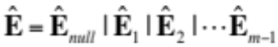, | (13)

where the numbered subscripts indicate the order of introduced model effects (with the null model always first), forming an 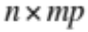 matrix of residuals. The 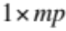 row-vectors of this matrix are shuffled in the RRPP, and then 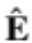 is repartitioned to create separate matrices of randomized residuals. These matrices are used to find m matrices of pseudorandom phenotypic values (step 9), from which m random test statistics are calculated for the m effects. For every m iterations of statistics calculation, within every random permutation, the residuals from the full model for the previous (m – 1) iterations are randomized to evaluate the m^{th} effect. However, within each permutation, the m statistics are calculated from the same exact random positions (rows) of residual vectors. The result is m sampling distributions of statistics calculated the same way.

This procedure can also be adapted to linear mixed (hierarchical) models. One only needs to be specific about the method of adding effects to reduced models. This procedure should also be commensurate with Bayesian Markov chain Monte Carlo (MCMC) approaches to parameter estimation for multivariate data, sensu Ovaskainen and Soininen (2011). Performing RRPP for np-MANOVA is a procedure that is initiated once model parameters have been estimated; thus, it would not preclude any method of parameter estimation, including least squares, maximum likelihood, restricted maximum likelihood, or Bayesian MCMC methods. However, embedding MCMCs within RRPP permutations will require an immense amount of computing time.

Because np-MANOVA with RRPP is non-parametric, it can be applied to phenotypic data where 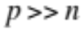. In such cases, if Y is not full rank, it might be valuable to determine the “relevant dimensions” in the data space for model effects, which can be found by the positive eigenvalues of a singular value decomposition of the sums of squares and cross-products of the full matrix, for any model effect,

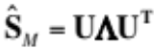, | (15)

where 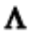is the 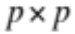 matrix of eigenvalues, of which the first 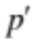 are greater than 0, and U is the matrix of eigenvectors, of which the first represent the relevant dimensions. Another appeal of this approach is that one could calculate the coefficient of determination (step 7) for the major axis of covariation for the model effect as,

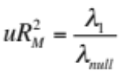, | (16)
where 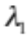 is the first eigenvalue calculated in step 15, and 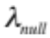 is the same eigenvalue calculated from a singular value decomposition of . This coefficient of determination is the “univariate” estimation along the axis of greatest covariation for the model effect. This statistic might have appeal in high-dimensional data spaces where coefficients of determination, as calculated in step 7, are quite small even though effect sizes are large. Such a result would be likely if .

Computational Details for Examples

(This section is largely redundant with the Materials and Methods, and Results of the main article, but provides greater analytical details and additional results)

Methods
In the first example, the design matrix of the full model, Body Shape ~ Population + Sex + Population × Sex, has the form,

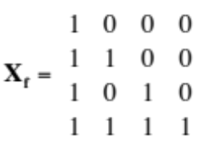,

where the 0s and 1s are dummy variables indicating group associations. The first column is a column of 1s for the intercept; the second column is a variable to indicate if pupfish belong to the marsh (0) or sinkhole (1) population; the third column is a variable to indicate pupfish are female (0) or male (1); and the third column is a product of the second and third column, for the interaction between population and sex. Removing the interaction (fourth column) reduces the matrix to only include main effects. Removing additionally the third column reduces the matrix to have only the population effect. Removing additionally the second column reduces the matrix for the “null” model, containing only the intercept. The corresponding rows of the matrix above were repeated for every specimen such that was a 54 × 4 matrix.

In the second example, the design matrix of the full model, Body Shape ~ log(CS) + (Population × Sex) + log(CS) × (Population × Sex), has the form,

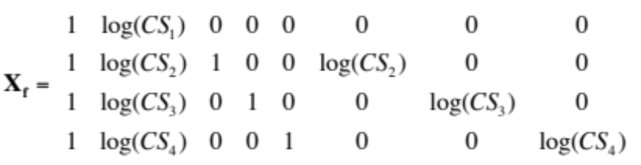

where the dummy variables are as in example 1. The second column is a column of values of the covariate (log of centroid size); the last three columns are these values multiplied times the corresponding dummy variables. The corresponding rows of the matrix above were repeated for every specimen such that was a 54 × 8 matrix.

The coefficients for the four possible models in example 1(null, P, P+S, and P*S, corresponding to the addition of column variables, where P represents population and S represents sex) were calculated as in step 2 above. (Since observations were independent, C was an identity matrix.) Effect sums of squares and cross-products matrices were calculated as in steps 3-5 above. Steps 2-5 were repeated for body shape using both 10- and 56-landmark configurations.

The coefficients for the four possible models in example 2 (null, CS, CS + (P*S), and CS*(P*S), corresponding to the addition of sets of column variables, where CS represents log centroid size) were calculated as in step 2 above. However, the number of columns in these design matrices were 1, 2, 5, and 8, respectively, as sets of variables are not split up for general effects. (I.e., columns 3-5 correspond to the P*S effect; columns 6-8 correspond to the CS*(P*S) effect. Effect sums of squares and cross-products matrices were calculated as in steps 3-5 above. Steps 2-5 were repeated for body shape using both 10- and 56-landmark configurations. The data for 10- and 56- landmark configurations are explained below.

The Cartesian coordinates of landmarks were used to generate “Procrustes residuals” via generalized Procrustes analysis (GPA; Rohlf and Slice 1990). GPA centers, scales to unit size, and rotates configurations using a generalized least squares criterion, until they are optimally invariant in location, size, and orientation, respectively. The aligned coordinates are the Procrustes residuals, and they define the shape difference between two or more configurations by a metric called “partial Procrustes distance”, which is the square root of the summed squared differences between corresponding landmarks. Whereas fixed landmarks define or suggest recognizably discrete anatomical points, sliding semilandmarks are used to estimate curvature (Gunz and Mitteroecker, 2013). Their placement is arbitrary to a certain extent, but attempted to be almost equidistant along a curve. GPA slides semilandmarks such that they minimize Procrustes distance between them, defining a parsimonious explanation of curves using stationary points, based on the a priori number of points selected. While useful in defining body shape, semilandmarks introduce the problem of creating high-dimensional data, which can be exacerbated by singularities in the data matrix, as the Cartesian coordinates of these landmarks are not independently sampled.

Procrustes residuals are frequently projected into a Euclidean tangent space of the shape space, and principal components analysis (PCA) is performed to transform Procrustes variables into “shape” variables (the “real” eigenvectors of the tangent space). The maximum number of shape variables is a minimum of p or n – 1, but the number of shape variables can be further reduced by redundancies from GPA (specifically due to scaling, rotating, and translating configurations, and because of non-independence of semilandmarks). We used projections of all Procrustes residuals into tangent space as shape variables but did not constrain the number of variables based on relevant PCs. Working with Procrustes residuals is preferred because (1) the coefficients estimated from linear models correspond to Cartesian displacements of anatomical points, which is more intuitive than PC scores and (2) the trace of 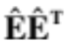using projected Procrustes residuals is exactly the same as SS using PC scores, but the diagonal of the former provides subject-specific Procrustes distances from estimated values based on the linear models. Thus, high-dimensional data might be preferred to using reduced-dimension variables, like found from PCA. Nevertheless, we used projections of Procrustes residuals onto first two PCs of shape variation to visualize shape differences among subjects and groups.
For analysis of phenotypic change in Example 1, we were interested in the model, Body Shape ~ Population + Sex + Population × Sex. With 54 specimens, using a landmark configuration with only 10 landmarks would allow for estimation of P-values, using parametric methods. Including the additional 2 landmarks and 44 semilandmarks precludes using parametric methods. Thus, we performed a non-parametric (np)–MANOVA, using RRPP with 10,000 permutations, on both types of landmark configurations to compare results between the two configuration types, plus performed a parametric MANOVA by converting Pillai’s trace for each model effect to approximate F values for the 10-landmark data, to compare results between parametric and non-parametric methods. Upon finding a significant population by sex interaction, we re-ran the analysis but also with re-estimation of population by sex means, specifically randomizing residuals from the reduced model, Body Shape ~ Population + Sex. For each permutation, we calculated pairwise Procrustes distances among means. RRPP thus generated six sampling distributions of pairwise distances among the four means, from which the probabilities of observing greater random distances than the observed distances, by chance, could be ascertained, holding constant the main effects. In essence, this was not a post-hoc test as much as it was a simultaneous test of pairwise mean differences, using the exact same random permutations as the np-MANOVA. However, it allowed a more precise assessment of the reasons for a significant interaction. As a method of comparison, we also performed a “full” randomization of values, as is done in some statistical programs, like the adonis function in the vegan package for R (Oksanen et al, 2013). The purpose of this analysis was to simply evaluate if different inferences arise from disregarding significant main effects.

For analysis of allometric phenotypic change in example 2, the same data were used as in the example 1, but the intent was to compare phenotypic change associated with body size (static body shape allometry) among the Population × Sex groups. The linear model used was Body Shape ~ log(CS) + (Population × Sex) + log(CS) × (Population × Sex), where log(CS) is the natural log of centroid size used as a measure of body size. Centroid size is the square root of the summed squared distances of landmarks from configuration centroids. As in the previous example, non-parametric MANOVA analyses, using RRPP with 10,000 permutations, were performed on both the 10- and 56-landmark configurations. A parametric MANOVA was performed on the 10-landmark configuration, as the comparatively smaller number of variables permitted its use. Based on the outcome of analyses, PC plots were generated to visualize variation in shape after accounting for a common allometry. A posthoc test of pairwise differences between least squares means was also performed, as in example 1, as np-MAONVA revealed that population by sex groups had common shape-size allometries (see below).

Any np-MANOVA effects or pairwise differences were considered significant is their P-values were less than a type I error rate of α = 0.05. Because the RRPP method introduced here performs the exact same random placement of residuals for every test statistic calculated, we did not consider the inferences to be separate tests, but rather separate inferences from the same test. Thus, it was not necessary to use a pairwise adjustment of α in order to maintain a familywise α = 0.05. We calculated the effect size for all np-MANOVA effects as the number of standard deviations of an effect above an expected value of 0 (from the null hypothesis), based on the standard deviation of the sampling distribution for the effect statistic (SS). This allowed comparison of the effect sizes between results from the 10- and 56-landmark configurations.

Results: The np-MANOVA analyses performed with RRPP in example 1 indicated that main effects were significant for both 10- and 56-landmark configurations, but the interaction between population and sex was only significant for the 56-landmark configuration (Table S1; also Table 1 in the main article). Coefficients of determination and effect sizes based on sampling distributions of the statistics (Z scores) were all larger using the 56-landmark configurations. These results were consistent with PC plots of shape variation (Figure 2, main article). In the 56-landmark case, means were more distinct, as evidenced by the comparatively smaller dispersion of individual shapes relative to the distances between means. Unexpectedly, sexual dimorphism was larger in the case of the marsh pupfish, and marsh females were most divergent, based on 56-landmark configurations. The significant population by sex interaction for the 56-landmark configurations indicates heterogeneity among population by sex means that cannot be explained by main effects alone. The post-hoc test of pairwise distances – based purely on randomization of the population by sex interaction – indicated that sexual dimorphism was significant only for marsh fish (Table 2, main article). The difference in mean shape between females from both populations was also nearly significant, supporting that marsh females were most divergent in body shape, as observed in the PC plot (Figure 2, main article). No pairwise differences in shape were significant for the 10-landmark configurations, based on randomization of the population by sex interaction. Thus, post-hoc tests performed as expected, based on the results of np-MANOVA.

Transformation grids (Figure 2, main article) indicated that the divergent body shapes of marsh females revealed in the 56-landmark configurations were strongly the result of opercular curvature (landmarks defining the ventral curvature of the head). While both configurations indicated that females had more streamlined body shapes than males, and that sinkhole fish had relatively shorter caudal regions (indicated by divergence along the second PC), only the 56-landmark configuration was able to detect subtle differences in head shape. Hence, it revealed greater sexual dimorphism in body shape for Marsh pupfish, and a larger effect size for the population by sex interaction. In essence, more variables increased statistical power, in this case.

Two interesting issues were also revealed. First, parametric MANOVA suggested that there was a significant population by sex interaction, which np-MANOVA did not find, for the 10-landmark configuration data. We performed a diagnostic analysis of the residuals, using Procrustes distances, which revealed substantial heterogeneity of within-group variance (Figure S1). This result was also evident by comparing the size of convex hulls in the PC plots (Figure 2, main article). Homogeneity of within-group variance is an assumption of parametric MANOVA that was obviously violated in this case. Heterogeneity of within-group variance will lead to larger, overlapping convex hulls via RRPP, likely reducing the statistical power to detect mean differences. By contrast, parametric MANOVA performed on data with large heterogeneity of within-group variance is likely to reveal differences in means by not acknowledging the impressive overlap of convex hulls (e.g., Figure 2, 10-landmark configurations, main article). Based on this example, np-MANOVA with RRPP is less likely to result in a type I error but might increase the likelihood of a type II error. (E.g., np-MANOVA with RRPP did not reveal a significant difference between male and female body shapes for marsh pupfish, using the 10-landmark configuration.) Thus, np-MANOVA with RRPP might be a more conservative test, especially for data that present departures from parametric MANOVA assumptions.

A second issue was that using a standard randomization test (randomizing vectors of raw phenotypic values, rather than residuals) led to different inferences. All effects were significant (Table S2), although effect sizes were comparable to (but slightly larger than) using RRPP on reduced models. Additionally, all pairwise distances were significant (0.0001 < P < 0.0073; results not shown). This result demonstrates a substantial problem with using a full randomization, which does not account for reduced model effects (unless the reduced model contains only an intercept). Type I errors are likely to be higher, at least for pairwise considerations, if an improper null model is used to generate sampling distributions of statistics.

In the second example, results of the np-MANOVA were rather consistent between the 10- and 56-landmark configurations, and the effect sizes for each model effect were comparable, except for the noticeably larger effect for the population by sex interaction for the 56-landmark configuration (Table S3; also Table 3, main article). In both cases, an interaction between log(CS) and the population by sex groups was not significant, indicating a common shape-size allometry among groups. In essence, both linear models, plus the np-MANOVAs were akin to analyses of covariance. Because all population by sex groups had common shape-size allometries, for both 10- and 56-landmark configurations, it was possible to compare the least squares means of the groups (estimated shapes at mean size) with the same post-hoc test performed in example 1. (In this case, the residuals came from the reduced model, Body shape ~ log(CS).) For both the 10- and 56-landmark configurations, all pairwise distances were significant (Table 4, main article). Interestingly, the sexual dimorphisms were similar between marsh and sinkhole pupfish for the 10-landmark configuration, but sexual dimorphism was larger for marsh pupfish with the 56-landmark configuration. These results were confirmed by PC plots, which were made by projecting Procrustes residuals from a linear regression of shape on log(CS) onto their “allometry-free” principal components. After accounting for shape-size allometry, the population by sex effects from example 1 were exacerbated, indicating that inferences in example 1 were constrained by variation in body size among the four groups.

Parametric MANOVA performed on the 10-landmark configuration data did not reveal a significant effect between log(CS) and the population by sex groups. Diagnostic analysis of Procrustes residuals indicated that the dispersion of shapes was greater for sinkhole pupfish than marsh pupfish (i.e., sinkhole fish were more variable in shape), even after accounting for shape-size allometries (Figure S2). Thus, sinkhole fish tended to be more variable is shape, after accounting for shape allometry (Figure 3, main article).
Alarmingly, all effects were significant for the 56-landmark data, including the interaction, using randomization of raw shape vectors (Table S4), despite comparable or even smaller effect sizes than when using RRPP on reduced models. This result highlights the danger of ignoring significant main effects in null models.

R-script for Examples

Current implementation of np-MANOVA is available in the R package, geomorph, version 2.1. Future updates to this package will permit np-MANOVA with generalized least squares estimation of parameters and modified residuals. The current version uses residuals from general linear models. An R script for analyses of the example data analyzed in this Supplementary Information, and the main article, are provided as a separate file, collyer.et.al.examples.R. The data are deposited in Dryad (doi:10.5061/dryad.1p80f), as file, collyer.et.al.pupfish.data.csv.

Table S1. MANOVA summaries for the 10-landmark configuration data (Procrustes residuals). 10,000 random permutations were used for RRPP. Degrees of freedom for all approximated F-values, based on Pillai’s trace, were 20 df in the numerator and 31 df in the denominator.
 |  | Non-parametric MANOVA with RRPP |  |  |  |  | Parametric MANOVA
Source | df | SS | R² | F | P | Z | Pillai’s trace | F app. | P
Population | 1 | 0.0110 | 0.1378 | 11.0511 | 0.0001 | 11.2771 | 0.9299 | 20.5738 | <0.0001
Sex | 1 | 0.0171 | 0.2140 | 17.1686 | 0.0001 | 14.4609 | 0.8049 | 6.3928 | <0.0001
Population x Sex | 1 | 0.0020 | 0.0250 | 2.0049 | 0.8697 | 2.2338 | 0.7019 | 3.6499 | <0.0001
Error | 50 | 0.0498

Table S2. Non-parametric MANOVA summary for the 56-landmark configuration data (Procrustes residuals), using RRPP with 10,000 random permutations.
Source | df | SS | R² | F | P | Z
Population | 1 | 0.0090 | 0.1625 | 16.3684 | 0.0001 | 12.3902
Sex | 1 | 0.0154 | 0.2798 | 28.1818 | 0.0001 | 14.9256
Population x Sex | 1 | 0.0034 | 0.0613 | 6.1771 | 0.0001 | 2.7008
Error | 50 | 0.0273

Table S3. MANOVA summaries for the 10-landmark configuration data (Procrustes residuals). 10,000 random permutations were used for RRPP. Degrees of freedom for all approximated F-values, based on Pillai’s trace, were 20 df in the numerator and 27 df in the denominator for log(CS), and 60 df in the numerator and 87 df in the denominator for the other terms.
 |  | Non-parametric MANOVA with RRPP |  |  |  |  | Parametric MANOVA
Source | df | SS | R² | F | P | Z | Pillai’s trace | F app. | P
log(CS) | 1 | 0.0180 | 0.2257 | 20.7756 | 0.0001 | 18.4582 | 0.9213 | 15.8020 | <0.0001
(Population x Sex) | 3 | 0.0179 | 0.2238 | 6.8688 | 0.0001 | 13.9847 | 2.3645 | 5.3952 | <0.0001
log(CS) x (P x S) | 3 | 0.0041 | 0.0508 | 1.5594 | 0.9499 | 3.4257 | 1.4101 | 1.2859 | 0.1407
Error | 46 | 0.0093

Table S4. Non-parametric MANOVA summary for the 56-landmark configuration data (Procrustes residuals), using RRPP with 10,000 random permutations.
Source | df | SS | R² | F | P | Z
log(CS) | 1 | 0.0137 | 0.2480 | 29.1092 | 0.0001 | 18.8917
(Population x Sex) | 3 | 0.0179 | 0.3251 | 12.7234 | 0.0001 | 12.7114
log(CS) x (Pop. x Sex) | 3 | 0.0019 | 0.0351 | 1.3724 | 0.0001 | 1.1137
Error | 46 | 0.0216
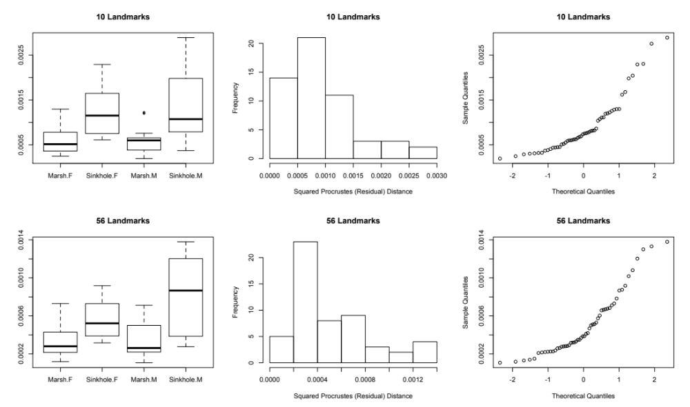
Figure S1. Diagnostic plots of squared residual Procrustes distances, for the full model in example 1. The left panels are box plots of squared residuals. Boxes represent the interquartile range (median shown as bold line), and fences indicate maximum and minimum values within 1.5 times the interquartile range. Outliers are shown as circles. Middle panels are histograms and right panels are normal quantile plots of squared residual distances. In each case, obvious within-group heterogentiy of variance and non-normally distributed residual distances are evident, but is less extreme in the 56-landmark case.

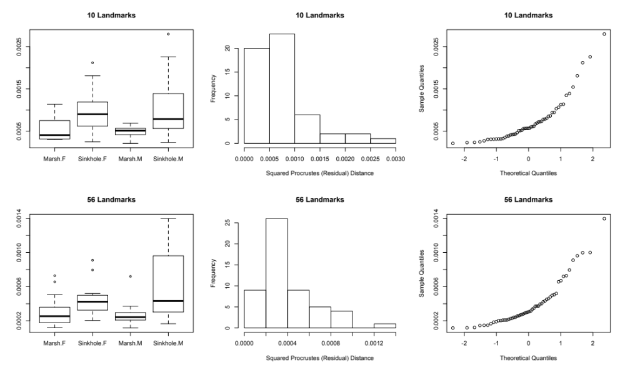
Figure S2. Diagnostic plots of squared residual Procrustes distances, for the full model in example 22. The left panels are box plots of squared residuals. Boxes represent the interquartile range (median shown as bold line), and fences indicate maximum and minimum values within 1.5 times the interquartile range. Outliers are shown as circles. Middle panels are histograms and right panels are normal quantile plots of squared residual distances. In each case, obvious within-group heterogentiy of variance and non-normally distributed residual distances are evident.

References

Adams DC, Collyer ML (2007). Analysis of character divergence along environmental gradients and other covariates. Evolution 61(3): 510-515.

Adams DC, Collyer ML (2009). A general framework for the analysis of phenotypic trajectories in evolutionary studies. Evolution 63(5): 1143-1154.

Anderson MJ, Robinson J (2001). Permutation tests for linear models. Australian & New Zealand Journal of Statistics 43(1): 75-88.

Collyer ML, Adams DC (2007). Analysis of two-state multivariate phenotypic change in ecological studies. Ecology 88(3): 683-692.

Collyer ML, Adams DC (2013). Phenotypic trajectory analysis: comparison of shape change patterns in ecology and evolution. Hystrix 24(1): 75-83.

Collyer ML, Stockwell CA, Dean CA, Reiser MH (2007). Phenotypic plasticity and contemporary evolution in introduced populations: Evidence from translocated populations of white sands pupfish (Cyrpinodon tularosa). Ecological Research 22(6): 902-910.

Davison AC, Hinkley DV. (1997). Cambridge University Press: Cambridge.

Freedman D, Lane D (1983). A nonstochastic interpretation of reported significance levels. Journal of Business and Economic Statistics 1: 292–298.

Gunz P, Mitteroecker P (2013). Semilandmarks: a method for quantifying curves and surfaces. Hystrix-Italian Journal of Mammalogy 24(1): 103-109.

Martins EP, Hansen TF (1997). Phylogenies and the comparative method: A general approach to incorporating phylogenetic information into the analysis of interspecific data. American Naturalist 149(4): 646-667.

McArdle BH, Anderson MJ (2001). Fitting multivariate models to community data: A comment on distance-based redundancy analysis. Ecology 82(1): 290-297.

Oksanen J, Blanchet FG, Kindt R, Legendre P, Minchin PR, O'Hara RB et al. (2013). R Foundation for Statistical Computing.

Ovaskainen O, Soininen J (2011). Making more out of sparse data: hierarchical modeling of species communities. Ecology 92(2): 289-295.

Rencher AC (2008). Linear models in statistics, 2nd edition. John Wiley & Sons, Inc.: Hoboken, NJ.

Shaw RG, Mitchell-Olds T (1993). ANOVA for unbalanced data - an overview. Ecology 74(6): 1638-1645.

Turner TF, Collyer ML, Krabbenhoft TJ (2010). A general hypothesis-testing framework for stable isotope ratios in ecological studies. Ecology 91(8): 2227-2233.

