OCE 101: Introduction to Biological and Physical Oceanography
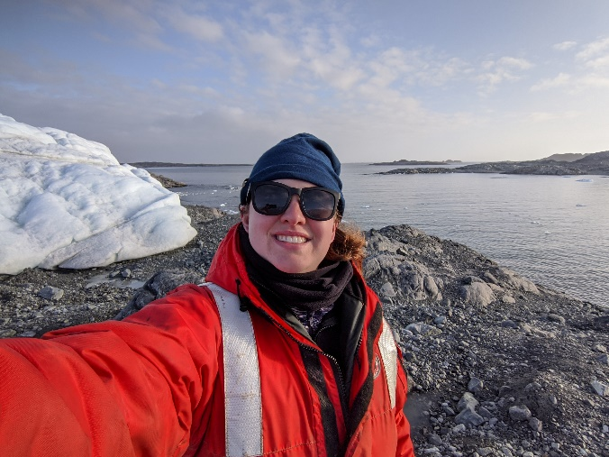
Course Information:
Lecture Time: Monday, Wednesday, Friday, 12 – 1:30 PM
Location: XXX Hall, Room 123
Credit Hours: 3
Course URL: oce101.fakeurl.fakeuniversity.edu
Prerequisites: NONE

About communication/office hours:
- I check my email from ~9-4PM daily. I do not check or respond to emails outside these hours. I will typically respond to emails within 24-48 hours, except for weekends and university holidays. If I am away from my email for an extended period outside of weekends/university holidays, you will receive an automatic reply detailing when to expect a response.
Instructor Information:
Dr. Katherine Gallagher, PhD (she/her/hers)
Email: Katherine.L.Hudson@stonybrook.edu
Office Hours: 2 – 4 PM Monday & Wednesday
Office: XXX Hall, Room 987

- If you have a conflict with office hours and would like to meet, please email me to set up a time. I am always happy to meet one-on-one outside of office hours to help with course content, advising help, or general career advice!

ACKNOWLEDGEMENTS
Land Acknowledgement:
Stony Brook University resides on the ancestral, traditional, and contemporary lands of the aboriginal territory of the Setauket or the Setalcott tribe. I acknowledge federal and state recognized tribes who live here now and those who were forcibly removed from their homelands. In offering this land acknowledgement, I affirm indigenous sovereignty, history, and experience.

University Policies:
I will follow and expect you to follow all University policies and codes in this course. This includes but is not limited to:
- The following is a portion from Stony Brook University’s Academic Integrity Policy (https://www.stonybrook.edu/commcms/academic_integrity/policies_procedures/index.php)
- Academic dishonesty includes any act that is designed to obtain fraudulently, either for oneself or for someone else, academic credit, grades, or other recognition that is not properly earned or that adversely affects another's grade or misrepresents one's academic status.
- The following represents examples of academic dishonesty and does not constitute an exhaustive list:
  - Plagiarism: copying someone else's writing or paraphrasing it too closely, even if it constitutes only some of your written assignment, without proper citation.
  - Cheating on exams or assignments by the use of books, electronic devices, online resources, notes, or other aids when these are not permitted, or by copying from another student.
  - Ringers: taking an exam for someone else or permitting someone else to take one’s exam or paying someone to take exam/complete assignments
  - Submitting the same paper in more than one course without permission from the instructors
  - Posting answers or requesting answers on websites, group chats, or social media when it is prohibited
  - Stealing, concealing, destroying or inappropriately modifying classroom or other instructional material, such a posted exams, library materials, laboratory supplies or computer programs
  - Presenting fabricated excuses for missed assignment or tests
  - Falsifying attendance roster; signing in for someone else; unauthorized clicker use; using someone else's clicker
  - Electronic communication devices, including cellular phones, speakers, calculators, electronic translators, smart watches, and headphones must be secured in a closed container (and not, for example, worn on a belt or around the neck) and must be turned off (and not, for example, simply set on vibration mode) during any examination. Note: even if a student does not answer a ringing cell phone during an exam, it can be considered academic dishonesty for not having it turned off.
- Consequences and policies for violating this policy can be found on the university’s website.
- Code of Student Responsibility

Accessibility:
If you need accommodations, please contact the SBU Student Accessibility Support Center. If there is anything I can do to make this course more accessible (and you are comfortable sharing with me), please let me know. I am trying to do my part to help make oceanography accessible to all!

MY COURSE POLICIES
I ask that you respect… | I expect you to… | You can expect me to…
Each Other | - Address classmates by their preferred name and/or pronouns  - For example, please address me as Dr. or Professor Gallagher  - Listen to me and your peers actively and respectfully  - Recognize and celebrate the diverse experiences of your peers | - Address you by your preferred name and/or pronouns  - If these differ from your university record, please let me know.  - Listen actively and respectfully when you share your thoughts and ideas  - Respect and celebrate the diversity of your experiences, my peers, and individuals within the field of study
An important note on diversity: It is my intent to present materials that respect and celebrate both the diversity within our classroom and within the field of study. I recognize that I (and the field of study) am far from perfect in this regard. Therefore, I am continuously trying to improve the diversity of voices I share in this and all my classes. If you have a resource(s) to help me in this endeavor, please share them! Your suggestions are encouraged and appreciated.

I ask that you respect… | I expect you to… | You can expect me to…
Our Time | - Arrive to class on time and ready to learn  - If you are late, please do your best to not disturb the lecture or your peers.  - Limit distractions by:  - Silencing all devices.  - Laptops/iPads/note taking devices are allowed in lectures if they do not become a distraction.  - Reducing messes.  - Food and drinks are allowed in class if they do not become a distraction.  - Limit chatter during lectures | - Start class promptly  - Come to class prepared to lecture  - Work continuously to improve this course  - Having my time wasted is my biggest pet peeve. Therefore, I want to teach a course in which you feel like your time is valued and being used effectively.  - Respectful, constructive feedback on the course is always welcome.
Our Autonomy | - Communicate with me if you must miss a lecture/exam or need more time on an assignment  - Please reach out before the missed lecture/exam/due date if you are able or, in the case of an emergency, within one week of the missed lecture/exam/due date.  - Opportunities to make up missed work and/or extensions will be given at the discretion of the instructor.  - Late assignments without prior and/or prompt communication and/or a valid excuse will lose a letter grade per day after the due date. | - Communicate with you if I need to cancel a lecture  - I will do my best to let you know about a canceled lecture at least 24 hours in advance.  - When communicating about a canceled lecture, I will do my best to inform you of any changes to our lecture schedule.  - If the lecture schedule needs to be altered significantly, I will distribute an updated version via email/course website.
Our Humanity | - Treat yourself as a person first, and an academic second.  - Be kind to yourself and others.  - Take care of your mental health.  - Utilize your peer networks or university resources as needed. | - Treat myself and you as a person first, and an academic second.  - Be kind to myself and you.  - Take care of my mental health  - Direct you to any necessary resources, if requested.

THE COURSE
Course Description:
In this course, we will explore the physical and biological components of the feature that makes up a majority of the surface area of the planet – the ocean. This course is designed to serve as an introduction to two key aspects of oceanography (the study of oceans). In the first part of the course, we will explore how and why the ocean moves, a study known as physical oceanography. In the second portion of the course, we will learn about the organisms that call the ocean home and the ocean properties that help control their distributions, a study known as biological oceanography. In the third and final portion of this course, we will explore how these two aspects of oceanography interact to help build the ocean ecosystems we know today. We will also discuss how data are collected to answer scientific questions about physical and biological oceanography. Students will walk away from this course with a broad understanding of physical and biological oceanography, and an understanding of what a career in oceanography entails.

Course Objectives:
Students who successfully complete this course will be able to:
- List 5 different phytoplankton functional types.
- Define ‘thermohaline circulation’.
- Discuss components of the biological pump.
- Explain the formation of the Ekman spiral and resulting Ekman transport.
- Illustrate seasonal phytoplankton bloom dynamics.
- Interpret temperature, salinity, and density water column profiles.
- Plot oceanographic data in a computer software/program of their choice.
- Compare and contrast methods of data collection.
- Design an experiment on a hypothesis discussed in class (intermediate disturbance hypothesis, critical depth theory, etc.).
- Assess the effectiveness of global observation networks in collecting both biological and physical oceanographic data.

Course Materials:
- A clicker app on your phone (required)
- Essentials of Oceanography, 10th Ed. by Trujillo and Thurman (optional)

About textbook/readings: Readings will be assigned weekly to supplement lectures and provide a different presentation/perspective of lecture material. I will pull relevant chapters from the optional textbook listed above. If you plan to continue in oceanography, this is a good reference book to have – it has served me well in the past 10+ years! However, I recognize that academic textbooks are a scam, so I will be providing all necessary readings from this book and elsewhere on the course website.

Grade Breakdown:
Your grade will be calculated based on weekly homework, three exams, a final project, and class participation.
Homework: I will assign small, weekly homework assignments designed to get you to reflect on the lectures from the previous week. These will be due weekly on Thursday evenings. This homework will include various multiple-choice and/or short-answer questions based on the lectures and supplemental readings. They will be provided online through the course website. These will only be graded to help you gauge your understanding of the course material. While your performance on the homework will not impact your grade, completing the homework is mandatory to help you and me gauge your understanding of the material. This will allow me to review topics as needed throughout the course. Homework will be worth 10% of your grade.
Figure 1. A pie chart illustrating the percentages used to calculate grades in this course.

Exams: There will be 3 exams throughout this course – 2 midterms and a final. While the mid-terms will not be cumulative as they will be focused on the first two sections of the course, the final will be cumulative. Each exam will be worth 20% of your grade. Exams will include a mix of knowledge-based and application questions to test your retention of and ability to apply the material taught in this course.

Final Project: One of my goals in this course is not only to teach you about oceanography, but how to be an effective scientist. As a result, the final project will be to design an experiment to answer a research question related to the concepts taught in this course. More details will be provided as the course progresses. This final project will be worth 20% of your grade.

Class Participation: There will be opportunities throughout this course for clicker questions, discussions, brainstorming, and participation in group activities to help you retain the information in the lectures. I expect you to be an active participant in these activities - they are to help you after all! Therefore, participation in these activities will be 10% of your grade.

Grading Scale:
Your grade will be calculated as follows:
Grade | A | A- | B+ | B | B- | C+ | C | C- | D | F
Percent  Range | 100 – 93.4 | 93.3 – 90 | 89.9 – 86.7 | 86.6 – 83.4 | 83.3 – 80 | 79.9 – 79.7 | 76.6 – 73.4 | 73.3 – 70 | 69.9 – 59.6 | < 59.5

Course Schedule:
There will be 3 sections of this course, which will conclude in the midterms and final exam:
- Physical Oceanography
- Biological Oceanography
- Biophysical interactions

Schedule Overview:
I will spend the Monday and Wednesday lectures focusing on the fundamental concepts of the section, or in the case of the final section, how the fundamentals from the previous two sections interact to structure the ocean environment. In Friday lectures, we will discuss how oceanographers do science – the kinds of the questions oceanographers are asking, how they collect data, and the conclusions they make from those data – in relationship to the topics discussed in the Monday & Wednesday lectures. Friday lectures will also provide the opportunity for review, if necessary, based on the homework.

Tentative Weekly Schedule:
**This schedule is subject to change as needed throughout the semester.**

