|  |
| --- |
| Kickstart My Chart |
| Report For Analytics Bootcamp: Homework 01 |

|  |
| --- |
| Kerry Harp  12-22-2020 |

Drawing conclusions from the data provided in the charts below, for Kickstarter campaigns:

1. Generally, the number of world-wide campaigns and success rates are higher for those in the arts area (film & video, music, theater). With theater having the most activity, the sub-category of “Plays” having the highest participation.
2. The success to failure ratio varies with the campaign category type. The category of “Music” shows the most success compared to failures.

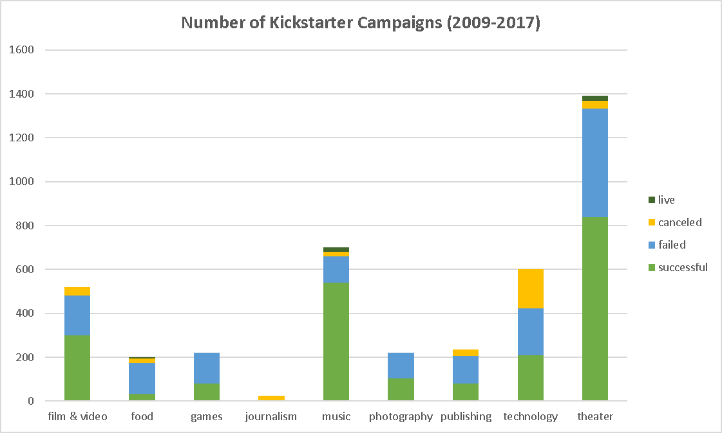

,

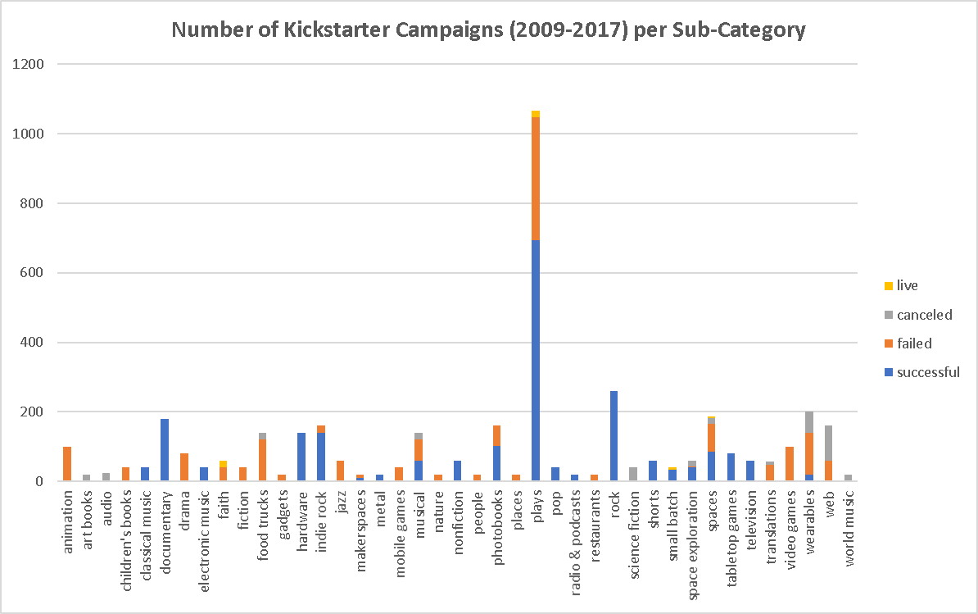

1. Generally, the best time of year to conduct a successful campaign is late spring (May) and the worst time is in December. The failure rate is highest in January. These together would infer that December and January would not be good times for a Kickstarter campaign. The number of canceled campaigns is consistent throughout the year and relatively low compared to both successful and failed campaigns.

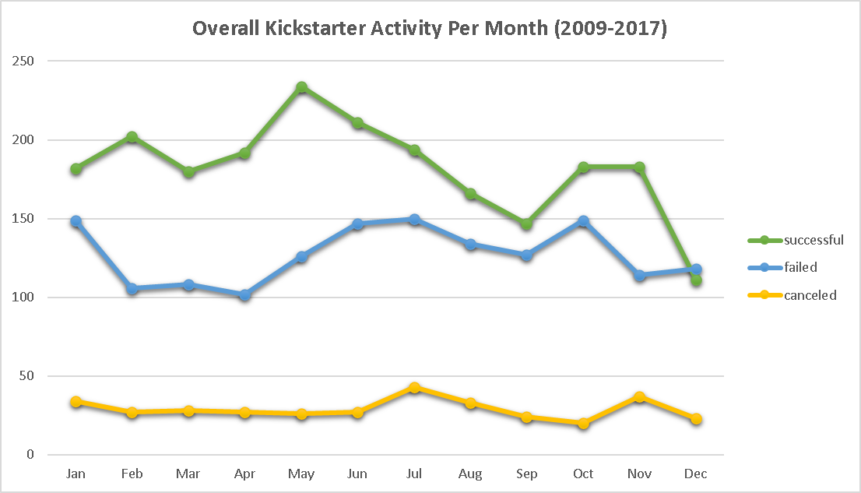

This dataset has some limitations. For example:

* There is no specific data why a campaign has been canceled. Was it canceled because it was failing, therefore recategorizing it as a failed campaign? Was it canceled because the organization/company no longer exists? There are 350 items in the canceled state—8.5% of the entire dataset—which may be a significant number.
* Analysis should be done on the outliers that may skew the overall data. For example, the maximum goal was $100,000,000 with a vague blurb of, “My ambition for this knows no bounds. Seeing Sephoria in a live-action is a dream of mine.” Likely, there are 24 goals set that are under $100. This brings into question, what are the min/max boundaries? What is the basic need(s) for the fundraised money? What makes a Kickstarter campaign valid/invalid for this dataset?
* The names of the campaigns should be reviewed. There is one record with the name being a date, “11/4/2008.” Is this really the name or is the data incorrectly entered? There are campaigns with the same name. Should naming a campaign be unique?

There are some graphs that may be helpful for others starting a Kickstarter campaign:

* What is the average time (to reach goal) for a successful campaign?
* What is the average campaign success to failure ratio?
* What is the average donation per category/subcategory?
* How often are the campaigns picked by staff successful?