A PROJECT TITLE

ON

Water Quality Classification Using Support Vector Machine and Random Forest Algorithms

project report submitted in partial fulfilment of the requirements for the Course

MACHINE LEARNING

BACHELOR OF TECHNOLOGY

In

A.Y.: 2026-27

By

Name: K.Kavya sri Roll No.: 2520030564

Name: Sanjith raj Roll No.: 2520030463

Under the Esteemed guidance of

Dr.N.Nirmalajyothi

Associate Professor, CSE

Department of Computer Science and Engineering

Abstract
This project presents a supervised machine learning system for classifying water samples as potable or non-potable using physicochemical water-quality measurements. The Water Potability dataset contains 3,276 records, nine input features, and a binary target variable, Potability. The workflow includes data inspection, duplicate checking, missing-value treatment using median imputation, exploratory data analysis, an 80:20 train-test split, feature scaling for SVM, model training, hyperparameter tuning with GridSearchCV, and evaluation using accuracy, precision, recall, F1-score, ROC-AUC and confusion matrices. Two classifiers, Support Vector Machine (SVM) and Random Forest (RF), were trained and compared before and after tuning. The tuned SVM achieved an F1-score of 0.4371, while the tuned Random Forest achieved 0.4125. The tuned SVM was selected as the final model because greater importance was given to recall and F1-score for the potable-water class. A final unseen test sample was also demonstrated; in that example the actual class was potable while the model predicted non-potable, showing that the system can still produce false-negative errors.
Keywords: Water Potability, Machine Learning, SVM, Random Forest, Classification, Water Quality

1. Introduction

1.1 Purpose of the Project
Water quality directly affects human health and the safety of drinking water. Conventional assessment commonly depends on collecting samples and performing laboratory measurements. Although laboratory testing is important, it can require time, equipment and trained personnel. A data-driven approach can help analyse previously measured physicochemical parameters and provide a fast preliminary classification of whether a water sample is potable or non-potable.
Machine learning is useful for this problem because water quality depends on several measurements together rather than on a single parameter. The project is relevant to water-monitoring teams, treatment facilities and researchers who need an automated classification aid. The aim is not to replace laboratory certification, but to demonstrate how supervised learning can support faster screening and comparison of water-quality samples.

1.2 Problem Statement
The problem is formulated as a binary classification task. Given nine physicochemical measurements—pH, Hardness, Solids, Chloramines, Sulfate, Conductivity, Organic_carbon, Trihalomethanes and Turbidity—the system predicts the target variable Potability, where 1 represents potable water and 0 represents non-potable water.

1.3 Existing Methods and Disadvantages
Traditional laboratory testing provides direct measurements but can be slower and more resource-intensive for repeated large-scale screening. Rule-based or single-parameter approaches can also miss interactions among multiple water-quality variables. Recent machine-learning studies show that classification performance depends strongly on the dataset, preprocessing, class balance, feature selection and model configuration. SVM can be sensitive to feature scale and parameter selection, while tree-based models can capture non-linear relationships but may vary with hyperparameters.
Another limitation is that performance reported in one study may not transfer directly to another dataset or region. Therefore, this project compares SVM and Random Forest on the same dataset using the same test set and multiple metrics, including recall and F1-score, rather than relying only on accuracy.

1.4 Proposed System
The proposed system follows a complete machine-learning pipeline: load and inspect the dataset, check duplicates and missing values, split the data into training and testing sets, fit median imputation and scaling only on the training data, perform EDA, train SVM and Random Forest, tune their hyperparameters with GridSearchCV, evaluate the models, compare their metrics, select the final model, and demonstrate prediction on unseen data. The main contribution is a clear student-scale comparison of two widely used classifiers with leakage-aware preprocessing.

1.5 Research Objectives( atleast 4)
- Prepare and inspect the Water Potability dataset for binary classification.
- Perform missing-value analysis, duplicate checking and exploratory data analysis.
- Apply leakage-free median imputation and feature scaling where required.
- Train SVM and Random Forest classifiers on the water-quality features.
- Tune model hyperparameters using GridSearchCV and cross-validation.
- Compare models using accuracy, precision, recall, F1-score, ROC-AUC and confusion matrices.

7. Select a final model and demonstrate prediction on unseen data.
Ten recent studies from 2024–2025 were reviewed. The studies were selected for direct relevance to machine-learning-based water-quality, water-potability, or water-quality classification. Bibliographic details and DOIs were checked against publisher/index pages.
S.No. | Title | Reference with DOI | Problem / gap | Objective | Methods | Inference | Future direction
1 | Predicting water potability using a machine learning approach | El-Bacha, R., Salhi, A., Hafid, A., & Rabi, S. (2025). Environmental Challenges, 19, 101131. DOI: 10.1016/j.envc.2025.101131 | Conventional water-quality assessment can be time-consuming and difficult to scale. | Predict water potability using supervised ML on physicochemical measurements. | SVM and Random Forest; training, validation and testing. | RF reported 70% test accuracy, 72% precision and 0.75 ROC-AUC. | Improve robustness with balanced and representative data and broader validation.
2 | Predictive Analytics for Water Safety: Data Mining and Supervised Learning in Potability Classification | Sofiah, N. A., Olivia, F., & Jambak, M. I. (2024). Indonesian Journal of Computer Science, 13(4). DOI: 10.33022/ijcs.v13i4.3884 | Need automated classification of water safety from measured parameters. | Compare supervised methods for water-potability classification. | KNN, Naive Bayes, SVM and Neural Network. | Neural Network reached 85% accuracy; SVM reached 73%. | Test more datasets and additional classification approaches.
3 | Optimizing machine learning for water safety: A comparative analysis with dimensionality reduction and classifier performance in potability prediction | Chatterjee, D., Ghosh, P., Banerjee, A., & Das, S. S. (2024). PLOS Water. DOI: 10.1371/journal.pwat.0000259 | Classifier performance varies and dimensionality reduction may affect results. | Compare classifiers before and after PCA for water-potability prediction. | Seven classifiers including SVM, RF, KNN, Naive Bayes and XGBoost; PCA. | SVM achieved 69% accuracy on the original data; RF achieved 66.9%. | Explore tuning, ensembles and robust validation.
4 | Reliable water quality prediction and parametric analysis using explainable AI models | Nallakaruppan, M. K., Gangadevi, E., Shri, M. L., Balusamy, B., Bhattacharya, S., & Selvarajan, S. (2024). Scientific Reports, 14, 7520. DOI: 10.1038/s41598-024-56775-y | High-performing ML models can be difficult to interpret. | Classify drinkable water and explain influential parameters. | LR, SVM, Gaussian NB, DT and RF with SHAP-based XAI. | RF was selected for explanation and reported very high performance on its dataset. | Improve interpretability and validate across external datasets.
5 | Comprehensive analysis of multiple classifiers for enhanced river water quality monitoring with explainable AI | Ramya, S., Srinath, S., & Tuppad, P. (2024). Case Studies in Chemical and Environmental Engineering, 10, 100822. DOI: 10.1016/j.cscee.2024.100822 | Multiple classifiers and explainability methods need systematic comparison. | Evaluate classifiers for river water-quality classification and explain predictions. | 14 classifiers including SVM, RF, Gradient Boosting, XGBoost and CatBoost; LIME/SHAP. | Gradient Boosting achieved the highest reported accuracy in that study; RF and SVM also performed strongly. | Use explainable and real-time monitoring frameworks.
6 | Automated Water Quality Assessment Using Big Data Analytics | Mohialden, Y. M., Hussien, N. M., & Salman, S. A. (2024). Mesopotamian Journal of Big Data, 2024, 211–222. DOI: 10.58496/MJBD/2024/015 | Need scalable data-driven assessment of water potability. | Classify water potability using several ML classifiers. | Random Forest, Gradient Boosting and SVM on 3,276 records. | RF reported 66.77% accuracy, followed by Gradient Boosting 66.01% and SVM 62.80%. | Explore broader features and larger monitoring datasets.
7 | Water Quality Prediction Using Machine Learning Models | IEEE ICCSP (2025). DOI: 10.1109/ICCSP64183.2025.11088772 | Water quality prediction and classification involve multiple parameter types and models. | Investigate ML models for Water Quality Index and Water Quality Classification. | RF, XGBoost, Gradient Boosting, AdaBoost, KNN, DT, SVM and MLP. | The study evaluates multiple classifiers for WQI/WQC using standard performance metrics. | Compare models across regions and improve generalization.
8 | An ensemble-driven machine learning framework for enhanced water quality classification | Singh, P., Hasija, T., Bharany, S., Tun Naeem, H. N., Rao, B. C., Hussen, S., & Ur Rehman, A. (2025). Discover Sustainability, 6, 552. DOI: 10.1007/s43621-025-01467-4 | Single classifiers may not capture complex water-quality relationships. | Improve water-quality classification using voting ensembles. | DT, LR and SVM plus hard/soft voting ensembles. | Soft voting achieved 96.39% accuracy on the Telangana dataset. | Validate ensemble approaches on more regions and data streams.
9 | Water Quality Classification Using SVM with PSO-Based Parameter Optimization | Seviya, T., & Hakim, L. (2025). Information Technology Education Journal, 4(3). DOI: 10.59562/intec.v4i3.9746 | Manually selected SVM parameters may limit classification performance. | Optimize SVM parameters automatically for water-quality classification. | SVM with Particle Swarm Optimization and preprocessing. | PSO was used to search for more suitable SVM kernel parameters. | Compare PSO with GridSearchCV and other optimization methods.
10 | Machine Learning-Based Water Quality Classification Assessment | Chen, W., Xu, D., Pan, B., Zhao, Y., & Song, Y. (2024). Water, 16(20), 2951. DOI: 10.3390/w16202951 | Individual models may lose performance on complex and imbalanced water-quality data. | Develop a robust classification framework for water-quality assessment. | GBDT, MLP and hybrid attention models with Bayesian optimization. | The proposed hybrid models achieved high test accuracy and AUC on a large groundwater dataset. | Improve lightweight deployment and imbalanced-data handling.

3. Methodology

3.1 Proposed System Flow Diagram
The proposed workflow is:
Dataset → Data Inspection → Duplicate Check → Missing-Value Treatment → EDA → Feature Selection → Train/Test Split → SVM & Random Forest Training → GridSearchCV Tuning → Evaluation → Model Comparison → Final Prediction

3.2 Dataset Description
The project uses the publicly available Kaggle Water Potability dataset. It contains 3,276 water samples and 10 columns: nine numerical input features and the binary target Potability. The features are ph, Hardness, Solids, Chloramines, Sulfate, Conductivity, Organic_carbon, Trihalomethanes and Turbidity. All nine input features are floating-point measurements and Potability is an integer label. The class distribution is 1,998 non-potable samples (0) and 1,278 potable samples (1). The dataset source used for the project is the Kaggle Water Potability dataset.

3.3 Experimental Setup
The experiments were carried out in VS Code using a Jupyter Notebook with Python 3.14.3. The main libraries used were Pandas and NumPy for data handling, Matplotlib/Seaborn for visualization, and scikit-learn for preprocessing, SVM, Random Forest, GridSearchCV and evaluation. The project was run locally on a Windows system.

3.4 Data Preprocessing
- • Data inspection and schema validation: checked shape, columns, data types and missing values.
- • Duplicate removal: 0 duplicate rows were found, so the dataset size remained 3,276 × 10.
- • Missing-value analysis: ph had 491 missing values, Sulfate had 781, and Trihalomethanes had 162; the other columns had no missing values.
- • Imputation: missing numerical values were filled using median imputation. The imputer was fitted only on X_train and then used to transform X_train and X_test.
- • Categorical encoding: not required because all input features are numerical.
- • Scaling: StandardScaler was fitted only on the training data and applied to training and test data for the SVM model. Random Forest used the imputed numerical data without scaling.
- • Target preparation: Potability was used directly as the binary target, with 0 = non-potable and 1 = potable.
- • Train/test split: 80% training (2,620 samples) and 20% testing (656 samples).

• Leakage prevention: test data was not used to learn imputation or scaling parameters; only training data was used for fitting these preprocessing steps.
EDA included descriptive statistics, target-class distribution, feature histograms and correlation analysis. The class distribution showed more non-potable than potable samples. The correlation values between individual features and Potability were generally weak, indicating that no single measured variable had a strong linear relationship with the target. The plots were used to understand feature ranges, spread and possible skewness before modelling.

3.6 Feature Engineering and Feature Selection (if applicable)
No new derived features were created. All nine original physicochemical variables were retained because each represents a different aspect of water quality and the project objective was to compare the two classifiers using the available measurements. The final feature list was: ph, Hardness, Solids, Chloramines, Sulfate, Conductivity, Organic_carbon, Trihalomethanes and Turbidity.

3.7 Model Building and Training
Two supervised classification models were implemented. The first was Support Vector Machine with an RBF kernel. The second was Random Forest with 100 trees in the initial model. SVM was trained on imputed and standardized data, while Random Forest was trained on imputed numerical data. Predictions were generated on the held-out test set.

3.8 Hyperparameter Tuning(if applicable)
Hyperparameter tuning was performed using GridSearchCV with cross-validation. For SVM, the search considered C and gamma; the selected configuration was C = 10 and gamma = scale. For Random Forest, the search considered the number of trees, maximum tree depth and minimum samples required to split a node; the selected configuration was n_estimators = 100, max_depth = None and min_samples_split = 5.

3.9 Model Evaluation
Because this is a binary classification problem, the evaluation used accuracy, precision, recall, F1-score, ROC-AUC, confusion matrices and classification reports. Recall and F1-score for the potable class were given particular attention because missing a potable sample can appear as a false-negative classification in the demonstration.

4. Results and Discussion

4.1 Preprocessing Results
Initial dataset shape: 3,276 × 10. Duplicate rows: 0. Missing values before treatment: ph = 491, Sulfate = 781, Trihalomethanes = 162. After leakage-free training/test preprocessing, the model input arrays had 2,620 × 9 for training and 656 × 9 for testing, with missing values imputed. No categorical encoding was required. Standardization was applied to the SVM pipeline using parameters learned from training data only.

4.2 Model Performance
Model | Accuracy | Precision | Recall | F1-score | ROC AUC
SVM – Before tuning | 0.671 | 0.704 | 0.270 | 0.390 | 0.649
Random Forest – Before tuning | 0.659 | 0.631 | 0.301 | 0.407 | 0.641
SVM – Tuned | 0.639 | 0.558 | 0.359 | 0.437 | 0.630
Random Forest – Tuned | 0.657 | 0.622 | 0.309 | 0.413 | 0.668
Published reference: El-Bacha et al. (2025)* | 0.700 | 0.720 | — | — | 0.750
* Published reference is not a direct head-to-head comparison because preprocessing, split strategy and evaluation protocol can differ. It is included only as contextual literature evidence.

4.3 Visual Results and discussion
The following visual summaries show the model comparison and confusion matrices for the tuned models.
The untuned SVM achieved 67.07% accuracy and an F1-score of 0.390. The untuned Random Forest achieved 65.85% accuracy and an F1-score of 0.407. After tuning, SVM accuracy decreased to 63.87%, but its F1-score increased to 0.437 and potable-class recall increased to 0.359. Tuned Random Forest achieved 65.70% accuracy and F1-score 0.413. Tuned Random Forest had the highest ROC-AUC of the four model versions at about 0.668, while tuned SVM had ROC-AUC about 0.630. The final model was selected using the project's stated emphasis on potable-class recall and F1-score, not accuracy alone. The final demonstration also produced one false negative: actual class 1 (potable) was predicted as class 0 (non-potable).
Figure 1. Model performance comparison
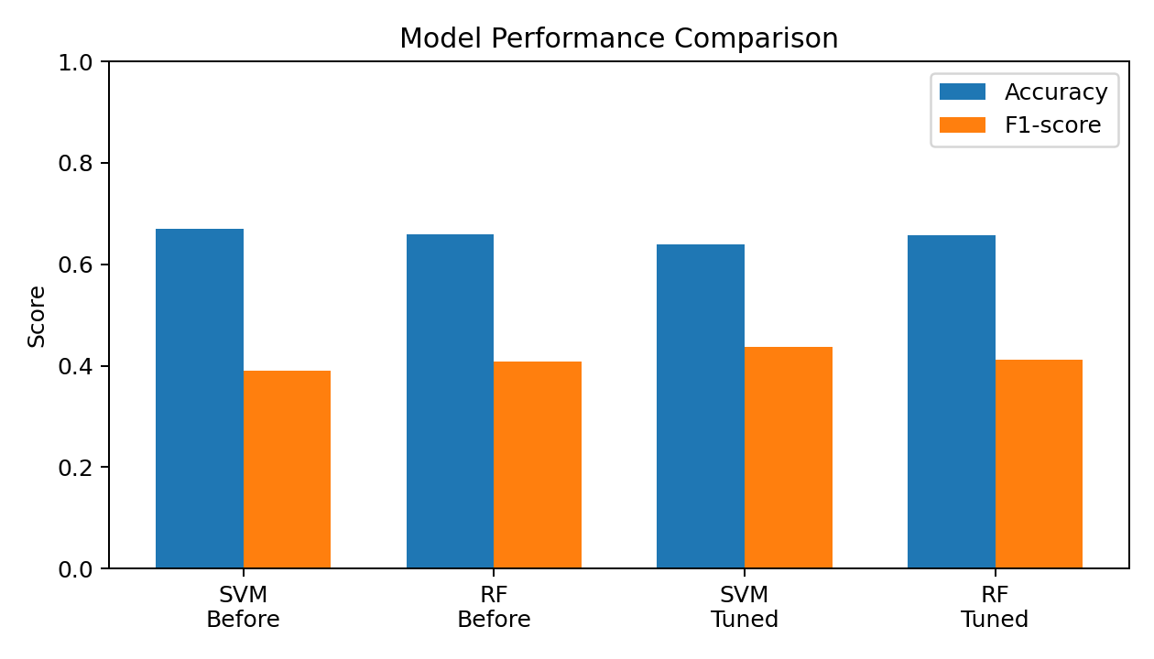
Figure 2. Tuned SVM confusion matrix
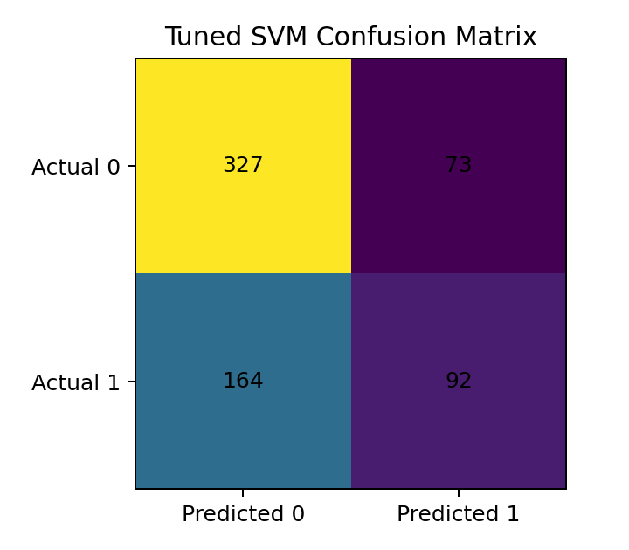
Figure 3. Tuned Random Forest confusion matrix
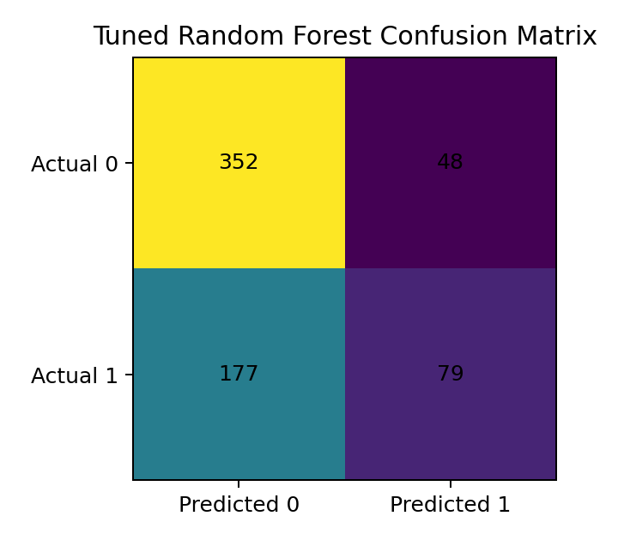

5. Conclusion
The project demonstrates a complete machine-learning workflow for water-potability classification. The Water Potability dataset was inspected, cleaned and analysed, and leakage-aware preprocessing was applied. SVM and Random Forest were trained and tuned using GridSearchCV and evaluated with multiple classification metrics. The tuned SVM was selected as the final model because it produced the higher F1-score and potable-class recall among the tuned models. The results also show that model choice depends on the metric being emphasized: tuned Random Forest had slightly higher accuracy and ROC-AUC, while tuned SVM had the stronger potable-class F1-score and recall. The final sample demonstration produced a false negative, highlighting the need for further improvement before any real-world safety-critical deployment. The system should therefore be viewed as a machine-learning screening study rather than a replacement for certified laboratory water testing.

6. Future Work
- • Use larger and more diverse water-quality datasets from multiple regions.
- • Test additional classifiers such as Gradient Boosting, XGBoost and calibrated ensemble methods.
- • Investigate class-balancing methods and threshold tuning to improve potable-class recall.
- • Explore explainable AI methods such as SHAP to understand feature contributions.
- • Perform deeper hyperparameter optimization and repeated cross-validation.
- • Validate the final model on an independent external dataset.
- • Develop a deployable application only after robustness and safety validation.

7. References
References were formatted consistently in APA-style form. DOI and publication details were checked against publisher or indexed sources.
1. El-Bacha, R., Salhi, A., Hafid, A., & Rabi, S. (2025). Predicting water potability using a machine learning approach. Environmental Challenges, 19, 101131. https://doi.org/10.1016/j.envc.2025.101131
2. Sofiah, N. A., Olivia, F., & Jambak, M. I. (2024). Predictive Analytics for Water Safety: Data Mining and Supervised Learning in Potability Classification. The Indonesian Journal of Computer Science, 13(4). https://doi.org/10.33022/ijcs.v13i4.3884
3. Chatterjee, D., Ghosh, P., Banerjee, A., & Das, S. S. (2024). Optimizing machine learning for water safety: A comparative analysis with dimensionality reduction and classifier performance in potability prediction. PLOS Water. https://doi.org/10.1371/journal.pwat.0000259
4. Nallakaruppan, M. K., Gangadevi, E., Shri, M. L., Balusamy, B., Bhattacharya, S., & Selvarajan, S. (2024). Reliable water quality prediction and parametric analysis using explainable AI models. Scientific Reports, 14, 7520. https://doi.org/10.1038/s41598-024-56775-y
5. Ramya, S., Srinath, S., & Tuppad, P. (2024). Comprehensive analysis of multiple classifiers for enhanced river water quality monitoring with explainable AI. Case Studies in Chemical and Environmental Engineering, 10, 100822. https://doi.org/10.1016/j.cscee.2024.100822
6. Mohialden, Y. M., Hussien, N. M., & Salman, S. A. (2024). Automated Water Quality Assessment Using Big Data Analytics. Mesopotamian Journal of Big Data, 2024, 211–222. https://doi.org/10.58496/MJBD/2024/015
7. Water Quality Prediction Using Machine Learning Models. (2025). IEEE ICCSP. https://doi.org/10.1109/ICCSP64183.2025.11088772
8. Singh, P., Hasija, T., Bharany, S., Tun Naeem, H. N., Rao, B. C., Hussen, S., & Ur Rehman, A. (2025). An ensemble-driven machine learning framework for enhanced water quality classification. Discover Sustainability, 6, 552. https://doi.org/10.1007/s43621-025-01467-4
9. Seviya, T., & Hakim, L. (2025). Water Quality Classification Using SVM with PSO-Based Parameter Optimization. Information Technology Education Journal, 4(3). https://doi.org/10.59562/intec.v4i3.9746
10. Chen, W., Xu, D., Pan, B., Zhao, Y., & Song, Y. (2024). Machine Learning-Based Water Quality Classification Assessment. Water, 16(20), 2951. https://doi.org/10.3390/w16202951

Signature of the Guide Course Instructor
11. Kaggle. Water Potability Dataset (public dataset originally published by Aditya Kadiwal). https://www.kaggle.com/datasets/adityakadiwal/water-potability

