NETWORK DOCUMENTATION REPORT
Data Communications and Networking

Table of Contents
Table of Contents 1
1. Introduction 2
2. Network Topology 2
3. IP Addressing Table 2
4. Configuration Summary 3
4.1 VLANs and Switch Configuration 3
4.2 Spanning Tree Protocol (STP) 5
4.3 Inter-VLAN Routing 10
4.4 Routing Protocols – RIP and OSPF 15
4.5 DHCP, DNS and HTTP Servers 18
4.6 Access Control Lists (ACLs) 21
4.7 Wireless LAN 22
5. Testing and Verification 22
6. Challenges and Solutions 23
Challenge 1: DHCP Failure Across VLANs 23
Challenge 2: DNS Resolution Timeout 23
Challenge 3: Wireless Clients Receiving Incorrect Addressing 23
Additional Issues Encountered During Configuration 23

1. Introduction
Organisation: Mokoena Business Solutions (MBS) is a growing IT solutions company based in Maseru, Lesotho. The organisation provides Network Design, IT Support and Cloud Security services to clients across the region.
Purpose of the Network: The network was designed to deliver a secure, scalable enterprise infrastructure for MBS headquarters. It supports segmented departments (Administration, Technical Services, Management and Wireless users), centralised servers (DHCP, DNS and HTTP), inter-departmental security through Access Control Lists (ACLs), dynamic routing (RIP and OSPF) and wireless access for mobile employees. The design ensures efficient resource sharing, strong security controls and capacity for future growth.
This report documents the design, configuration, testing and troubleshooting of the network implemented in Cisco Packet Tracer, demonstrating practical application of the technologies covered in the module.

2. Network Topology
A hierarchical (three-tier) design was adopted:
- Core layer: CORE multilayer switch (IE-9320) – high-speed backbone and STP root bridge.
- Distribution layer: DISTRIBUTION multilayer switch (3650-24PS) – Inter-VLAN routing (SVIs), ACLs and DHCP helper addresses.
- Access layer: Dedicated access switches for Administration, Technical Services, Management and Servers (2960-24TT series).
- Server farm: Centralised DHCP, DNS and HTTP servers in VLAN 40.
- Wireless: Access points providing SSID MBS-WiFi with WPA2-PSK (AES) security for employee laptops.
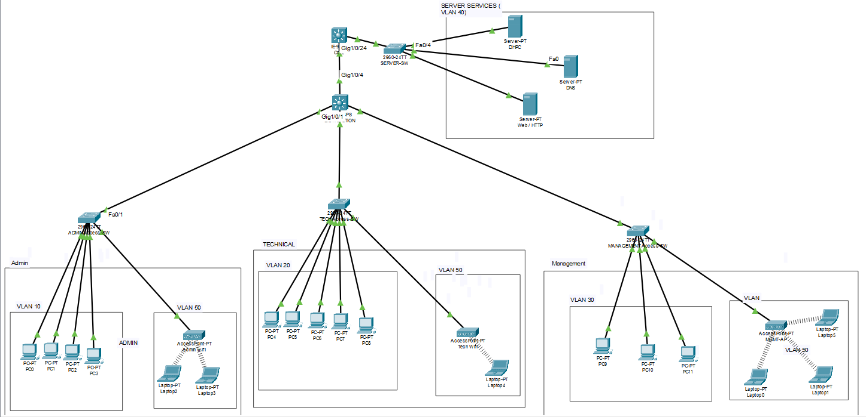
Figure 2.1 – Network Topology (Hierarchical Design: CORE → DISTRIBUTION → Access Switches + Server Farm + Wireless)

3. IP Addressing Table
The following IP addressing scheme was implemented. Separate VLANs provide logical segmentation for each department and the server farm.
Device / VLAN | Network | Subnet Mask | Gateway | IP / DHCP Range | Purpose
VLAN 10 Admin | 192.168.10.0 | 255.255.255.0 | 192.168.10.2 | 192.168.10.10–120 (DHCP) | Administration
VLAN 20 Technical | 192.168.20.0 | 255.255.255.0 | 192.168.20.2 | 192.168.20.10–120 (DHCP) | Technical Services
VLAN 30 Management | 192.168.30.0 | 255.255.255.0 | 192.168.30.2 | 192.168.30.10–120 (DHCP) | Management
VLAN 40 Servers | 192.168.40.0 | 255.255.255.0 | 192.168.40.1 / .2 | .10 DHCP, .11 DNS, .12 HTTP | Server Farm
VLAN 50 Wireless | 192.168.50.0 | 255.255.255.0 | 192.168.50.2 | 192.168.50.10–120 (DHCP) | Wireless Employees
CORE–DIST Link | 10.0.0.0/30 | 255.255.255.252 | — | .1 and .2 | Routing Link
Default gateways for client VLANs are the SVIs configured on the DISTRIBUTION Layer-3 switch. Server addresses are assigned statically.

4. Configuration Summary

4.1 VLANs and Switch Configuration
VLANs 10 (Administration), 20 (Technical Services), 30 (Management), 40 (Servers) and 50 (Wireless) were created and named on the access and server switches. Access ports were assigned to the appropriate VLANs. Trunk links between access switches, DISTRIBUTION and CORE were configured with switchport mode trunk and allowed VLANs 10,20,30,40,50 to carry inter-VLAN traffic.
VLAN membership evidence:
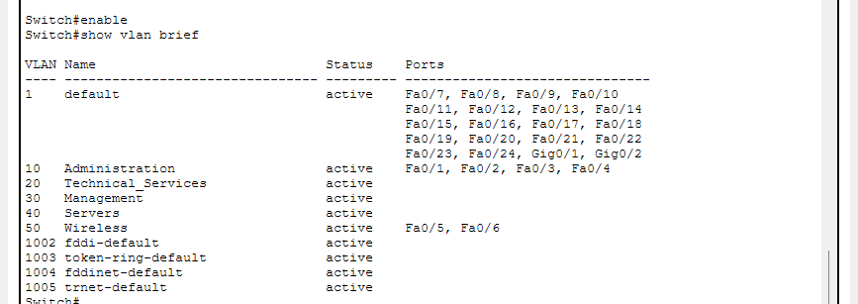
Figure 4.1 – ADMIN-Access-SW VLAN configuration / membership
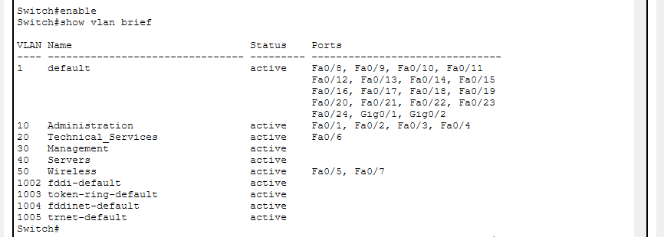
Figure 4.2 – TECH-Access-SW VLAN configuration / membership
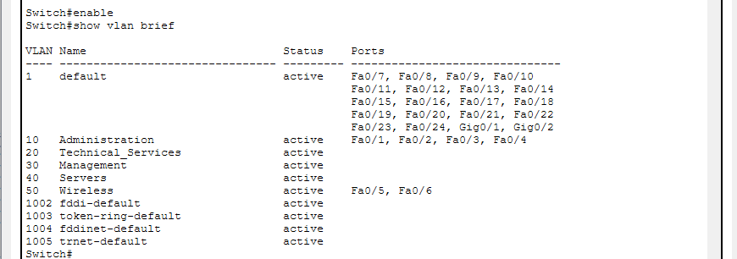
Figure 4.3 – MANAGEMENT-Access-SW VLAN configuration / membership
Trunk configuration evidence:
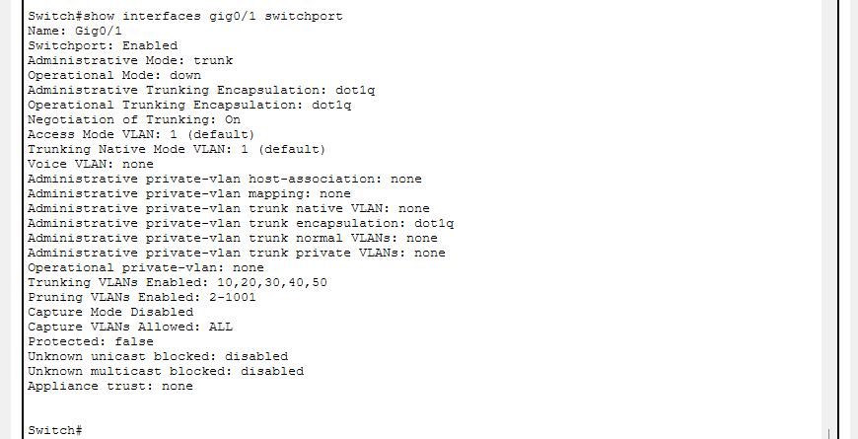
Figure 4.4 – ADMIN-Access-SW trunk configuration
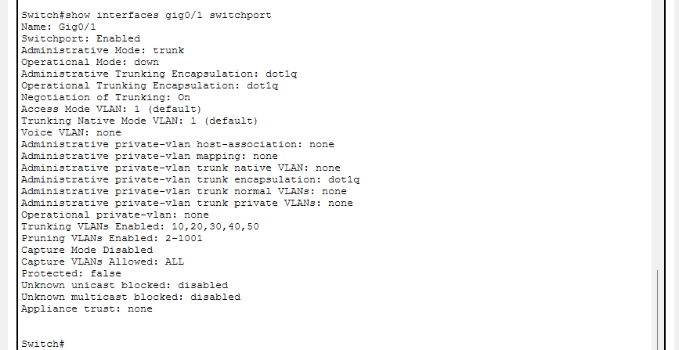
Figure 4.5 – TECHNICAL-Access-SW trunk configuration

Same-VLAN communication demonstration:
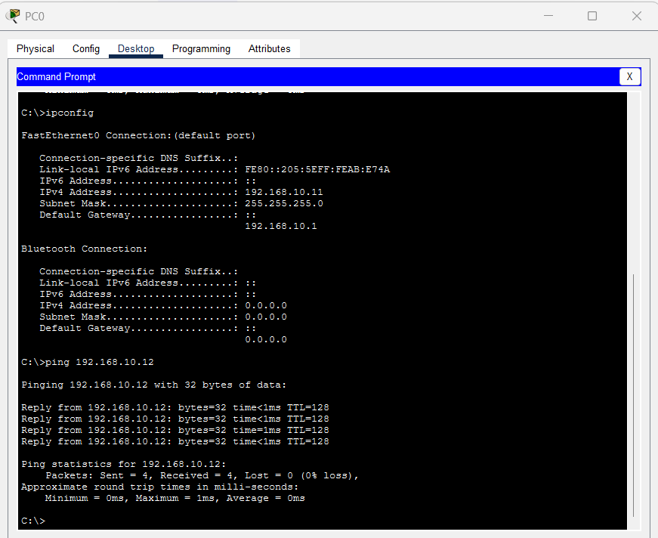
Figure 4.6 – Successful ping between two Administration PCs (same VLAN 10) – 0% packet loss
Why VLANs are useful in an enterprise network:
- Security – isolates departments (e.g. Administration traffic is separated from Technical Services).
- Performance – reduces the size of broadcast domains, limiting broadcast traffic to devices within the same VLAN.
- Management – allows logical grouping of users independent of physical location.

4.2 Spanning Tree Protocol (STP)
Rapid PVST+ was enabled. The CORE switch was configured as the primary root bridge for all VLANs using spanning-tree vlan 10,20,30,40,50 priority 4096 (Bridge ID priority 4096 / 4106). DISTRIBUTION received a higher priority (8192). Access ports were configured with PortFast.
STP evidence – Root Bridge, Root Port, Designated & Blocking ports:
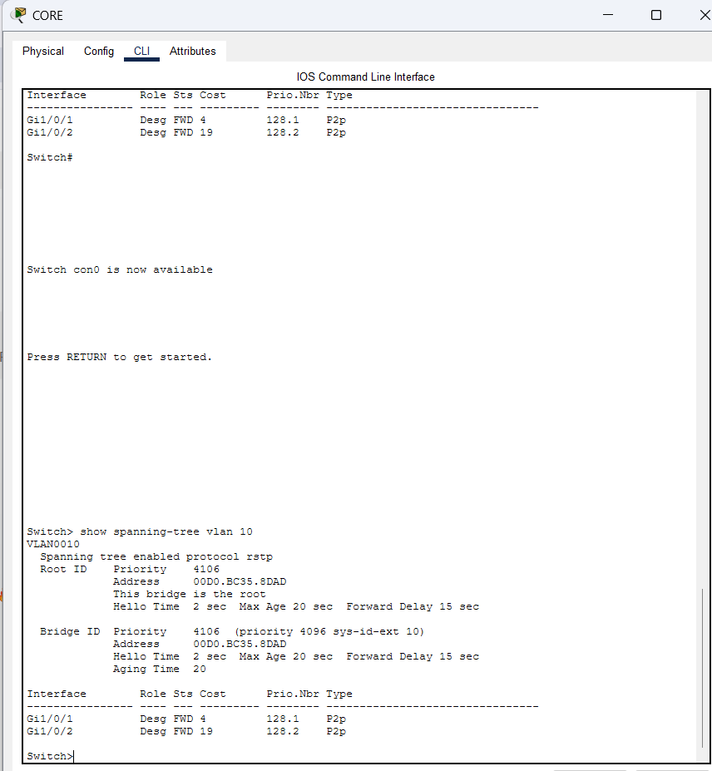
Figure 4.7 – CORE-SW: Root Bridge for VLAN 10 (Root ID 4106, this bridge is root, ports Designated FWD)
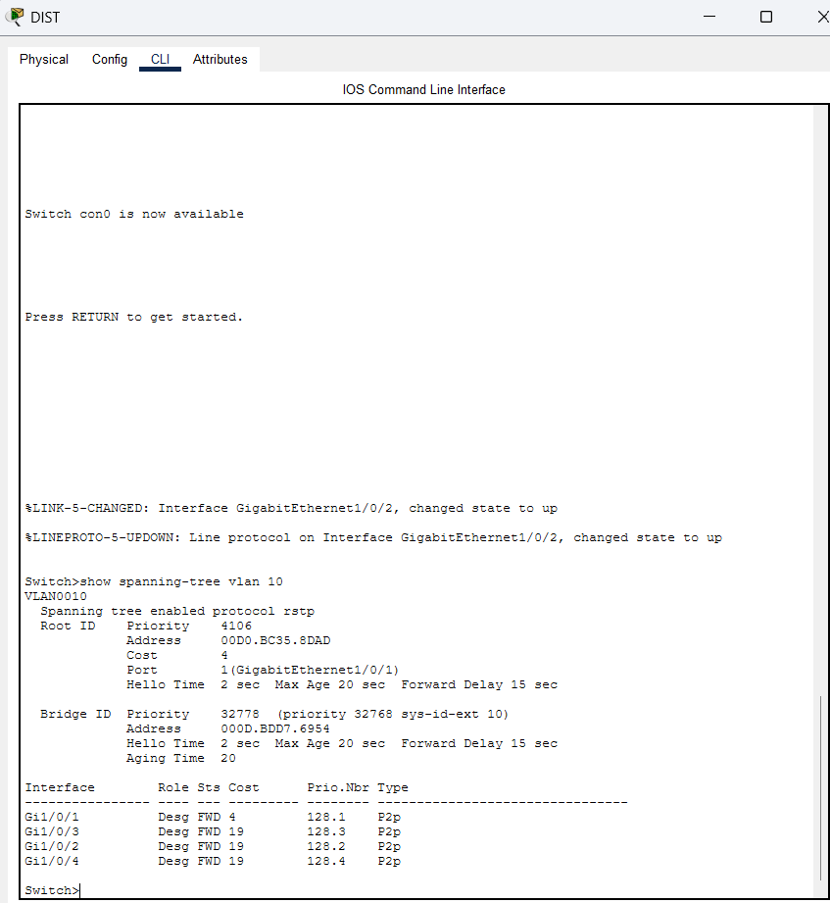
Figure 4.8 – DIST-SW: Root Port toward CORE (Cost 4, Port Gi1/0/1)
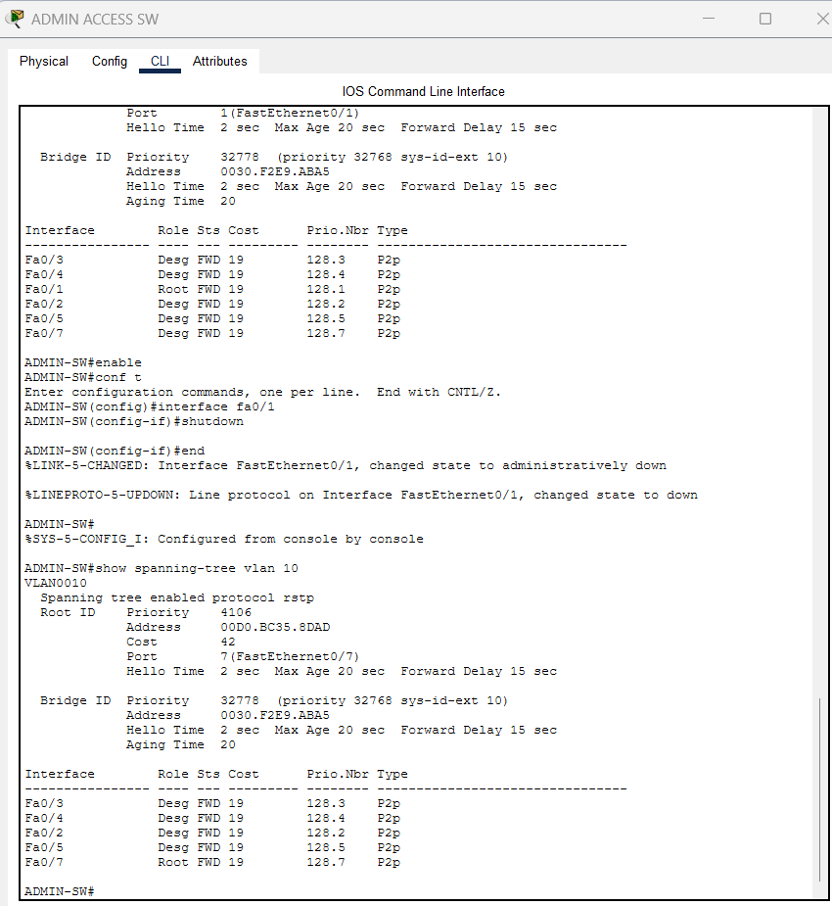
Figure 4.9 – ADMIN-SW normal state: Root Port Fa0/1 FWD toward DIST (Cost 23)
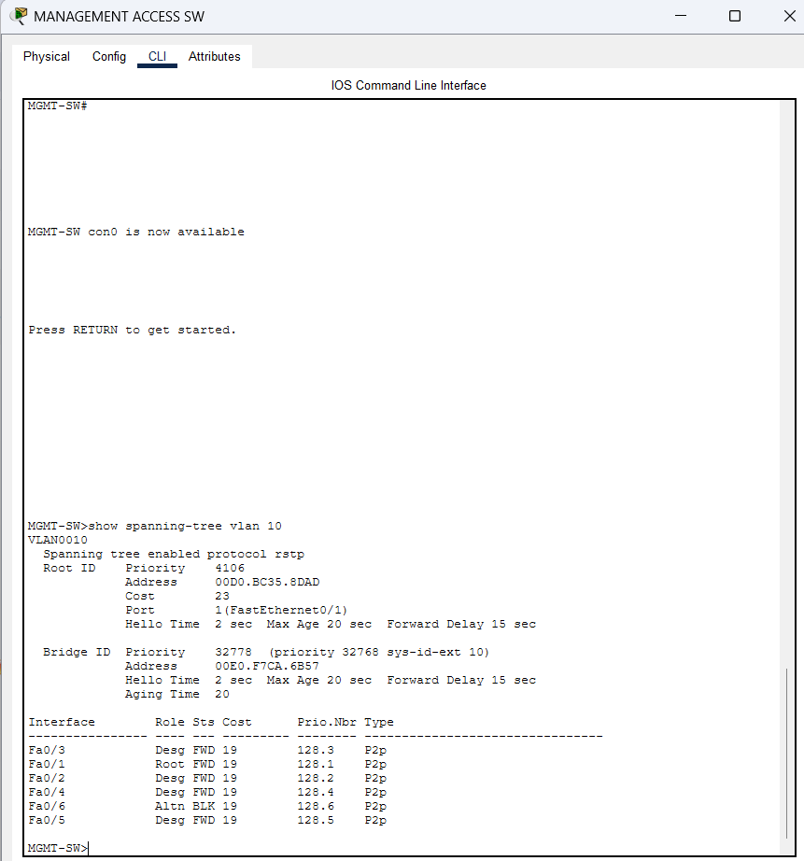
Figure 4.10 – MGMT-SW: Alternate/Blocking port (Fa0/6 Altn BLK) preventing the physical loop
STP response after link failure (rapid reconvergence):
Figure 4.11 – ADMIN-SW after primary uplink failure: new Root Port selected via alternative path (RSTP < 3 s convergence)
Why RSTP? Rapid-PVST converges in 2–3 seconds using the Proposal/Agreement process versus 30–50 seconds for classic STP. This prevents prolonged outages and broadcast storms when a link fails.
If STP were not implemented, redundant links would create switching loops, causing broadcast storms, MAC table instability and network outage.

4.3 Inter-VLAN Routing
Inter-VLAN routing is performed on the DISTRIBUTION Layer-3 switch using Switch Virtual Interfaces (SVIs). Each VLAN SVI is assigned the gateway address (192.168.x.2) and IP routing is enabled. Client devices use these SVIs as their default gateway.
Communication tests between departments and servers:
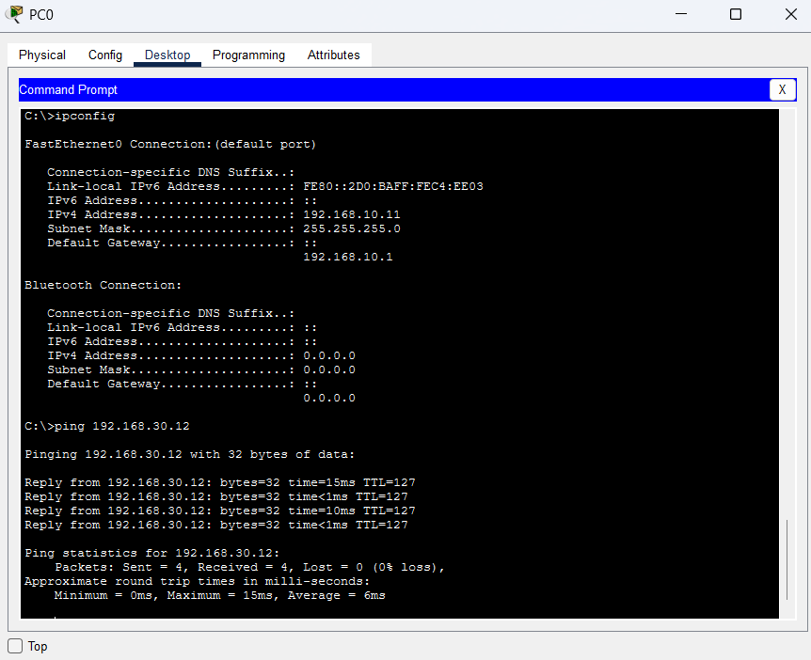
Figure 4.12 – Administration ↔ Management connectivity test
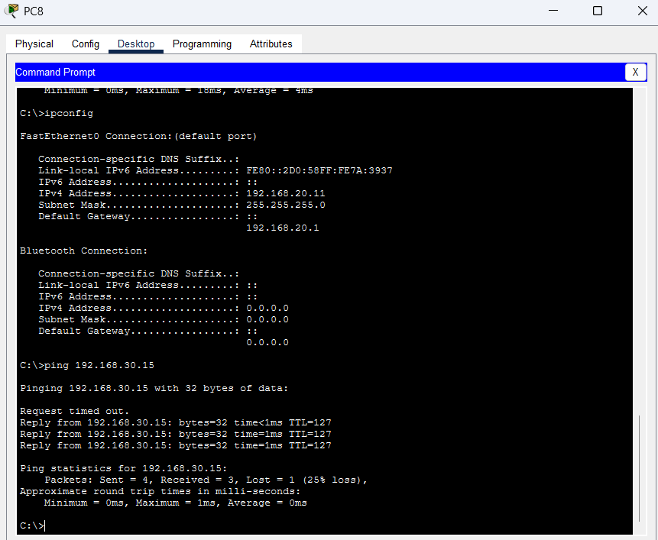
Figure 4.13 – Technical Services ↔ Management connectivity test
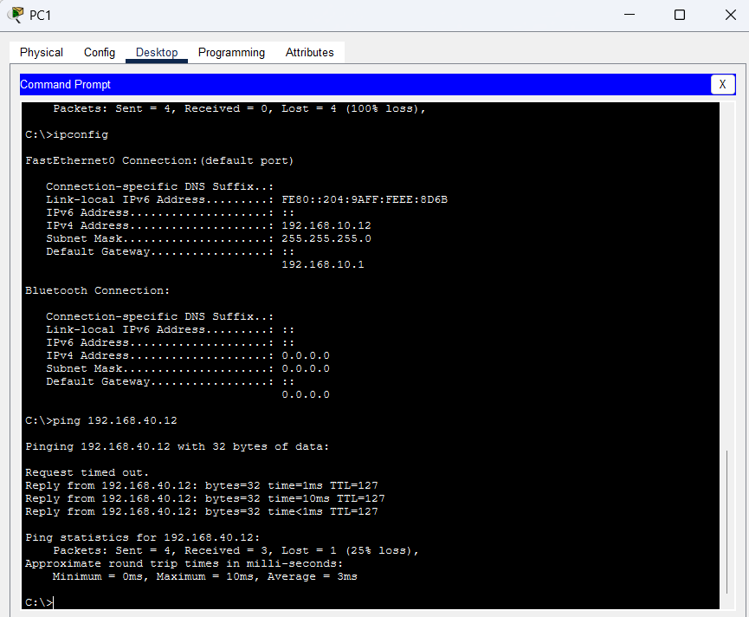
Figure 4.14 – Departments ↔ Servers connectivity test (Admin to Server)
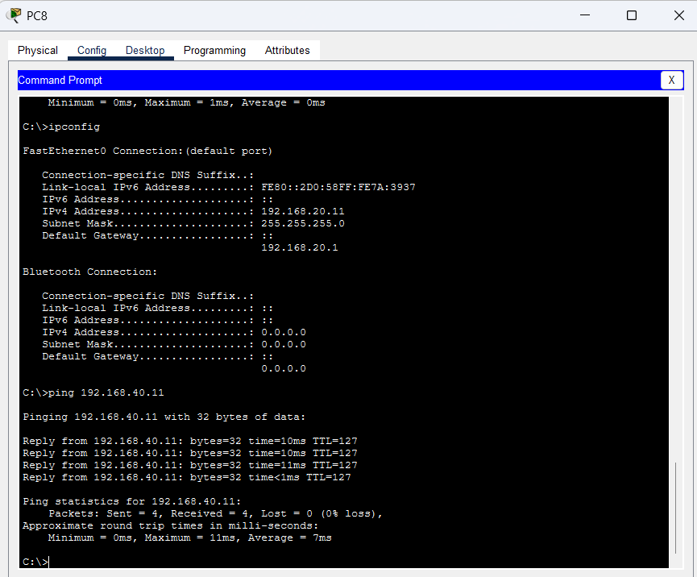
Figure 4.15 – Technical to Server connectivity
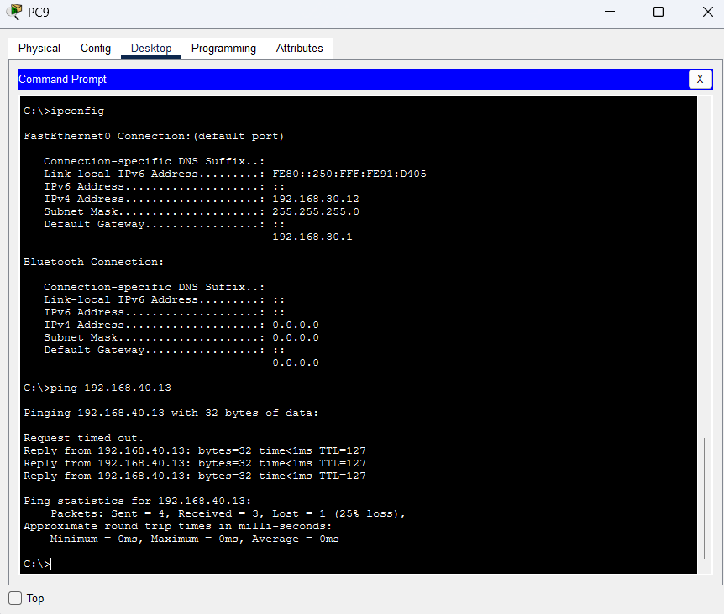
Figure 4.16 – Management to Server connectivity
How inter-VLAN routing allows communication between different broadcast domains:
Each VLAN is a separate broadcast domain. A Layer-2 switch never forwards a frame from one VLAN to another. Inter-VLAN routing breaks this isolation in a controlled way using a Layer-3 device (DISTRIBUTION).
Step-by-step example (192.168.10.11 → 192.168.30.12):
- Source PC determines the destination is not on its local subnet and forwards the packet to its default gateway (VLAN 10 SVI 192.168.10.2).
- Frame travels via the access switch (access port VLAN 10) and trunk to DISTRIBUTION.
- DISTRIBUTION receives the frame on the VLAN 10 SVI, strips the Layer-2 header, consults the routing table (directly connected VLAN 30) decrements TTL and re-encapsulates the frame for VLAN 30.
- The frame is forwarded out the trunk to the Management access switch and delivered to the destination host. Reply follows the reverse path. ACLs can be applied on the SVIs to enforce policy.

4.4 Routing Protocols – RIP and OSPF
RIP (RIPv2): Configured on the relevant routers for legacy connectivity. Version 2, no auto-summary and network statements for the required subnets were used. RIP uses hop count as its metric (maximum 15 hops) and periodic updates (every 30 s).
OSPF: Configured in a single Area 0 as the preferred dynamic routing protocol. OSPF uses cost (based on bandwidth) as its metric, converges rapidly through LSA flooding and SPF calculation and scales better for larger networks through hierarchical areas.
Routing verification evidence:
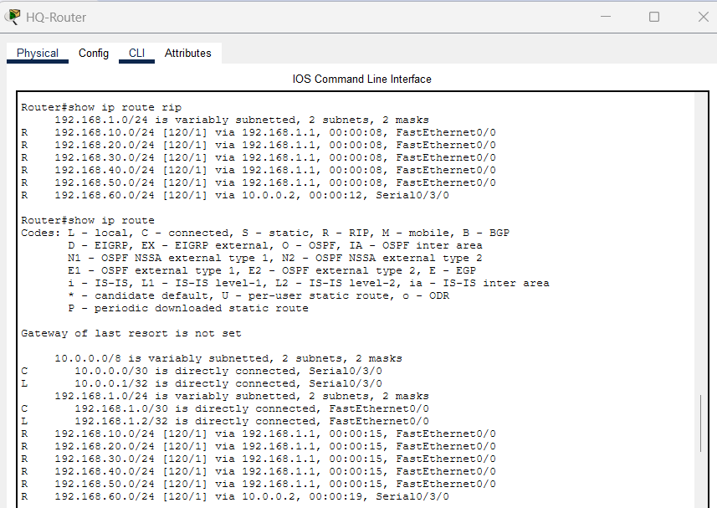
Figure 4.17 – RIP: show ip route (HQ Router) – routes learned via RIP
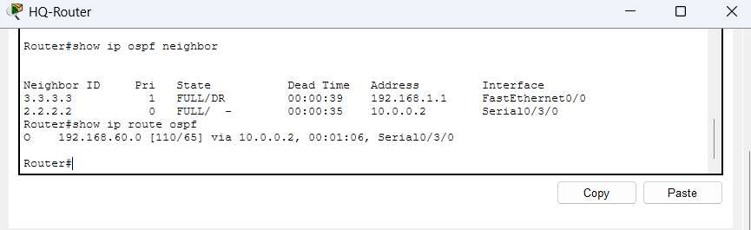
Figure 4.18 – OSPF: show ip ospf neighbor (HQ Router)
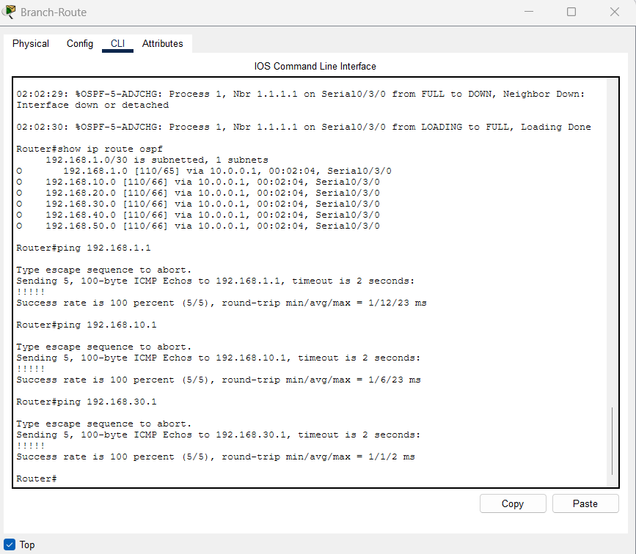
Figure 4.19 – Branch: show ip route ospf – routes learned via OSPF
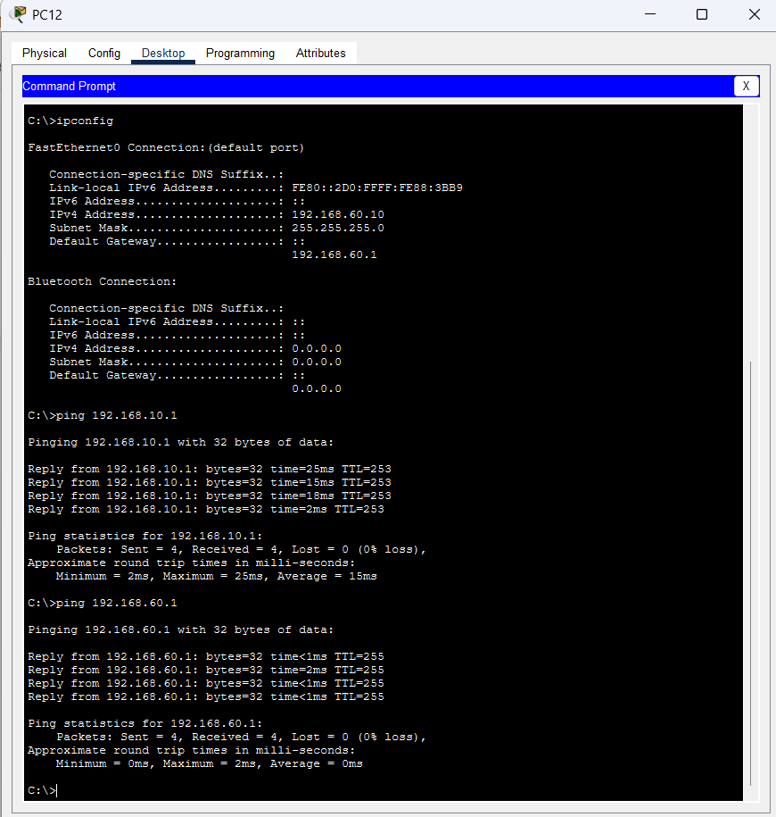
Figure 4.20 – Final verification: Branch PC successful end-to-end ping to HQ VLAN 10 (0% loss, TTL=253)
How RIP determines the best route: RIP is a distance-vector protocol using the Bellman-Ford algorithm. It selects the path with the lowest hop count (maximum 15 hops; 16 is unreachable). It broadcasts the full routing table every 30 seconds using UDP port 520 and uses timers (invalid 180 s, hold-down 180 s, flush 240 s) to help prevent routing loops.
Comparison of RIP and OSPF:
Aspect | RIP | OSPF
Metric | Hop count | Cost (10⁸ / bandwidth)
Convergence | Slow (30 s + hold-down) | Fast (LSA flooding + SPF)
Scalability | Limited (< 15 hops, flat) | High (hierarchical areas)
Best suited for | Small networks | Enterprise / large networks
OSPF is preferred because of its lower administrative distance and superior convergence and scalability characteristics.

4.5 DHCP, DNS and HTTP Servers
DHCP: A centralised DHCP server (192.168.40.10) provides IP address, subnet mask, default gateway and DNS server information to clients. ip helper-address 192.168.40.10 is configured on the DISTRIBUTION SVIs so that DHCP broadcasts from other VLANs are forwarded to the server.
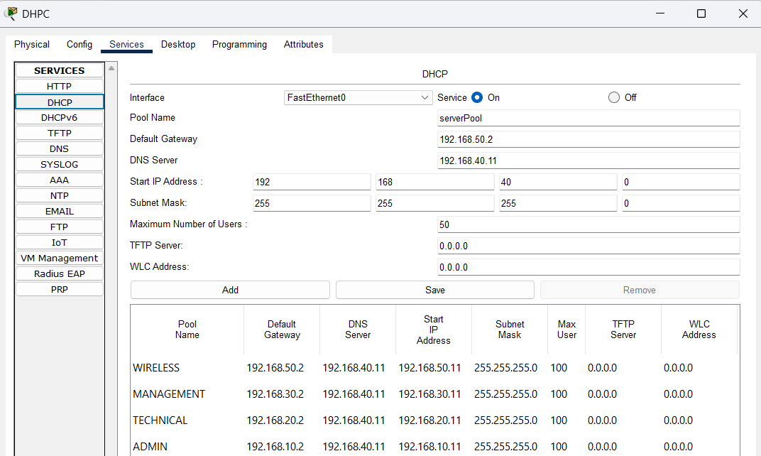
Figure 4.21 – DHCP server configuration (pools for the VLANs)
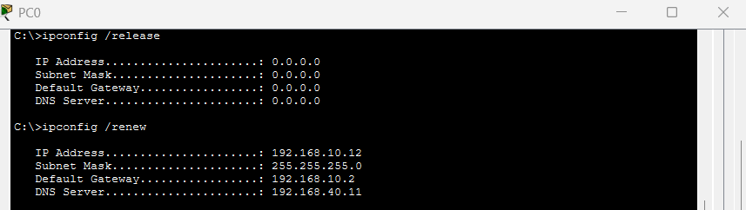
Figure 4.22 – Client obtains IP address automatically via DHCP
DNS: DNS server 192.168.40.11 hosts an A record for www.mbs.local pointing to the HTTP server (192.168.40.12). Clients can therefore reach the company website by name.
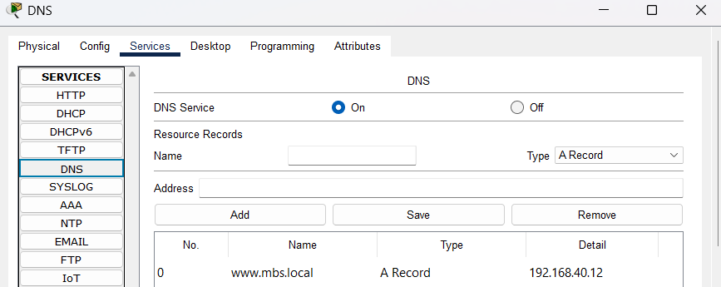
Figure 4.23 – DNS A record configured for www.mbs.local → HTTP server
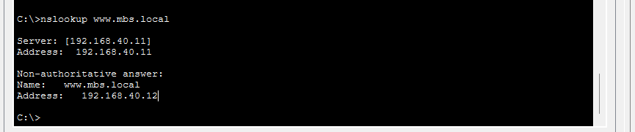
Figure 4.24 – Successful DNS resolution (Client uses DNS instead of IP)
HTTP: The web server hosts a simple company page containing the organisation name, a welcome message, at least three services offered by MBS, and contact information. Both HTTP and HTTPS services are enabled. The complete client path Client → DHCP → DNS → HTTP was verified.
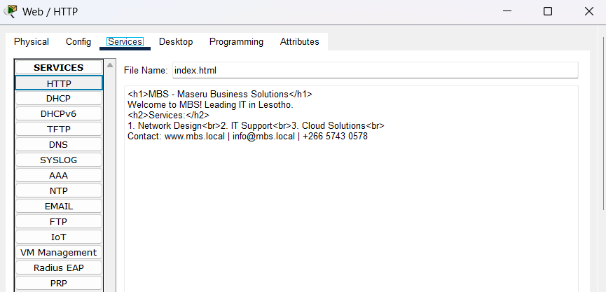
Figure 4.25 – HTTP server configuration
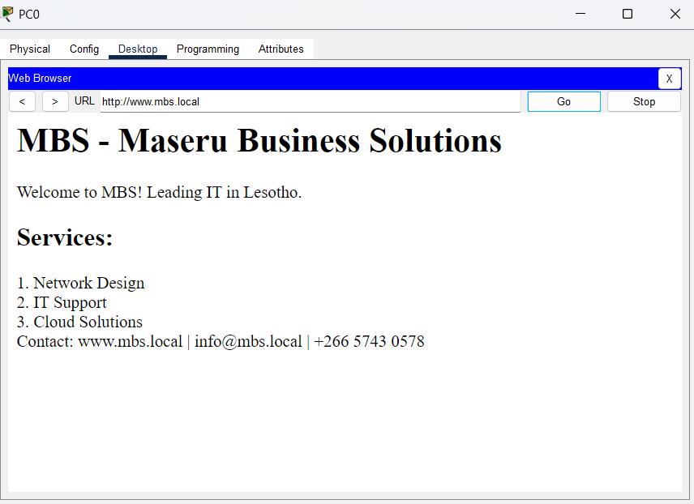
Figure 4.26 – Website accessed via domain name (full chain: Client → DHCP → DNS → HTTP)

4.6 Access Control Lists (ACLs)
Extended ACLs were applied inbound on the VLAN SVIs of the DISTRIBUTION switch to enforce the following policy:
- Administration users may access the HTTP server.
- Technical Services users may access the HTTP and DNS servers.
- Management users may access all internal servers.
- Wireless users are blocked from accessing the Administration network.
- All users are permitted to reach the DNS server (required for name resolution).
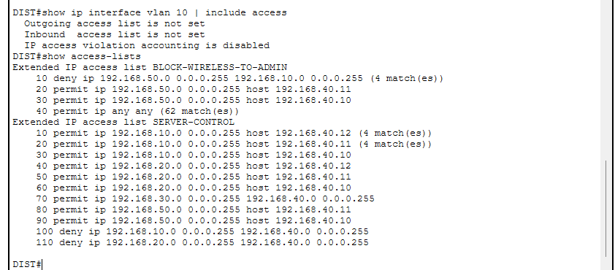
Figure 4.27 – ACL configuration (BLOCK-WIRELESS-TO-ADMIN and SERVER-CONTROL)
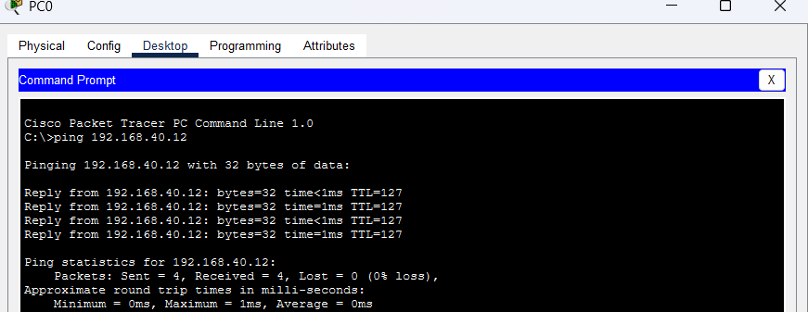
Figure 4.28 – Permitted traffic test (Administration PC accessing allowed resources)
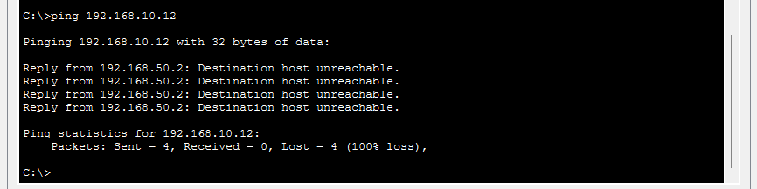
Figure 4.29 – Denied traffic test (Wireless PC blocked from Administration network)
ACL logic: The BLOCK-WIRELESS-TO-ADMIN ACL is applied inbound on VLAN 50 to filter traffic as it enters the gateway. Rule 1 denies source 192.168.50.0/24 to destination 192.168.10.0/24, preventing Wireless from accessing Administration. The SERVER-CONTROL ACL permits specific server access based on department policy while still allowing DNS (port 53) for name resolution.

4.7 Wireless LAN
Wireless access points were configured with SSID MBS-WIFI, WPA2-PSK (AES) encryption and a strong password. At least two wireless clients (laptops with wireless modules) associate successfully, obtain IP addresses automatically via the central DHCP service and can access the organisation’s web server using the DNS name.
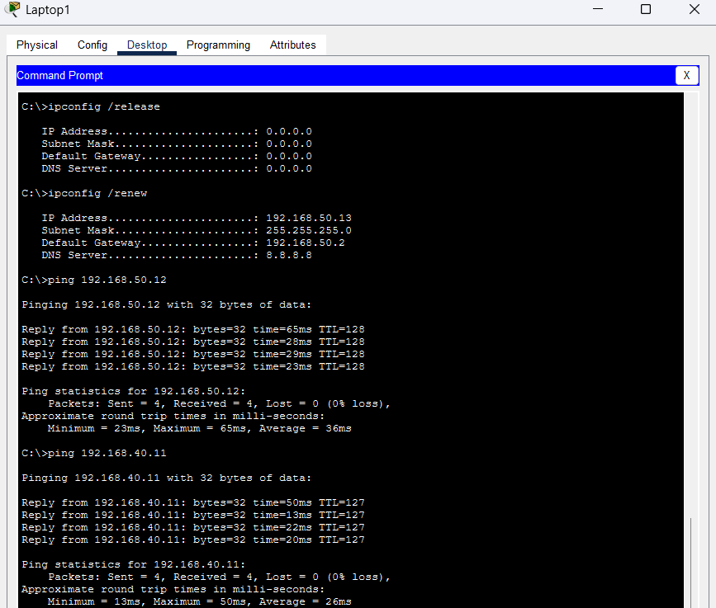
Figure 4.30 – Wireless clients obtain IP automatically and access network resources / web server
Two security measures implemented:
1. WPA2-PSK (AES) Encryption: WPA2-Personal with AES encrypts all wireless traffic between clients and the AP using CCMP. This prevents eavesdropping. AES is stronger than TKIP. A complex 16-character passphrase with uppercase, lowercase, numbers and symbols resists brute-force and dictionary attacks.
2. SSID Management + additional hardening: Default SSID changed to MBS-WiFi (avoids vendor defaults that help attackers identify device type). WPS disabled to prevent PIN brute-force. Optional MAC filtering, reduced transmit power and regular passphrase rotation further improve security. Best practice is to move to WPA3 where devices support it.

5. Testing and Verification
The following tests were performed to confirm correct operation of the network (supporting screenshots appear in Section 4 above):
- Intra-VLAN connectivity: PCs belonging to the same VLAN successfully ping each other (0 % loss) – see Figure 4.6.
- Inter-VLAN routing: Administration ↔ Management, Technical Services ↔ Management and Departments ↔ Servers communication verified – Figures 4.12 – 4.16.
- STP: Root bridge, Root Port, Designated and Blocking ports confirmed; rapid reconvergence after primary link failure demonstrated – see Figures 4.7– 4.11.
- DHCP: Clients across VLANs obtain correct IP, mask, gateway and DNS via the helper-address mechanism – see Figures 4.21– 4.22.
- DNS & HTTP: nslookup www.mbs.local resolves correctly; website is reachable by domain name – see Figures 4.23 – 4.26.
- ACLs: Permitted traffic succeeds; denied traffic (Wireless → Administration) is blocked – see Figures 4.27– 4.29.
- Wireless: Clients associate, receive DHCP leases and access network resources – see Figure 4.30.

6. Challenges and Solutions

Challenge 1: DHCP Failure Across VLANs
Problem: Clients received APIPA addresses (169.254.x.x) and could not reach the DNS server.
Solution: The DISTRIBUTION SVIs were missing the ip helper-address command and the server-switch uplink was incorrectly configured as an access port instead of a trunk. Adding the helper-address on all SVIs and converting the uplink to a trunk that allowed all required VLANs resolved the issue. Clients then successfully renewed their leases.

Challenge 2: DNS Resolution Timeout
Problem: nslookup www.mbs.local returned “Request timed out”.
Solution: The DNS server lacked a default gateway and the trunk to the server switch was misconfigured. Adding the correct gateway and fixing the trunk, together with verifying the A record, restored name resolution.

Challenge 3: Wireless Clients Receiving Incorrect Addressing
Problem: Wireless laptops obtained addresses from the AP’s local DHCP pool instead of the central server, resulting in incorrect DNS settings.
Solution: DHCP was disabled on the wireless access point, the AP was given a static address in VLAN 50, and the helper-address on the VLAN 50 SVI was confirmed. After renewal, clients received correct addressing from the central DHCP server and could resolve and access the web server.

Additional Issues Encountered During Configuration
# | Problem | Symptom | Discovery Method | Fix Applied
1 | Access port set as trunk | PC shows no link / orange indicator | show interfaces status | switchport mode access + access vlan
2 | Physical loop between switches | VLANs unstable | show interfaces status / STP | Removed redundant cable / allowed RSTP to block
3 | Incorrect VLAN assignment | Wrong subnet on PCs | Requirement check + show vlan | Re-assigned ports to correct VLANs
4 | VLAN SVI administratively down | Ping to gateway fails | show ip interface brief | no shutdown on SVI + ip routing

