Gold Girl

Java Game Report

Kenny Li & James Flood

Table of Contents

Executive Summary iii

1.0 Introduction 1

2.0 Methods 3

2.1 Experiment Setup 3

2.2 Simulation Procedure 3

2.3 Recording and Analysis of Data 4

3.0 Results 5

4.0 Conclusions 6

5.0 References 7

Table of Figures

Figure 1: A Containerised-Load Fire Setup 3

Figure 2: A Generic Typical Time/Temperature Graph 4

Figure 3: A graph of the maximum fire temperature after applying Agent H3 5

Figure 4: A graph of the Maximum fire area after applying Agent H3 6

1.0 Introduction

We have been tasked to develop an offline Java game that is inspired by the 1980’s game Pacman. The aim of the game is for Pacman to consume as many pellets as possible, while avoiding collision with the ghosts.

We have developed our game using Java 9 and JavaFX and designed it similar to the original game but altering features such as different enemies, win conditions and power ups while having a storyline.

2.0 Methods

2.1 Experiment Setup

In the simulation, the volume of the cargo compartment was 58m3 (8.2m long x 4.2m wide x 1.7m high). Ceiling thermocouples (Type K chromel/alumel 22 gauge) were placed evenly along the compartment roof, in three rows, at 1.25m intervals with the thermocouples beads protruding 25mm from the ceiling (Type K thermocouples, data sheets.). In order to be within the FAA test specifications, extra care was taken to ensure that one of the thermocouples was placed directly above the seat of the fire (Bennet, 2011).

Two thermocouples were placed to be used to monitor and verify correct operation of the igniter. One was placed inside one was above the box in the LD-3 container containing the igniter to initiate the fire. Although not being recorded, the readings for the thermocouples were used to monitor and verify correct operation of the igniter. The suppression agent was measured by a continuous gas analyser with a real time display. However, this was not required for the acceptance data to be submitted to national air safety boards and regulatory bodies.

2.2 Simulation Procedure

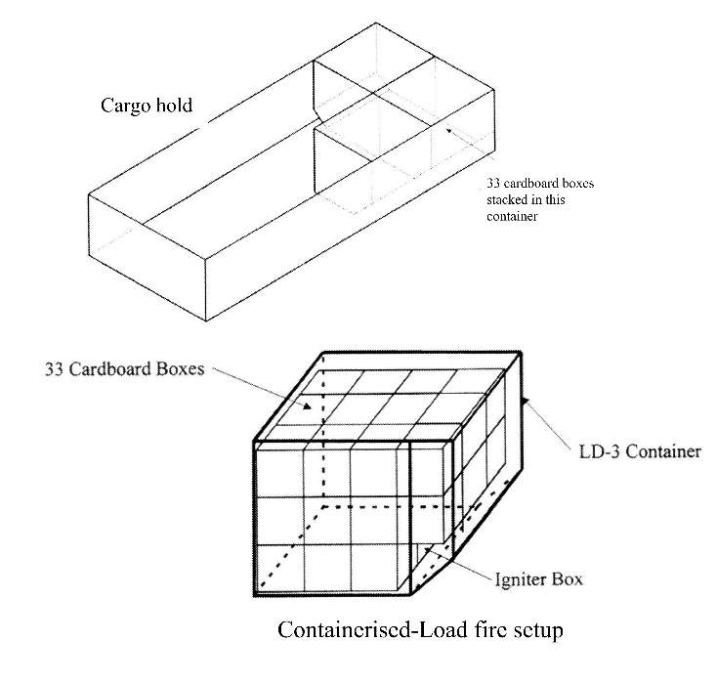The fire scenario that has been simulated is a containerised-load bulk fire. The fire load consisted of 33 single-walled corrugated cardboard boxes (450mm x 450mm x 450mm). These cardboard boxes were stacked in three layers, four tiers deep. Each box contained 1.5kg of office copier paper (80gm/m2) that were loosely packed and shredded into strips. To ensure that the boxes had low humidity and standard temperature, they were stored in a room with standard conditions for 24 hours before the test. After that, they were then packed as tight as possible to eliminate any significant air gaps between adjacent boxes. Two additional LD-3 containers were placed adjacent to the first container as shown in Figure 1.

The igniter consisted of 2 metres of nichrome wire (7 ohm resistance) wrapped around four folded paper towels. The igniter was then placed on the bottom layer within the centre of a box in the second tier of the stacked boxes. Furthermore, several ventilation holes were punched on the side of the box to ensure that the fire did not self-extinguish. This experiment is repeated six times so that there is a reduction in error.

Figure 1: A Containerised-Load Fire Setup

2.3 Recording and Analysis of Data

Once the boxes were placed, the gas analyser was switched on to allow it to settle. The readout board for the thermocouples was checked to ensure all thermocouples are verified to be working. A data-logger was connected to the thermocouple readout board to produce a graph of temperature versus time. The test timer was checked to be working properly and then set to zero. The fire was then initiated by passing 240V AC to the igniter wire.

Once the data was recorded, $t_{1}$ is used to show the time that the temperature in the hold reached 100°C. Furthermore, $t_{2}$ ( $t_{1}$ + 1 minute) shows the time when the suppression system was activated. Data from the thermocouples was collected from time $t_{3}$ ( $t_{2}$ + 2 minutes) until $t_{4}$ ( $t_{3}$ + 28 minutes) during 1-minute intervals.

A generic graph of a typical time/temperature output from the data logger is then produced which can be seen in Figure 2.

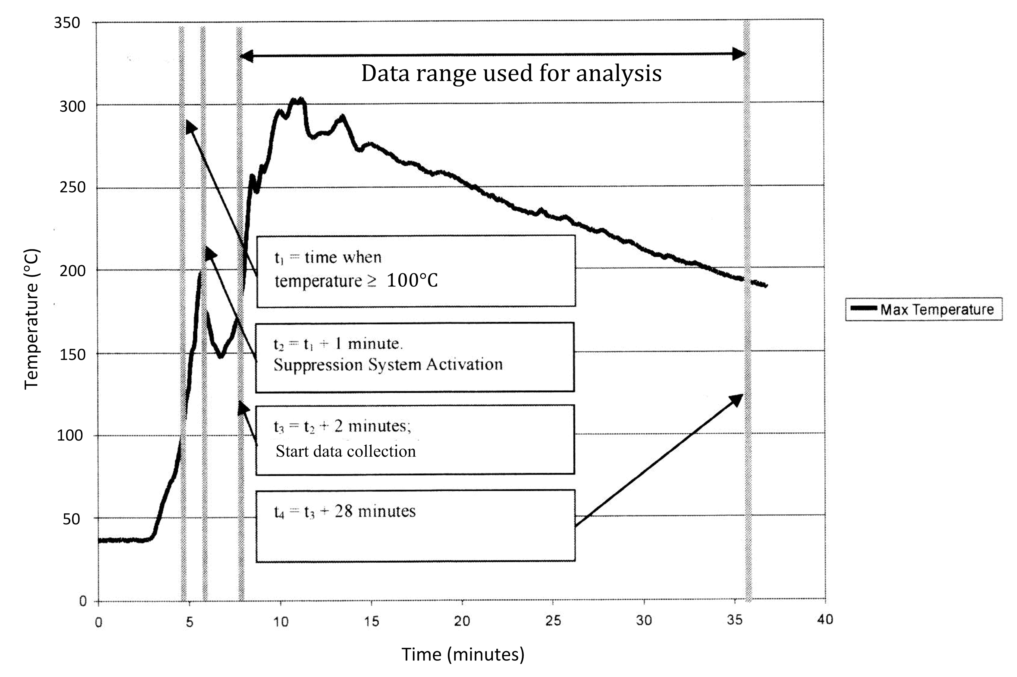

Figure 2: A Generic Typical Time/Temperature Graph

3.0 Results

|  |  |  |
| --- | --- | --- |
| **Test** | **Max Temp (°C)** | **Area (°C - mins)** |
| 1 | 252 | 3829 |
| 2 | 264 | 4803 |
| 3 | 301 | 5428 |
| 4 | 303 | 4555 |
| 5 | 281 | 3964 |
| 6 | 306 | 5523 |
| **Standard Deviation** | 20.678 | 650.344 |
| **Maximum Value** | 306 | 5523 |
| **Sum of Std. Dev. + Max.** | 326.678 | 6173.344 |
| **Results for Halon 1301** | 380 | 7500 |

Table 1: Results from the experiment

Table 1 shows that the maximum temperature of the fire after applying Agent H3 is 306°C. When we consider the standard deviation with the maximum, the fire temperature can only reach 328.622°C. This is far below the result for Halon 1301. The table also shows the maximum area of the fire after applying Agent H3. This reaches a fire area of 5523°C-mins. When we account for standard deviation, the fire area can only reach up to 6235.416°C-mins. This is also far below the result for Halon 1301.

Figure : A graph of the maximum fire temperature after applying Agent H3

The graph shown in Figure 3 plots the results for the 6 tests of the maximum fire temperature.

Figure : A graph of the Maximum fire area after applying Agent H3

The graph shown in Figure 4 shows the area under the temperature/time graph that was the output of the data logger.

4.0 Conclusions

This report is to analyse whether Agent H3 is a suitable replacement for the pre-existing Halon 1301. From the results of the experiment, it can be seen that the maximum temperature and the maximum fire area (after applying Agent H3) are both less than that of Halon 1301. It can be concluded that the CFC-free Agent H3 satisfies both the temperature acceptance criterion and the maximum temperature/time are criterion required for the national air safety body approval.

5.0 References

Bennet, R. (2011), *Replacing halon in fire protection systems: A progress report.* Washington: Boeing Commercial Airplanes.

United Nations Environment Programme. (2006). *Handbook for the Montreal protocol on substances that deplete the ozone layer* *(7th ed.).* Nairobi, Kenya:.

Type K thermocouples, data sheets. Retrieved from <http://www.thermometricscorp.com/thertypk.html>