Safe Ride App

CIS 422 Software Methodology I

Matti Cone, Lindy Myers and Katie Lillard

4/19/16

**Introduction**

The purpose of the Safe Ride project is to create a web-based app that makes it easier for the users to make a reservation for a ride with Safe Ride at night. The intended audience for this web-based app is the students, faculty and staff of the University of Oregon and the employees of Safe Ride. While we are still in the process of working on the final kinks we have created a front website with HTML, CSS and Bootstrap and the backside is on NodeJS.

**Concept of Operations**

This web-based app will be used to make ride reservations 24-hours a day with Safe Ride. When loading the website there will be user entry textboxes for the rider to fill out. They will need to fill out the necessary information for their ride. Once the user has finished filling out the textboxes and clicked the submit button then all that data will be sent to our dispatchers.

**Behavioral Requirements**

Inputs will be the Riders:

- Name

- UO ID number

- Phone number

- Party size

- Desired pick-up time

- Pick-up location

- Drop-off location

- Any other additional information (like having a bike)

Outputs to Dispatcher:

- The above information in list form of all rider requests

**Software Requirements Specification (SRS)**

Matti was in charge of the backend requirements of MongoDB and NodeJS.

Lindy and Katie were in charge of the frontend requirements HTML, CSS, JQuery and JavaScript, utilizing Bootstrap for reactive design.

**Iterations**

Project1:

Week 1: Educating ourselves

Week 2: Lindy and Katie work on front end, Matti works on back end

Week 3: Lindy designs, Matti and Katie connect front and back end

Week 4: Testing and frills

Project2:

- Mobile GPS tracking

- Mobile app for user input

- Separate website for dispatchers

**Software Architecture**

Using Twitter Bootstrap creates this web-based app’s front end and MongoDB creates the database on the server. Then we used Express to communicate between the front and backend. We used Mongoose to communicate between the server and backend.

**Block Diagram**

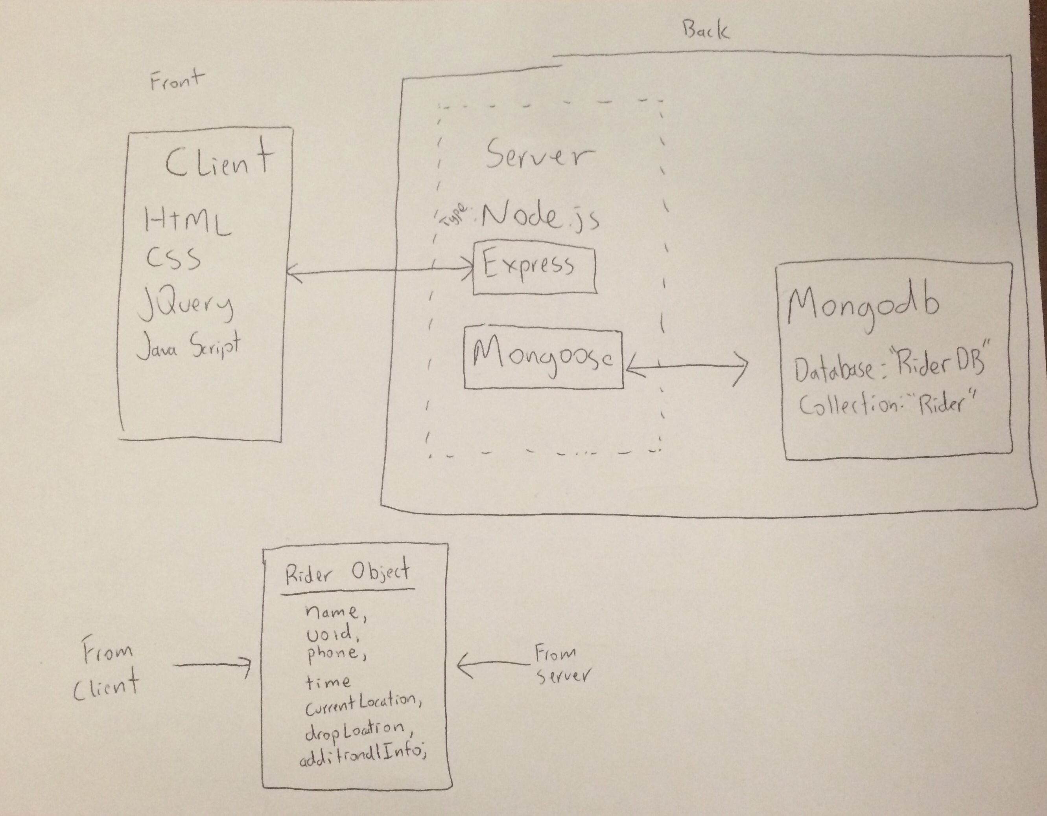

**Files in GitHub**

README.md – the original commit and description of what our Safe Ride app does

Bkg.png – white box for added styling

Saferide.html – the website that the web-based app is held on

Saferide_banner.png – the Safe Ride logo that is put at the top of the website

Server.js – the server side of the project

Style.css – the styling that contributes to the website