**<https://www.cs.uoregon.edu/Classes/16S/cis422/docs/proposal.php>**

**Purpose of the proposed system**

The purpose of the Safe Ride project is to create a web-based app and an accompanying android app that makes it easier for the users to make a reservation for a ride with Safe Ride at night. The intended audience for this app is the students, faculty and staff of the University of Oregon and the employees of Safe Ride.

**Stakeholders**

* Users:
  + Riders: Efficiently request a ride over the phone or computer
  + Dispatch: Have request information clearly laid out for ease of scheduling rides

**System context**

We are building our program with HTML, CSS and Java Script on our front-end and then Express, Mongoose and Mongodb on our back-end. For this updated project we plan to add a map feature to it so we will be using Google Maps API.

**Behavioral requirements**

Use case: request a pick up:

*Input fields*

- Name

- UO ID number

- Phone number

- Party size

- Desired pick-up time

- Pick-up location

- Drop-off location

- Any other additional information (like having a bike)

Use Case: dispatcher retrieve request information:

- Go to Saferide & submit login information

- Click button to retrieve list of requests

- The above information in list form of all rider requests

**Other requirements**

- Only dispatchers will be only ones allowed to see who has requested a ride and where they are going

- Allow an ‘undue’ / ‘edit’ / ‘delete’ capabilities for both the riders and dispatchers

- Adding Google mapping to the web-based app to make it easier for riders to say where to be picked-up/dropped-off.

**Value**

This app will make it not only easier for students, faculty or staff to request a ride with Safe Ride but will also make it easier for dispatchers to organize rides in the most efficient way possible. This web-based app will become most useful during the busiest times for Safe Ride every night, 9-10pm Sunday-Thursday and 8-11pm Friday-Saturday. It will make it so riders will be able to get a confirmation as to whether or not they can schedule a ride that fits into the schedule. It will also make scheduling smoother for dispatchers in the office during these busy times.

**Design Concept**

Diagram:

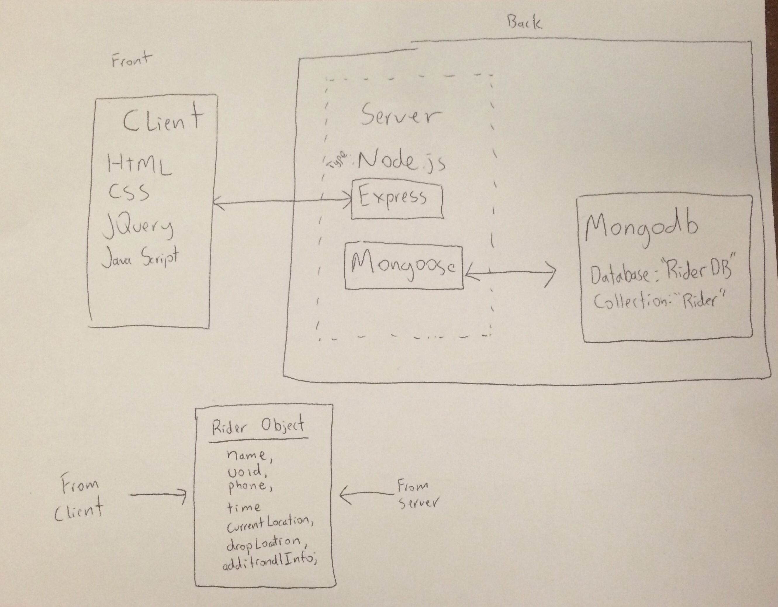

We have identified client server communication as a risk, as well as checking ride request requirements for accuracy (specifically location bounds). Major design components include the front end user interface, which will be done in HTML and CSS, scripts written in JQuery will be used to communicate with the server (back-end), and eventually send requests to a MongoDB database. We will use a Rider object, which includes relevant user fields to represent users.

From a security standpoint, we run the risk of not creating a protected login page for dispatchers. User data needs to be secured, and doing so may involve the eventual purchase of a certificate and/or coordination with the University.

From a development standpoint, we have identified potential risk in communication between an android app and the existing web app. The mobile application needs to be compatible with the same backend database as the web application, and both must submit ride requests in real time, as well as check user input in real time.