<https://docs.bigchaindb.com/projects/server/en/latest/quickstart.html>

# Prerequisite

Vagrant boxes up and running with a specific IP Address. See multichain document for details.

We are using config.vm.box = "ubuntu/xenial64"

# in the Vagrant Box:

## install rethinkdb

source /etc/lsb-release **&&** echo "deb http://download.rethinkdb.com/apt $DISTRIB_CODENAME main" | sudo tee /etc/apt/sources.list.d/rethinkdb.list wget -qO- https://download.rethinkdb.com/apt/pubkey.gpg | sudo apt-key add - sudo apt-get update sudo apt-get install rethinkdb

## In instance 1 of Box 1 : Launch rethinkdb

$ rethinkdb

## In instance 2 of Box 1 (new terminal) : Install other tools on ubuntu

$ sudo apt-get update

$ sudo apt-get install g++ python3-dev libffi-dev

$ sudo apt-get install python3-pip

$ sudo pip3 install --upgrade pip setuptools

if problems : try following

$ export LC_ALL=en_US.UTF-8

$ export LANG=en_US.UTF-8

$ export LANGUAGE=en_US.UTF-8

<https://github.com/bigchaindb/bigchaindb/issues/1008>

## In instance 2 of Box 1 Install Bigchain

$ sudo pip3 install bigchaindb

$ bigchaindb -y configure rethinkdb

## In instance 2 of Box 1 Run Bigchain

$ bigchaindb start

this will create a config file

INFO:bigchaindb.commands.bigchain:BigchainDB Version 0.9.1

INFO:bigchaindb.config_utils:Configuration loaded from `/home/ubuntu/.bigchaindb`

🡪 need to update this config file and replace localhost with the ip addres ( do ip a to get it).

{

"backlog_reassign_delay": 120,

"server": {

"workers": null,

"bind": "localhost:9984",

"threads": null

},

"database": {

"port": 28015,

"host": "localhost",

"backend": "rethinkdb",

"name": "bigchain"

## In instance 2 of Box 1 stop / restart bigchaindb

Stop the running with CTRL+C

Run again

$ bigchaindb start

## In OS : Check you can reach config file

This is explained in <https://docs.bigchaindb.com/projects/py-driver/en/latest/quickstart.html>

now a chrome can access it.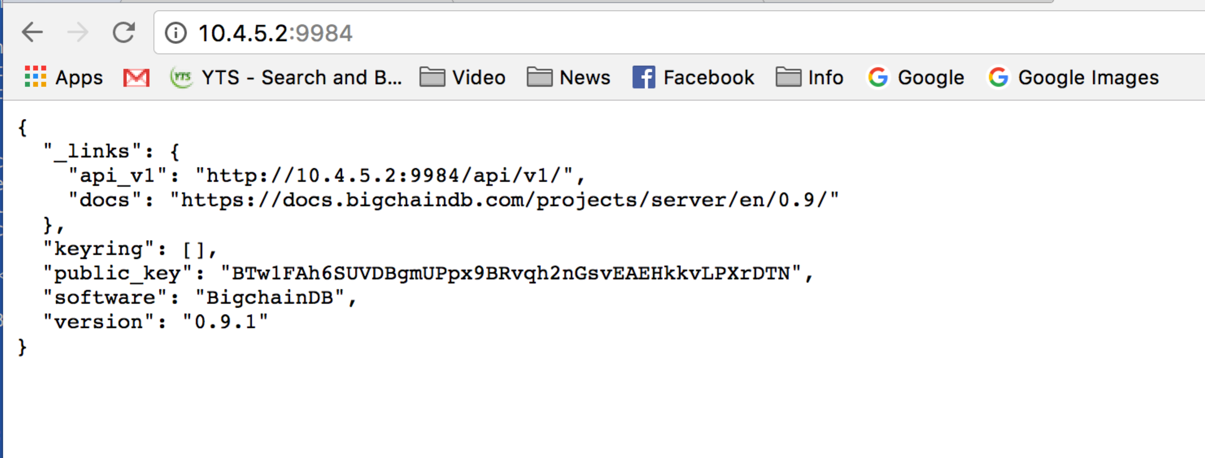

## In instance 3 of Box 1 (new terminal) : Install Python tools

This is explained in <https://docs.bigchaindb.com/projects/py-driver/en/latest/quickstart.html>

Ultimately we want to run

$ pip install bigchaindb_driver

but before this : prerequisites

$ sudo apt-get update

$ sudo apt-get install libffi-dev

need python 3.5

$ python –version

$ pip –version

$ pip install --upgrade setuptools

## In instance 3 of Box 1 : run a python to create asset and record transaction

The .py file on local OS (in vagrant folder) will be reachable in the box in /vagrant

Update test.py with hereunder text. Then :

$ python test.py

result : (depending on the code)

ubuntu@xen-2:/vagrant$ python 5.py

Tx valid in: 0 secs

Is Bob the new owner 2222? True

was alice before ??? True

example python transaction :

from bigchaindb_driver import BigchainDB

from bigchaindb_driver.crypto import generate_keypair

from time import sleep

from sys import exit

alice, bob, amit = generate_keypair(), generate_keypair(), generate_keypair()

bdb = BigchainDB('http://10.4.5.2:9984')

article_asset = {

'data': {

'article1': {

'http': 'http://www.bluetrails.nl',

'author': 'An de Rijdt'

},

},

}

article_asset_metadata = {

'planet': 'earth'

}

prepared_creation_tx = bdb.transactions.prepare(

operation='CREATE',

signers=amit.public_key,

asset=article_asset,

metadata=article_asset_metadata

)

fulfilled_creation_tx = bdb.transactions.fulfill(

prepared_creation_tx,

private_keys=amit.private_key

)

sent_creation_tx = bdb.transactions.send(fulfilled_creation_tx)

txid = fulfilled_creation_tx['id']

trials = 0

while trials < 60:

try:

if bdb.transactions.status(txid).get('status') == 'valid':

print('Tx valid in:', trials, 'secs')

break

except bigchaindb_driver.exceptions.NotFoundError:

trials += 1

sleep(1)

if trials == 60:

print('Tx is still being processed... Bye!')

exit(0)

asset_id = txid

transfer_asset = {

'id': asset_id

}

output_index = 0

output = fulfilled_creation_tx['outputs'][output_index]

transfer_input = {

'fulfillment': output['condition']['details'],

'fulfills': {

'output': output_index,

'txid': fulfilled_creation_tx['id']

},

'owners_before': output['public_keys']

}

prepared_transfer_tx = bdb.transactions.prepare(

operation='TRANSFER',

asset=transfer_asset,

inputs=transfer_input,

recipients=bob.public_key,

)

fulfilled_transfer_tx = bdb.transactions.fulfill(

prepared_transfer_tx,

private_keys=amit.private_key,

)

sent_transfer_tx = bdb.transactions.send(fulfilled_transfer_tx)

print("Is Bob the new owner 2222?",

sent_transfer_tx['outputs'][0]['public_keys'][0] == bob.public_key)

print("was alice before ???",

fulfilled_transfer_tx['inputs'][0]['owners_before'][0] == amit.public_key)