**ValuWaste Advantage 4**

WasteLogger

(Advantage Point Roll Release: v4.2)

**Product Definition**

**v0.95**

**Prepared by:**

Stephen Rogers, CTO

LeanPath, Inc.

[sarogers@leanpath.com](mailto:sarogers@leanpath.com)

503.381-8288

|  |  |  |
| --- | --- | --- |
| **Revision History** | | |
| V0.95 | 7/1/10 | Expand data model to include colors; |
| v0.92 | 5/24/10 | ARS marketing/branding notes added  Post-NRA feedback |
| v0.83 | 4/21/10 | SAR – post-agreement on new data entry-centric design changes |
| v0.82 | 4/2/10 | SAR/ARS – post-feedback from Intel |
| v0.8 | 3/3/10 | SAR – minor edit pass to incorporate AS/SAR mtg results |
| v0.25+ | 3/1/10 | AS – major pass completing Marketing and much of requirements. |
| V0.25 | 1/30/10 | SAR – Consolidated spec from all known emails, discussions, memos etc. |

Contents

1 Document Overview 5

2 Product Proposal 5

2.1 Product Overview 5

2.1.1 Goals 5

2.1.2 Objectives 5

2.1.3 Feature Summary 5

2.2 Market Analysis 6

2.2.1 Target Market 6

2.2.1.1 Market Size 6

2.2.1.2 Target Customers 6

2.2.2 Market Research 6

2.2.2.1 Competition 7

2.2.2.2 Customer Feedback 7

2.2.3 Issues and Risks 7

2.3 R&D Analysis 8

2.3.1 Technology Roadmap Implications/Impacts 8

2.3.2 Issues and Risks 8

2.3.2.1 Lack of Example Data Collection Forms 8

2.3.2.2 Configurability Expectations 8

2.3.2.3 Use Cases/Models 8

2.4 Cost-Benefit Analysis 10

2.4.1 Benefits 10

2.4.1.1 Justification Narrative 10

2.4.2 ROI 10

2.4.2.1 Revenue 10

2.4.2.2 Costs (Product Development and Introduction) 11

2.4.2.3 ROI Calculation 11

3 Product Definition 12

3.1 Product Conceptual Overview 12

3.2 Use Model Analysis 12

3.2.1 Use Process Model 1 12

3.2.2 Use Process Model 2 12

3.2.3 Analysis 13

3.2.4 Conclusion – Select Use Process Model 1 14

4 Detailed Requirements Analysis 15

4.1 Meta-Requirements 16

4.2 Detailed Requirements Baseline 42

4.3 Detailed Requirements – Additional Considerations 21

5 Example Forms 31

5.1 “QuickCheck” Transaction Format Proto #1 (SAR) 31

5.2 “QuickCheck” Transaction Format Proto #2 (SAR, JH, DB, ARS) 32

5.3 “QuickCheck” Transaction Format Proto #3 (JH, ARS) 32

5.4 Tabular Proto #2 (SAR) 33

5.5 “QuickCheck” Proto #3 (Jennifer and Dave response to SAR) 34

5.6 Forms Header - Detail 35

6 Product Management, Development Plan 36

6.1 Plan Requirements 36

7 Appendix – First Use Feedback (Bon Appetit) 41

7.1 SAR Notes 42

# Document Overview

This document is a combined product proposal and product definition for the first major enhancement to manual waste tracking for ValuWaste 4. The focus of this effort to provide an **end-to-end solution** for using **paper forms** as the primary data collection method, with **analogous data entry UIs** for entering the collected data into the standard ValuWaste Advantage 4 data stream. Once in the data stream, all normal features of ValuWaste Advantage 4 can be brought to bear on the problem.

This product proposal dimension is brief, since the market need and demand for this product enhancement is already stipulated. Missing sections in the normal product proposal format should be back-filled as data is available, but these earlier sections – presumed to already be approved – will not gate development, which is already commenced as of the first draft of this document.

# Product Proposal

## Product Overview

An initial version of the ValuWaste 4 Manual Tracker product was included in the ValuWaste Advantage 4 initial release.

### Goals

* Broaden the market for LeanPath waste tracking products to applications where:
  + Paper-based waste tracking is the norm, most efficient, or only practical method of primary data collection.
  + Customers can’t afford or justify (e.g. based on potential savings) a hardware based Tracker solution.
  + Customers want to pilot waste reduction programs using a software-only solution.

### Objectives

* Allow entry of waste data directly into ValuWaste Advantage 4, without involvement of Tracker hardware.
* Ability to mirror paper tracking documents in the data entry UI:

### Feature Summary

* Use manual data recording and data entry to eliminate the need for the Tracker and scale
  + Data recording and entry tools will both be designed for 1) efficiency and 2) accuracy. Given that users will be estimating waste (and/or using a non-LeanPath scale to record data), it must be assumed that the weight accuracy will be limited. Efforts will be made in product and process design to control accuracy of the data recording and entry processes, recognizing the limitations of manual processing and human error in both of these process steps.
* Leverage ValuWaste Advantage 4 as much as possible – limited development time makes this a high priority
* Provide as rich a reporting and management tool as VWA4, while minimizing development time and resources
  + Reporting will be limited only to the extent required by the nature of the data collected (e.g., if a certain parameter is not available, it can obviously not be reported upon)
  + The richness of available reporting is a dimension that should be controllable under the licensing scheme.
* Require a ‘rich’ support environment to overcome deficiencies in product and process design, eg, it is assumed limited new user documentation will be made available for these installations; rather, training and technical support will compensate for any inadequacies of the user documentation.
* Product will be provided to customers via a software download (no physical media)

## Market Analysis

### Target Market

This product is designed to serve both existing LeanPath markets and new markets:

Existing markets: Non-commercial foodservice operations and contract managers that cannot or will not allocate capital to purchase the full ValuWaste automated system yet still see the value of waste tracking. This product will have particular resonance with smaller B&I accounts, college cafes that are spread over a campus setting, and K-12 sites with numerous, small kitchen facilities.

New markets: There are many “out of home” foodservice markets which have not yet been targeted by LeanPath sales and marketing to-date due to their limited opportunity for ROI at LeanPath’s current price points and product configurations, as well as their ability to access and allocate capital. These markets would still benefit from waste tracking, at an affordable price point and they include:

* Fullservice Restaurants
* Limited Service Restaurants
* Convenience Stores & Supermarkets (Retail Host Foodservice)
* Coffee Shops
* Snack Bars

#### Market Size

[redacted]

#### Target Customers

* On-site foodservice – Sm/Med self-operated facilities and managed services operations that cannot afford a scale but want to track waste (e.g. Bon Appetit)
* Full-service and Limited Service Restaurants – Full and Limited Service sites that cannot afford a scale but want to track waste (e.g. SPU project)
* C-Stores and Supermarkets (e.g. tracking expired taquitos and pastries)
* Coffee-shops (e.g. tracking expired coffee and pastries)
* Snack Bars

### Market Research

* Sales projections above were derived from the 2008 National Restaurant Industry report, with the exception of the coffee shop market size which was sourced to the Specialty Coffee Association.
* Customers representing large opportunities have requested a lower cost solution from LeanPath. Specifically, Bon Appetit has requested a solution that could be deployed to its field broadly. Bon Appetit has approximately 500 cafes in the US and 300+ accounts.
* In 2007 Compass Group elected to create the Trim Trax product after reviewing LeanPath’s offering and concluding it required too much capital to serve as a universal solution across all their B&I accounts (some of which are quite small).
* The editor of Fare Magazine (which covers the convenience retailing business) reports to LeanPath that she has identified significant C-Store interest in waste tracking.
* Seattle Public Utilities, after investing in a volume foodservice program with LeanPath, felt it needed to gain greater leverage with its investment and be able to apply LeanPath practices more broadly within the city.
* 7-11 Stores in Oregon track waste currently using paper sheets.

#### Competition

* There is no direct competition in the form of a standalone waste tracking program that offers robust analytics and paper entry protocols.
* There are substitution alternatives available, with the primary threat being Point of Sale (POS) systems which allow staff to record shrink as a type of sale. This allows waste to be normalized by product type within the existing system of record. It does not offer a detailed perspective on date, time, person discarding, station, and reason for loss. Nor do we believe these systems offer waste specific reporting.
* We do not know how thoroughly each segment has flocked to POS as a waste tracking solution. We do, however, know that Convenience Retailing is identifying this as an issue. We also know that coffee waste is difficult to track since it requires volume estimating.
* There is also the risk of customers ignoring the issue and doing nothing. This could stem from a belief that a) they have no waste or b) they or their staff lacks the time to pursue a tracking effort.

#### Customer Feedback

##### Manual Waste Entry v4.0 - Beta Experience

There is no feedback available on the current Manual Entry tools bundled with VWA 4. They were offered to the field, but all those with the current application also have automated waste tracking tools and for obvious reasons have defaulted to using those. Manual Waste Tracking has also not been a point of focus during the training and support process thus far for VWA 4 customers.

### Issues and Risks

* The target markets are new for LeanPath. We have limited experience and contacts in these markets and there may be surprises lurking. However, viewed from a portfolio perspective, it is highly probable that there is sufficient opportunity among the basket of markets to balance adverse findings in any one market niche.
* There is a fundamental product development risk: can we develop a paper-to-software data entry process that staff finds sufficiently easy and fast enough to do regularly. If we slay this dragon, we get to the gold. If not, we are going to have an uphill battle with all markets.

## R&D Analysis

### Technology Roadmap Implications/Impacts

Owing to the benefits of .NET and the ValuWaste Advantage 4 technology architecture, this feature set should require no major breakthroughs, and is thought to fit in as an incremental add-on to ValuWaste Advantage 4.0 (i.e. a standard task).

### Issues and Risks

At time of this writing, which imminently precedes development, there seem to be some key areas of missing guidance to inform detailed requirements and design.

#### Lack of Example Data Collection Forms

Data collection forms are critical for success of this product. They are equally, if not more, important than the data entry UI, and in fact the architecture of this product is guided by paper form requirements. Ideally, form designs and approaches should be designed and tested with customers before committing R&D resources to design and implement the product.

* Forms will be tested with representatives of Bon Appetit Management company in a paper phase during specification finalization
* It is anticipated that the product will be tested in a formal Beta program with Bon Appetit as an anchor/charter customer.
* Fare Magazine is willing to partner with LeanPath on a C-Store waste tracking study which could be a marketing initiative or could be brought into a beta program for R&D purposes if desired.
* LeanPath can independently contact other verticals to involve them in the beta process, with the most likely areas being C-Stores, Full-Service, and Limited Service Restaurants.
* SPU may provide a platform for testing and accessing 6-7 specific verticals with this effort, but timing is unknown given the new Mayoral Administration in Seattle.

#### Configurability Expectations

Requirements for form configurability are mostly anecdotal and do not seem to be sufficiently understood to drive R&D design at this time. Based on LeanPath’s experience with the existing automated tracking product, there is an expectation that operators will look to LeanPath to provide an optimized layout/interface for tracking, with configurability options linked to specific items tracked rather than overall form layout.

#### Use Cases/Models

Required use cases are mostly anecdotal and do not seem to be sufficiently understood to drive R&D design at this time.

* Convenience Store or Supermarket
  + Front line retail staff member records waste at the end of a shift or whenever product is discarded
  + Manager or supervisor collects paper sheets from each store and enters into software at a store level or a district level.
  + Manager runs reports by store and also runs comparison reports within the region.
  + *District Manager may want summary statistics*
* On-Site Foodservice - Centralized
  + Workers record waste as it occurs on specialized paper forms which are assigned to the operation for a specific day or even a specific area or worker
  + Supervisor or manager enters data into a PC on-site at the customer location.
  + Manager runs reports for the location.
* On-Site Foodservice – Hub and Spoke
  + Workers at the **point of production** record waste as it occurs on specialized paper forms which are assigned to the operation for a specific day or even a specific area or worker
  + Supervisor or manager enters data into a PC on-site at the production location.
  + Manager runs reports for the location.
  + Workers at the **point of consumption** record waste as it occurs on specialized paper forms which are assigned to the operation for a specific day or even a specific area or worker
  + Supervisor or manager enters data into a networked PC on-site at the production location or returns the paper form to the origin along with pans and other vessels. This situation would lend itself to web-based data entry.
  + Manager runs reports for the various point-of-service locations in the hub and spoke model.
* Coffee Shop
  + Front line coffee staff records food waste at the end of a shift or whenever product is discarded. Staff records coffee using approximations of vessel sizes when coffee expires and has to be discarded.
  + Manager or supervisor collects paper sheets from each store and enters into software at a store level or a district level.
  + Manager runs reports by store and also runs comparison reports within the region.
  + *District Manager may want summary statistics*
* Full-service Restaurant
  + Chef or Sous Chef or Lead records food that is discarded due to overproduction, spoilage or expiration on paper forms
  + Prep cooks record trim waste on paper sheets
  + Sous Chef or Chef or Lead enters data into on-site computer
  + Manager or Chef prints reports
  + *District Manager may want summary statistics*

## Cost-Benefit Analysis

### Benefits

* Increase Sales – Required to access markets that cannot afford automated product
* Cost Improvement
  + Product cost reduction – Eliminate hardware COGS, database complexity, and training/coaching from cost structure. Allow for streamlined support.
  + Improve internal efficiency
    - support
* Strategic
  + Customer request
* Customer efficiency
* Usability
* Quality
* Cosmetic
* Customer efficiency
  + Reliability
* Usability

#### Justification Narrative

**(Jan 31, 2008: ARS Background description memo)**

Manual data entry is designed to allow for customers to create ad hoc data acquisition models that unify a broader set of waste data in the Advantage application than can be practically recorded by direct use of ValuWaste Tracker stations. For example, catering waste, coffee waste, and remote kiosks all lend themselves to waste tracking using paper tally sheets. This is because there may not be enough space at these locations to accommodate a Tracker, the volume of the location may not justify the Tracker investment, or the mobility and power accessibility of the event may preclude use of a Tracker. In these scenarios, we believe paper tools can be used to record key data that will later be unified with data generated on Trackers in one live customer database.

In addition to the above, there is a compelling market opportunity with the targeted customers identified in this document that cannot or will not acquire automated tools yet want to track waste. This solution provides a lower-cost, lower-value, but still effective offering, thereby segmenting the Out of Home Food Market effectively for LeanPath.

### ROI

#### Revenue

[redacted]

Components to add in:

* Target Product Pricing
  + [redacted]
* Projected Volume
  + [redacted]

#### Costs (Product Development and Introduction)

##### Schedule and Budget – R&D

##### [redacted]

##### Schedule and Budget – Marketing and Sales

##### [redacted]

##### Schedule and Budget – Customer Support

#### ROI Calculation

redacted]

# Product Definition

## Product Conceptual Overview

The general concept of WASTELOGGER is simple – provide a **software-only** product offering for tracking waste that uses **paper forms** as the primary data collection method, with **manual entry of waste transactions** into the **standard ValuWaste Advantage 4 database, analysis and reporting platform**. By providing a **lower cost product offering** that does not incur the expense and physical constraints of hardware Trackers, the market reach and application diversity of ValuWaste 4 can be (hopefully) greatly expanded.

The paper data entry forms will serve, in a number of ways, the same role as the ValuWaste 4 Tracker, so some of the overarching requirements are similar:

* **Configurability** – allow the data collection interface (paper forms) to be configurable by providing a similar method to the Manage Trackers functionality in ValuWaste Advantage 4.
* **Optimized Data entry UIs** – develop data entry UIs that have similar qualities to ValuWaste 4 Tracker, in that they are engineered, in concert with the data entry forms, to be as efficient and effective as possible for the task of data entry.
* **Manual Waste Entry Library Manager** – provide an administrative module that allows the manager/user to create and manage an extensible library of waste collection form/UI sets for all applicable operational settings into which the ValuWaste 4 waste tracking system will be deployed.,

## Use Model Analysis

### Use Process Model 1

The “log sheet-centric” vision put forth by ARS can be summarized somewhat as follows:

1. LeanPath provides a small number of base form designs to users.  These designs  offer a specific range of configurability options that are under the control of the manager-user, who can select a small number of food types (and other waste transaction dimensions) that will populate the form.  The base form layout (think object class, with properties that drive configurability) is carefully designed such that it will fit a wide variety of customers, situations and usage models.  Some ability to turn dimensions on and off is allowed.
2. Each of these configured form instances can be saved under a unique name, preferably in a categorical hierarchy, like the way types are organized.
3. The configured “Log Sheet” instances would be selected by the user and loaded as needed. A loaded form instance would provide:
4. Primary Needs (Daily)
   1. Ability to print the forms as needed for on-premises “walk around” data collection.
   2. Ability to call up the corresponding data entry UI, for a data entry session based on filled-out paper forms.
5. Secondary Need (less frequent)
   1. Ability to manage configuration of the forms – edit, add new forms, delete forms, etc.

### Use Process Model 2

The “data entry-centric” vision put forth by SAR can be summarized somewhat as follows:

1. LeanPath provides a large number of base form designs to users, in the form of templates. These form templates support a wide variety of common foodservice (and non-foodservice, as we expand beyond into new markets) operational models.
2. Users are free to create any paper form design they want, using whatever tool they are most comfortable and familiar with (e.g. Word, Publisher, Excel, etc).
3. Advantage provides a tool that allows users to create data entry UIs that are laid out similarly to their custom form designs, by dragging, dropping and resizing the standard ValuWaste Advantage 4 manual data entry controls onto a screen form that resembles their paper form, and contains filtered type choices corresponding to their forms.
4. Predesigned data entry UIs are provided for each LeanPath library template, simplifying creation of these, but as with forms, users can build their own data entry UIs if they wish.
5. As with Use Process Model 1, the user can save each UI instance under a unique name for later re-u**s**e.

### Use Process Model 3

This is the data-entry-centric model described in Use Process Model 2, with additional refinements to exactly how the UI is made configurable and adaptable across a range of form types:

1. No programmatic support for paper form design will be provided.
2. A single general purpose data entry UI will be built. This UI will allow users a range of flexibility to create and save data entry UI layouts and fill-in options as “templates”. Templates are a way of accomplishing what was described in Use Process Model 2, point 3. That goal could be restated as “Advantage will provide a data entry UI that is designed for maximum use of use, speed and efficiency for the data entry user. This is accomplished through judicious employment of layout, shown/hidden controls, defaults and other design refinements, as well as by providing ways to quickly adapt the UI to specific form types and processes.”
3. An ability to quickly check / correct entered data will also be provided.

### Analysis

Use Process Models 1 and 2/3 are functionally complementary, although they imply significantly different emphasis in technical architecture. At time of this writing, it is necessary to pick one of them and run with it, reserving the potential for adding the other one later.

Initially, product marketing chose use model 1, and it was designed and partially implemented based on experimental forms designed by SAR and refined by the team. Based on issues encountered with how users actually use paper forms in field tests conducted at Intel, the partially completed implementation of WASTELOGGER based on Use Process Model 1 was rejected for the time being, based on inability to settle on a definite form design. Accordingly, a redesign and reimplementation is being done based on Use Process Model 3. Some specific issues that led to this decision:

1. Designing a log sheet-centric model (paper forms are generated by Advantage, through selection of parameters, and data entry UIs are designed around specific types of paper forms) is much more expensive in terms of R&D.
2. The log sheet-centric model requires mature form designs up front. We are not there yet – current designs are not functioning that well in field testing.
3. While focusing on paper forms, we are not solving the equally (if not more) challenging design problem of building data entry UIs that are efficient and flexible enough to be accepted by customers.

### Conclusion – Select Use Process Model ~~1~~ 2/3

~~For several reasons, we will start out with the traditional approach proposed by Andrew – property sheet driven approach that utilizes the report infrastructure to the greatest degree.~~

~~Possibly later we could add a more flexible approach. Until then, one of the form UIs generated with this approach could be used for entering data collected from a custom-designed form~~

By choosing to focus on Use Process Model 2/3, we can develop paper form approaches in parallel with more general/flexible data entry UIs, and tune the former using standard paper document tools rather than C#.

# Architectural Overview

The main functional modules in WASTELOGGER include the following (temporary names):

Enter Log Sheet Data Task

Review Log Data Task/popup

Manage Types/Trackers/Sites

Manage Form Catalog

## Enter Log Sheet Data Task

|  |  |
| --- | --- |
| **Requirements** | **Notes / Implications** |
| 1. Templates |  |
| * 1. View | * Main Enter Log Sheet Data Task screen, ready to enter data. |
| * 1. Configure | * Configure mode, which enables show/hide, defaults, inheritance, etc. |
| * 1. Save | * Save template under a name. |

## Review Log Data Task/popup

* Transaction viewer optimized for manually entered transactions.
* View in grid with column sorting, column hiding.
* Filters optimized around Session, Formset
* Much simpler than View Transactions
* Can be shown during data entry.

## Manage Types/Trackers/Sites

* The standard Manage Trackers module is used to configure “virtual Trackers” that are used to drive the WASTELOGGER Enter Log Data module.

## Use Model – Flow

1. Create Log Sheets
   1. Use any print document application – Word, Excel, Publisher, etc.
2. Load log sheet form documents into VWA4.NET
   1. Use Manage Form Catalog UI to load print documents into VWA, and associate each of these form instances with a specific data entry UI instance.
   2. If desired, create Form Sets (series) that are sequences of forms that can be printed together. N copies of each form instance loaded into a Form Set can be printed. Example: “Weekly Forms for Cafeteria 1” might have 4 different forms, in which the second form prints 3 copies.
3. Print Log Sheets
   1. Typical – select appropriate “Form Set” in VWA, and print. It will print the appropriate number of each type of form for a standard week or other period.
   2. You can also select an individual form and print n copies of that.
4. Distribute log sheets to appropriate waste tracking locations.
5. Have employees track waste by making notes on the log sheets.
6. Collect sheets periodically.
7. Enter Log Sheet Data (VWA4.NET)
   1. Start Data Entry Session
      1. Choose an existing Session, or create a New Session. If New, then enter session name (default is offered, can be modified).
      2. Choose Form Set (loads data entry template, which is also based on a particular virtual Tracker to use for filtering choices)
      3. All data in this session that is associated with the Form Set is loaded. The last entered transaction (if any) populates the Previous Transaction section, and the Current Transaction section is initialized for data entry.
      4. If Review Log Sheet Transactions is being shown, it also populates in the same order.
      5. User either enters new data, or scrolls backwards to edit existing data. User can also click on a transaction in Review Log Sheet Transactions and it will become the
      6. At any time user can choose a different Form Set and do more data entry as desired.
   2. Close Session
   3. At any time a different Data Entry Session can be started or continued.
8. Review Log Sheet Transactions
   1. Review Log Sheet Transactions is a popup user dialog that stays on top.
   2. It is grid-based and can be:
      1. Filtered according to the current (or any, per user selection) Form Set template. This means that only columns that are shown are ones that are in the chosen FS template.
      2. Column-sorted by clicking on column headers.
      3. Printed.
   3. It is updated by event, each time a new transaction is entered, so it can be used as a running check while doing data entry.

# Detailed Requirements Analysis

## Meta-Requirements

|  |
| --- |
| The following points are guiding requirements for judging the effectiveness and fit of the WASTELOGGER design. These were discussed at various times over the last 2 years and need to be validated or rejected as design criteria at the beginning of the WASTELOGGER project.   * Prioritize **efficiency** over data tracking depth and accuracy (by definition if people are having to estimate weights and volumes it won’t be very accurate) * Reports may be limited by the available data that is captured * May need a ‘start-up’ consulting package to get new sites up and running * Physical media will not be required * Licensing will also need to support   + Limited duration trials and guided demos   + Monthly fee vs perpetual licensing (perpetual licenses not anticipated at this time) |

## Marketing/Branding Requirements

### VWA4 Changes for WasteLogger Release (DRAFT May 16 2010hh)

All notes to be discussed and implemented to the extent practical on the core code base.

#### Branding Changes

1. Change title bar at top of Window from “ValuWaste Advantage 4” to “LeanPath WasteLogger”. The first release of WasteLogger will be known internally as 1.0 but we will not market this version number externally.
2. Change splash screen to reflect WasteLogger branding
3. Change “About” to reflect WasteLogger name and branding
4. Change color of top menu bar and task group headers in Task List to create a visual demarcation between Advantage and WasteLogger
5. Add ability to turn Support phone # on and off on About screen. Some versions of WasteLogger will only have email support.
6. Add ability to specify a separate support URL and separate support email address for WasteLogger

#### Licensing/Configuration Changes

1. Add ability to Enable/Disable food cost adjustments in License Generator
2. In Manage Reports, add ability to Enable/Disable “Add New Report” and “Add New Collection” via License Generator.
3. Add Ability to Enable/Disable Recurring Transactions
4. Add Ability to Enable/Disable Financial Reports
5. Confirm that a License with Tracker Limit=0 prevents any important of T300 data. The goal is to require an Advantage License to be able to integrate with T300 data. Alternately, add the ability to Enable/Disable “Import Waste Data” entirely via the License Generator.

#### Overall Licensing Model

1. Add ability to lock a license to a specific CPU
2. Add ability to confirm license activation via online service on a monthly basis.

## Detailed Requirements Baseline (Use Process Model 3)

The following table is a technical requirements hierarchy centered on Use Process Model 3, the redesign of WASTELOGGER basic model.

|  |  |
| --- | --- |
| **Requirements** | **Notes / Implications** |
| 1. VWA4 Task: Enter Log Sheet Data |  |
| * 1. WASTELOGGER version of Enter Waste Data | * Original version of Enter Waste Data will remain for time being, probably be obsoleted later |
| 1. VWA4 Task: Manage Log Sheets |  |
| * 1. Open Log Sheet by name/key | * Keyed to PDF, doc or otherwise printable document * Probably stored in file system |
|  |  |

## Transaction Data Dimension Analysis for WASTELOGGER

|  |  |
| --- | --- |
| **Dimension (Weights DB Column)** | **Notes / Implications** |
| 1. TransKey | Transfer ID of the group of Tracker transactions that were imported or entered together. |
| * 1. User choices | * Create new – this is the first transaction of a new group that will be entered * Pick from existing – this transaction is associated with transactions that are already in the database |
| * 1. Show/Hide? | * Shown for session. |
| * 1. Configuration Options |  |
| 1. Timestamp | Timestamp of the end of the weight measurement |
| * 1. User choices | * Automatic – enters current date/time * Copy previous – enters date/time of prior transaction * Form set – enters date/time for this transaction from the Form set date/time * Manual – user can enter date/time using picker |
| * 1. Show/Hide? | * Shown for session; optional for transaction. |
| * 1. Configuration Options | * Shown as per-transaction variable? * Format of Date/time (via .NET Format string) |
| 1. Quantity x Units | Driving Transaction Weight based on user input. |
| * 1. User choices | * Weight Entry * Each Entry * Volume Entry |
| * 1. Show/Hide? | * Must be shown |
| * 1. Configuration Options | * None |
| 1. User Type | User Type selection |
| * 1. User choices | * Copy previous – enters value from prior transaction * Form set – enters value for this transaction from the form set variable * Manual – user can enter using picker |
| * 1. Show/Hide? | * Must be shown as Form set variable and/or per-transaction variable |
| * 1. Configuration Opt ions | * Shown as Form set variable and/or per-transaction variable |
| 1. IsPreconsumer | 0 - Post consumer waste, 1 - Pre consumer waste, 2 - Intermediate waste |
| * 1. User choices | * Automatic – enters default mode based on Tracker defaults * Copy previous – enters value from prior transaction * Form set – enters value for this transaction from the Form set variable * Manual – user can enter using picker |
| * 1. Show/Hide? | * Yes |
| * 1. Configuration Opt ions | * Shown as Form set variable and/or per-transaction variable |
| 1. Food Type | Food Type selection – determines:   * FoodTypeCost * FoodTypeDiscount   From current values in type catalog. |
| * 1. User choices | * Copy previous – enters value from prior transaction * Form set – enters value for this transaction from the form set variable * Manual – user can enter using picker |
| * 1. Show/Hide? | * Must be shown as Form set variable and/or per-transaction variable |
| * 1. Configuration Opt ions | * Shown as Form set variable and/or per-transaction variable |
| 1. Loss Type | Loss Type selection. |
| * 1. User choices | * Copy previous – enters value from prior transaction * Form set – enters value for this transaction from the form set variable * Manual – user can enter using picker |
| * 1. Show/Hide? | * Must be shown as Form set variable and/or per-transaction variable |
| * 1. Configuration Opt ions | * Shown as Form set variable and/or per-transaction variable |
| 1. Container Type | Container Type selection – determines:   * ContainerWeight * ContainerCost   From current values in type catalog. |
| * 1. User choices | * Copy previous – enters value from prior transaction * Form set – enters value for this transaction from the form set variable * Manual – user can enter using picker |
| * 1. Show/Hide? | * Must be shown as Form set variable and/or per-transaction variable |
| * 1. Configuration Opt ions | * Shown as Form set variable and/or per-transaction variable |
| 1. Station Type | Station Type selection. |
| * 1. User choices | * Automatic – enters default mode based on Tracker defaults * Copy previous – enters value from prior transaction * Form set – enters value for this transaction from the form set variable * Manual – user can enter using picker |
| * 1. Show/Hide? | * Yes |
| * 1. Configuration Opt ions | * Not shown, shown as Form set variable and/or shown as per-transaction variable |
| 1. Disposition Type | Disposition Type selection. |
| * 1. User choices | * Automatic – enters default mode based on Tracker defaults * Copy previous – enters value from prior transaction * Form set – enters value for this transaction from the form set variable * Manual – user can enter using picker |
| * 1. Show/Hide? | * Yes |
| * 1. Configuration Opt ions | * Not shown, shown as Form set variable and/or shown as per-transaction variable |
| 1. Daypart Type | Daypart Type selection. |
| * 1. User choices | * Automatic – enters default mode based on Tracker defaults * Copy previous – enters value from prior transaction * Form set – enters value for this transaction from the form set variable * Manual – user can enter using picker |
| * 1. Show/Hide? | * Yes |
| * 1. Configuration Options | * Not shown, shown as Form set variable and/or shown as per-transaction variable |
| 1. Event Order Type | Event Order Type selection. |
| * 1. User choices | * Copy previous – enters value from prior transaction * Form set – enters value for this transaction from the form set variable * Manual – user can enter using picker   + Link to Manage Event Orders task if user needs to enter another EO |
| * 1. Show/Hide? | * Yes |
| * 1. Configuration Options | * Not shown, shown as Form set variable and/or shown as per-transaction variable |
|  |  |

## UI Functionality

|  |  |
| --- | --- |
| **UI Function** | **Notes / Implications** |
| 1. Start Session | Start a data entry session   * Sets a new Transkey |
| * 1. Fill in Session variables | * Any session variables must be filled in at the beginning of a session. |
| * 1. Pre-fill with another Session | * Choose another session from which to pre-fill the variables for this session. * Setting to allow this to be automatic or require user to click a button to initiate it. |
| 1. Continue Previous Session | Continues a previously started data entry session   * Select a Transkey from prior session |
| * 1. Session Picker | Picker is populated from Transfers table:   * Transkey (ID) * Timestamp (Session Timestamp) |
|  |  |
|  |  |
|  |  |
|  |  |

## Misc UI Notes

* New UI Session form – add ability to Cancel

# Data Model

## Weights Table

The existing Weights table will be extended.

| **Field** |  | **New?** | **Notes / Implications** |
| --- | --- | --- | --- |
| 1. **(all existing fields)** | Autonumber | No | Retain all existing fields |
| 1. DETID | Number | Yes | FK -> DataEntryTemplates.ID |
| 1. Timestamp_DE | Number | Yes | Timestamp of when the transaction was actually entered manually. |
| 1. QuantityString_DE | Text | Yes | Quantity string for display to user describing manual input data and method. |

## Transfers Table

The existing Transfers table will be extended.

| **Field** |  | **New?** | **Notes / Implications** |
| --- | --- | --- | --- |
| 1. **TransKey** | Autonumber |  | PK |
| 1. Timestamp | Date/Time |  | (Session Start Time) |
| 1. TermID | Text |  | FK -> Terminals.TermID |
| 1. TrackerSWVersion | Text |  | SW Version of VWT involved (empty for Manual entries) |
| 1. SiteID | Number |  | FK -> Sites.ID |
| 1. TypeCatalogID | Number |  | FK -> TypeCatalogs.ID table |
| 1. IsPrior | Yes/No |  | Re-transmission from VWT? (No for Manual entries) |
| 1. SessionEnd | Date/Time | Yes | Date/time when the session was last ended. |
| 1. User | Text | Yes | FK-> UserType.TypeID  Refers to the user who is doing this data entry session. |
| 1. SessionNotes | Text | Yes | Notes that the User can add to describe this session. |
| 1. ManualDESession | Yes/No | Yes | Is this a manual data entry Session? |

## DataEntryTemplates Table (New)

| **Field** |  | **Notes / Implications** |
| --- | --- | --- |
| 1. **ID** | Autonumber | PK |
| 1. DETName | Text | Name of Data Entry Template (FormSet) |
| 1. Description | Text | Notes regarding this DE Template. |
| 1. Timestamp_NTPrefill | Text | In a new Transaction’s Timestamp:   * “Auto” => Pre-fill Current Date/Time * “Prev” => Pre-fill from Previous Transaction * “Sess” => Pre-fill from Session Start Time * “Null” => Pre-fill with null/empty |
| 1. Timestamp_TFormat | Text | Formatting string used to format the Timestamp in the DET transaction displays |
| 1. Timestamp_TransShow | Yes/no | Show Timestamp in Transaction? |
| 1. Timestamp_Formset_Show | Yes/no | Show Timestamp in Formset header? |
| 1. Quantity_CTDefaultMode | Text | Default Quantity Mode for Current Transaction:   * “Wt” => Weight mode * “Each” => Each mode * “Vol” => Volume mode * “Prev” => Use mode from previous transaction |
| 1. FormSet_displayorder | Text | Comma-delimited list of fields to show in order after Timestamp. Can consist of one each from following list:   * “Wastemode” * “User” * “Food” * “Loss” * “Container” * “Station” * “Disposition” * “Daypart” * “Eventorder” |
| 1. FormSet_Wastemode | Text | Setting of Waste mode for Form set:   * “Pre” * “Post” * “Int” |
| 1. FormSet_Backcolor | Int | Setting of backcolor for the form set enclosing Formset panel. |
| 1. FormSet_UserType | Text | Setting of Usertype (via TypeID key) for Form set. |
| 1. FormSet _UserType_BackColor | Int | Setting of the backcolor of the User type field panel in the Form set. |
| 1. FormSet _UserType_ForeColor | Int | Setting of the font color of the User type field panel in the Form set. |
| 1. FormSet_FoodType | Text | Setting of Food type (via TypeID key) for Form set. |
| 1. FormSet _FoodType_BackColor | Int | Setting of the backcolor of the Food type field panel in the Form set. |
| 1. FormSet _FoodType_ForeColor | Int | Setting of the font color of the Food type field panel in the Form set. |
| 1. FormSet_LossType | Text | Setting of Loss type (via TypeID key) for Form set. |
| 1. FormSet _LossType_BackColor | Int | Setting of the backcolor of the Loss type field panel in the Form set. |
| 1. FormSet _LossType_ForeColor | Int | Setting of the font color of the Loss type field panel in the Form set. |
| 1. FormSet_ContainerType | Text | Setting of Container type (via TypeID key) for Form set. |
| 1. FormSet _ContainerType_BackColor | Int | Setting of the backcolor of the Container type field panel in the Form set. |
| 1. FormSet _ContainerType_ForeColor | Int | Setting of the font color of the Container type field panel in the Form set. |
| 1. FormSet_StationType | Text | Setting of Station type (via TypeID key) for Form set. |
| 1. FormSet _StationType_BackColor | Int | Setting of the backcolor of the Station type field panel in the Form set. |
| 1. FormSet _StationType_ForeColor | Int | Setting of the font color of the Station type field panel in the Form set. |
| 1. FormSet_DispositionType | Text | Setting of Disposition type (via TypeID key) for Form set. |
| 1. FormSet _DispositionType_BackColor | Int | Setting of the backcolor of the Disposition type field panel in the Form set. |
| 1. FormSet _DispositionType_ForeColor | Int | Setting of the forecolor of the Disposition type field panel in the Form set. |
| 1. FormSet_DaypartType | Text | Setting of Daypart type (via TypeID key) for Form set. |
| 1. FormSet _DaypartType_BackColor | Int | Setting of the backcolor of the Daypart type field panel in the Form set. |
| 1. FormSet _DaypartType_ForeColor | Int | Setting of the font color of the Daypart type field panel in the Form set. |
| 1. FormSet_EventorderType | Text | Setting of Eventorder type (via TypeID key) for Form set. |
| 1. FormSet _EventorderType_BackColor | Int | Setting of the backcolor of the Eventorder type field panel in the Form set. |
| 1. FormSet _Eventorder_ForeColor | Int | Setting of the font color of the Eventorder type field panel in the Form set. |
| 1. Session_displayorder | Text | Comma-delimited list of fields to show in order for Session. Can consist of one each from following list:   * “Wastemode” * “User” * “Food” * “Loss” * “Container” * “Station” * “Disposition” * “Daypart” * “Eventorder” |
| 1. Transaction_displayorder | Text | Comma-delimited list of fields to show in order after Quantity. Can consist of one each from following list:   * “Wastemode” * “Food” * “Loss” * “Container” * “Station” * “Disposition” * “Daypart” * “Eventorder” |
| 1. Wastemode _CTDefaultMode | Text | Default waste mode (pre/post/intermediate) for Current Transaction:   * “Auto” => Pre-fill from Tracker Default * “Prev” => Pre-fill from Previous Transaction * “Form” => Pre-fill from FormSet mode * “Null” => Pre-fill with null/empty |
| 1. Transaction _Backcolor | Int | Setting of backcolor for the form set enclosing Transaction panel. |
| 1. UserNotes_TShow | Yes/no | Show User Notes in Transactions? |
| 1. User_CTDefaultMode | Text | Default User for Current Transaction:   * “Prev” => Pre-fill from Previous Transaction * “Sess” => Pre-fill from Session User type * “Form” => Pre-fill from FormSet type * “Null” => Pre-fill with null/empty |
| 1. UserType_BackColor | Int | Setting of the backcolor of the User type field panel in the Transaction UI. |
| 1. UserType_ForeColor | Int | Setting of the font color of the User type label in the Transaction UI. |
| 1. User_TShow | Yes/no | Show User field in Transactions? |
| 1. FoodType_CTDefaultMode | Text | Default FoodType for Current Transaction:   * ~~“Auto” => Pre-fill from Tracker Default~~ * “Prev” => Pre-fill from Previous Transaction * “Form” => Pre-fill from FormSet FoodType * “Null” => Pre-fill with null/empty |
| 1. FoodType_BackColor | Int | Setting of the backcolor of the Food type field panel in the Transaction UI. |
| 1. FoodType_ForeColor | Int | Setting of the font color of the Food type label in the Transaction UI. |
| 1. LossType _CTDefaultMode | Text | Default LossType for Current Transaction:   * ~~“Auto” => Pre-fill from Tracker Default~~ * “Prev” => Pre-fill from Previous Transaction * “Form” => Pre-fill from FormSet LossType * “Null” => Pre-fill with null/empty |
| 1. LossType_BackColor | Int | Setting of the backcolor of the Loss type field panel in the Transaction UI. |
| 1. LossType_ForeColor | Int | Setting of the font color of the Loss type label in the Transaction UI. |
| 1. ContainerType _CTDefaultMode | Text | Default ContainerType for Current Transaction:   * ~~“Auto” => Pre-fill from Tracker Default~~ * “Prev” => Pre-fill from Previous Transaction * “Form” => Pre-fill from FormSet ContainerType * “Null” => Pre-fill with null/empty |
| 1. ContainerType _BackColor | Int | Setting of the backcolor of the Container type field panel in the Transaction UI. |
| 1. ContainerType _ForeColor | Int | Setting of the font color of the Container type field panel in the Transaction UI. |
| 1. StationType _CTDefaultMode | Text | Default StationType for Current Transaction:   * “Auto” => Pre-fill from Tracker Default * “Prev” => Pre-fill from Previous Transaction * “Form” => Pre-fill from FormSet StationType * “Null” => Pre-fill with null/empty |
| 1. StationType _BackColor | Int | Setting of the backcolor of the Station type field panel in the Transaction UI. |
| 1. StationType _ForeColor | Int | Setting of the font color of the Station type field panel in the Transaction UI. |
| DispositionType _CTDefaultMode | Text | Default DispositionType for Current Transaction:   * “Auto” => Pre-fill from Tracker Default * “Prev” => Pre-fill from Previous Transaction * “Form” => Pre-fill from FormSet DispositionType * “Null” => Pre-fill with null/empty |
| 1. DispositionType _BackColor | Int | Setting of the backcolor of the Disposition type field panel in the Transaction UI. |
| 1. DispositionType _ForeColor | Int | Setting of the font color of the Disposition type field panel in the Transaction UI. |
| 1. DaypartType _CTDefaultMode | Text | Default DaypartType for Current Transaction:   * “Auto” => Pre-fill from Tracker Default * “Prev” => Pre-fill from Previous Transaction * “Form” => Pre-fill from FormSet DaypartType * “Null” => Pre-fill with null/empty |
| 1. DaypartType _BackColor | Int | Setting of the backcolor of the Daypart type field panel in the Transaction UI. |
| 1. DaypartType _ForeColor | Int | Setting of the font color of the Daypart type field panel in the Transaction UI. |
| 1. DaypartType_SShow | Yes/no | Show Daypart Type field in Session Summary? |
| 1. EventOrderType _CTDefaultMode | Text | Default EventOrderType for Current Transaction:   * “Prev” => Pre-fill from Previous Transaction * “Form” => Pre-fill from FormSet EventOrderType * “Null” => Pre-fill with null/empty |
| 1. EventOrderType _BackColor | Int | Setting of the backcolor of the EventOrder type field panel in the Transaction UI. |
| 1. EventOrderType _ForeColor | Int | Setting of the font color of the EventOrder type field panel in the Transaction UI. |
|  |  |  |

## EachFormats Table

| **Field** |  | **Notes / Implications** |
| --- | --- | --- |
| 1. **ID** | Autonumber | PK |
| 1. FoodTypeID | Text | FK -> FoodType.TypeID |
| 1. EachFormatName | Text | Name of this Each Format |
| 1. EachQuantity | Number | (Decimal) 1 Muffin |
| 1. WtMultiplier | Number | (Decimal) Per 4.5 Oz |
| 1. UnitsWtID | Number | FK -> UnitsWeight.ID |
| 1. SortOrder | Number | (Integer) Lowest # is the default; ascending can be used as a way to create a precedence of EachFormat Types for a single Food type. Helps handle the one to many issue. |
| 1. Description | Text | Notes regarding this Each Format |
|  |  |  |

# Detailed Requirements – Additional Considerations

The following table collects additional requirements that should be discussed and rejected or approved for incorporation at the appropriate time. (#14 and #15 should be included and they both relate to the general concept of embedding meta-selections on stations, dates, dayparts, pre v. post consumer, etc on the header of the sheet – per Section 9 above)

|  |  |
| --- | --- |
| **Requirements** | **Notes / Implications** |
| 1. Language Support |  |
| * 1. Spanish language support | * No support for any language other than English at this time. |
| 1. Data Recording Optimization |  |
| * 1. Who records data | * Data will be recorded real time throughout the work day by regular kitchen staff * Data will be hand-written onto a pre-printed data recording form (8 ½ x 11). * Although higher or lower transactional volume is supported, nominal transactions per shift is assumed to be 5 – 50. |
| 1. Data Entry |  |
| * 1. Periodic, shift-oriented | * Data entry will be performed periodically (typically once per shift, or per day, or other manageable period) by a lead, supervisor or management employee. * Data will be directly entered from the hand-written data recording forms into the VWA4-MT-V1 application * The concept of a “shift” does not exist in the current product. We have users and dayparts, but not shifts. We need to think carefully about whether we need to add this element or whether daypart could suffice for those that want to track waste from a particular period that is linked to a specific type of menu. |
| 1. Reporting |  |
| * 1. The product will leverage existing VWA reporting capabilities   2. The product will require some additional reporting capabilities | * Comparison reports that show total waste across multiple sites will be needed, since much of the data for C-Stores, Coffee Shops, K-12 and colleges, will aggregate into a central database from smaller other sites. This could be very similar to the Tracker comparison bar chart in VWA 3.1+. * How will this site definition be determined within the existing data model? Will it be a “Virtual Tracker”? Will it use the existing multi-site model (which does not allow cross-reporting)? Will it use the concept of Stations and hierarchy within Stations? * With the automated system, a transaction was defined as a data recording on the scale. In the WASTELOGGER world there will be two transactions: the initial recording on paper and then the entry into the system (analogous to a Waste Transfer in our current model). We will need the ability to report on recent “Waste Transfers” to be able to see where there are missing gaps in data since we need compliance both at the Log Sheet level and the data entry level. These reports will need to be designed, but should include the ability to highlight data gaps versus expected data, whether by date, shift, site, or station, * A multi-site trend report – using a line graph - would also be a useful tool to monitor results over a period time between sites.. |

# Example Forms

## “QuickCheck” Transaction Format Proto #1 (SAR)

This Proto Format is the preferred direction and should be amended to include a richer header that includes a series of “default selections” for that specific Log Sheet. The defaults could be any dimension or a date. The header will need to be big and bold to ensure that sheets do not get switched or mismatched with the intended user. A serial number at the footer could tie back to the unique Log Sheet in VWA to make it easy to definitely connect the Log Sheet and the assumptions linked to its transactions in the VWA UI interface.

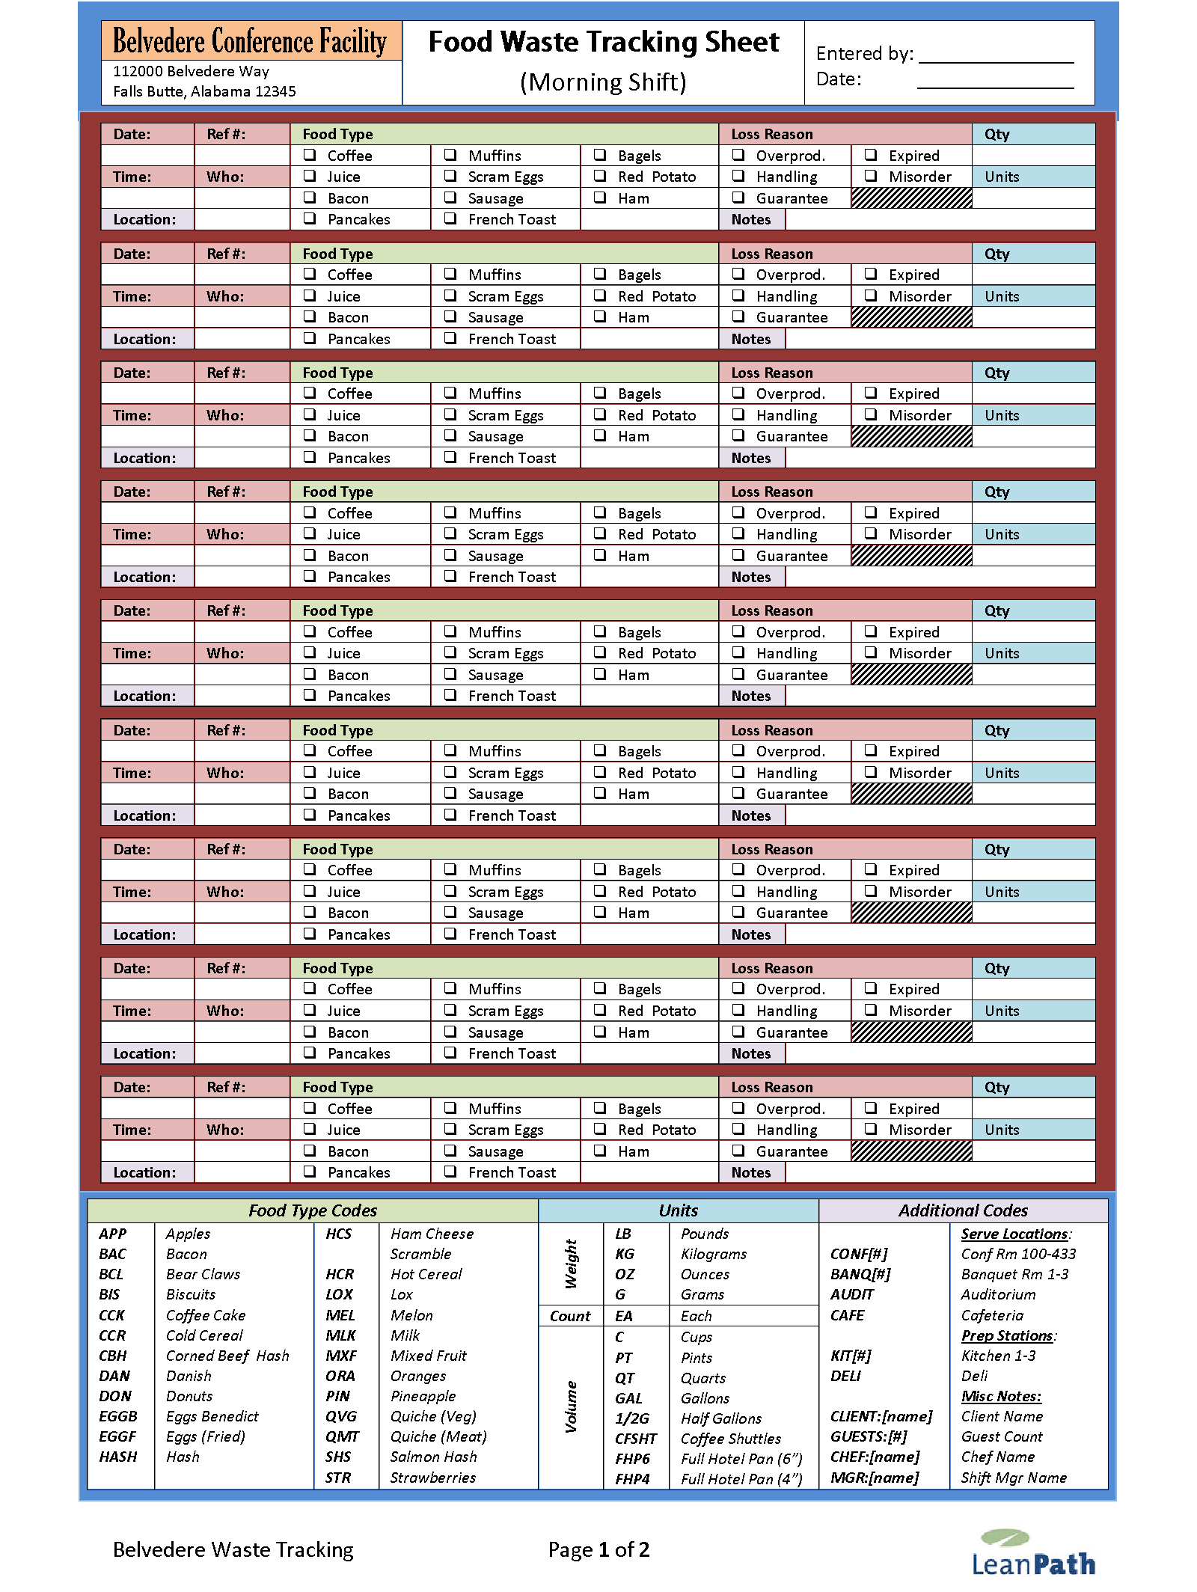

## “QuickCheck” Transaction Format Proto #2 (SAR, JH, DB, ARS)

Just the transaction portion:

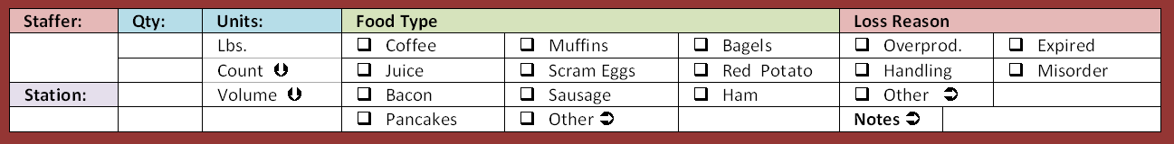

## “QuickCheck” Transaction Format Proto #3 (JH, ARS)

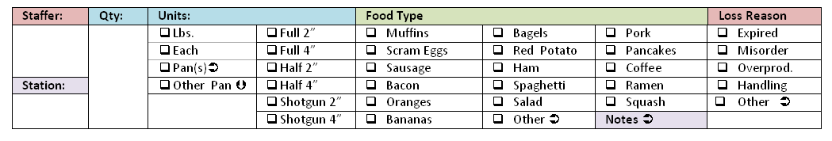

## Tabular Proto #2 (SAR)

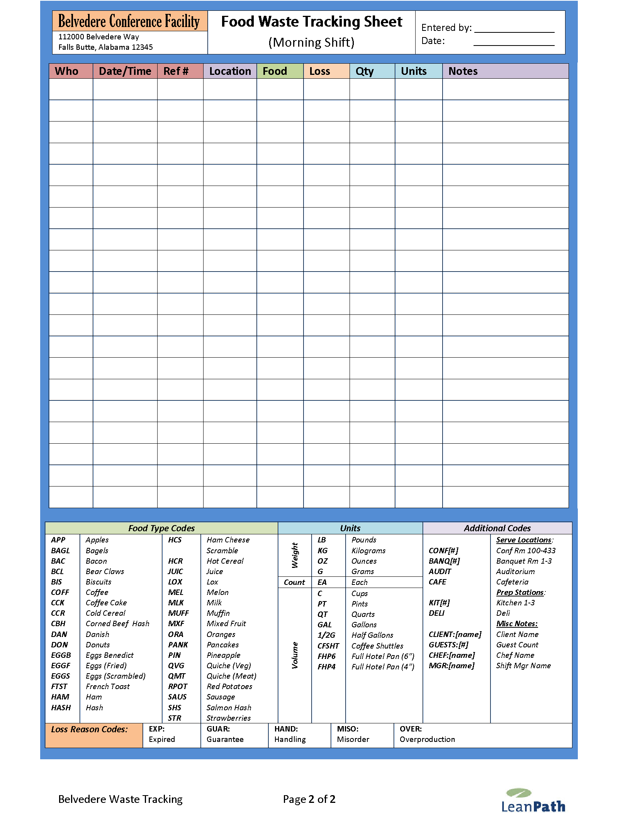

## “QuickCheck” Proto #3 (Jennifer and Dave response to SAR)

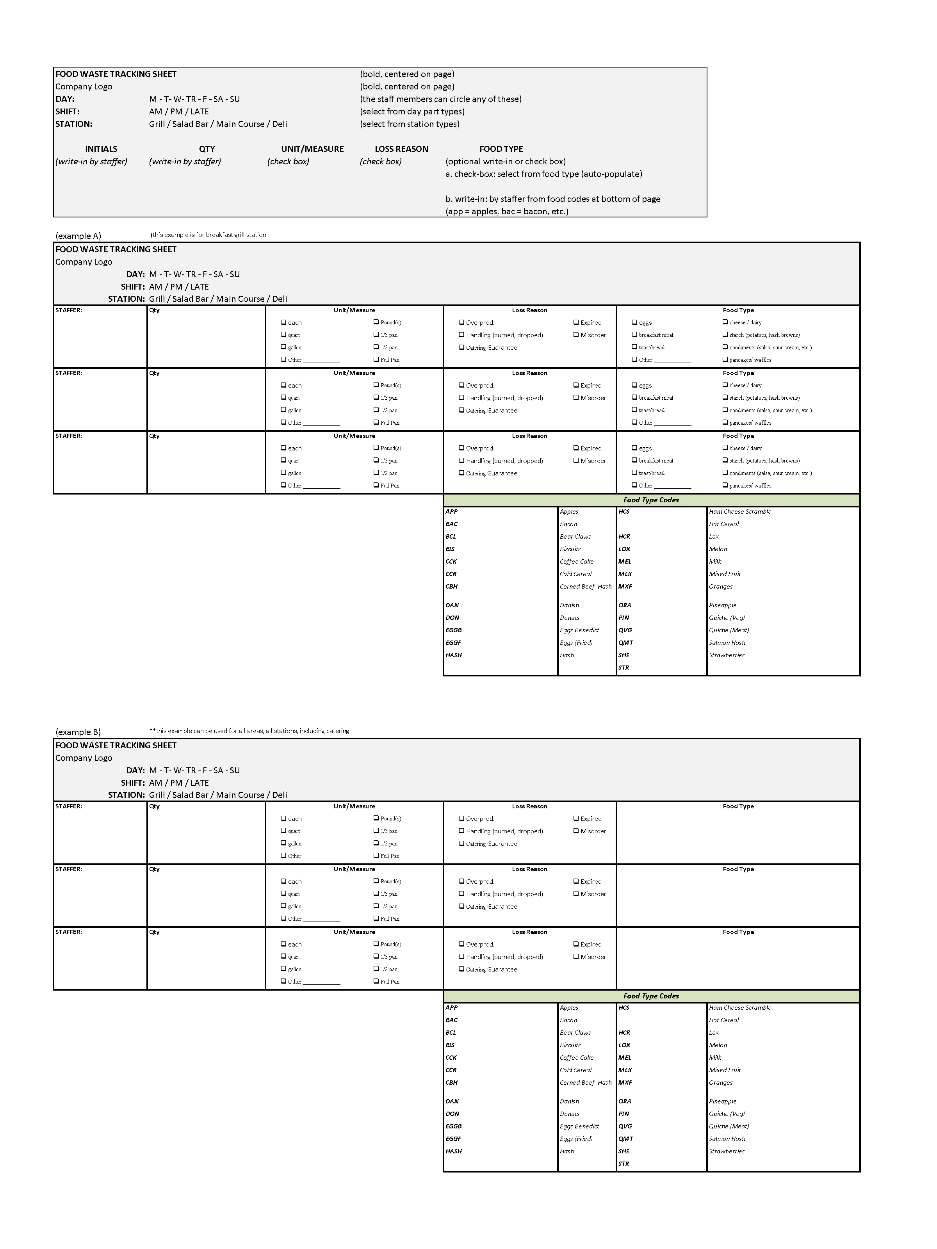

## Forms Header - Detail

# Product Management, Development Plan

## Plan Requirements

This table details out key issues and tasks that need to be incorporated into the WASTELOGGER plan.

| **Requirements** | **Level** | **Priority** | **Notes / Implications** |
| --- | --- | --- | --- |
| 1. **High Impact Product Marketing Decisions** | **Must Have** | **URGENT** |  |
| * 1. Licensing |  |  | WASTELOGGER will be licensed with an Initial License Fee and an ongoing support and usage fee. The license expires without payment. There is no perpetual license offered at this time, although we may consider it at some point if the market requires. |
| * 1. Versioning / structure |  |  | WASTELOGGER will be built atop the existing VWA 4 code base. We do not anticipate a separate code branch for WASTELOGGER. |
| * 1. User levels |  |  | * Administrators will have full access to everything. * Managers will have full access to those things within their license (i.e. if they have not paid for Automated Tracking they will not have access to it), including printing Log Sheets, Managing Log Sheets, and Entering Data. * Default Users will have access to printing Log Sheets and Entering waste data only. A potential issue: they will have access to all the reporting because that is allowed in the current VWA 4 at the default level. Should we offer a fourth, lower level that cuts out all functionality (reporting, dashboards, etc) and allows only printing Log Sheets and entering data? I am imaging that with all the manual data entry a lot more work and interaction with the application will get delegated to lower level people, who may come to the PC and treat it just like a time clock application or other information appliance. They will need minimal distraction and access only to those features they need. This might imply a window with only two tasks on the task bar and no dashboard (or make that optional to show the Dashboard to raise staff awareness at the same time they enter data). |
| * 1. Functional removal of segregated pieces. |  |  | Functionality will be removed from WASTELOGGER licenses in the following areas:   * WASTELOGGER should be an on/off feature in all licenses (i.e. full licenses of VWA will not necessarily inherit WASTELOGGER with their next upgrade) * Automated waste tracking will not be allowed in a basic WASTELOGGER License. If a customer wishes to acquire LeanPath hardware, we anticipate there will also be a software licensing buy-up to get the full ValuWaste Advantage platform. * Type count will be restricted. The initial expectation is type count will be limited to 20 food types and 10 loss types to start. This will be a primary driver of up-sell revenue in the WASTELOGGER market (pricing will not require drastically higher investment; incremental revenue generator) . We will need market testing experience to determine optimal price points. * Both of the items above (type limits and import waste data) can already be limited using the existing VWA License Generator. * Additional items that would be nice to control:   + # of UI Log Sheets allowed per license (highly desired, since this will map to the # of “sites” that can consolidated within a single license)   + # of Stored Reports allowed per License (lower priority) |
| * 1. No scale Tracker |  |  | At this time, we should not offer a tracker without a scale. It would provide much of the value of our core product and would not eliminate much of our manufacturing cost. Therefore, it would function (from a pricing perspective) more like a discount version of the Automated System than a souped-up version of the WASTELOGGER system. We should evaluate this in the context of pricing and options for the automated program more than WASTELOGGER. However, if the WASTELOGGER paper-to-digital process does not work as well as we wanted, this might be the desired interim solution. |
| 1. **Customer Feedback** | **Must Have** | **URGENT** | [Primary: Jennifer/DB] |
| * 1. Example Forms |  |  | Need initial validation of approach. There is a lot of investment in creating forms and they need to be right to begin with. Not easy to adjust depending on what kinds of adjustments are desired. |
| * 1. Example Cheat Sheets |  |  | Need initial validation of how extra codes that don’t fit in checkboxes will be hinted in cheat sheets. This is a big assumption for practicality in supporting larger populations of potential codes, and directly analogous to how codes are hinted in grocery stores and some restaurants. |
| * 1. Proposed Process |  |  | Go over full proposed process and get reactions. Process is also a difficult thing to change after committing to approach. |
| * 1. Example UI | Nice to Have |  | Not worth the effort to prototype this just for feedback since we can more easily make UI adjustments after implementing it. Forms and process are the driver of the UI anyway. |
| 1. **Collateral Impacts Assessment** | **Must Have** | **HIGH** | [Primary: SAR] |
| * 1. Need to assess Reporting system impacts |  |  | WASTELOGGER will create a variety of additions and changes to the VW reporting system, or possibly instantiate the creation of a new form specific printing system and library manager. These have to be carefully analyzed before implementing |
| * 1. Need to assess Database impacts |  |  | WASTELOGGER will likely impose a variety of additions and changes to the VW database. These have to be carefully analyzed before implementing |
| * 1. Need to assess configurator impacts |  |  | Some ideas being thrown around will likely force additions and changes to Delphi and ValuWaste Advantage 4.NET configurators. These have to be carefully analyzed before implementing |
| 1. **Meta-requirements** |  |  |  |
| * 1. Spanish language support | Not Needed | Low | * None |

# Appendix – First Use Feedback (Bon Appetit)

* Manager will delegate data entry.

Andrew’s Impressions 4/2/10 (from Review of Sissilee's First Batch of Sheets)

* Quantity and unit check box are concepts that can be merged.  We don't need a check box in one place for the container with the units elsewhere
* The large area for quantity attracts attention which is fine, but it may be unbalanced since it might excuse reading and paying sufficient attention to the units column
* Stations are being written in by hand with a lot of consistency.  This validates the MBR idea to carry the last selection forward to the next frame when entering the data in WASTELOGGER interface.  This is also true for "reason" - items seem to come in naturally grouped by "reasons."
* The overall number of transactions is low compared to what I might have expected
* There is a tendency for some users to group items, thinking that more than one food item can go in a single frame (e.g. flautas, rice, other Mexican station foods).
* On the above, they are also feeling they need to fill out something for each relevant box - how many of each of those items they have within a single frame.  If we took inspiration from this, we would radically alter our notion of a transaction from a series of frames to a single sheet with the staff required to enumerate how many of a given item for a given station for a given day.   The risk would be what happens when you have multiple items under a specific menu example.   That might be a case for more write-ins or greater use of tally's.
* Lots of extra items being added manually by hand.  Is this a problem?  No, as long as people can get to a picker pretty quickly in the WASTELOGGER interface to find things.  Maybe a search box that prompts with type names as you type (a la Google auto-complete)
* I do not see a lot of use for Short codes since people seem fine writing things down manually.  The short code may not help that much.
* Some staff feel the need to be complete.  For example, after checking "Starch" they write-in more detail "noodles."
* Rather than adding a levels concept, I recommend we train people to use fractions.  I have 1.5 pans of Lasagna, etc.
* Adding a concept of "Nothing" as a check box allows someone to return a sheet, show they tracked, but had nothing to enter.  We should create the concept of a zero transaction to record this participation.
* Did the conversation about tracking transfers get into the spec?  We had discussed how on Tracker every automated waste transfer gets logged and the same should be true here for each manual logging in order to track whether data is being input.   The question that rises is whether the "paper logging transaction" should be tied to the data entry session overall or to each sheet of the data entry process.
* Does Johnny have anything we can see to validate this is heading in the right direction?

## SAR Notes

* Loss Reason not getting used much
* Add more write-in room
* Switch loss reason & food type
* Nothing Logged indicator
* Transfer concept – transaction is a boxed entry; want transfers also (it was entered from…) during

# Appendix – Use Process Model 1 Design Notes

## Detailed Requirements Baseline (Use Process Model 1)

The following table consolidates prior discussions and emails into a technical requirements hierarchy.

|  |  |
| --- | --- |
| **Requirements** | **Notes / Implications** |
| 1. ValuWaste Advantage 4 tasks | Forms function are all within ValuWaste Advantage 4 Task infrastructure. |
| 1. Task: Print Waste Log Sheets | * Print form series (see below) and individual Log Sheets |
| * 1. Open series or individual Log Sheet by name/key |  |
| 1. Task: Input Waste Log Sheets | * Data Entry UIs for the Log Sheets (see below) |
| * 1. Open Log Sheet UI by name/key | * Consider whether current “Default User” security level works for data entry by a front-line worker. Should there be an even simpler version of the existing UI for data entry workers that shows only the input UI and not any of the other features? |
| * 1. Form UIs optimized for similar layout, ease of data entry relative to the specific form they correspond to. | * Save multiple transactions at a time (page level saving rather than transaction level saving). |
| * 1. Form UIs use ValuWaste Advantage 4 type libraries to speed input | * Pickers from type library and/or Tracker definition |
| 1. Task: Manage Waste Log Sheets | * Configuration UI for setting up form instances and series and saving them under names. * Can this be accessed as a sub-task from #2 above Task: Print Waste Log Sheets. An anticipated use case would be a situation where a user wishes to print a log sheet, sees the need for a change, wants to clone or amend an existing sheet and then save it. Ideally these features could be accesses from within the Print Task UI |
| * 1. Design/edit waste form and save | * Generates both a print and input instance, saved under that name / key. |
| * 1. Create waste series | * Link together forms in a series, for printing as a group |
| 1. Waste Forms Meta-Requirements |  |
| * 1. Use headers to drive defaults that apply to entire pages | * Both print and UIs |
| 1. Small number of customizable base forms |  |
| * 1. “Customize” means property sheets are filled in to control optional appearance and behavior choices. | * Each filled in property sheet defines a new form instance, which can be saved for later re-use (see below) |
| * 1. Base forms refers to layout options that require a separate ActiveReport form design to accommodate the layout variation. |  |
| 1. Customized forms are saved as named instances |  |
| * 1. Like ValuWaste Advantage 4 reports | * Hierarchical storage in folder/categories. |
| 1. Ability to print forms individually or as part of series |  |
| * 1. Like ValuWaste Advantage 4 reports | * Separate “Print Forms Collection” task |
| * 1. Auto-date forms | * For a date range e.g. one form page per day |
| 1. Customizable headers/footers |  |
| * 1. Data that applies to all the transactions on a form | * Date * Type dimensions (food, loss, station, daypart, EO, pre v. post, disposition) * Names of staff * Optional data, notes, instructions |
| * 1. Selective ability to hide/show parts | * Driven by property sheets |
| * 1. Unique key of the form instance | * To match up with data entry UI |
| 1. Transaction frames | Lower density design. |
| * 1. Repeated identical multi-row sections that define a single complete transaction | * All data needed to enter a single transaction * Takes advantage of default inheritance |
| * 1. Default inheritance | * Defaults cascade from above, starting with header. * Immediately prior transactions can be used as defaults also, although nothing will be recorded unless there is unit data added for the transaction. |
| 1. Transaction tables | Higher density design. |
| * 1. Repeated identical single-row transactions in table format | * All data needed to enter a single transaction in a single row * Takes advantage of default inheritance |
| * 1. Default inheritance | * Defaults cascade from above, starting with header. * Immediately prior transactions can be used as defaults also |
| 1. Quantities and Units |  |
| * 1. Take full advantage of the ValuWaste Advantage 4 data entry modalities | * Volume by explicit amount or container type capacity * Weight explicit * Count by item type (This is a significant topic that remains open. Our current system does not address the notion of Each other than via the concept of volumes, which sometimes works and sometimes doesn’t if we don’t have that data.) |
| * 1. Volume entry notes | * Allow user to directly enter container volumes during data entry if they are not available |
| * 1. Weight entry notes | * Allow user to directly enter food weights per item during data entry if they are not available * This is a new database field, so needs to be analyzed in larger context |

# Post-NRA

| **Requirements** | **Level** | **Notes / Implications** |
| --- | --- | --- |
| 1. **All sessions are new sessions** | **Must Have** |  |
| * 1. Don’t encourage them to use sessions as an organizing principle. |  | New session is the default.  Ability to open prior session.  Streamline. |
|  |  |  |
| 1. **Sites** | **Must Have** |  |
| * 1. Pick a Tracker to go into the new session. |  | Tracker => “List” |
|  |  |  |
| 1. **WasteLogger has a task bar** | **Must Have** |  |
| * 1. Different look and feel for task bar |  |  |
|  |  |  |
| 1. **Configuration interface** | **Must Have** |  |
| * 1. Customer Service does the configuration. |  | Walled off |
|  |  |  |
| 1. **Color coding of entry** | **Must Have** |  |
|  |  |  |
|  |  |  |
| 1. **Transactions within a session** | **Must Have** |  |
| * 1. Default timestamp – from Previous; also want to just have the date (not time) |  |  |
| * 1. Default timestamp mode |  |  |
|  | **Must Have** |  |
|  |  |  |
|  |  |  |
|  | **Must Have** |  |
|  |  |  |
|  |  |  |
|  | **Must Have** |  |
|  |  |  |
|  |  |  |
|  | **Must Have** |  |
|  |  |  |
|  |  |  |
|  | **Must Have** |  |
|  |  |  |
|  |  |  |

## Open items

1. Better to name organize session concept for reporting purposes and for reopening prior transactions.
2. How to update the reports so that they handle Tracker vs. “List”. (low priority)
   1. In general, wall off the configuration interface.

|  |  |  |  |  |  |
| --- | --- | --- | --- | --- | --- |
|  | Menu Bar | Footer | Header | Taskbar |  |
| Advanced Menu | Show/Hide |  |  |  |  |
| Shortcuts |  | Show/Hide |  | Configurable |  |
| Settings |  | Show/Hide |  | Configurable |  |
| Current Database |  | Show/Hide |  |  |  |
| Current User |  | Show/Hide |  |  |  |
| LeanPath logo |  | Show/Hide |  |  |  |
| ValuWaste logo |  |  | Show/Hide |  |  |
| WasteLogger logo |  |  | Show/Hide |  |  |
| Add New Report |  | Show/Hide  (Settings) |  |  |  |
| Compress Archive Dir | Show/Hide |  |  |  |  |
| Print Task Pane | ? |  | Show/Hide |  |  |
|  |  |  |  |  |  |