Kevin Lin
DAT402
Project 2
12/05/2025

Predictive Determinants of the Human Development Index
For Project 2 of this course, our goal is to determine what the predictive determinants of the Human Development Index (HDI) are and if any leading indicators influence this metric. I utilized data from Kaggle, called Human Development World Index in order to explore which factors could affect HDI. The variables I chose are as follows: Adolescent Birth Rate – Births per 1000 Women Ages 15 to 19, Carbon Dioxide Emissions per Capita Production in Tonnes, Coefficient of Human Inequality, Expected Years of Schooling, Gender Development Index (GDI), Gender Inequality Index (GII), Gross National Income Per Capita, Human Development Index, Inequality Adjusted Human Development Index, Life Expectancy at Birth, Maternal Mortality Ratio – Deaths per 100000 Live Births, Mean Years of Schooling and Planetary Pressures Adjusted Human Development Index for the years 2000 to 2024.
For data cleaning, I first melted all the columns into long format and then extracted the year from the variables and converted them from string to int. This allows me to perform the next steps properly. Next, I created a list of variables listed above I wanted to analyze and dropped the rest. Then, I filtered out my data frame by year inclusive of 2000 and above. I then created a mapping for the variable names to shorten them for readability and accessibility. I dropped all rows with missing HDI so I could properly conduct my analysis as HDI is the dependent variable for this project. Finally, I created a continent map for all of the countries so I could run analysis based on region in order to have more readable trend analysis. Luckily, the data was rather clean for the year range I wanted to examine closely so I did not have to clean the data as much.
For the first analysis, I decided to create a general correlation map of HDI vs indicators to have a general direction of which variables to focus more on due to the vast number of variables in this data set. This would allow me to compare and contrast in more detail by countries and year since I had an idea of what to actually explore. While looking at the correlation map of all the indicators, almost every variable has a significant positive or negative correlation to HDI. For Adolescent Birth Rate, it had a negative correlation at -0.81, CO2 Emissions per Capita at 0.57, Coefficient of HI at -0.89, Expected Years of Schooling at 0.91, GDI at 0.70, GII at -0.89, GNI per Capita at 0.75, Life Expectancy at Birth at 0.91, Maternal Mortality Ratio per 10,000 Live Births at -0.80 and finally, Mean Years of Schooling at 0.90. Outside of CO2 Emissions per Capita, every other correlation had a value of +/- 0.70 or higher and I would consider that significant positive/negative correlation. The positive correlations in order are Life Expectancy at Birth, Expected Years of Schooling, Mean Years of Schooling, GNI per Capita and GDI. The negative correlations in order are Coefficient of HI, GII, Adolescent Birth Rate and Maternal Mortality Ratio per 10,000 Live Births.
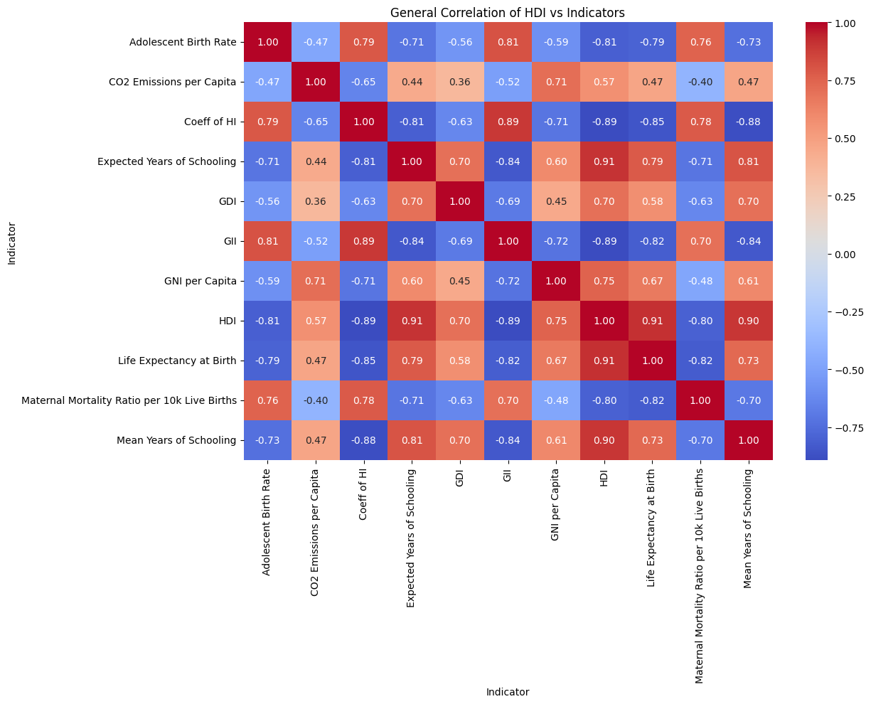
The positive correlations in order are Life Expectancy at Birth, Expected Years of Schooling, Mean Years of Schooling, GNI per Capita, GDI and CO2 Emissions per Capita. The negative correlations in order are Coefficient of HI, GNI and Adolescent Birth Rate, and Maternal Mortality Ratio per 10,000 Live Births. These correlations tell us that education is of utmost importance as it predicts higher HDI whereas higher GII predicts lower HDI and highlights why inequality is crucial to understand. The Coefficient of HI, as defined by the United Nations Development Program is a formula of an unweighted average of inequality in health, education and income when it comes to opportunities and achievements. A higher number of these variables is bad as it represents the overall human inequality of the population.
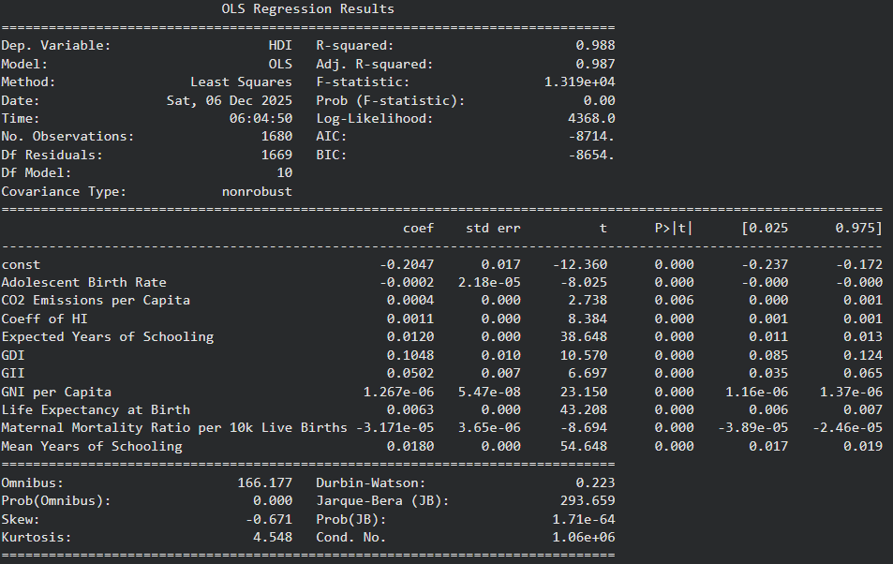
Above is my regression analysis on all the indicators I have selected. Almost all of my p-values are 0.000, with CO2 Emissions per Capita at 0.006 which means that each variable I selected contributed significantly to predicting HDI. With an R-squared value of 0.988, 98.8% of the variability of the dependent variable, HDI, is explained by the independent variables within the regression model. Furthermore, Mean Years of Schooling has the highest coefficient of 0.018, which is the strongest positive predictor of HDI.
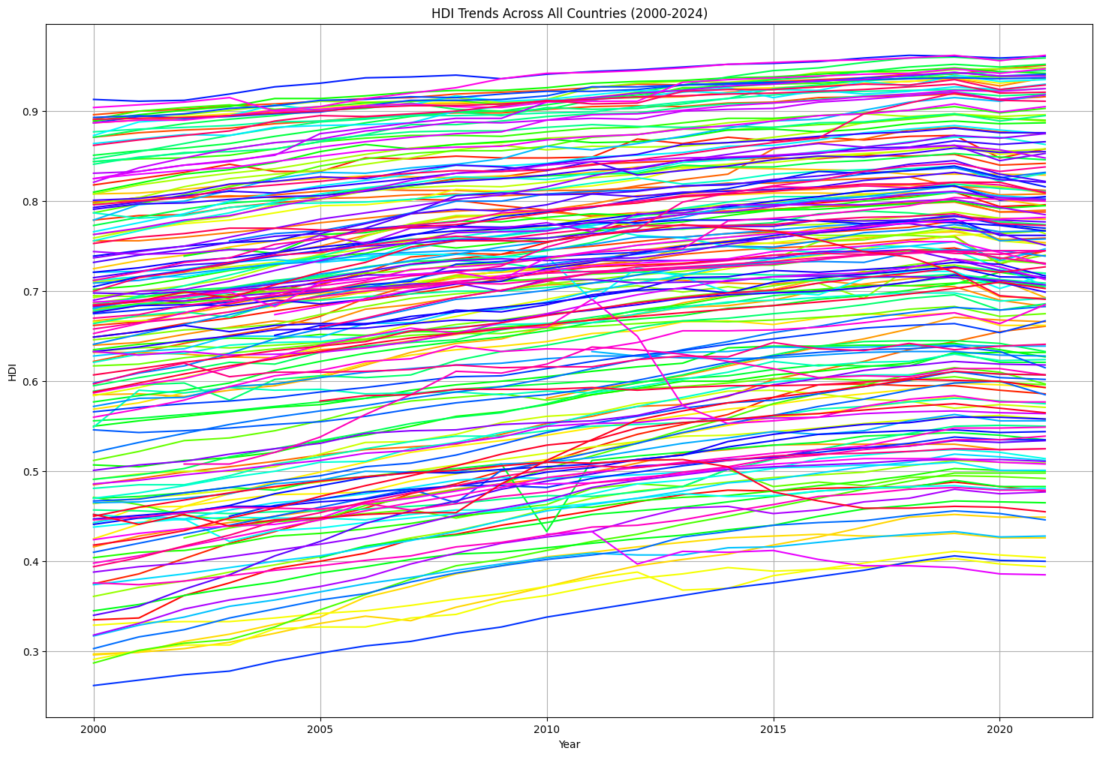
I decided to look at the overall trend of HDI across the selected years, but as one would expect, it is quite messy due to the large number of countries within the data set. However, you can see a pattern of an upward trend of HDI over time. I decided to map all the various countries to their respective continents, and this will be easier to digest.
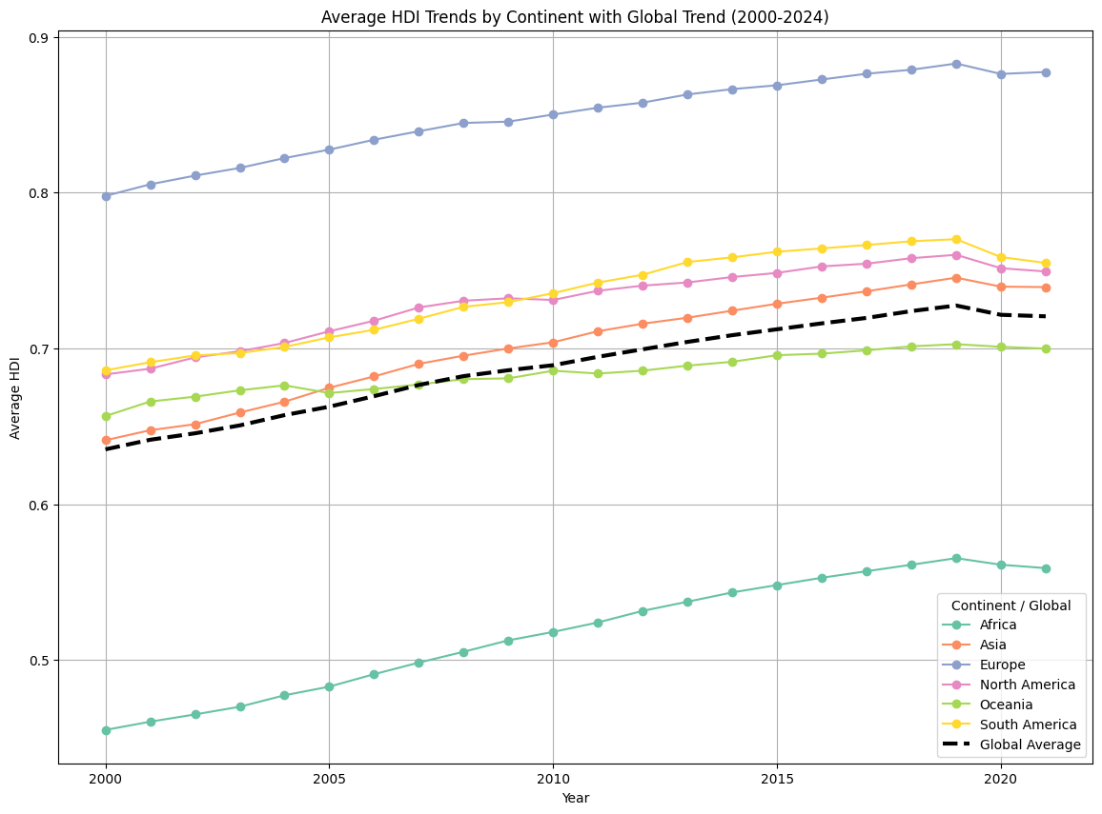
Looking at this graph, it is much clearer to us of how HDI changed over time and in addition I have also included a global average just to see the overall trend for all of humanity. This information shows us a rising trend in HDI globally until a large dip in 2020 and it would most certainly be associated with COVID-19, a worldwide pandemic. Forced closures of schools, drops in life expectancy and loss of jobs would greatly contribute to the drop of HDI as those are its three core values.
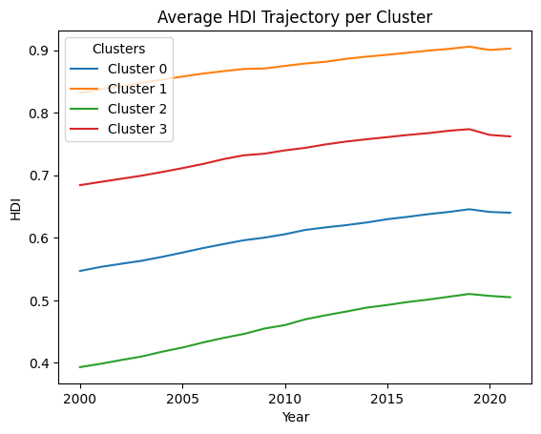
This figure above shows an analysis of kmeans clustering with 4 clusters. This would group similarly trending HDI countries together into different brackets of overall HDI. While the slopes of these country clusters show similar growth rates, only the first cluster shows a rebound in HDI growth pos-COVID-19. Cluster 1 stood out and it includes countries like United States, United Kingdom, United Arab Emirate, Canada, Denmark, Germany, South Korea, Japan, Singapore, etc.
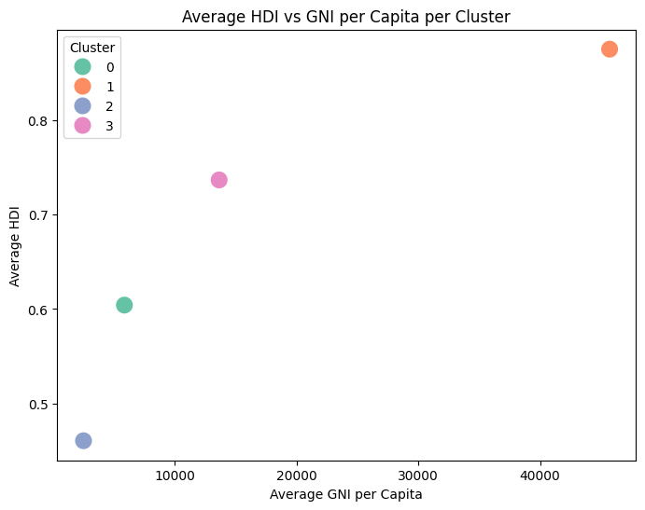
If I compare HDI vs GNI per Capita, It is easy to see that these countries in cluster 1 is more than double the average GNI per Capita which solely puts them into the most developed countries category. A very strong correlation can be made between average GNI per Capita and HDI, which makes a lot of sense as higher incomes generally means a higher quality of life.
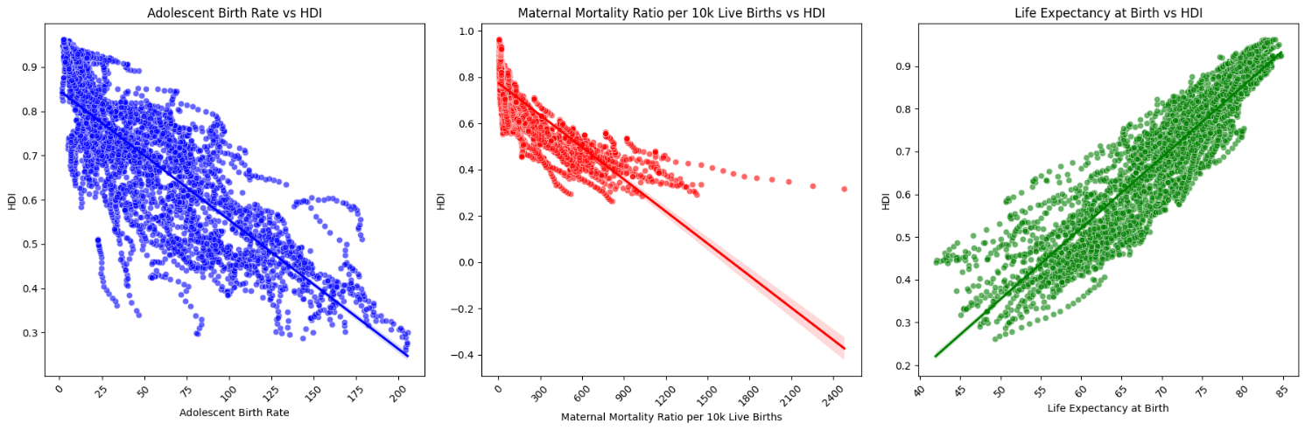
I also decided to compare all the birth/death rate and life expectancy factors to see how they compare vs HDI and plotted an average trend line so see its correlation. Higher birth rates among younger women ages 15 – 19 shows a detailed negative correlation vs HDI as well as maternal mortality ratio per 10,000 live births. On the contrary, a higher life expectancy at birth has a largely positive correlation vs HDI. This graph on top of the general correlation figure in the beginning shows that I have picked out strong predictive determinants of HDI.
In conclusion, the strongest positive predictors of HDI include factors such as longer life expectancy, more years of schooling, lower maternal mortality ratio and lower adolescent birth rates. Income and gender inequality/development also shows signs of influence but not as strongly.

