Homework 7

Table 1: Response Time of GPIO Speeds

File Type | Mean | Min | Max | CPU Usage
MMAP | 410.49ns | 220ns | 4.30ns | ~90%
Kernel | 352.11us | 285us | 535us | ~2%
Python | 907.65us | 850us | 1.75ms | ~40%

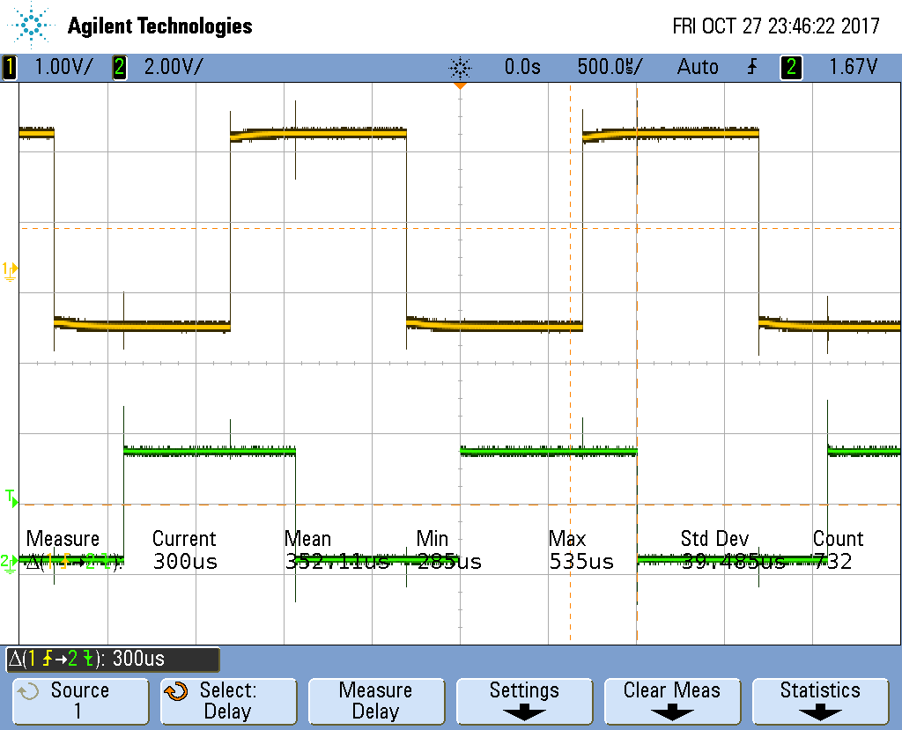

Figure 1: Oscilloscope Screenshot of Kernel

By looking at the results from the oscilloscope measurements, it is easy to tell that the Python has the slowest GPIO response time by a large margin. Kernel came in second, being about 40% the time of Python. MMAP was the quickest by a large margin. However, this comes at a price because MMAP ended up using around 90% of the CPU, while the other two were significantly lower with the Kernel almost taking up none of the CPU.

