JOE STREET STREET FIZZ
Mocktail-inspired fruit sodas with layered flavours, sparkling fizz, and chewy sinkers.

Section | Drink | Description | Price
SUNSET SERIES | Strawberry Sunset | Strawberry and citrus layered with sparkling fizz. Sweet, bright, and refreshing. | ₱89 / ₱99
SUNSET SERIES | Mango Sunset | Mango and passion-style brightness layered into a tropical sparkling drink. | ₱89 / ₱99
SUNSET SERIES | Berry Sunset | Blueberry and lychee layered for a rich yet refreshing sparkling blend. | ₱89 / ₱99
FRESH & LIGHT | Cucumber Breeze | Cucumber with a clean sparkling finish. Cool, crisp, and easy to enjoy. | ₱89 / ₱99
FRESH & LIGHT | Lychee Fizz | Lychee with a clean sparkling finish. Light, floral, and smooth. | ₱89 / ₱99
FRESH & LIGHT | Guava Spritz | Guava with a gentle sparkling lift. Smooth, fruity, and easy to enjoy. | ₱89 / ₱99

Seasonal Specials: Calamansi and Passion Fruit may be offered separately when available.

STREET FIZZ STANDARD RULES
STANDARD FIZZ RULE  • Use 7-Up / lime soda for all standard Street Fizz drinks.  • Reduce syrups because 7-Up already adds sweetness.  • Keep drinks refreshing, not syrup-heavy.  • Make drinks only when ordered and serve immediately. | MIXED ICE RULE  • Fill cup only 80 to 85% with ice, not overly packed.  • Use solid ice maker ice first.  • Use crushed ice only to fill gaps.  • Crushed ice melts faster, so keep flavour controlled but not weak.
SUNSET SERIES RULE  • Keep the bottom layer darker and heavier.  • Pour Tang mix and 7-Up slowly over ice.  • Do not fully stir.  • Serve layered for the sunset effect. | FRESH & LIGHT RULE  • Use lighter syrup portions.  • Stir lightly only.  • Drink should look clean and sparkling.  • Do not add fruit or herbs unless approved for operations.
STANDARD COMPONENTS
Nata  • 12oz: 1 tbsp  • 16oz: 2 tbsp  • Use for all standard Street Fizz drinks. | Jam / Walling  • 12oz: 2 tbsp  • 16oz: 4 tbsp  • Use only for Sunset drinks. Partial walling only. | Tang Mix  • Keep very light.  • Use only for Sunset top layer.  • It should support colour, not become juice.

Strawberry Sunset — ₱89 / ₱99
SUNSET SERIES • 12oz and 16oz cups
Strawberry and citrus layered with sparkling fizz. Sweet, bright, and refreshing.
Ingredients - 12oz  • 2 tbsp strawberry syrup  • 1 tbsp strawberry jam  • 1 tbsp nata  • 1 tbsp popping boba  • Light pomelo Tang mix  • 80 to 85% cup ice  • Top with 7-Up / lime soda  Ingredients - 16oz  • 2 tbsp strawberry syrup  • 4 tbsp strawberry jam  • 2 tbsp nata  • 1 tbsp popping boba  • Light pomelo Tang mix  • 80 to 85% cup ice  • Top with 7-Up / lime soda  Build  1. Add strawberry syrup and strawberry jam to the cup.  2. Add nata and popping boba  3. Fill cup 80 to 85% with ice, solid ice first and crushed ice to fill gaps.  4. Pour light pomelo Tang mix slowly over the ice.  6. Top gently with 7-Up / lime soda.  7. Do not fully mix. Serve layered.  Staff Note: Keep the pomelo mix light. The drink should look layered, not cloudy. | Visual Build  Layer/serving guide for staff  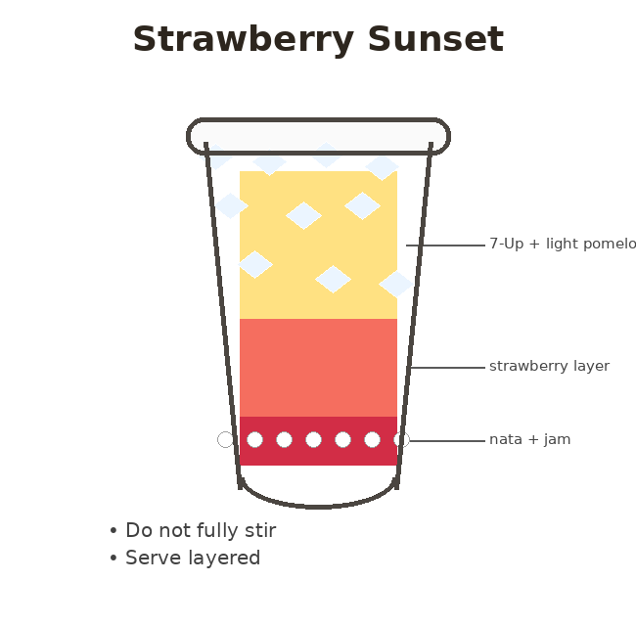  Visual Goal  • Deep strawberry red bottom  • Orange-peach middle  • Light sparkling top  • Nata visible at bottom

Mango Sunset — ₱89 / ₱99
SUNSET SERIES • 12oz and 16oz cups
Mango and passion-style brightness layered into a tropical sparkling drink.
Ingredients - 12oz  • 30ml mango syrup  • 1 tbsp mango jam  • 1 tbsp nata  • 1 tbsp popping boba  • Light mixed berries Tang mix  • 80 to 85% cup ice  • Top with 7-Up / lime soda  Ingredients - 16oz  • 40ml mango syrup  • 2 tbsp mango jam  • 2 tbsp nata  • 1 tbsp popping boba  • Light mixed berries Tang mix  • 80 to 85% cup ice  • Top with 7-Up / lime soda  Build  1. Add mango syrup and mango jam to the cup.  2. Add nata and popping boba.  3. Fill cup 80 to 85% with ice, solid ice first and crushed ice to fill gaps.  4. Pour light mixed berries Tang mix slowly over the ice.  5. Top gently with 7-Up / lime soda.  6. Do not fully mix. Serve layered.  Staff Note: Mango should remain the main taste. Keep the Tang mix light so it does not become juice-like. | Visual Build  Layer/serving guide for staff  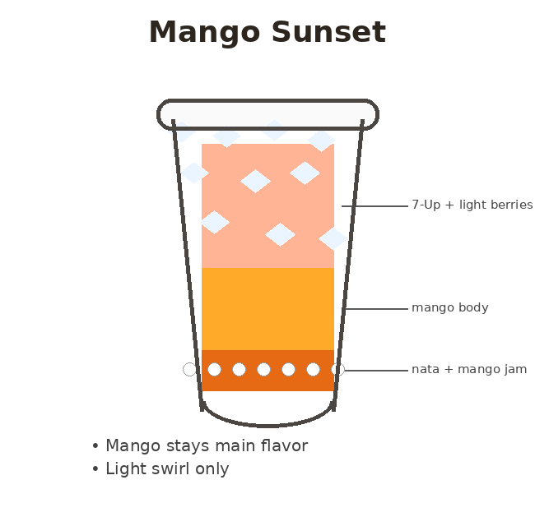  Visual Goal  • Golden mango bottom  • Soft pink/orange top  • Tropical sunset look  • Nata visible at bottom
Berry Sunset — ₱89 / ₱99
SUNSET SERIES • 12oz and 16oz cups
Blueberry and lychee layered for a rich yet refreshing sparkling blend.
Ingredients - 12oz  • 1 tbsp blueberry syrup  • 2 tbsp blueberry jam  • 1 tbsp nata  • 1 tbsp popping boba  • Light lychee Tang mix  • 80 to 85% cup ice  • Top with 7-Up / lime soda  Ingredients - 16oz  • 1 tbsp blueberry syrup  • 4 tbsp blueberry jam  • 2 tbsp nata  • 2 tbsp popping boba  • Light lychee Tang mix  • 80 to 85% cup ice  • Top with 7-Up / lime soda  Build  1. Add blueberry syrup and blueberry jam to the cup.  2. Add nata and popping boba  3. Fill cup 80 to 85% with ice, solid ice first and crushed ice to fill gaps.  4. Pour light lychee Tang mix slowly over the ice.  5. Top gently with 7-Up / lime soda.  6. Do not fully mix. Serve layered.  Staff Note: Keep lychee light. Berry should show as the deeper bottom layer. | Visual Build  Layer/serving guide for staff  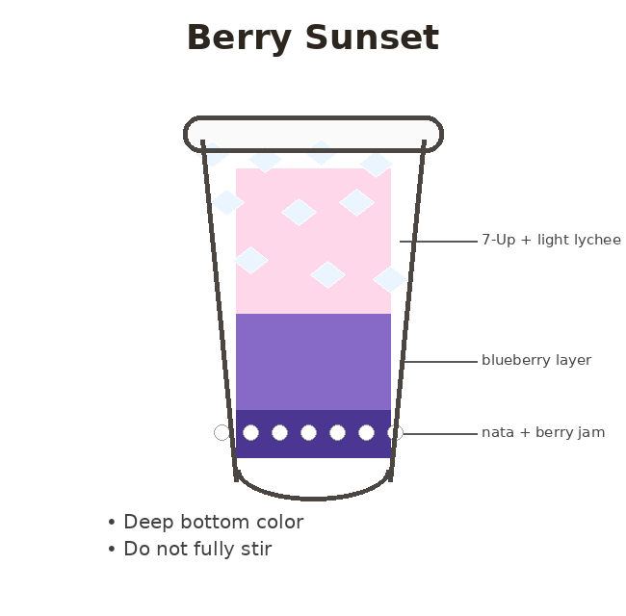  Visual Goal  • Deep purple-blue bottom  • Soft lychee-pink top  • Clean gradient  • Nata visible at bottom

Cucumber Breeze — ₱89 / ₱99
FRESH & LIGHT • 12oz and 16oz cups
Cucumber with a clean sparkling finish. Cool, crisp, and easy to enjoy.
Ingredients - 12oz  • 20ml cucumber syrup  • 1 tbsp nata  • 1 tbsp popping boba  • 80 to 85% cup ice  • Top with 7-Up / lime soda  Ingredients - 16oz  • 30ml cucumber syrup  • 2 tbsp nata  • 2 tbsp popping boba  • 80 to 85% cup ice  • Top with 7-Up / lime soda  Build  1. Add cucumber syrup to the cup.  2. Add nata and popping boba  3. Fill cup 80 to 85% with ice, solid ice first and crushed ice to fill gaps.  4. Top gently with 7-Up / lime soda.  5. Stir lightly only.  6. Serve immediately.  Staff Note: Use reduced syrup because 7-Up already adds sweetness. Optional: add a very small calamansi splash only if needed. | Visual Build  Layer/serving guide for staff  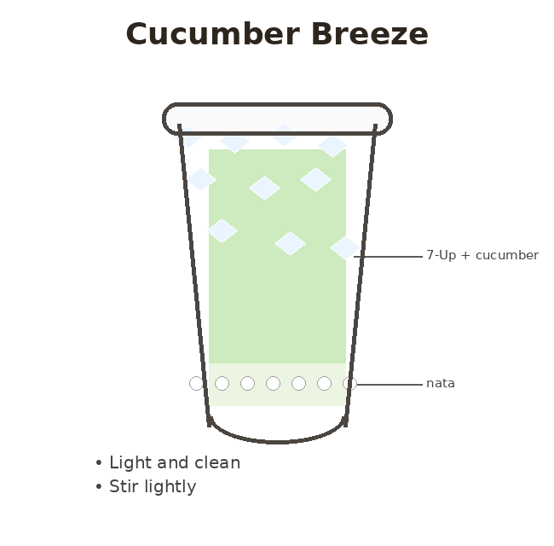  Visual Goal  • Soft pale green tone  • Clean sparkling look  • Nata visible at bottom

Lychee Fizz — ₱89 / ₱99
FRESH & LIGHT • 12oz and 16oz cups
Lychee with a clean sparkling finish. Light, floral, and smooth.
Ingredients - 12oz  • 20 ml lychee syrup  • 1 tbsp nata  • 1 tbsp popping boba  • 80 to 85% cup ice  • Top with 7-Up / lime soda  Ingredients - 16oz  • 30ml lychee syrup  • 2 tbsp nata  • 2 tbsp popping boba  • 80 to 85% cup ice  • Top with 7-Up / lime soda  Build  1. Add lychee syrup to the cup.  2. Add nata and popping boba.  3. Fill cup 80 to 85% with ice, solid ice first and crushed ice to fill gaps.  4. Top gently with 7-Up / lime soda.  5. Stir lightly only.  6. Serve immediately.  Staff Note: Lychee should taste light and floral, not candy-sweet. | Visual Build  Layer/serving guide for staff  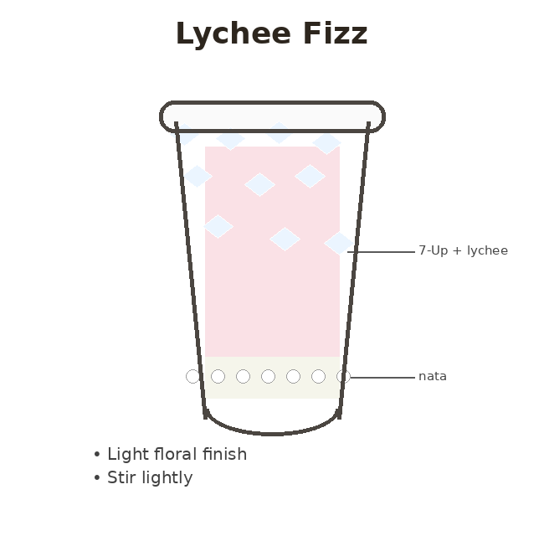  Visual Goal  • Nearly clear or light blush tone  • Clean sparkling look  • Nata visible at bottom

Guava Spritz — ₱89 / ₱99
FRESH & LIGHT • 12oz and 16oz cups
Guava with a gentle sparkling lift. Smooth, fruity, and easy to enjoy.
Ingredients - 12oz  • 20ml guava syrup  • 1 tbsp nata  • 1 tbsp popping boba  • 80 to 85% cup ice  • Top with 7-Up / lime soda  Ingredients - 16oz  • 30ml guava syrup  • 2 tbsp nata  • 2 tbsp popping boba  • 80 to 85% cup ice  • Top with 7-Up / lime soda  Build  1. Add guava syrup to the cup.  2. Add nata and popping boba  3. Fill cup 80 to 85% with ice, solid ice first and crushed ice to fill gaps.  4. Top gently with 7-Up / lime soda.  5. Stir lightly only.  6. Serve immediately.  Staff Note: Guava should feel smooth and fruity. Avoid making it syrup-heavy. | Visual Build  Layer/serving guide for staff  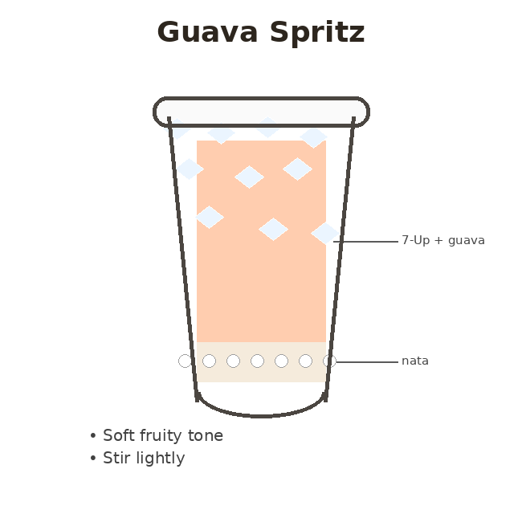  Visual Goal  • Soft pink-peach tone  • Clean sparkling look  • Nata visible at bottom

QUICK STAFF CHEAT SHEET
SUNSET DRINKS  • Syrup + jam + nata + popping boba at bottom  • Ice 80 to 85%  • Light Tang mix  • Top with 7-Up slowly  • Do not fully mix | FRESH & LIGHT DRINKS  • Syrup + nata + popping boba  • Ice 80 to 85%  • Top with 7-Up slowly  • Light stir only  • Serve immediately

Joe Street Cafe | Street Fizz Visual Staff Build Guide

