INFLUENCE OF MICROLEARNING THROUGH SOCIAL MEDIA ON STUDENTS' LEARNING BEHAVIOUR

Project submitted to MUST in partial fulfilment of the requirements for the award of the degree of
MASTER OF BUSINESS ADMINISTRATION (FINANCE)

Submitted by
PRAHADHESVARYAA K S
Register No: OSI2509093

ISSM Business School,
Chennai.

JUNE 2026

CERTIFICATE

This is to certify that the project “INFLUENCE OF MICROLEARNING THROUGH SOCIAL MEDIA ON STUDENTS' LEARNING BEHAVIOUR” is a record of research work done by PRAHADHESVARYAA K S (Register No: OSI2509093) during the Academic Year 2025–2026 at ISSM Business School, Chennai, Tamil Nadu, India. This project has not previously formed the basis for the award of any Degree, Diploma, Associate-ship, Fellowship or any other similar title to anyone, and the project represents entirely an independent work on the part of the candidate.

Project Guide

Principal
ISSM Business School

DECLARATION

I, PRAHADHESVARYAA K S (Register No: OSI2509093), hereby declare that the project “INFLUENCE OF MICROLEARNING THROUGH SOCIAL MEDIA ON STUDENTS' LEARNING BEHAVIOUR” is a bonafide record of research work done by me and is based on primary data collected through a structured questionnaire. I further declare that this work has not previously formed the basis for the award of any degree, diploma, associate-ship or other similar title.

Place: Chennai
Date: 30-06-2026

Signature of the Student
PRAHADHESVARYAA K S

ACKNOWLEDGEMENT

I would like to express my sincere gratitude to all those who have supported and guided me throughout the course of this project. The successful completion of this project would not have been possible without their encouragement, valuable insights, and continuous assistance.
I express my sincere thanks to ISSM Business School for the valuable guidance, encouragement, and support extended throughout this study. I am thankful to the Programme Co-ordinator and the faculty members for their constant motivation and guidance in completing this project.
I also thank the 150 respondents who spared their valuable time to complete the questionnaire, without whom this study would not have been possible. Finally, I am grateful to my family and friends for their continuous support and encouragement.

ABSTRACT

The rapid growth of social media has transformed the way students access information and learn. Microlearning – the delivery of knowledge through short, focused pieces of content such as reels, short videos, infographics, and posts – has become increasingly popular on platforms like Instagram, YouTube, and similar networks. This study examines the influence of microlearning through social media on the learning behaviour of students. Primary data were collected from 150 respondents through a structured questionnaire measured on a five-point Likert scale. The data were analysed using simple percentage analysis and the chi-square test of independence. The results indicate that respondents report high levels of usage and engagement with educational content on social media and a positive perception of its effectiveness, while perceiving comparatively few challenges. The chi-square test found no statistically significant association between the frequency of using social media to learn and the overall perceived effectiveness of microlearning. The study concludes that microlearning through social media is widely used and positively perceived as a convenient, engaging, and time-saving mode of learning, though concerns about depth and accuracy of content remain. Recommendations for improving microlearning practices are offered.

Keywords: microlearning, social media, learning behaviour, student engagement, educational content, digital learning.

TABLE OF CONTENT

CHAPTER NO. | CHAPTER | PAGE NO
I | INTRODUCTION | 1 - 8
II | REVIEW OF LITERATURE | 9 - 13
III | RESEARCH METHODOLOGY | 14 - 17
IV | DATA ANALYSIS & INTERPRETATION | 18 - 47
V | FINDINGS, SUGGESTIONS & CONCLUSION | 48 - 51
 | REFERENCES | 52 - 53
 | ANNEXURE | 54 - 56

CHAPTER – I
INTRODUCTION

CHAPTER – I

INTRODUCTION

1.1 Background of the Study
The way people learn has changed dramatically over the past decade. The widespread use of smartphones and high-speed internet, combined with the explosive growth of social media platforms such as Instagram, YouTube, TikTok, and X, has created an environment in which learning is no longer confined to classrooms and textbooks. Increasingly, students turn to short, engaging pieces of digital content to acquire new knowledge and skills. This shift has given rise to the concept of microlearning – the delivery of information in small, focused, easily digestible units that can be consumed in a few minutes.
Microlearning through social media takes the form of short educational videos, reels, infographics, carousel posts, quizzes, and explanatory threads. A concept that once required reading long chapters or attending lengthy lectures can now be understood through a 60-second video. This convenience and accessibility have important consequences for how students engage with information, how motivated they feel to learn, and how well they retain and apply what they learn.

1.2 Concept of Microlearning and Social Media
Microlearning refers to a learning approach in which content is broken down into short, self-contained segments that focus on a single idea or skill. When delivered through social media, microlearning benefits from features that traditional learning materials lack: on-demand access, multimedia formats, interactivity through likes, comments, polls and quizzes, and the ability to share content instantly. Social media platforms act as informal learning networks where educational creators, institutions, and peers distribute knowledge to large audiences at little or no cost.

1.3 Learning Behaviour
Learning behaviour refers to the patterns, habits, and attitudes that govern how individuals acquire, process, retain, and apply knowledge. It is shaped by factors such as motivation, engagement, the format of content, ease of access, and the perceived usefulness of the learning experience. Microlearning through social media can influence learning behaviour in two directions: it may enhance interest, motivation, and flexibility, while at the same time introducing challenges such as distraction, shallow understanding, and difficulty in judging the accuracy of content.

1.4 Statement of the Problem
While microlearning through social media has clearly increased the convenience and appeal of learning, its actual influence on students' learning behaviour is not fully understood. There is a concern that short content may encourage superficial learning, cause distraction, or provide information that is incomplete or inaccurate. At the same time, its accessibility, interactivity, and engaging formats may improve motivation and make learning more effective. It is therefore important to study empirically how microlearning through social media influences learning behaviour and whether its perceived effectiveness differs across levels of usage and engagement.

1.5 Objectives of the Study
The primary objective of the study is to analyse the influence of microlearning through social media on students' learning behaviour.
Specific Objectives:
➢ To study the usage and adoption pattern of microlearning through social media among respondents.
➢ To examine respondents' perceptions of the effectiveness and benefits of microlearning through social media.
➢ To analyse the level of engagement with, and real-life application of, learning through social media.
➢ To identify the challenges and limitations of microlearning through social media.
➢ To offer suggestions for improving microlearning through social media.

1.6 Scope of the Study
The study focuses on students and young individuals who use social media for learning. It covers the behavioural dimensions of usage, perceived effectiveness, engagement and application, and challenges, as perceived and self-reported by the respondents. The study is based on primary data collected from 150 respondents through an online structured questionnaire. The geographic scope is limited to the respondents reached through the survey, and the study period covers the data collection conducted in 2026.

1.7 Need and Significance of the Study
As social media becomes a primary source of information for a large section of students, understanding its role in learning is valuable for several stakeholders. For students, the study highlights how microlearning affects their motivation, engagement, and understanding. For educators and institutions, it provides insight into how short digital content can complement formal teaching. For content creators and platform designers, it offers a perspective on designing educational content that is both engaging and reliable.

1.8 Limitations of the Study
➢ The study relies on self-reported perceptions, which may differ from actual learning outcomes.
➢ The questionnaire did not capture demographic information such as age, gender, or education, which limits demographic comparison.
➢ The study focuses only on selected behavioural dimensions of learning through social media.
➢ The study is cross-sectional and does not capture changes in learning behaviour over time.

1.9 Chapterization
The research is organized into five chapters:
Chapter I – Introduction: Provides background, concepts, and framework of the study.
Chapter II – Review of Literature: Examines previous studies related to microlearning and social media.
Chapter III – Research Methodology: Describes research design, data collection, and analysis methods.
Chapter IV – Data Analysis and Interpretation: Presents analysis of the collected data.
Chapter V – Findings, Suggestions and Conclusion: Summarizes results and provides recommendations.

1.10 Conclusion of the Chapter
This chapter has provided a comprehensive overview of microlearning and social media and their potential influence on students' learning behaviour. It has established the foundation for understanding how short, engaging digital content can shape the way students learn, and it has set out the objectives, scope, and significance of the study that guide the subsequent chapters.

CHAPTER – II
REVIEW OF LITERATURE

CHAPTER – II

REVIEW OF LITERATURE
The Review of Literature is a critical summary and evaluation of existing research and scholarly work relevant to a specific topic or field of study. It helps identify gaps in knowledge, understand the current state of research, and provides a theoretical foundation for a new study. This chapter reviews relevant studies on microlearning, social media, and their influence on learning and engagement, and helps to identify the research gap addressed by the present study.
Hug (2005) introduced and conceptualised microlearning as learning in small steps through short units of content, arguing that it fits well with the fast-paced, fragmented nature of digital media consumption.
Giurgiu (2017) examined microlearning as a strategy for the modern learner and found that short, focused learning units improve knowledge retention and are well suited to mobile and social platforms.
A Study on the Use of Social Media for Informal Learning (2018) reported that students increasingly use platforms such as YouTube and Instagram to supplement formal education, valuing the convenience and visual nature of the content.
Research on Short-Form Video and Learning Engagement (2021) found that short educational videos increase learner attention and motivation, though very short formats may limit depth of understanding.
A Study on Microlearning and Knowledge Retention (2020) concluded that bite-sized content improves recall compared with lengthy materials, particularly when the content is visual and interactive.
A Study on Social Media as a Learning Tool among University Students (2019) found that educational content on social media positively influences students' interest and self-directed learning behaviour.
Research on the Role of Interactivity in Online Learning (2020) highlighted that interactive features such as quizzes, polls, and comments enhance engagement and improve the learning experience.
A Study on Distraction and Multitasking on Social Media (2019) cautioned that while social media supports learning, non-educational content can cause distraction and reduce learning efficiency.
Research on the Credibility of Educational Content on Social Media (2021) noted that learners often find it difficult to judge the accuracy of information, raising concerns about the reliability of informal learning sources.
A Study on Mobile Learning and Flexibility (2018) found that the ability to learn anytime and anywhere is one of the strongest advantages of social-media-based learning for students.
Research on Gen-Z Learning Preferences (2022) reported that younger learners strongly prefer short, video-based content over long text-based materials, aligning with the microlearning approach.
A Study on Educational Influencers and Content Creators (2021) found that following educational accounts positively affects learners' motivation and their intention to continue learning.
Research on the Effectiveness of Microlearning in Skill Development (2022) concluded that microlearning improves problem-solving and practical skills when learners actively apply the content.
A Study on Information Overload in Digital Learning (2020) found that excessive information on social media can create confusion and reduce the effectiveness of learning.
Recent Research on Microlearning and Learner Confidence (2023) reported that consuming short educational content increases learners' confidence in understanding new topics and encourages further exploration.

2.1 Research Gap
The reviewed literature confirms that microlearning and social media strongly influence learning, with many studies reporting improved engagement, motivation, and retention, alongside concerns about distraction, depth, and credibility. However, most studies focus on a single aspect – such as engagement or retention – and relatively few examine usage, perceived effectiveness, engagement, and challenges together. The present study addresses this gap by empirically analysing these dimensions among 150 respondents and testing the association between usage frequency and perceived effectiveness using the chi-square test.

CHAPTER – III
RESEARCH METHODOLOGY

CHAPTER – III

RESEARCH METHODOLOGY
Research methodology is a systematic way of solving the research problem. It includes the methods and techniques used for collecting, analysing, and interpreting data related to the study. This chapter explains the research design, sampling method, data collection methods, and statistical tools used in the study titled “INFLUENCE OF MICROLEARNING THROUGH SOCIAL MEDIA ON STUDENTS' LEARNING BEHAVIOUR”.
RESEARCH DESIGN
This study uses a descriptive research design. Descriptive research helps in describing the characteristics, opinions, and behaviour of respondents regarding microlearning through social media. A quantitative research method is used to collect measurable data for statistical analysis.
HYPOTHESIS
Hypothesis is a tentative assumption or prediction made by the researcher regarding the relationship between variables in a study. In this study, the hypothesis is formulated to examine whether there is a significant association between the frequency of using social media to learn and the overall perceived effectiveness of microlearning.
Null Hypothesis (H₀): There is no significant association between the frequency of using social media to learn and the overall perceived effectiveness of microlearning.
Alternative Hypothesis (H₁): There is a significant association between the frequency of using social media to learn and the overall perceived effectiveness of microlearning.
SAMPLING METHOD
The sampling method adopted for this study is convenience sampling, a non-probability sampling technique where respondents are selected based on their availability and willingness to participate in the study.
SAMPLING UNIT
The sampling unit of the study consists of students and young individuals who use social media for learning.
SAMPLE SIZE
The sample size for this research is 150 respondents.
SAMPLING AREA
The study was conducted through an online survey, with respondents primarily drawn from Chennai and surrounding regions.
PERIOD OF STUDY
The study was conducted during the year 2026, over the period of data collection through the online questionnaire.
DATA COLLECTION METHOD
Both primary and secondary data were used in this study.
PRIMARY DATA
Primary data were collected directly from respondents through a structured questionnaire administered using Google Forms. The questionnaire contained 25 statements measuring usage, perceived effectiveness, engagement and application, and challenges, each rated on a five-point Likert scale.
SECONDARY DATA
Secondary data were collected from journals, research articles, and reliable online sources related to microlearning and social media learning.
STATISTICAL TOOLS USED
The following statistical tools were used in the study:
❖ SIMPLE PERCENTAGE ANALYSIS
Simple percentage analysis is used to analyse the responses of the respondents to each statement.
Percentage of responses = (Number of responses / Total respondents) × 100
❖ CHI-SQUARE TEST
The chi-square test is used to identify whether there is any significant association between the frequency of using social media to learn and the overall perceived effectiveness of microlearning.

CHAPTER – IV
DATA ANALYSIS AND INTERPRETATION

CHAPTER – IV

DATA ANALYSIS AND INTERPRETATION
This chapter presents the analysis of the primary data collected from 150 respondents. The responses to each of the 25 statements are analysed using simple percentage analysis and presented through frequency tables, interpretations, and charts, followed by a chi-square test of independence.
TABLE – 4.1
FREQUENT USE OF SOCIAL MEDIA TO LEARN
S. NO | PARTICULAR | FREQUENCY | PERCENTAGE
1 | Strongly Disagree | 7 | 5%
2 | Disagree | 11 | 7%
3 | Neutral | 24 | 16%
4 | Agree | 68 | 45%
5 | Strongly Agree | 40 | 27%
 | TOTAL | 150 | 100%
INTERPRETATION
The table 4.1 shows that 27% strongly agree, 45% agree, 16% neutral, 7% disagree and 5% strongly disagree. It is found that the majority of the respondents were agreeing that they frequently use social media to learn new information.
CHART – 4.1
FREQUENT USE OF SOCIAL MEDIA TO LEARN
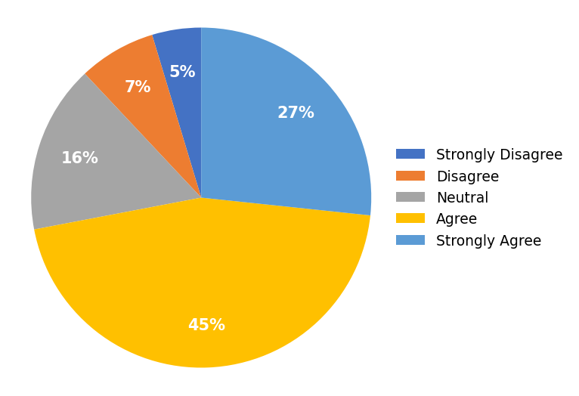

TABLE – 4.2
FOLLOWING EDUCATIONAL ACCOUNTS / CONTENT CREATORS
S. NO | PARTICULAR | FREQUENCY | PERCENTAGE
1 | Strongly Disagree | 3 | 2%
2 | Disagree | 8 | 5%
3 | Neutral | 28 | 19%
4 | Agree | 64 | 43%
5 | Strongly Agree | 47 | 31%
 | TOTAL | 150 | 100%
INTERPRETATION
The table 4.2 shows that 31% strongly agree, 43% agree, 19% neutral, 5% disagree and 2% strongly disagree. It is found that the majority of the respondents were agreeing that they follow educational accounts or content creators on social media.
CHART – 4.2
FOLLOWING EDUCATIONAL ACCOUNTS / CONTENT CREATORS
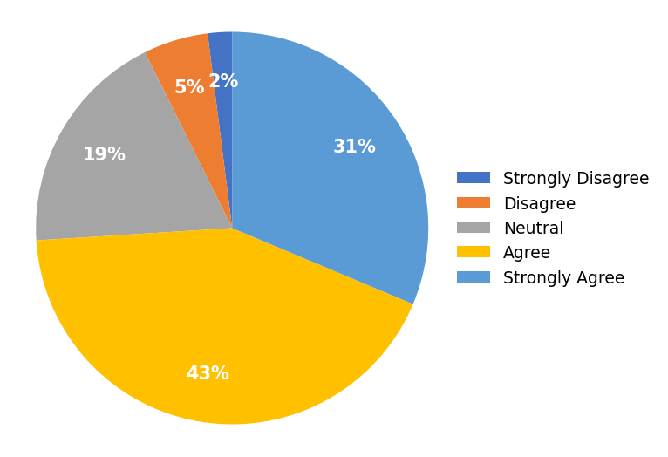

TABLE – 4.3
WATCHING SHORT EDUCATIONAL VIDEOS REGULARLY
S. NO | PARTICULAR | FREQUENCY | PERCENTAGE
1 | Strongly Disagree | 6 | 4%
2 | Disagree | 10 | 7%
3 | Neutral | 30 | 20%
4 | Agree | 64 | 43%
5 | Strongly Agree | 40 | 27%
 | TOTAL | 150 | 100%
INTERPRETATION
The table 4.3 shows that 27% strongly agree, 43% agree, 20% neutral, 7% disagree and 4% strongly disagree. It is found that the majority of the respondents were agreeing that they watch short educational videos on social media regularly.
CHART – 4.3
WATCHING SHORT EDUCATIONAL VIDEOS REGULARLY
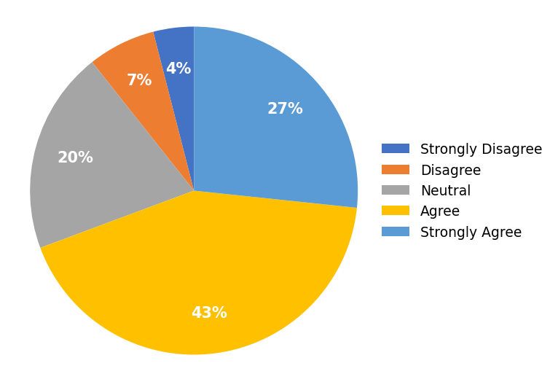

TABLE – 4.4
PREFERENCE FOR SHORT LEARNING CONTENT
S. NO | PARTICULAR | FREQUENCY | PERCENTAGE
1 | Strongly Disagree | 4 | 3%
2 | Disagree | 16 | 11%
3 | Neutral | 27 | 18%
4 | Agree | 51 | 34%
5 | Strongly Agree | 52 | 35%
 | TOTAL | 150 | 100%
INTERPRETATION
The table 4.4 shows that 35% strongly agree, 34% agree, 18% neutral, 11% disagree and 3% strongly disagree. It is found that the majority of the respondents were agreeing that they prefer short learning content over lengthy learning materials.
CHART – 4.4
PREFERENCE FOR SHORT LEARNING CONTENT
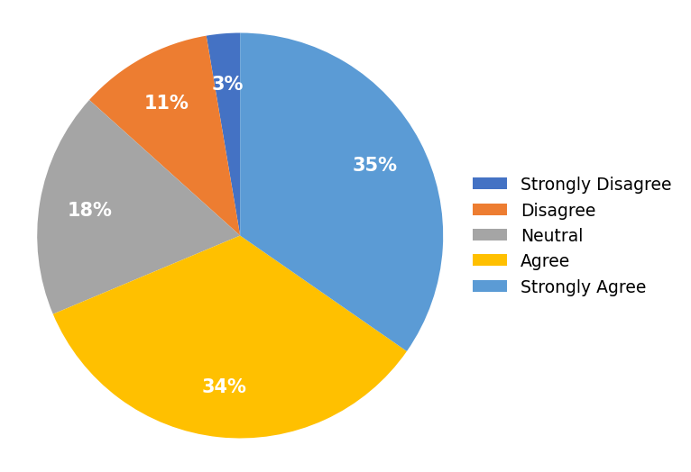

TABLE – 4.5
USING SOCIAL MEDIA TO IMPROVE KNOWLEDGE
S. NO | PARTICULAR | FREQUENCY | PERCENTAGE
1 | Strongly Disagree | 10 | 7%
2 | Disagree | 14 | 9%
3 | Neutral | 27 | 18%
4 | Agree | 66 | 44%
5 | Strongly Agree | 33 | 22%
 | TOTAL | 150 | 100%
INTERPRETATION
The table 4.5 shows that 22% strongly agree, 44% agree, 18% neutral, 9% disagree and 7% strongly disagree. It is found that the majority of the respondents were agreeing that they use social media to improve their academic or professional knowledge.
CHART – 4.5
USING SOCIAL MEDIA TO IMPROVE KNOWLEDGE
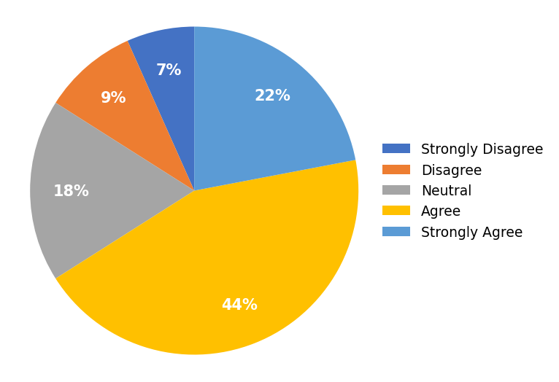

TABLE – 4.6
UNDERSTANDING CONCEPTS QUICKLY
S. NO | PARTICULAR | FREQUENCY | PERCENTAGE
1 | Strongly Disagree | 9 | 6%
2 | Disagree | 8 | 5%
3 | Neutral | 27 | 18%
4 | Agree | 65 | 43%
5 | Strongly Agree | 41 | 27%
 | TOTAL | 150 | 100%
INTERPRETATION
The table 4.6 shows that 27% strongly agree, 43% agree, 18% neutral, 5% disagree and 6% strongly disagree. It is found that the majority of the respondents were agreeing that microlearning through social media helps them understand concepts quickly.
CHART – 4.6
UNDERSTANDING CONCEPTS QUICKLY
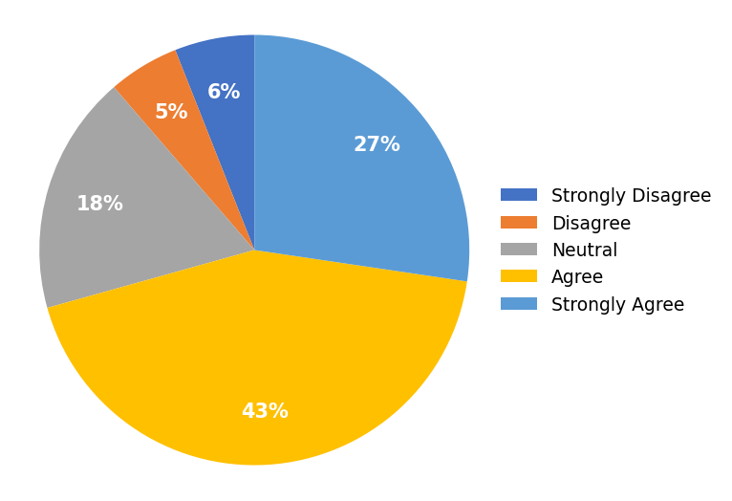

TABLE – 4.7
REMEMBERING INFORMATION FROM SHORT CONTENT
S. NO | PARTICULAR | FREQUENCY | PERCENTAGE
1 | Strongly Disagree | 4 | 3%
2 | Disagree | 15 | 10%
3 | Neutral | 33 | 22%
4 | Agree | 61 | 41%
5 | Strongly Agree | 37 | 25%
 | TOTAL | 150 | 100%
INTERPRETATION
The table 4.7 shows that 25% strongly agree, 41% agree, 22% neutral, 10% disagree and 3% strongly disagree. It is found that the majority of the respondents were agreeing that they can easily remember information learned through short educational content.
CHART – 4.7
REMEMBERING INFORMATION FROM SHORT CONTENT
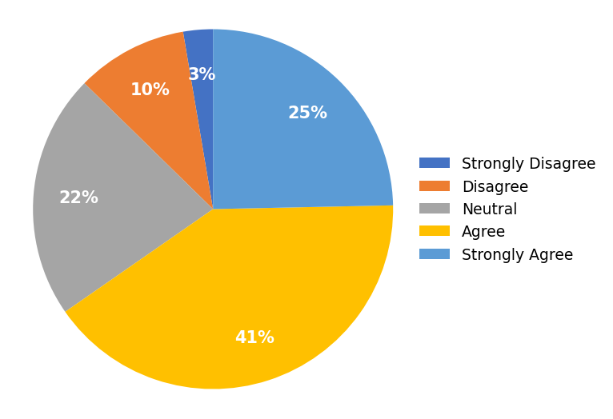

TABLE – 4.8
LEARNING THROUGH SOCIAL MEDIA SAVES TIME
S. NO | PARTICULAR | FREQUENCY | PERCENTAGE
1 | Strongly Disagree | 3 | 2%
2 | Disagree | 14 | 9%
3 | Neutral | 22 | 15%
4 | Agree | 64 | 43%
5 | Strongly Agree | 47 | 31%
 | TOTAL | 150 | 100%
INTERPRETATION
The table 4.8 shows that 31% strongly agree, 43% agree, 15% neutral, 9% disagree and 2% strongly disagree. It is found that the majority of the respondents were agreeing that learning through social media saves them time.
CHART – 4.8
LEARNING THROUGH SOCIAL MEDIA SAVES TIME
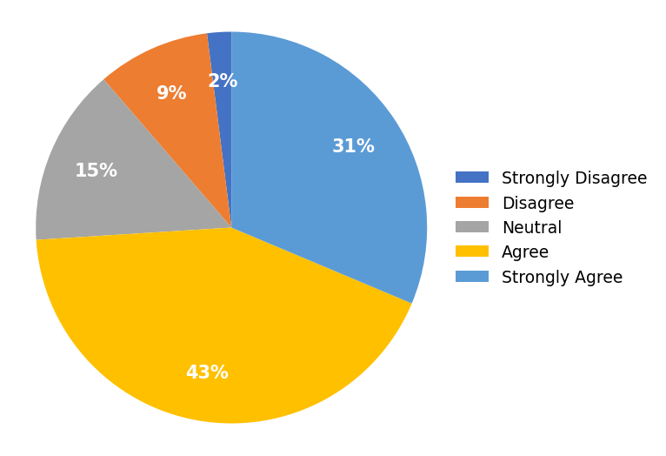

TABLE – 4.9
MICROLEARNING MAKES LEARNING ENJOYABLE
S. NO | PARTICULAR | FREQUENCY | PERCENTAGE
1 | Strongly Disagree | 5 | 3%
2 | Disagree | 14 | 9%
3 | Neutral | 24 | 16%
4 | Agree | 54 | 36%
5 | Strongly Agree | 53 | 35%
 | TOTAL | 150 | 100%
INTERPRETATION
The table 4.9 shows that 35% strongly agree, 36% agree, 16% neutral, 9% disagree and 3% strongly disagree. It is found that the majority of the respondents were agreeing that microlearning makes learning more enjoyable.
CHART – 4.9
MICROLEARNING MAKES LEARNING ENJOYABLE
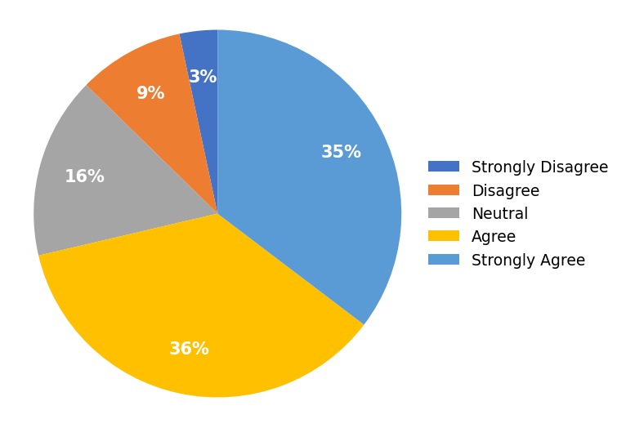

TABLE – 4.10
EASY ACCESS TO EDUCATIONAL RESOURCES
S. NO | PARTICULAR | FREQUENCY | PERCENTAGE
1 | Strongly Disagree | 9 | 6%
2 | Disagree | 13 | 9%
3 | Neutral | 29 | 19%
4 | Agree | 55 | 37%
5 | Strongly Agree | 44 | 29%
 | TOTAL | 150 | 100%
INTERPRETATION
The table 4.10 shows that 29% strongly agree, 37% agree, 19% neutral, 9% disagree and 6% strongly disagree. It is found that the majority of the respondents were agreeing that social media provides easy access to educational resources.
CHART – 4.10
EASY ACCESS TO EDUCATIONAL RESOURCES
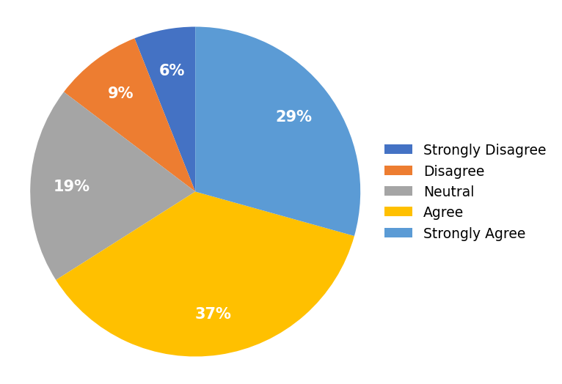

TABLE – 4.11
INCREASED INTEREST IN LEARNING
S. NO | PARTICULAR | FREQUENCY | PERCENTAGE
1 | Strongly Disagree | 11 | 7%
2 | Disagree | 14 | 9%
3 | Neutral | 28 | 19%
4 | Agree | 63 | 42%
5 | Strongly Agree | 34 | 23%
 | TOTAL | 150 | 100%
INTERPRETATION
The table 4.11 shows that 23% strongly agree, 42% agree, 19% neutral, 9% disagree and 7% strongly disagree. It is found that the majority of the respondents were agreeing that educational content on social media increases their interest in learning.
CHART – 4.11
INCREASED INTEREST IN LEARNING
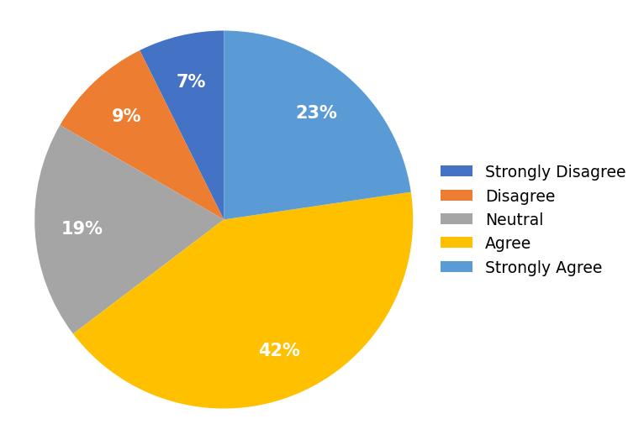

TABLE – 4.12
MOTIVATION TO LEARN AFTER WATCHING CONTENT
S. NO | PARTICULAR | FREQUENCY | PERCENTAGE
1 | Strongly Disagree | 4 | 3%
2 | Disagree | 15 | 10%
3 | Neutral | 25 | 17%
4 | Agree | 67 | 45%
5 | Strongly Agree | 39 | 26%
 | TOTAL | 150 | 100%
INTERPRETATION
The table 4.12 shows that 26% strongly agree, 45% agree, 17% neutral, 10% disagree and 3% strongly disagree. It is found that the majority of the respondents were agreeing that they feel motivated to learn after watching educational content on social media.
CHART – 4.12
MOTIVATION TO LEARN AFTER WATCHING CONTENT
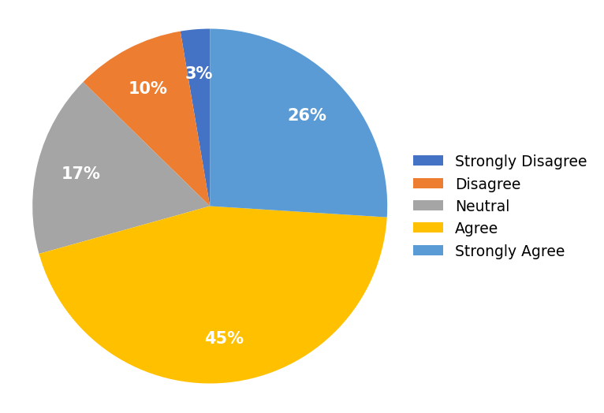

TABLE – 4.13
INTERACTIVE FEATURES IMPROVE LEARNING
S. NO | PARTICULAR | FREQUENCY | PERCENTAGE
1 | Strongly Disagree | 9 | 6%
2 | Disagree | 12 | 8%
3 | Neutral | 22 | 15%
4 | Agree | 54 | 36%
5 | Strongly Agree | 53 | 35%
 | TOTAL | 150 | 100%
INTERPRETATION
The table 4.13 shows that 35% strongly agree, 36% agree, 15% neutral, 8% disagree and 6% strongly disagree. It is found that the majority of the respondents were agreeing that interactive features such as quizzes, polls, and comments improve their learning experience.
CHART – 4.13
INTERACTIVE FEATURES IMPROVE LEARNING
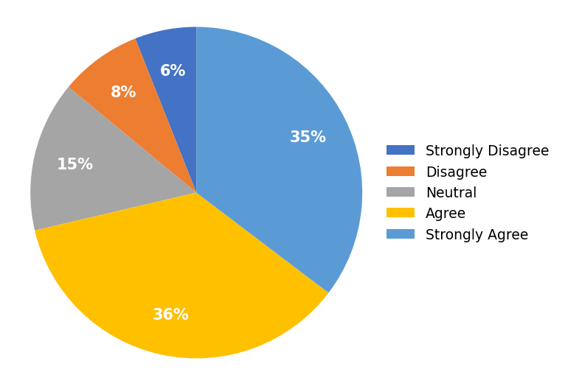

TABLE – 4.14
SHARING EDUCATIONAL CONTENT WITH OTHERS
S. NO | PARTICULAR | FREQUENCY | PERCENTAGE
1 | Strongly Disagree | 2 | 1%
2 | Disagree | 8 | 5%
3 | Neutral | 20 | 13%
4 | Agree | 71 | 47%
5 | Strongly Agree | 49 | 33%
 | TOTAL | 150 | 100%
INTERPRETATION
The table 4.14 shows that 33% strongly agree, 47% agree, 13% neutral, 5% disagree and 1% strongly disagree. It is found that the majority of the respondents were agreeing that they share useful educational content with their friends or classmates.
CHART – 4.14
SHARING EDUCATIONAL CONTENT WITH OTHERS
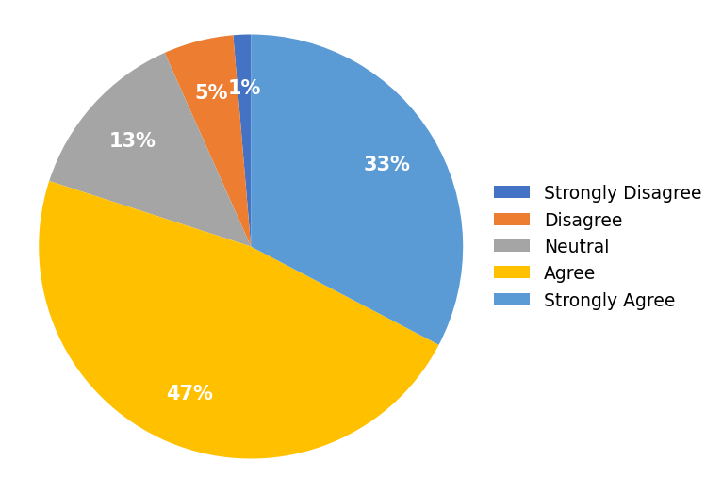

TABLE – 4.15
ENGAGING WITH EDUCATIONAL POSTS
S. NO | PARTICULAR | FREQUENCY | PERCENTAGE
1 | Strongly Disagree | 5 | 3%
2 | Disagree | 9 | 6%
3 | Neutral | 32 | 21%
4 | Agree | 57 | 38%
5 | Strongly Agree | 47 | 31%
 | TOTAL | 150 | 100%
INTERPRETATION
The table 4.15 shows that 31% strongly agree, 38% agree, 21% neutral, 6% disagree and 3% strongly disagree. It is found that the majority of the respondents were agreeing that they engage with educational posts by liking, commenting, or saving them.
CHART – 4.15
ENGAGING WITH EDUCATIONAL POSTS
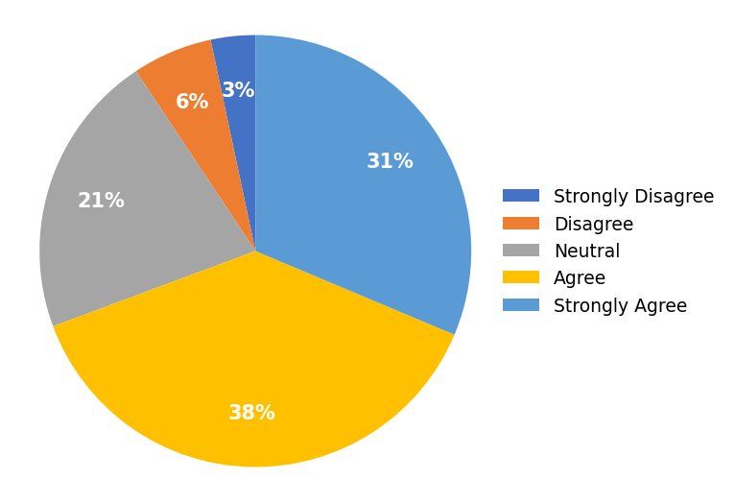

TABLE – 4.16
IMPROVED PROBLEM-SOLVING SKILLS
S. NO | PARTICULAR | FREQUENCY | PERCENTAGE
1 | Strongly Disagree | 7 | 5%
2 | Disagree | 12 | 8%
3 | Neutral | 27 | 18%
4 | Agree | 60 | 40%
5 | Strongly Agree | 44 | 29%
 | TOTAL | 150 | 100%
INTERPRETATION
The table 4.16 shows that 29% strongly agree, 40% agree, 18% neutral, 8% disagree and 5% strongly disagree. It is found that the majority of the respondents were agreeing that microlearning through social media improves their problem-solving skills.
CHART – 4.16
IMPROVED PROBLEM-SOLVING SKILLS
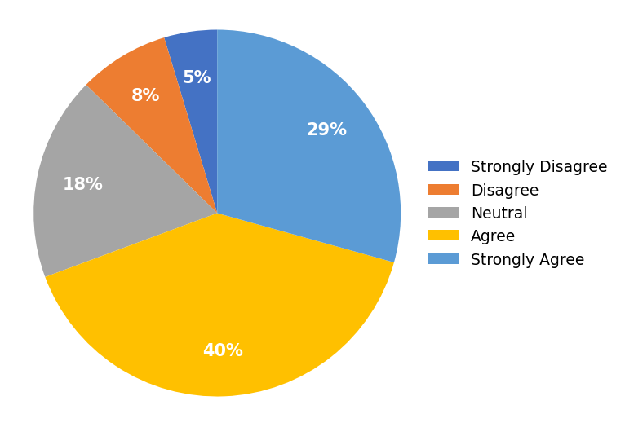

TABLE – 4.17
APPLYING KNOWLEDGE IN REAL-LIFE SITUATIONS
S. NO | PARTICULAR | FREQUENCY | PERCENTAGE
1 | Strongly Disagree | 4 | 3%
2 | Disagree | 18 | 12%
3 | Neutral | 26 | 17%
4 | Agree | 69 | 46%
5 | Strongly Agree | 33 | 22%
 | TOTAL | 150 | 100%
INTERPRETATION
The table 4.17 shows that 22% strongly agree, 46% agree, 17% neutral, 12% disagree and 3% strongly disagree. It is found that the majority of the respondents were agreeing that they can apply the knowledge gained from social media in real-life situations.
CHART – 4.17
APPLYING KNOWLEDGE IN REAL-LIFE SITUATIONS
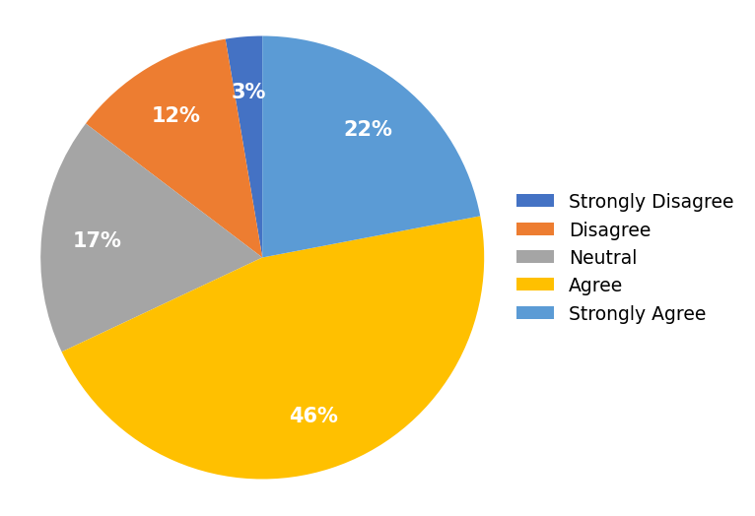

TABLE – 4.18
INCREASED CONFIDENCE IN UNDERSTANDING TOPICS
S. NO | PARTICULAR | FREQUENCY | PERCENTAGE
1 | Strongly Disagree | 6 | 4%
2 | Disagree | 14 | 9%
3 | Neutral | 26 | 17%
4 | Agree | 56 | 37%
5 | Strongly Agree | 48 | 32%
 | TOTAL | 150 | 100%
INTERPRETATION
The table 4.18 shows that 32% strongly agree, 37% agree, 17% neutral, 9% disagree and 4% strongly disagree. It is found that the majority of the respondents were agreeing that learning through social media increases their confidence in understanding new topics.
CHART – 4.18
INCREASED CONFIDENCE IN UNDERSTANDING TOPICS
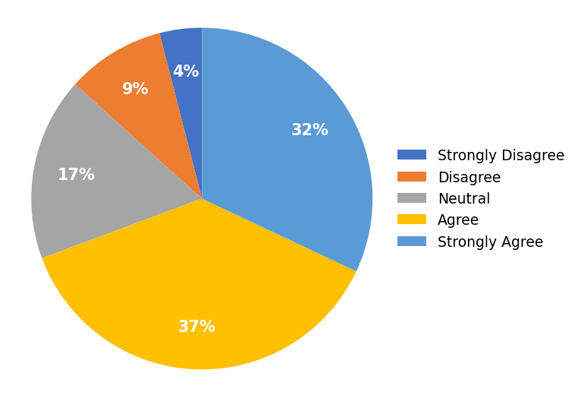

TABLE – 4.19
PREFERENCE FOR VIDEOS OVER TEXT-BASED CONTENT
S. NO | PARTICULAR | FREQUENCY | PERCENTAGE
1 | Strongly Disagree | 6 | 4%
2 | Disagree | 8 | 5%
3 | Neutral | 21 | 14%
4 | Agree | 75 | 50%
5 | Strongly Agree | 40 | 27%
 | TOTAL | 150 | 100%
INTERPRETATION
The table 4.19 shows that 27% strongly agree, 50% agree, 14% neutral, 5% disagree and 4% strongly disagree. It is found that the majority of the respondents were agreeing that they prefer learning through videos rather than text-based content.
CHART – 4.19
PREFERENCE FOR VIDEOS OVER TEXT-BASED CONTENT
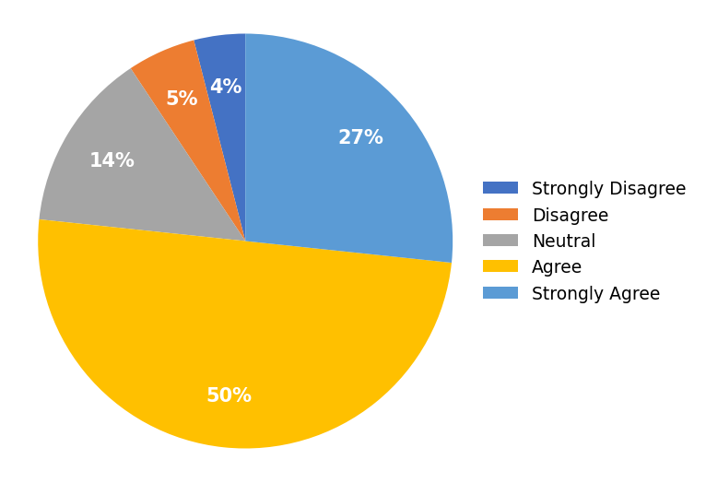

TABLE – 4.20
LEARNING ANYTIME AND ANYWHERE
S. NO | PARTICULAR | FREQUENCY | PERCENTAGE
1 | Strongly Disagree | 7 | 5%
2 | Disagree | 11 | 7%
3 | Neutral | 35 | 23%
4 | Agree | 56 | 37%
5 | Strongly Agree | 41 | 27%
 | TOTAL | 150 | 100%
INTERPRETATION
The table 4.20 shows that 27% strongly agree, 37% agree, 23% neutral, 7% disagree and 5% strongly disagree. It is found that the majority of the respondents were agreeing that social media helps them learn anytime and anywhere.
CHART – 4.20
LEARNING ANYTIME AND ANYWHERE
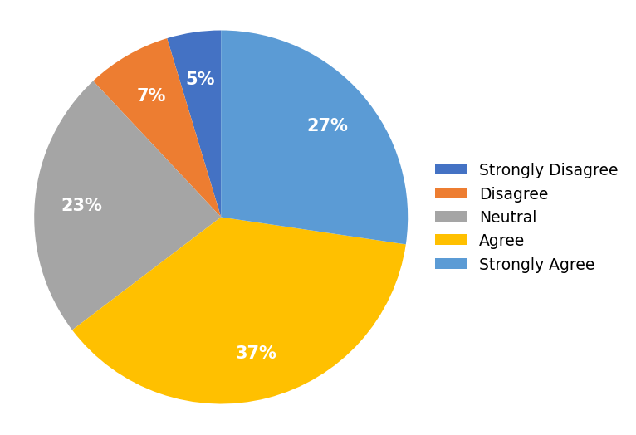

TABLE – 4.21
DISTRACTION BY NON-EDUCATIONAL CONTENT
S. NO | PARTICULAR | FREQUENCY | PERCENTAGE
1 | Strongly Disagree | 52 | 35%
2 | Disagree | 47 | 31%
3 | Neutral | 29 | 19%
4 | Agree | 11 | 7%
5 | Strongly Agree | 11 | 7%
 | TOTAL | 150 | 100%
INTERPRETATION
The table 4.21 shows that 7% strongly agree, 7% agree, 19% neutral, 31% disagree and 35% strongly disagree. It is found that the majority of the respondents were disagreeing that they often get distracted by non-educational content while learning on social media.
CHART – 4.21
DISTRACTION BY NON-EDUCATIONAL CONTENT
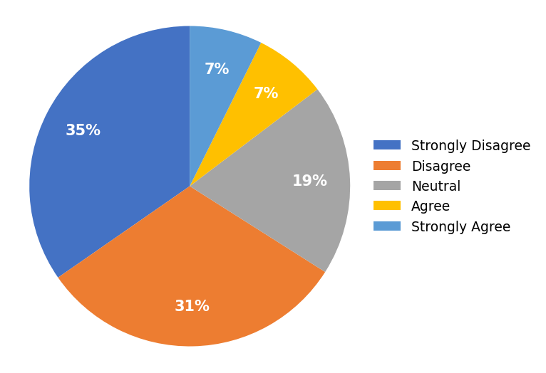

TABLE – 4.22
SHORT CONTENT LACKS SUFFICIENT DETAIL
S. NO | PARTICULAR | FREQUENCY | PERCENTAGE
1 | Strongly Disagree | 46 | 31%
2 | Disagree | 52 | 35%
3 | Neutral | 24 | 16%
4 | Agree | 17 | 11%
5 | Strongly Agree | 11 | 7%
 | TOTAL | 150 | 100%
INTERPRETATION
The table 4.22 shows that 7% strongly agree, 11% agree, 16% neutral, 35% disagree and 31% strongly disagree. It is found that the majority of the respondents were disagreeing that short educational content sometimes lacks sufficient detail.
CHART – 4.22
SHORT CONTENT LACKS SUFFICIENT DETAIL
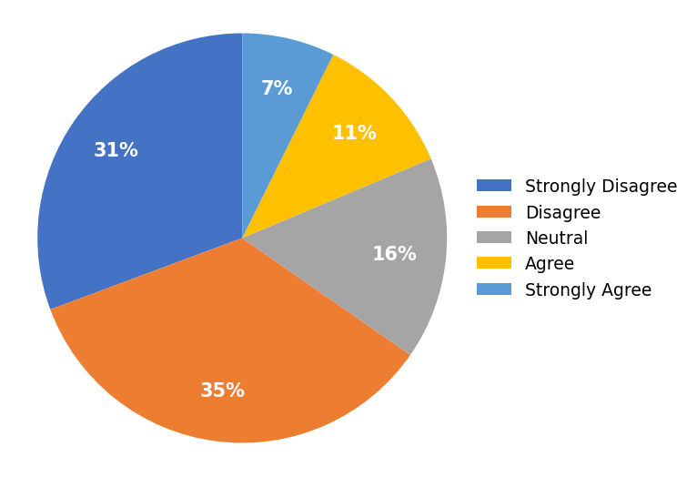

TABLE – 4.23
DIFFICULTY JUDGING CONTENT ACCURACY
S. NO | PARTICULAR | FREQUENCY | PERCENTAGE
1 | Strongly Disagree | 42 | 28%
2 | Disagree | 54 | 36%
3 | Neutral | 26 | 17%
4 | Agree | 17 | 11%
5 | Strongly Agree | 11 | 7%
 | TOTAL | 150 | 100%
INTERPRETATION
The table 4.23 shows that 7% strongly agree, 11% agree, 17% neutral, 36% disagree and 28% strongly disagree. It is found that the majority of the respondents were disagreeing that it is difficult to judge whether educational content on social media is accurate.
CHART – 4.23
DIFFICULTY JUDGING CONTENT ACCURACY
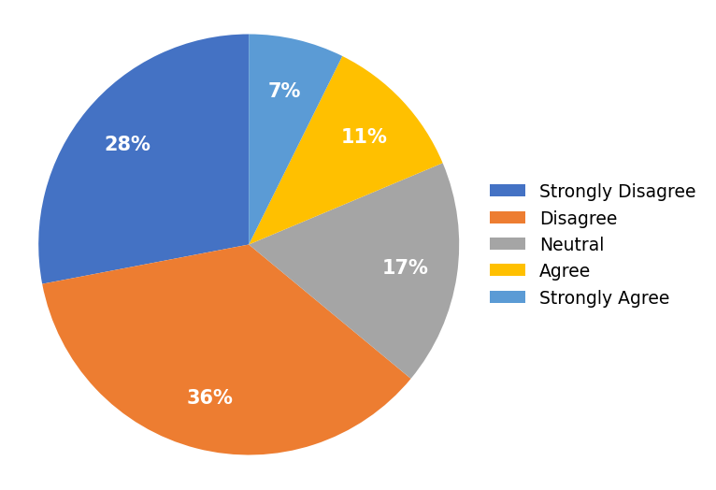

TABLE – 4.24
INFORMATION OVERLOAD CAUSES CONFUSION
S. NO | PARTICULAR | FREQUENCY | PERCENTAGE
1 | Strongly Disagree | 46 | 31%
2 | Disagree | 44 | 29%
3 | Neutral | 28 | 19%
4 | Agree | 18 | 12%
5 | Strongly Agree | 14 | 9%
 | TOTAL | 150 | 100%
INTERPRETATION
The table 4.24 shows that 9% strongly agree, 12% agree, 19% neutral, 29% disagree and 31% strongly disagree. It is found that the majority of the respondents were disagreeing that too much information on social media makes learning confusing.
CHART – 4.24
INFORMATION OVERLOAD CAUSES CONFUSION
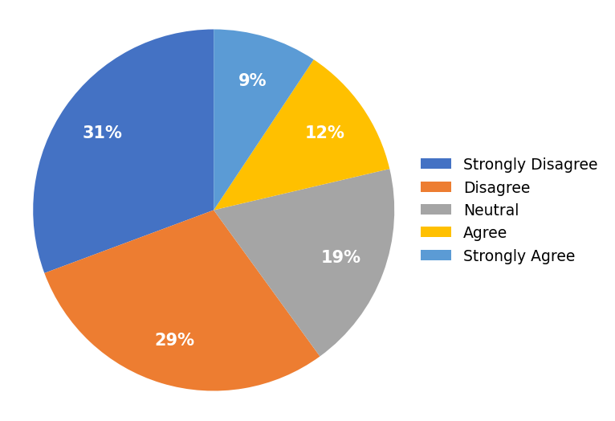

TABLE – 4.25
OVERALL EFFECTIVENESS OF MICROLEARNING
S. NO | PARTICULAR | FREQUENCY | PERCENTAGE
1 | Strongly Disagree | 6 | 4%
2 | Disagree | 15 | 10%
3 | Neutral | 27 | 18%
4 | Agree | 52 | 35%
5 | Strongly Agree | 50 | 33%
 | TOTAL | 150 | 100%
INTERPRETATION
The table 4.25 shows that 33% strongly agree, 35% agree, 18% neutral, 10% disagree and 4% strongly disagree. It is found that the majority of the respondents were agreeing that overall, microlearning through social media is an effective way to learn.
CHART – 4.25
OVERALL EFFECTIVENESS OF MICROLEARNING
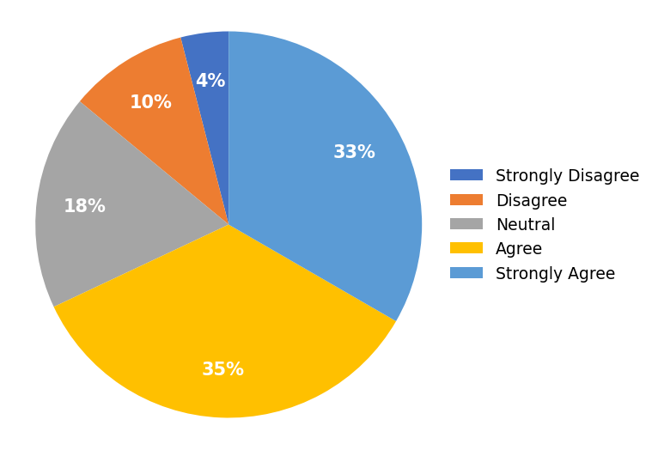

INTERPRETATION BASED ON CHI-SQUARE TEST OF INDEPENDENCE
PROBLEM OF THE STATEMENT
Respondents were asked whether they frequently use social media to learn new information (Q1) and whether, overall, microlearning through social media is an effective way to learn (Q25). There were 5 answer choices through a linear scale: Strongly Disagree, Disagree, Neutral, Agree, and Strongly Agree. A test for an association between these two responses using the Chi-Square Test of Independence is done. (Use α = 0.05)
HYPOTHESIS
H0: The frequency of using social media to learn is not associated with the overall perceived effectiveness of microlearning.
H1: The frequency of using social media to learn is associated with the overall perceived effectiveness of microlearning.
CLUSTERED BAR CHART
One way to visualize the association between two categorical variables is by using a clustered bar chart. The clusters in the chart are determined by the responses to Q1 (frequency of using social media to learn), while the coloured bars represent the responses to Q25 (overall effectiveness).
CHART – 4.26
CLUSTERED BAR CHART
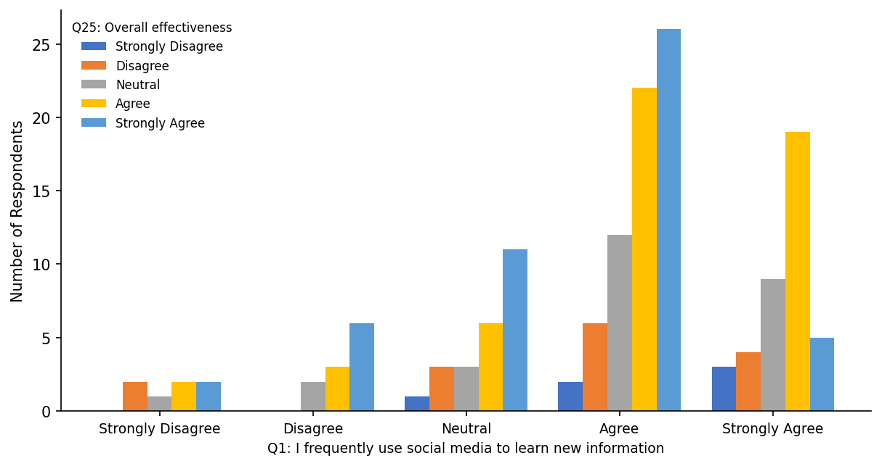

OUTPUT TABLES
The first table is the case processing summary, which tells us the number of valid cases used for analysis. Only cases with no missing values can be used in the test.
Case Processing Summary
 | Valid | Missing | Total
Q1 * Q25 | 150 (100.0%) | 0 (0.0%) | 150 (100.0%)
Q1 * Q25 Crosstabulation
Q1 \ Q25 | Strongly Disagree | Disagree | Neutral | Agree | Strongly Agree | Total
Strongly Disagree | 0 | 2 | 1 | 2 | 2 | 7
Disagree | 0 | 0 | 2 | 3 | 6 | 11
Neutral | 1 | 3 | 3 | 6 | 11 | 24
Agree | 2 | 6 | 12 | 22 | 26 | 68
Strongly Agree | 3 | 4 | 9 | 19 | 5 | 40
Total | 6 | 15 | 27 | 52 | 50 | 150
Chi-Square Tests
Test | Value | df | Asymptotic Significance (2-sided)
Pearson Chi-Square | 18.064 | 16 | 0.32
N of Valid Cases | 150
a. 16 cells (64.0%) have an expected count less than 5. The minimum expected count is 0.28.
FINDINGS
➢ The value of the test statistic (Pearson Chi-Square) is 18.064.
➢ The corresponding p-value of the test statistic is 0.32.
➢ Since 16 of the 25 cells (64.0%) have an expected count less than 5, the assumption of the test is partially violated.
DECISION AND CONCLUSION
Since the p-value (0.32) is greater than the chosen significance level (α = 0.05), we do not reject the null hypothesis.
Therefore, it is concluded that there is no significant association between the frequency of using social media to learn and the overall perceived effectiveness of microlearning. Based on the results, we can state the following:
No association was found between the frequency of using social media to learn and the overall perceived effectiveness of microlearning (χ² = 18.064, p = 0.32).

CHAPTER – V
FINDINGS, SUGGESTIONS AND CONCLUSIONS

CHAPTER – V

FINDINGS, SUGGESTIONS AND CONCLUSIONS

5.1 FINDINGS
➢ 72% of the respondents agreed or strongly agreed that they frequently use social media to learn new information.
➢ 74% of the respondents agreed or strongly agreed that they follow educational accounts or content creators on social media.
➢ 74% of the respondents agreed or strongly agreed that learning through social media saves them time.
➢ 71% of the respondents agreed or strongly agreed that microlearning makes learning more enjoyable.
➢ 80% of the respondents agreed or strongly agreed that they share useful educational content with their friends or classmates.
➢ 65% of the respondents agreed or strongly agreed that social media helps them learn anytime and anywhere.
➢ 68% of the respondents agreed or strongly agreed that, overall, microlearning through social media is an effective way to learn.
➢ Only 15% agreed that they get distracted by non-educational content, and only 19% found it difficult to judge the accuracy of content, indicating that most respondents do not perceive strong challenges.
➢ The chi-square test showed no significant association between the frequency of using social media to learn and overall perceived effectiveness (χ² = 18.064, p = 0.32).

5.2 SUGGESTIONS
➢ Educational content creators should ensure that short content is accurate, well-sourced, and sufficiently detailed to avoid superficial learning.
➢ Social media platforms can introduce dedicated 'learning modes' or curated educational feeds to reduce distraction from non-educational content.
➢ Educators and institutions should integrate curated social-media microlearning content to complement formal teaching.
➢ Learners should manage their time and minimise distraction from non-educational content while learning on social media.
➢ Interactive features such as quizzes and polls should be encouraged, as they improve engagement and the overall learning experience.

5.3 CONCLUSION
In conclusion, the study reveals that microlearning through social media is widely used and positively perceived: respondents actively follow educational content, find it convenient, enjoyable, and time-saving, and engage with and apply what they learn. Perceived challenges such as distraction, lack of depth, and questionable accuracy are comparatively low.
The chi-square test indicated that the frequency of using social media to learn is not significantly associated with the overall perceived effectiveness of microlearning, suggesting that the positive perception of microlearning is broadly uniform across respondents. The overall evidence suggests that microlearning through social media is an effective and engaging complement to traditional learning, provided that concerns about depth and credibility are addressed.

REFERENCES

Hug, T. (2005). Micro Learning and Narration: Exploring possibilities of utilization of narrations and storytelling for the designing of micro units and didactical micro-learning arrangements.
Giurgiu, L. (2017). Microlearning an Evolving Elearning Trend. Scientific Bulletin, 22(1), 18-23.
A study on the use of social media for informal learning (2018).
Research on short-form video and learning engagement (2021).
A study on microlearning and knowledge retention (2020).
A study on social media as a learning tool among university students (2019).
Research on the role of interactivity in online learning (2020).
A study on distraction and multitasking on social media (2019).
Research on the credibility of educational content on social media (2021).
A study on mobile learning and flexibility (2018).
Research on Gen-Z learning preferences (2022).
A study on educational influencers and content creators (2021).
Research on the effectiveness of microlearning in skill development (2022).
A study on information overload in digital learning (2020).
Recent research on microlearning and learner confidence (2023).

ANNEXURE
QUESTIONNAIRE
Each statement was rated on a five-point Likert scale (1 = Strongly Disagree to 5 = Strongly Agree).
SECTION A – USAGE & ADOPTION BEHAVIOUR
1. I frequently use social media to learn new information.
• Strongly Disagree
• Disagree
• Neutral
• Agree
• Strongly Agree
2. I follow educational accounts or content creators on social media.
• Strongly Disagree
• Disagree
• Neutral
• Agree
• Strongly Agree
3. I watch short educational videos on social media regularly.
• Strongly Disagree
• Disagree
• Neutral
• Agree
• Strongly Agree
4. I prefer short learning content over lengthy learning materials.
• Strongly Disagree
• Disagree
• Neutral
• Agree
• Strongly Agree
5. I use social media to improve my academic or professional knowledge.
• Strongly Disagree
• Disagree
• Neutral
• Agree
• Strongly Agree
SECTION B – PERCEIVED EFFECTIVENESS & BENEFITS
6. Microlearning through social media helps me understand concepts quickly.
• Strongly Disagree
• Disagree
• Neutral
• Agree
• Strongly Agree
7. I can easily remember information learned through short educational content.
• Strongly Disagree
• Disagree
• Neutral
• Agree
• Strongly Agree
8. Learning through social media saves me time.
• Strongly Disagree
• Disagree
• Neutral
• Agree
• Strongly Agree
9. Microlearning makes learning more enjoyable.
• Strongly Disagree
• Disagree
• Neutral
• Agree
• Strongly Agree
10. Social media provides easy access to educational resources.
• Strongly Disagree
• Disagree
• Neutral
• Agree
• Strongly Agree
11. Educational content on social media increases my interest in learning.
• Strongly Disagree
• Disagree
• Neutral
• Agree
• Strongly Agree
12. I feel motivated to learn after watching educational content on social media.
• Strongly Disagree
• Disagree
• Neutral
• Agree
• Strongly Agree
SECTION C – ENGAGEMENT & APPLICATION
13. Interactive features such as quizzes, polls, and comments improve my learning experience.
• Strongly Disagree
• Disagree
• Neutral
• Agree
• Strongly Agree
14. I share useful educational content with my friends or classmates.
• Strongly Disagree
• Disagree
• Neutral
• Agree
• Strongly Agree
15. I engage with educational posts by liking, commenting, or saving them.
• Strongly Disagree
• Disagree
• Neutral
• Agree
• Strongly Agree
16. Microlearning through social media improves my problem-solving skills.
• Strongly Disagree
• Disagree
• Neutral
• Agree
• Strongly Agree
17. I can apply the knowledge gained from social media in real-life situations.
• Strongly Disagree
• Disagree
• Neutral
• Agree
• Strongly Agree
18. Learning through social media increases my confidence in understanding new topics.
• Strongly Disagree
• Disagree
• Neutral
• Agree
• Strongly Agree
19. I prefer learning through videos rather than text-based content.
• Strongly Disagree
• Disagree
• Neutral
• Agree
• Strongly Agree
20. Social media helps me learn anytime and anywhere.
• Strongly Disagree
• Disagree
• Neutral
• Agree
• Strongly Agree
SECTION D – CHALLENGES & LIMITATIONS
21. I often get distracted by non-educational content while learning on social media.
• Strongly Disagree
• Disagree
• Neutral
• Agree
• Strongly Agree
22. Short educational content sometimes lacks sufficient detail.
• Strongly Disagree
• Disagree
• Neutral
• Agree
• Strongly Agree
23. It is difficult to judge whether educational content on social media is accurate.
• Strongly Disagree
• Disagree
• Neutral
• Agree
• Strongly Agree
24. Too much information on social media makes learning confusing.
• Strongly Disagree
• Disagree
• Neutral
• Agree
• Strongly Agree
SECTION E – OVERALL
25. Overall, microlearning through social media is an effective way to learn.
• Strongly Disagree
• Disagree
• Neutral
• Agree
• Strongly Agree

