CONSUMER BUYING BEHAVIOUR AND SATISFACTION TOWARDS ONLINE SHOPPING (E-COMMERCE)

A PROJECT REPORT
Submitted in partial fulfilment of the requirements
for the award of the degree of
MASTER OF BUSINESS ADMINISTRATION (FINANCE)
Affiliated to MUST

ISSM Business School
JUNE 2026

Submitted by
[STUDENT NAME]
Register No : [REGISTER NUMBER]

DECLARATION
I hereby declare that the project report titled "Consumer Buying Behaviour and Satisfaction towards Online Shopping (E-Commerce)" submitted by me is a record of original work carried out under the guidance of By myself. The findings reported in this study are based on primary data collected through a structured questionnaire and have not been submitted earlier for the award of any degree, diploma, or similar title.

Place: Chennai
Date: 30-06-2026

[STUDENT NAME]
[REGISTER NUMBER]

ACKNOWLEDGEMENT
I express my sincere gratitude to ISSM Business school for the valuable guidance, encouragement, and support extended throughout this study. I am thankful to the Programme co-ordinator and the faculty members for their constant motivation. I also thank the 120 respondents who spared their valuable time to complete the questionnaire, without whom this study would not have been possible. Finally, I am grateful to my family and friends for their continuous support and encouragement.

ABSTRACT
The rapid expansion of e-commerce has fundamentally changed the way consumers search for, evaluate, and purchase products. Online shopping platforms offer convenience, wide product assortments, competitive prices, and doorstep delivery, and these attributes shape both buying behaviour and post-purchase satisfaction. This study examines consumer buying behaviour and satisfaction towards online shopping. Primary data were collected from 120 respondents through a structured questionnaire measured on a five-point Likert scale. The data were analysed using percentage analysis, descriptive statistics, Cronbach's alpha, an independent-samples t-test, one-way ANOVA, and Pearson correlation. The results indicate a favourable overall response, with a mean of 3.88 for online shopping experience and perceived benefits and 3.88 for customer satisfaction and repurchase intention. Both scales demonstrated high internal consistency (alpha = 0.9 and 0.918). The t-test found no statistically significant difference in perceived shopping experience between male and female respondents, and ANOVA found no statistically significant difference in satisfaction across age groups. However, a strong, positive and statistically significant correlation (r = 0.894, p < 0.001) was observed between shopping experience and customer satisfaction, indicating that a better perceived shopping experience is closely associated with higher satisfaction and repurchase intention. Recommendations for e-commerce firms are offered.

Keywords: e-commerce, online shopping, consumer buying behaviour, customer satisfaction, repurchase intention, digital retail.

TABLE OF CONTENTS
Chapter | Title
Chapter 1 | Introduction
Chapter 2 | Review of Literature
Chapter 3 | Research Methodology
Chapter 4 | Data Analysis and Interpretation
Chapter 5 | Findings, Suggestions, Conclusion and Summary
 | Appendix I - Questionnaire
 | Appendix II - Bibliography / References

CHAPTER 1: INTRODUCTION

1.1 Background of the Study
Electronic commerce, or e-commerce, refers to the buying and selling of goods and services over the internet. Over the past decade, the combination of affordable smartphones, inexpensive mobile data, secure digital payment systems, and rapidly improving logistics networks has transformed online shopping from a novelty into a routine activity for millions of consumers in India. Platforms such as Amazon, Flipkart, Meesho, Myntra, and Ajio now compete intensively on price, delivery speed, product range, and service quality.
This shift has significant implications for consumer behaviour. Shopping decisions that were once made in physical stores, based on direct inspection of the product and interaction with a salesperson, are now made on the basis of product images, written descriptions, ratings, reviews, and return policies. As a result, factors such as website usability, trust, price transparency, delivery reliability, and the ease of returns have become central determinants of how consumers buy and how satisfied they feel afterwards.

1.2 Concept of E-Commerce and Online Shopping
E-commerce covers a range of transaction models, including business-to-consumer (B2C), business-to-business (B2B), consumer-to-consumer (C2C), and consumer-to-business (C2B). This study is concerned with B2C retail e-commerce, in which individual consumers purchase products from online retailers or marketplaces. The key features that distinguish online shopping from traditional retail include round-the-clock availability, a virtually unlimited product assortment, the ability to compare prices instantly, access to other customers' reviews, multiple digital payment options, and home delivery with the option of return or exchange.

1.3 Consumer Buying Behaviour and Satisfaction
Consumer buying behaviour refers to the processes by which individuals recognise a need, search for information, evaluate alternatives, make a purchase decision, and assess the outcome after purchase. Customer satisfaction is the evaluation that results from comparing the perceived performance of a product or service with prior expectations. When performance meets or exceeds expectations, satisfaction results, which in turn encourages repeat purchase and positive word of mouth; when performance falls short, dissatisfaction leads to complaints, returns, or switching to a competing platform. In the online context, satisfaction is shaped not only by the product itself but also by the quality of the digital experience surrounding it.

1.4 Statement of the Problem
Although e-commerce adoption has grown rapidly, retaining customers remains difficult because switching costs online are very low. Consumers can move to a competing platform with a few taps if prices are higher, delivery is delayed, product quality disappoints, or returns are difficult. It is therefore important for e-commerce firms to understand which aspects of the online shopping experience matter most to consumers, how satisfied consumers actually are, and whether these perceptions differ across demographic groups such as gender and age. This study addresses these questions empirically.

1.5 Objectives of the Study
- To study the demographic profile and online shopping pattern of the respondents.
- To examine consumer perceptions of the online shopping experience and its perceived benefits.
- To analyse the level of customer satisfaction and repurchase intention towards online shopping.
- To study whether the perceived online shopping experience differs significantly between male and female consumers.
- To study whether customer satisfaction differs significantly across age groups.
- To examine the relationship between the online shopping experience and customer satisfaction.
- To offer suggestions to e-commerce firms for improving customer satisfaction and retention.

1.6 Scope of the Study
The study focuses on individual consumers who purchase products through online shopping platforms. It covers the demographic profile, shopping frequency, platform preference, perceptions of the online shopping experience, and satisfaction and repurchase intention, as perceived and self-reported by the respondents. The study is based on primary data collected from 120 respondents through a structured questionnaire. The geographic scope is limited to the respondents reached through the survey, and the study period covers the data collection conducted in 2026.

1.7 Need and Significance of the Study
Understanding consumer behaviour in e-commerce is valuable for several stakeholders. For online retailers and marketplaces, the study indicates which elements of the shopping experience are most closely associated with satisfaction and repeat purchase. For marketers, it provides insight into how different consumer segments respond to online shopping. For consumers, it highlights the factors worth considering when choosing a platform. For academic research, it contributes empirical evidence on the relationship between the online shopping experience and customer satisfaction.

1.8 Limitations of the Study
- The study relies on self-reported perceptions, which may differ from actual purchase behaviour recorded by platforms.
- The sample size is limited to 120 respondents and was drawn using convenience sampling, which limits generalisability.
- A substantial proportion of respondents selected 'Prefer not to say' for gender, which reduced the sample available for the gender-based comparison.
- No respondent selected the lowest scale point (Strongly Disagree) on any statement, so the analysis reflects a relatively narrow range of responses.
- The study is cross-sectional and does not capture changes in consumer behaviour over time.

CHAPTER 2: REVIEW OF LITERATURE
This chapter reviews relevant studies and theoretical models relating to e-commerce, consumer buying behaviour, service quality, and customer satisfaction. The review helps to establish the theoretical foundation of the study and to identify the research gap.
1. Oliver (1980) proposed the expectation-disconfirmation theory, which explains satisfaction as the outcome of comparing perceived performance with prior expectations. The model remains the dominant theoretical basis for studying customer satisfaction, including in online retail settings.
2. Davis (1989) developed the Technology Acceptance Model (TAM), which holds that perceived usefulness and perceived ease of use determine the acceptance and continued use of an information system. TAM is widely applied to explain the adoption of online shopping platforms.
3. Parasuraman, Zeithaml and Berry (1988) introduced the SERVQUAL model, identifying reliability, assurance, tangibles, empathy, and responsiveness as the dimensions along which customers evaluate service quality. Subsequent research adapted the model to electronic service quality.
4. A study on website quality and online purchase intention found that ease of navigation, clear product information, and page loading speed significantly influence a consumer's intention to complete a purchase.
5. Research on trust in online shopping reported that perceived security of payment and the credibility of the seller are among the strongest predictors of willingness to buy online, particularly for first-time purchasers.
6. A study on the role of online customer reviews concluded that both the volume and the valence of reviews significantly shape product evaluation and reduce the perceived risk of purchasing unfamiliar products.
7. Research on price sensitivity in e-commerce found that the ease of comparing prices across platforms increases price sensitivity and weakens loyalty to any single retailer.
8. A study on delivery performance and satisfaction reported that on-time delivery and accurate order fulfilment are strongly associated with overall satisfaction and with the intention to reorder.
9. Research on return and refund policies found that a liberal, clearly communicated return policy reduces purchase hesitation and increases both conversion and post-purchase satisfaction.
10. A study on mobile commerce adoption observed that the shift from desktop to mobile purchasing has made application design, checkout simplicity, and payment convenience critical determinants of completion rates.
11. Research on perceived risk in online shopping identified product risk, financial risk, and delivery risk as the principal concerns that discourage consumers from purchasing online.
12. A study on e-service quality and loyalty concluded that satisfaction mediates the relationship between service quality and customer loyalty, implying that service improvements affect retention largely through their effect on satisfaction.
13. Research on discounts and promotional offers found that cashbacks, coupons, and festive sales stimulate purchase volume but may attract deal-oriented customers with weaker long-term loyalty.
14. A study on demographic influences in online shopping reported mixed findings, with several studies observing that differences between demographic groups narrow as online shopping becomes a mainstream activity across segments.
15. Research on repurchase intention in e-commerce concluded that satisfaction with previous transactions is the most consistent predictor of the intention to purchase again from the same platform.

2.1 Research Gap
The reviewed literature establishes that website quality, trust, price, delivery performance, and return policies influence online purchase decisions, and that satisfaction is central to repurchase intention. However, many studies examine either the antecedents of purchase or satisfaction in isolation, and findings on demographic differences remain inconsistent. Relatively few studies examine the perceived shopping experience and satisfaction together while also testing for demographic differences and estimating the strength of the relationship between the two. The present study addresses this gap by analysing both dimensions among 120 online shoppers, testing for differences by gender and age using a t-test and ANOVA, and measuring the association between the two dimensions using Pearson correlation.

CHAPTER 3: RESEARCH METHODOLOGY

3.1 Research Design
The study adopts a descriptive research design, as it aims to describe and analyse the buying behaviour and satisfaction of online shoppers and to test specific hypotheses regarding demographic differences and the relationship between the study variables.

3.2 Sources of Data
Primary data were collected directly from respondents using a structured questionnaire. Secondary data were drawn from journals, research articles, industry reports, and reliable online sources, as presented in the review of literature.

3.3 Sampling Design
A convenience sampling method was used to reach respondents who shop online. The sample size for the study is 120 respondents.

3.4 Tools for Data Collection
A structured questionnaire was used. The first part captured demographic and behavioural information (age, gender, occupation, online shopping frequency, and most-used e-commerce platform). The second part contained fifteen statements rated on a five-point Likert scale ranging from 1 (Strongly Disagree) to 5 (Strongly Agree). For analysis, these statements were grouped into two dimensions: Online Shopping Experience and Perceived Benefits (items Q6 to Q12) and Customer Satisfaction and Repurchase Intention (items Q13 to Q20).
Note: In the response dataset used for this analysis, the fifteen scale statements are stored under the coded labels Q6 to Q20 rather than their full wording. The tables in Chapter 4 therefore refer to these item codes, and the full wording of each statement should be inserted in Appendix I before final submission.

3.5 Tools for Analysis
- Percentage analysis - to describe the demographic and behavioural profile of respondents.
- Mean and standard deviation - to summarise responses to the individual statements and the two dimensions.
- Cronbach's alpha - to assess the internal reliability of the two scales.
- Independent-samples t-test - to compare the online shopping experience score between male and female respondents.
- One-way ANOVA - to compare the customer satisfaction score across the five age groups.
- Pearson correlation - to examine the relationship between the shopping experience and satisfaction scores.
The analysis was carried out using Python (pandas, numpy and scipy libraries), and charts were generated using the matplotlib library.

3.6 Hypotheses of the Study
Hypothesis 1 (T-test):
H0: There is no significant difference in the perceived online shopping experience between male and female consumers.
H1: There is a significant difference in the perceived online shopping experience between male and female consumers.
Hypothesis 2 (ANOVA):
H0: There is no significant difference in customer satisfaction across different age groups.
H1: There is a significant difference in customer satisfaction across different age groups.
Hypothesis 3 (Correlation):
H0: There is no significant relationship between the online shopping experience and customer satisfaction.
H1: There is a significant relationship between the online shopping experience and customer satisfaction.

CHAPTER 4: DATA ANALYSIS AND INTERPRETATION
This chapter presents the analysis of the primary data collected from 120 respondents. It is organised into percentage analysis of the demographic and behavioural profile, descriptive analysis of the two dimensions, reliability analysis, and hypothesis testing.

4.1 Percentage Analysis of Demographic Profile
Table 4.1 Classification by Gender
Gender | No. of Respondents | Percentage (%)
Male | 41 | 34.2
Female | 35 | 29.2
Prefer not to say | 44 | 36.7
Total | 120 | 100.0
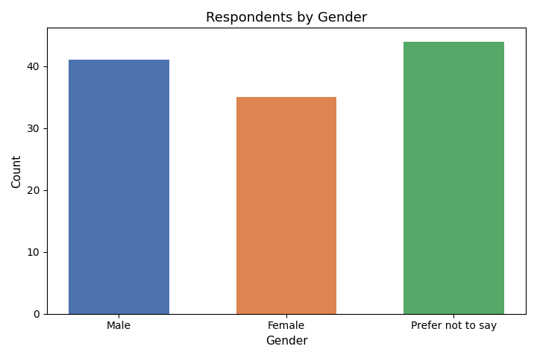
Respondents by Gender
Interpretation: Out of 120 respondents, 34.2% are male, 29.2% are female and 36.7% preferred not to disclose their gender. The relatively large proportion of undisclosed responses is noted as a limitation for the gender-based comparison carried out in section 4.5.

Table 4.2 Classification by Age
Age Group | No. of Respondents | Percentage (%)
Below 20 | 21 | 17.5
21-30 | 52 | 43.3
31-40 | 24 | 20.0
41-50 | 16 | 13.3
Above 50 | 7 | 5.8
Total | 120 | 100.0
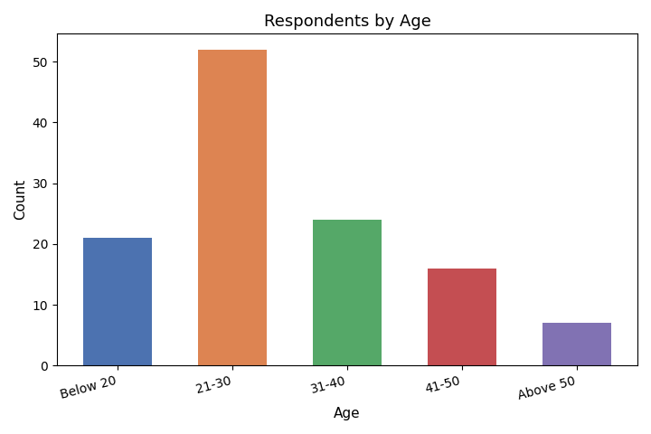
Respondents by Age
Interpretation: The sample is dominated by respondents in the 21-30 age group (43.3%), followed by 31-40 (20.0%) and below 20 (17.5%), reflecting the concentration of online shopping among younger consumers.

Table 4.3 Classification by Occupation
Occupation | No. of Respondents | Percentage (%)
Student | 45 | 37.5
Employed | 52 | 43.3
Self-employed | 11 | 9.2
Business Owner | 6 | 5.0
Other | 6 | 5.0
Total | 120 | 100.0
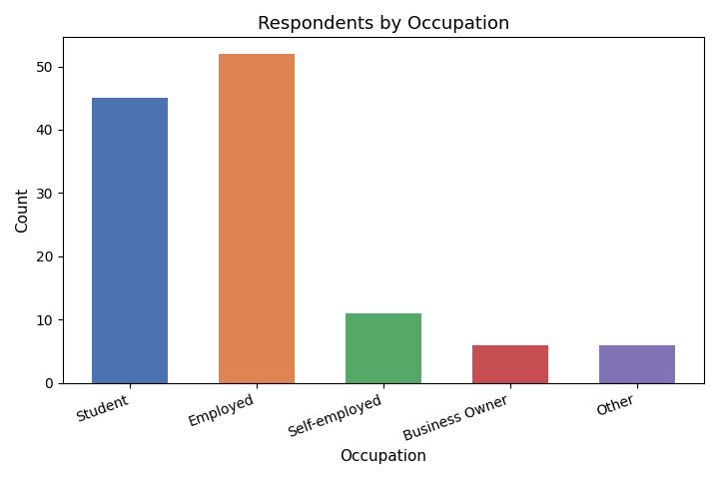
Respondents by Occupation
Interpretation: Employed respondents (43.3%) and students (37.5%) together account for more than four-fifths of the sample, indicating that the respondents are largely salaried individuals and students.

Table 4.4 Classification by Online Shopping Frequency
Shopping Frequency | No. of Respondents | Percentage (%)
Weekly | 37 | 30.8
Monthly | 52 | 43.3
Occasionally | 20 | 16.7
Rarely | 11 | 9.2
Total | 120 | 100.0
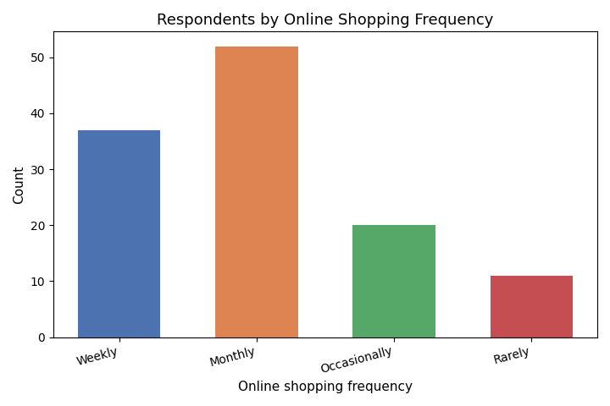
Respondents by Online Shopping Frequency
Interpretation: A majority of respondents shop online monthly (43.3%) or weekly (30.8%), showing that online shopping is a regular and established activity for most of the sample.

Table 4.5 Most Used E-Commerce Platform
Platform | No. of Respondents | Percentage (%)
Amazon | 57 | 47.5
Flipkart | 35 | 29.2
Meesho | 10 | 8.3
Myntra | 5 | 4.2
Ajio | 5 | 4.2
Other | 8 | 6.7
Total | 120 | 100.0
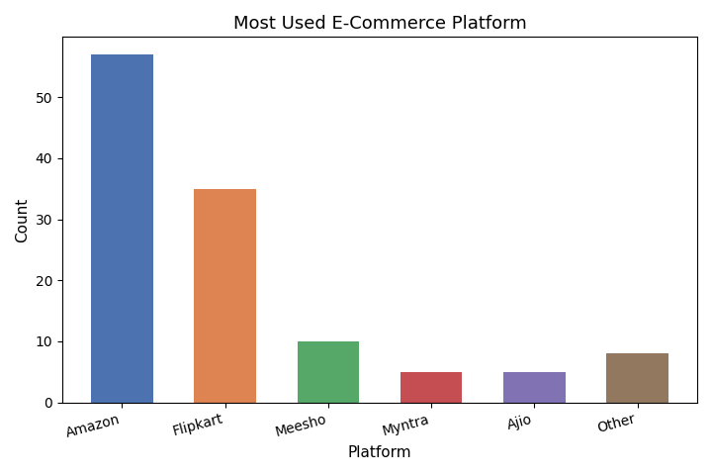
Most Used E-Commerce Platform
Interpretation: Amazon (47.5%) and Flipkart (29.2%) together account for more than three-quarters of the respondents, confirming the dominance of these two platforms in the Indian e-commerce market.

4.2 Descriptive Analysis of Online Shopping Experience and Perceived Benefits
Table 4.6 Mean Scores - Online Shopping Experience and Perceived Benefits
Item | Mean | S.D.
Q6 | 3.87 | 0.98
Q7 | 3.84 | 0.92
Q8 | 3.94 | 0.92
Q9 | 3.88 | 0.93
Q10 | 3.9 | 1.01
Q11 | 3.85 | 0.93
Q12 | 3.89 | 0.97
Interpretation: All seven items in this dimension record means above the neutral value of 3.0, ranging from 3.84 (Q7) to 3.94 (Q8). The overall dimension mean is 3.88, indicating that respondents hold a consistently favourable view of the convenience and benefits associated with online shopping. The standard deviations, which lie close to 1.0, show a moderate spread of opinion around these means.

4.3 Descriptive Analysis of Customer Satisfaction and Repurchase Intention
Table 4.7 Mean Scores - Customer Satisfaction and Repurchase Intention
Item | Mean | S.D.
Q13 | 3.81 | 0.97
Q14 | 3.83 | 0.99
Q15 | 3.93 | 0.92
Q16 | 3.92 | 0.95
Q17 | 3.87 | 1.0
Q18 | 3.92 | 0.96
Q19 | 3.98 | 0.97
Q20 | 3.77 | 1.06
Interpretation: The eight satisfaction and repurchase items also record uniformly positive means, ranging from 3.77 (Q20) to 3.98 (Q19), with an overall dimension mean of 3.88. This indicates that respondents are broadly satisfied with their online shopping experience and are inclined to purchase again from the same platforms.

4.4 Reliability Analysis
Table 4.8 Cronbach's Alpha
Scale | No. of Items | Cronbach's Alpha
Online Shopping Experience and Perceived Benefits | 7 | 0.9
Customer Satisfaction and Repurchase Intention | 8 | 0.918
Interpretation: The Cronbach's alpha values are 0.9 for the online shopping experience scale and 0.918 for the customer satisfaction scale. Both values comfortably exceed the commonly accepted threshold of 0.70 and fall in the 'high' to 'excellent' range, indicating strong internal consistency among the items within each dimension. The scales can therefore be treated as reliable composite measures, and the inferential results that follow can be interpreted with confidence.

4.5 Hypothesis Testing - Independent Samples T-Test
Objective: To test whether the perceived online shopping experience differs significantly between male and female consumers.
Table 4.9 T-Test - Shopping Experience Score by Gender
Gender | N | Mean | S.D.
Male | 41 | 3.983 | 0.743
Female | 35 | 3.804 | 0.793
t-value | p-value | Significance (alpha = 0.05)
1.012 | 0.315 | Not significant
Interpretation: The comparison is based on the 76 respondents who reported their gender as male or female; the 44 respondents who selected 'Prefer not to say' were excluded from this test. The calculated t-value is 1.012 with a p-value of 0.315, which is greater than 0.05. Therefore, the null hypothesis is ACCEPTED. There is no statistically significant difference in the perceived online shopping experience between male and female consumers, although the mean score for male respondents (3.983) is marginally higher than that for female respondents (3.804).

4.6 Hypothesis Testing - One-Way ANOVA
Objective: To test whether customer satisfaction differs significantly across age groups.
Table 4.10 ANOVA - Satisfaction Score by Age Group
Age Group | N | Mean | S.D.
Below 20 | 21 | 3.905 | 0.88
21-30 | 52 | 3.868 | 0.781
31-40 | 24 | 3.896 | 0.679
41-50 | 16 | 3.922 | 0.825
Above 50 | 7 | 3.714 | 0.877
F-value | p-value | Significance (alpha = 0.05)
0.098 | 0.983 | Not significant
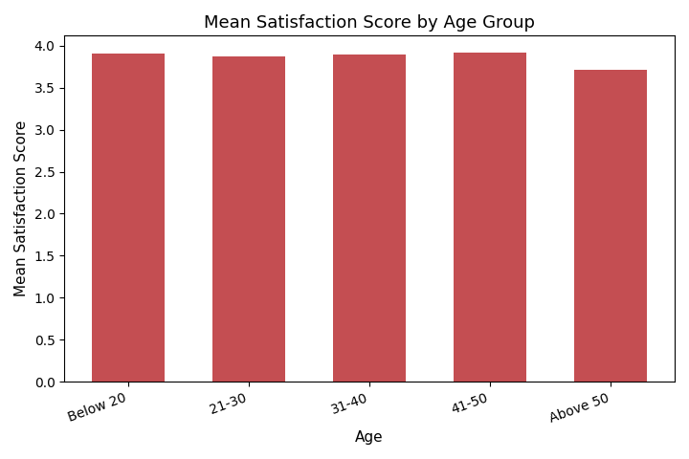
Figure 4.6 Mean Satisfaction Score by Age Group
Interpretation: The calculated F-value is 0.098 with a p-value of 0.983, which is greater than 0.05. Therefore, the null hypothesis is ACCEPTED. There is no statistically significant difference in customer satisfaction across the five age groups. As the figure shows, the mean satisfaction scores are closely clustered between 3.714 and 3.922, indicating that satisfaction with online shopping is broadly uniform regardless of the respondent's age.

4.7 Correlation Analysis
Objective: To examine the relationship between the online shopping experience and customer satisfaction.
Interpretation: A Pearson correlation was computed between the online shopping experience score and the customer satisfaction score. The correlation coefficient (r) is 0.894 with a p-value of less than 0.001, indicating a strong, positive and statistically significant relationship between the two dimensions. The null hypothesis is therefore REJECTED. Respondents who evaluate the online shopping experience more favourably also report substantially higher satisfaction and repurchase intention. This is the most important inferential finding of the study: while satisfaction does not vary meaningfully by gender or age, it is closely tied to the quality of the shopping experience itself.

CHAPTER 5: FINDINGS, SUGGESTIONS, CONCLUSION AND SUMMARY

5.1 Major Findings
- Out of 120 respondents, 41 (34.2%) are male, 35 (29.2%) are female and 44 (36.7%) preferred not to disclose their gender.
- The sample is dominated by young consumers, with 43.3% in the 21-30 age group.
- Employed respondents (43.3%) and students (37.5%) form the largest occupational groups.
- Online shopping is a regular activity: 43.3% shop monthly and 30.8% shop weekly.
- Amazon (47.5%) and Flipkart (29.2%) are the most widely used platforms.
- The overall mean score for the online shopping experience dimension is 3.88, with the highest-rated item being Q8 (mean 3.94).
- The overall mean score for the customer satisfaction and repurchase intention dimension is 3.88, with the highest-rated item being Q19 (mean 3.98).
- Both scales show high internal consistency, with Cronbach's alpha of 0.9 and 0.918 respectively.
- The t-test showed no significant difference in the perceived shopping experience between male and female consumers (t = 1.012, p = 0.315).
- The ANOVA showed no significant difference in satisfaction across age groups (F = 0.098, p = 0.983).
- A strong, positive and statistically significant correlation was found between the shopping experience and satisfaction (r = 0.894, p < 0.001).
- No respondent selected the lowest scale point (Strongly Disagree) on any of the fifteen statements, indicating a generally positive response pattern across the sample.

5.2 Suggestions
- Because satisfaction is strongly associated with the quality of the shopping experience, e-commerce firms should prioritise improvements to website and app usability, product information accuracy, and checkout simplicity.
- Delivery reliability and accurate order fulfilment should be treated as core service commitments, since they directly shape the post-purchase evaluation.
- Return and refund processes should be simple and clearly communicated, as this reduces purchase hesitation and protects satisfaction when a product disappoints.
- Since satisfaction does not differ significantly by gender or age, platforms can apply a broadly consistent service standard rather than heavily segmenting the core experience by demographics.
- Loyalty programmes and personalised recommendations should be used to convert satisfied customers into repeat purchasers, given the low switching costs in online retail.
- Future research should use a larger and more representative sample, and should capture the full wording of each scale item so that specific service attributes can be diagnosed individually.

5.3 Conclusion
The study set out to examine consumer buying behaviour and satisfaction towards online shopping. The findings indicate that online shopping is a well-established, routine activity for the respondents, concentrated among younger, employed consumers and dominated by the two largest marketplaces. Respondents evaluate the online shopping experience favourably (mean 3.88) and report correspondingly positive satisfaction and repurchase intention (mean 3.88), and both measurement scales proved highly reliable. Neither gender nor age produced statistically significant differences in these perceptions, suggesting that the appeal of online shopping now extends fairly evenly across demographic segments. The most substantive result is the strong positive correlation (r = 0.894) between the perceived shopping experience and satisfaction, which indicates that customer retention in e-commerce depends less on who the customer is than on how well the platform performs. Investments in usability, reliable delivery, and straightforward returns are therefore likely to yield the greatest gains in satisfaction and repeat purchase.

5.4 Summary
This project studied consumer buying behaviour and satisfaction towards online shopping using primary data from 120 respondents. The data were analysed through percentage analysis, descriptive statistics, Cronbach's alpha, an independent-samples t-test, one-way ANOVA, and Pearson correlation. The results showed frequent online shopping activity, favourable perceptions of the shopping experience, positive satisfaction and repurchase intention, high scale reliability, no significant demographic differences, and a strong significant relationship between the shopping experience and satisfaction. Based on the findings, suggestions were offered to help e-commerce firms improve customer satisfaction and retention.

APPENDIX I: QUESTIONNAIRE
Section A: Demographic and Behavioural Information
1. Age: Below 20 / 21-30 / 31-40 / 41-50 / Above 50
2. Gender: Male / Female / Prefer not to say
3. Occupation: Student / Employed / Self-employed / Business Owner / Other
4. How often do you shop online? Weekly / Monthly / Occasionally / Rarely
5. Which e-commerce platform do you use the most? Amazon / Flipkart / Meesho / Myntra / Ajio / Other

Section B: Online Shopping Experience and Perceived Benefits (1 = Strongly Disagree to 5 = Strongly Agree)
Note: The response dataset stores these statements under the item codes below. The full wording of each statement should be inserted here before final submission.
6. Q6 - [statement wording to be inserted]
7. Q7 - [statement wording to be inserted]
8. Q8 - [statement wording to be inserted]
9. Q9 - [statement wording to be inserted]
10. Q10 - [statement wording to be inserted]
11. Q11 - [statement wording to be inserted]
12. Q12 - [statement wording to be inserted]

Section C: Customer Satisfaction and Repurchase Intention (1 = Strongly Disagree to 5 = Strongly Agree)
13. Q13 - [statement wording to be inserted]
14. Q14 - [statement wording to be inserted]
15. Q15 - [statement wording to be inserted]
16. Q16 - [statement wording to be inserted]
17. Q17 - [statement wording to be inserted]
18. Q18 - [statement wording to be inserted]
19. Q19 - [statement wording to be inserted]
20. Q20 - [statement wording to be inserted]

APPENDIX II: BIBLIOGRAPHY / REFERENCES
Note: The following sources were referred to during the study. The entries marked as general studies should be replaced with the full citation details of the specific sources consulted, and the final formatting should be adjusted to the citation style (APA/MLA) required by your institution.
1. Oliver, R. L. (1980). A Cognitive Model of the Antecedents and Consequences of Satisfaction Decisions. Journal of Marketing Research, 17(4), 460-469.
2. Davis, F. D. (1989). Perceived Usefulness, Perceived Ease of Use, and User Acceptance of Information Technology. MIS Quarterly, 13(3), 319-340.
3. Parasuraman, A., Zeithaml, V. A., & Berry, L. L. (1988). SERVQUAL: A Multiple-Item Scale for Measuring Consumer Perceptions of Service Quality. Journal of Retailing, 64(1), 12-40.
4. General study on website quality and online purchase intention.
5. General study on trust and perceived security in online shopping.
6. General study on the influence of online customer reviews on purchase decisions.
7. General study on price sensitivity and price comparison in e-commerce.
8. General study on delivery performance and customer satisfaction.
9. General study on return and refund policies in online retail.
10. General study on mobile commerce adoption and checkout experience.
11. General study on perceived risk in online shopping.
12. General study on e-service quality, satisfaction and customer loyalty.
13. General study on discounts, promotional offers and purchase behaviour.
14. General study on demographic influences in online shopping behaviour.
15. General study on repurchase intention in e-commerce.

