INFLUENCE OF DIGITAL PAYMENT APPS (UPI) ON PERSONAL SPENDING AND SAVING BEHAVIOUR

Project submitted to MUST in partial fulfilment of the requirements for the award of the degree of
MASTER OF BUSINESS ADMINISTRATION (FINANCE)

Submitted by
LINGESH K
Register No: OSI2509030

ISSM Business School,
Chennai.

JUNE 2026

CERTIFICATE

This is to certify that the project “INFLUENCE OF DIGITAL PAYMENT APPS (UPI) ON PERSONAL SPENDING AND SAVING BEHAVIOUR” is a record of research work done by LINGESH K (Register No: OSI2509030) during the Academic Year 2025–2026 at ISSM Business School, Chennai, Tamil Nadu, India. This project has not previously formed the basis for the award of any Degree, Diploma, Associate-ship, Fellowship or any other similar title to anyone, and the project represents entirely an independent work on the part of the candidate.

Project Guide

Principal
ISSM Business School

DECLARATION

I, LINGESH K (Register No: OSI2509030), hereby declare that the project “INFLUENCE OF DIGITAL PAYMENT APPS (UPI) ON PERSONAL SPENDING AND SAVING BEHAVIOUR” is a bonafide record of research work done by me and is based on primary data collected through a structured questionnaire. I further declare that this work has not previously formed the basis for the award of any degree, diploma, associate-ship or other similar title.

Place: Chennai
Date: 30-06-2026

Signature of the Student
LINGESH K

ACKNOWLEDGEMENT

I would like to express my sincere gratitude to all those who have supported and guided me throughout the course of this project. The successful completion of this project would not have been possible without their encouragement, valuable insights, and continuous assistance.
I express my sincere thanks to ISSM Business School for the valuable guidance, encouragement, and support extended throughout this study. I am thankful to the Programme Co-ordinator and the faculty members for their constant motivation and guidance in completing this project.
I also thank the 167 respondents who spared their valuable time to complete the questionnaire, without whom this study would not have been possible. Finally, I am grateful to my family and friends for their continuous support and encouragement.

ABSTRACT

The Unified Payments Interface (UPI) has transformed the way individuals in India transact, save, and manage money. This study examines the influence of UPI-based digital payment applications on the personal spending and saving behaviour of users. Primary data were collected from 167 respondents through a structured questionnaire measured on a five-point rating scale. The data were analysed using simple percentage analysis and the chi-square test of independence. The results indicate that respondents report a high level of UPI usage for daily transactions, with a moderate perceived influence on spending and a relatively higher positive perception of saving discipline. The chi-square test found no statistically significant association between gender and the tendency to spend more than planned while using UPI. The study concludes that while UPI increases transactional convenience and encourages routine digital record-keeping, its perceived influence on spending and saving is broadly similar across demographic groups. Recommendations for promoting responsible digital payment habits are offered.

Keywords: UPI, digital payments, spending behaviour, saving behaviour, financial discipline, fintech.

TABLE OF CONTENT

CHAPTER NO. | CHAPTER | PAGE NO
I | INTRODUCTION | 1 - 8
II | REVIEW OF LITERATURE | 9 - 14
III | RESEARCH METHODOLOGY | 15 - 18
IV | DATA ANALYSIS & INTERPRETATION | 19 - 48
V | FINDINGS, SUGGESTIONS & CONCLUSION | 49 - 52
 | REFERENCES | 53 - 54
 | ANNEXURE | 55 - 58

CHAPTER – I
INTRODUCTION

CHAPTER – I

INTRODUCTION

1.1 Background of the Study
The financial landscape of India has undergone a remarkable transformation over the past decade. The introduction of the Unified Payments Interface (UPI) by the National Payments Corporation of India (NPCI) in 2016 created a real-time, mobile-first payment system that allows users to transfer money instantly between bank accounts using a smartphone. What began as a convenient alternative to cash and cards has rapidly become the dominant mode of retail payment in the country. By 2025, UPI was processing a very large share of the world’s real-time digital transactions, reflecting an unprecedented level of adoption across age groups, income segments, and geographies.
Applications such as Google Pay, PhonePe, Paytm and BHIM have made digital payments effortless. A transaction that once required carrying cash, visiting an ATM, or swiping a card can now be completed in seconds by scanning a QR code. This frictionless experience has important behavioural consequences. When money becomes intangible and payment becomes instantaneous, the psychological ‘pain of paying’ is reduced, which can influence how much and how often people spend, as well as how disciplined they are about saving.

1.2 Concept of Digital Payments and UPI
Digital payment refers to a transaction in which value is transferred electronically without the physical exchange of currency. UPI is a layer that sits on top of the existing banking infrastructure and enables peer-to-peer and person-to-merchant transactions through a single mobile application linked to a Virtual Payment Address (VPA). The key features of UPI include 24x7 availability, instant settlement, low or zero transaction cost for users, interoperability across banks and apps, and a simple authentication process.

1.3 Spending and Saving Behaviour
Spending behaviour refers to the patterns, frequency, and decision-making processes that govern how individuals use their money for consumption. Saving behaviour refers to the extent to which individuals set aside a portion of their income for future needs and exercise financial discipline. Both behaviours are influenced by income, financial literacy, convenience of payment, social influence, and the availability of incentives such as cashbacks and discounts. The convenience offered by UPI can pull behaviour in two opposite directions: it may encourage impulsive and more frequent spending, while at the same time the automatic digital record of every transaction may help users track expenses and budget more effectively.

1.4 Statement of the Problem
While UPI has clearly increased the convenience and speed of payments, its behavioural impact on personal finance is not fully understood. There is a concern that the ease of digital payments may lead to increased and unplanned spending, weaker awareness of how much is being spent, and a possible decline in saving. At the same time, digital records and budgeting features may improve financial discipline. It is therefore important to study empirically how UPI influences the spending and saving behaviour of users and whether this influence differs across demographic groups.

1.5 Objectives of the Study
The primary objective of the study is to analyse the influence of UPI-based digital payment applications on the personal spending and saving behaviour of users.
Specific Objectives:
➢ To study the usage pattern of UPI-based digital payment applications among respondents.
➢ To examine the influence of UPI on the personal spending behaviour of users.
➢ To analyse the influence of UPI on the personal saving behaviour of users.
➢ To study whether the tendency to spend more than planned is associated with the demographic profile of users.
➢ To offer suggestions for the responsible use of digital payment applications.

1.6 Scope of the Study
The study focuses on individual users of UPI-based digital payment applications. It covers the behavioural dimensions of spending and saving as perceived and self-reported by the respondents. The study is based on primary data collected from 167 respondents through an online structured questionnaire. The geographic scope is limited to the respondents reached through the survey, and the study period covers the data collection conducted in 2026.

1.7 Need and Significance of the Study
As UPI becomes the default mode of payment for a large section of the population, understanding its behavioural consequences is valuable for several stakeholders. For individuals, the study highlights how digital payments may affect their own financial discipline. For policymakers and financial educators, it provides insight into the need for financial-literacy initiatives in a cashless environment. For fintech companies, it offers a perspective on designing features that promote responsible spending and saving.

1.8 Limitations of the Study
➢ The study relies on self-reported perceptions, which may differ from actual transaction data.
➢ The sample is dominated by younger respondents (below 25 years) and lower income groups, which may limit generalisability.
➢ The study focuses only on selected behavioural dimensions of spending and saving.
➢ The study is cross-sectional and does not capture changes in behaviour over time.

1.9 Chapterization
The research is organized into five chapters:
Chapter I – Introduction: Provides background, concepts, and framework of the study.
Chapter II – Review of Literature: Examines previous studies related to digital payments and consumer behaviour.
Chapter III – Research Methodology: Describes research design, data collection, and analysis methods.
Chapter IV – Data Analysis and Interpretation: Presents analysis of the collected data.
Chapter V – Findings, Suggestions and Conclusion: Summarizes results and provides recommendations.

1.10 Conclusion of the Chapter
This chapter has provided a comprehensive overview of digital payments and UPI and their potential influence on the spending and saving behaviour of users. It has established the foundation for understanding how the convenience of digital payments can shape personal financial behaviour, and it has set out the objectives, scope, and significance of the study that guide the subsequent chapters.

CHAPTER – II
REVIEW OF LITERATURE

CHAPTER – II

REVIEW OF LITERATURE
The Review of Literature is a critical summary and evaluation of existing research and scholarly work relevant to a specific topic or field of study. It helps identify gaps in knowledge, understand the current state of research, and provides a theoretical foundation for a new study. This chapter reviews relevant studies published over the past ten years on digital payments, UPI, and their influence on consumer spending and saving behaviour, and helps to identify the research gap addressed by the present study.
Agarwal, Ghosh, Li and Ruan (2018) studied the impact of the 2016 demonetization in India and found that the usage of digital payments rose and monthly spending increased among households that were previously more cash-dependent, with spending remaining elevated even after cash availability recovered.
Brown, Nacht, Nellen and Stix (2023) examined cashless payments and consumer spending and found that present-biased consumers tend to spend more the more frequently they use cashless payment instruments, suggesting a behavioural link between payment convenience and higher expenditure.
A Study on UPI’s Impact on Spending Behaviour among Indian Users (2024) surveyed 276 respondents and reported that approximately 75% experienced increased spending due to UPI, attributing this largely to the intangible nature of digital money, which reduced the guilt usually associated with spending.
A Study on E-Wallets and Impulse Buying among Gen-Y and Gen-Z Consumers (2022) found that perceived enjoyment of using an e-wallet positively influenced impulse buying, while satisfaction with the e-wallet did not have a significant relationship with impulse purchases.
A Study on Sales Promotion, FOMO and Digital Payment Methods (2024) highlighted that despite their convenience, digital payment methods can contribute to impulse purchases, particularly among the younger generation influenced by fear of missing out and promotional offers.
A Study on the Impact of Instant Digital Transactions on Consumer Spending (2025) observed that the rise of instant digital transactions through UPI, mobile wallets and contactless payments enhanced convenience but also encouraged impulsive purchases and contributed to reduced savings.
A Study on the Behavioural Impact of Digital Wallets on Modern Consumers (2024) analysed how digital wallets have changed consumer expenditure trends and concluded that convenience and security significantly shape purchasing behaviour and consumption patterns.
A Study on Determinants of Behavioural Intention to Use Digital Payment among Indian Youngsters (2024) found that perceived value, trust, compatibility and social influence significantly influence the behavioural intention to use mobile wallets, whereas perceived enjoyment had a weaker effect.
A Study on UPI as a Digital Innovation and Financial Inclusion (2021) found that UPI positively impacts financial literacy, which in turn significantly influences financial inclusion and contributes to economic development.
A Study on Cashless Transactions among University Students (2021) reported that cashless payment modes are widely adopted by students and that incentives such as perceived free benefits increase their willingness to spend more.
A Comparative Analysis of UPI versus Traditional Payment Methods (2024) examined efficiency and user experience and concluded that UPI’s seamless, real-time system offers clear advantages over cash and cards and promotes a cashless economy.
An Empirical Study on Consumer Perception towards UPI in India (2024) explored consumer perception of UPI as an instant inter-bank payment system and identified convenience and trust as key drivers of adoption.
A Study on Intention and Adoption of E-Wallets (2022) found that perceived usefulness, ease of use, social influence, lifestyle compatibility and trust significantly and positively affect the intention to use and adopt e-wallets.
A Study on Sustainable Economic Development, Digital Payment and Consumer Demand (2022) established that the growth of digital payments is associated with changes in consumer demand and contributes to sustainable economic development.
An EY-CII Industry Report on Digital Payments in Rural and Semi-Urban India (2024) reported that UPI is the most preferred payment mode for a large proportion of users in rural and semi-urban areas, and that a very high share of respondents demonstrated a strong inclination to save and invest.
A Study Assessing the Role of UPI in Financial Inclusion and Digital Trust (2025) found that financial literacy and infrastructure significantly affect service experience and digital trust, although trust and policy awareness alone did not significantly drive sustained usage.
A Study on the Influence of Digital Wallets on Consumer Behaviour for Sustainable Growth (2025) examined how shifts in consumer purchasing behaviour driven by digital wallets affect sustainable economic growth.
A Study on Small-Scale Merchants’ Acceptance of UPI in India (2026) identified a gap in understanding UPI acceptance among small merchants and examined the factors driving their adoption of UPI payment apps.

2.1 Research Gap
The reviewed literature confirms that digital payments and UPI strongly influence consumer behaviour, with many studies reporting increased and impulsive spending. However, most studies focus either on the adoption of UPI or on spending alone, and relatively few examine spending and saving behaviour together while also testing whether these effects differ across demographic groups. The present study addresses this gap by empirically analysing both spending and saving behaviour among 167 UPI users and testing for demographic association using the chi-square test.

CHAPTER – III
RESEARCH METHODOLOGY

CHAPTER – III

RESEARCH METHODOLOGY
Research methodology is a systematic way of solving the research problem. It includes the methods and techniques used for collecting, analysing, and interpreting data related to the study. This chapter explains the research design, sampling method, data collection methods, and statistical tools used in the study titled “INFLUENCE OF DIGITAL PAYMENT APPS (UPI) ON PERSONAL SPENDING AND SAVING BEHAVIOUR”.
RESEARCH DESIGN
This study uses a descriptive research design. Descriptive research helps in describing the characteristics, opinions, and behaviour of UPI users regarding their spending and saving. A quantitative research method is used to collect measurable data for statistical analysis.
HYPOTHESIS
Hypothesis is a tentative assumption or prediction made by the researcher regarding the relationship between variables in a study. In this study, the hypothesis is formulated to examine whether there is a significant association between gender and the tendency to spend more than planned while using UPI.
Null Hypothesis (H₀): There is no significant association between gender and the tendency to spend more than planned while using UPI.
Alternative Hypothesis (H₁): There is a significant association between gender and the tendency to spend more than planned while using UPI.
SAMPLING METHOD
The sampling method adopted for this study is convenience sampling. Convenience sampling is a non-probability sampling technique where respondents are selected based on their availability and willingness to participate in the study.
SAMPLING UNIT
The sampling unit of the study consists of individual users of UPI-based digital payment applications.
SAMPLE SIZE
The sample size refers to the number of respondents selected for the study. The sample size for this research is 167 respondents.
SAMPLING AREA
The study was conducted through an online survey, with respondents primarily drawn from Chennai and surrounding regions.
PERIOD OF STUDY
The study was conducted during the year 2026, over the period of data collection through the online questionnaire.
DATA COLLECTION METHOD
Data collection is the process of gathering information for the purpose of analysis and interpretation. Both primary and secondary data were used in this study.
PRIMARY DATA
Primary data were collected directly from respondents through a structured questionnaire administered using Google Forms. The questionnaire included demographic questions and statements related to spending and saving behaviour, rated on a five-point scale.
SECONDARY DATA
Secondary data were collected from journals, research articles, industry reports, and reliable online sources related to digital payments and consumer behaviour.
STATISTICAL TOOLS USED
Statistical tools are used to analyse and interpret the collected data effectively. The following statistical tools were used in the study:
❖ SIMPLE PERCENTAGE ANALYSIS
Simple percentage analysis is used to analyse the demographic factors and responses of the respondents.
Percentage of responses = (Number of responses / Total respondents) × 100
❖ CHI-SQUARE TEST
The chi-square test is used to identify whether there is any significant association between a demographic variable and the spending behaviour of respondents.

CHAPTER – IV
DATA ANALYSIS AND INTERPRETATION

CHAPTER – IV

DATA ANALYSIS AND INTERPRETATION
This chapter presents the analysis of the primary data collected from 167 respondents. The responses are analysed using simple percentage analysis and presented through frequency tables, interpretations, and charts, followed by a chi-square test of independence.
TABLE – 4.1
GENDER OF THE RESPONDENTS
S. NO | PARTICULAR | FREQUENCY | PERCENTAGE
1 | Male | 96 | 57%
2 | Female | 71 | 43%
 | TOTAL | 167 | 100%
INTERPRETATION
The table 4.1 depicts the gender composition of the respondents. It is revealed that 57% of the respondents were male, 43% of the respondents were female. It is found that the majority of the respondents were male.
CHART – 4.1
GENDER OF THE RESPONDENTS
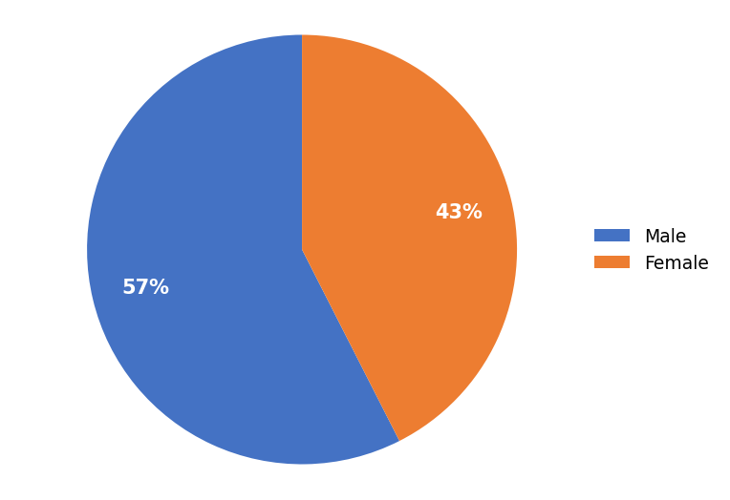

TABLE – 4.2
AGE OF THE RESPONDENTS
S. NO | PARTICULAR | FREQUENCY | PERCENTAGE
1 | Below 25 | 136 | 81%
2 | 25-35 | 28 | 17%
3 | Above 35 | 3 | 2%
 | TOTAL | 167 | 100%
INTERPRETATION
The table 4.2 depicts the age composition of the respondents. It is revealed that 81% of the respondents were below 25, 17% of the respondents were 25-35, 2% of the respondents were above 35. It is found that the majority of the respondents were below 25.
CHART – 4.2
AGE OF THE RESPONDENTS
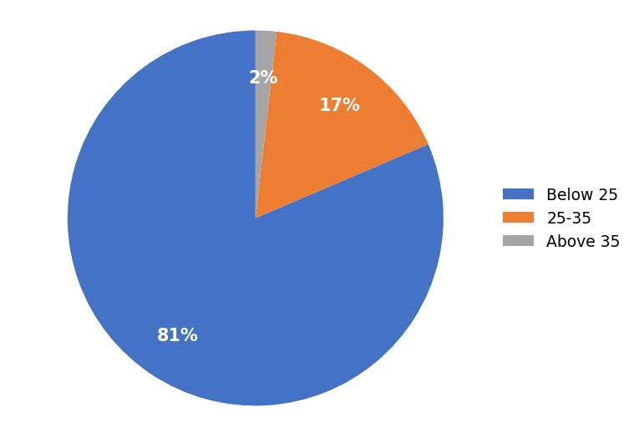

TABLE – 4.3
EDUCATIONAL QUALIFICATION OF THE RESPONDENTS
S. NO | PARTICULAR | FREQUENCY | PERCENTAGE
1 | School | 22 | 13%
2 | UG | 74 | 44%
3 | Professional/Masters | 71 | 43%
 | TOTAL | 167 | 100%
INTERPRETATION
The table 4.3 depicts the educational qualification of the respondents. It is revealed that 13% of the respondents were school, 44% of the respondents were ug, 43% of the respondents were professional/masters. It is found that the majority of the respondents were ug.
CHART – 4.3
EDUCATIONAL QUALIFICATION OF THE RESPONDENTS
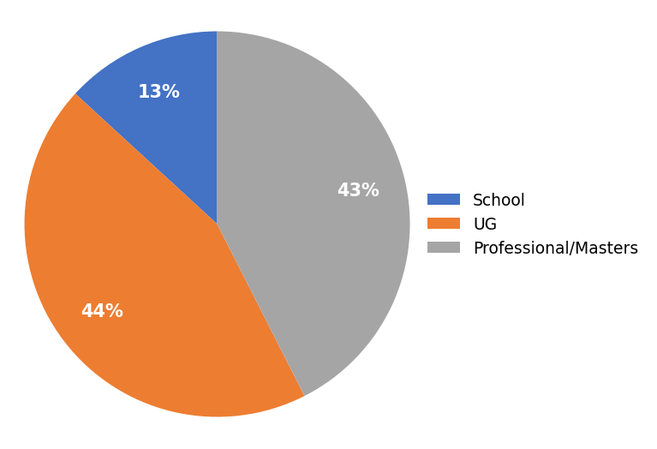

TABLE – 4.4
MONTHLY INCOME OF THE RESPONDENTS
S. NO | PARTICULAR | FREQUENCY | PERCENTAGE
1 | Below 25000 | 108 | 65%
2 | 25000-50000 | 40 | 24%
3 | 50000-100000 | 16 | 10%
4 | Above 100000 | 3 | 2%
 | TOTAL | 167 | 100%
INTERPRETATION
The table 4.4 depicts the monthly income of the respondents. It is revealed that 65% of the respondents were below 25000, 24% of the respondents were 25000-50000, 10% of the respondents were 50000-100000, 2% of the respondents were above 100000. It is found that the majority of the respondents were below 25000.
CHART – 4.4
MONTHLY INCOME OF THE RESPONDENTS
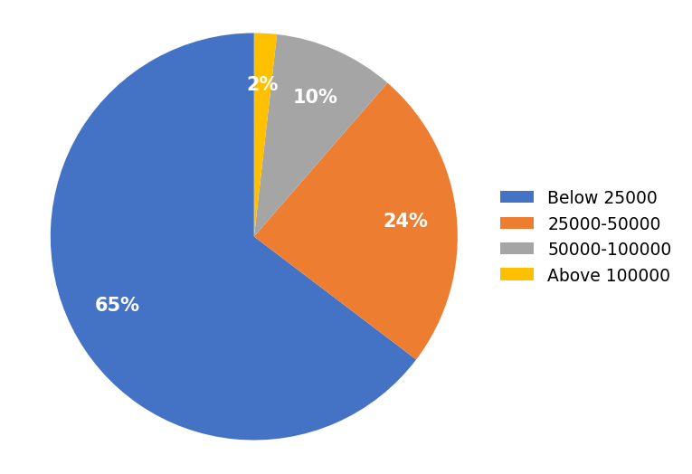

TABLE – 4.5
MOST USED UPI APPLICATION
S. NO | PARTICULAR | FREQUENCY | PERCENTAGE
1 | Google Pay | 77 | 46%
2 | PhonePe | 64 | 38%
3 | Paytm | 21 | 13%
4 | BHIM | 1 | 1%
5 | Others | 4 | 2%
 | TOTAL | 167 | 100%
INTERPRETATION
The table 4.5 depicts the most used UPI application of the respondents. It is revealed that 46% of the respondents were google pay, 38% of the respondents were phonepe, 13% of the respondents were paytm, 1% of the respondents were bhim, 2% of the respondents were others. It is found that the majority of the respondents were google pay.
CHART – 4.5
MOST USED UPI APPLICATION
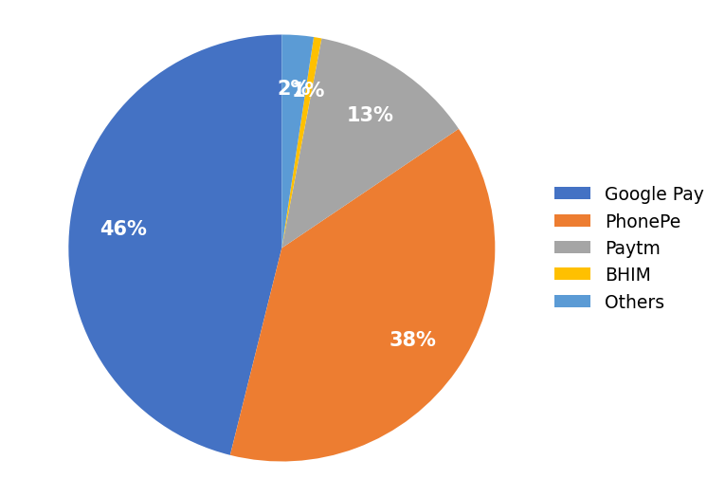

TABLE – 4.6
USE OF UPI FOR DAILY TRANSACTIONS
S. NO | PARTICULAR | FREQUENCY | PERCENTAGE
1 | Strongly Disagree | 5 | 3%
2 | Disagree | 4 | 2%
3 | Neutral | 21 | 13%
4 | Agree | 42 | 25%
5 | Strongly Agree | 95 | 57%
 | TOTAL | 167 | 100%
INTERPRETATION
The table 4.6 shows that 57% strongly agree, 25% agree, 13% neutral, 2% disagree and 3% strongly disagree. It is found that the majority of the respondents were agreeing that they use UPI for most of their daily transactions.
CHART – 4.6
USE OF UPI FOR DAILY TRANSACTIONS
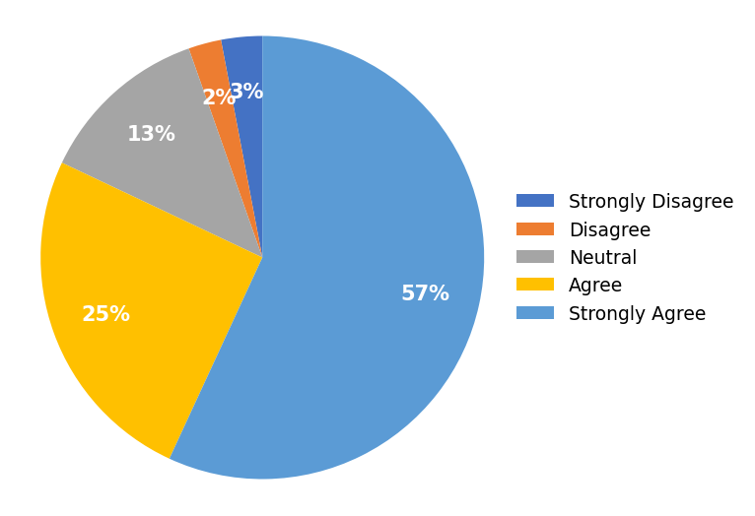

TABLE – 4.7
UPI AND SPENDING MORE THAN PLANNED
S. NO | PARTICULAR | FREQUENCY | PERCENTAGE
1 | Strongly Disagree | 18 | 11%
2 | Disagree | 36 | 22%
3 | Neutral | 42 | 25%
4 | Agree | 48 | 29%
5 | Strongly Agree | 23 | 14%
 | TOTAL | 167 | 100%
INTERPRETATION
The table 4.7 shows that 14% strongly agree, 29% agree, 25% neutral, 22% disagree and 11% strongly disagree. It is found that the majority of the respondents were agreeing that using UPI makes them spend more than planned.
CHART – 4.7
UPI AND SPENDING MORE THAN PLANNED
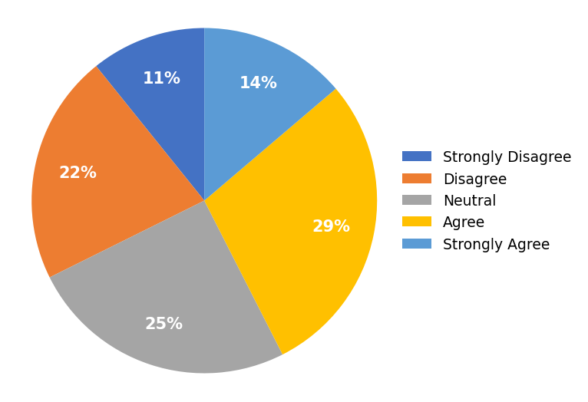

TABLE – 4.8
UPI AND IMPULSE / UNPLANNED PURCHASES
S. NO | PARTICULAR | FREQUENCY | PERCENTAGE
1 | Strongly Disagree | 11 | 7%
2 | Disagree | 36 | 22%
3 | Neutral | 47 | 28%
4 | Agree | 46 | 28%
5 | Strongly Agree | 27 | 16%
 | TOTAL | 167 | 100%
INTERPRETATION
The table 4.8 shows that 16% strongly agree, 28% agree, 28% neutral, 22% disagree and 7% strongly disagree. It is found that the majority of the respondents were neutral regarding whether they make more impulse or unplanned purchases because UPI is convenient.
CHART – 4.8
UPI AND IMPULSE / UNPLANNED PURCHASES
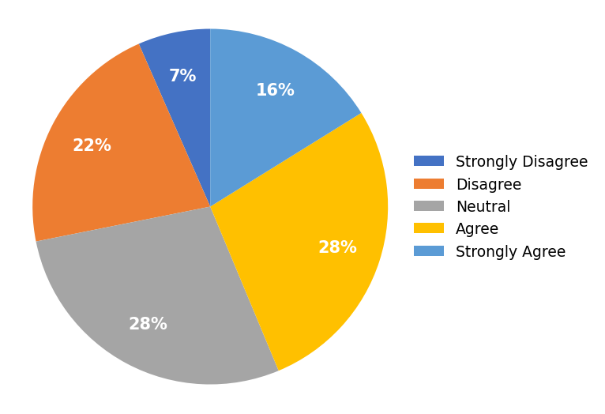

TABLE – 4.9
DIFFICULTY IN TRACKING SPENDING
S. NO | PARTICULAR | FREQUENCY | PERCENTAGE
1 | Strongly Disagree | 36 | 22%
2 | Disagree | 52 | 31%
3 | Neutral | 49 | 29%
4 | Agree | 22 | 13%
5 | Strongly Agree | 8 | 5%
 | TOTAL | 167 | 100%
INTERPRETATION
The table 4.9 shows that 5% strongly agree, 13% agree, 29% neutral, 31% disagree and 22% strongly disagree. It is found that the majority of the respondents were disagreeing that they find it harder to track spending when using UPI.
CHART – 4.9
DIFFICULTY IN TRACKING SPENDING
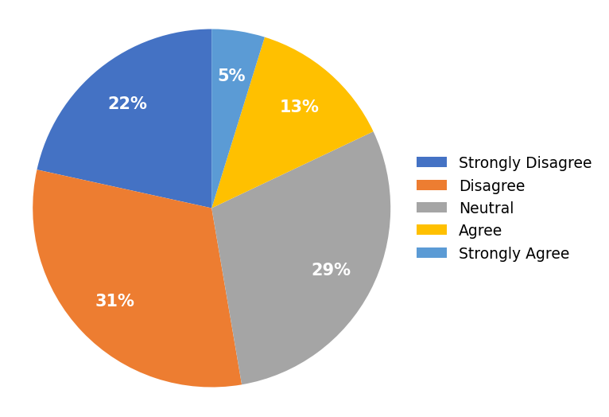

TABLE – 4.10
INFLUENCE OF CASHBACKS AND OFFERS ON SPENDING
S. NO | PARTICULAR | FREQUENCY | PERCENTAGE
1 | Strongly Disagree | 7 | 4%
2 | Disagree | 19 | 11%
3 | Neutral | 49 | 29%
4 | Agree | 65 | 39%
5 | Strongly Agree | 27 | 16%
 | TOTAL | 167 | 100%
INTERPRETATION
The table 4.10 shows that 16% strongly agree, 39% agree, 29% neutral, 11% disagree and 4% strongly disagree. It is found that the majority of the respondents were agreeing that UPI cashbacks and offers encourage them to spend more.
CHART – 4.10
INFLUENCE OF CASHBACKS AND OFFERS ON SPENDING
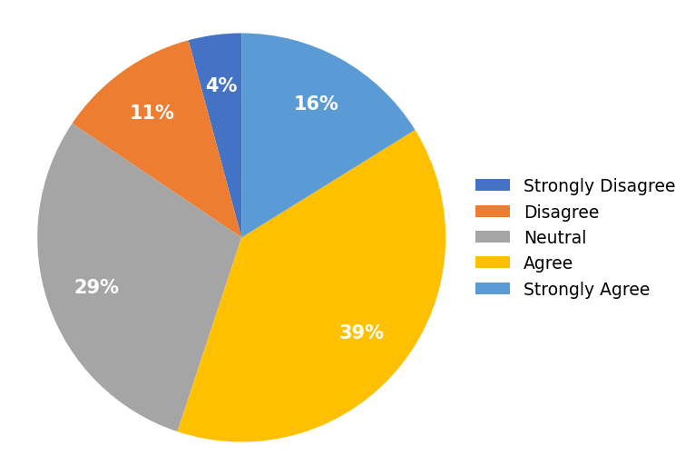

TABLE – 4.11
SPENDING ON SMALL ITEMS THROUGH UPI
S. NO | PARTICULAR | FREQUENCY | PERCENTAGE
1 | Strongly Disagree | 6 | 4%
2 | Disagree | 33 | 20%
3 | Neutral | 39 | 23%
4 | Agree | 49 | 29%
5 | Strongly Agree | 40 | 24%
 | TOTAL | 167 | 100%
INTERPRETATION
The table 4.11 shows that 24% strongly agree, 29% agree, 23% neutral, 20% disagree and 4% strongly disagree. It is found that the majority of the respondents were agreeing that they spend on small items that they would have skipped with cash.
CHART – 4.11
SPENDING ON SMALL ITEMS THROUGH UPI
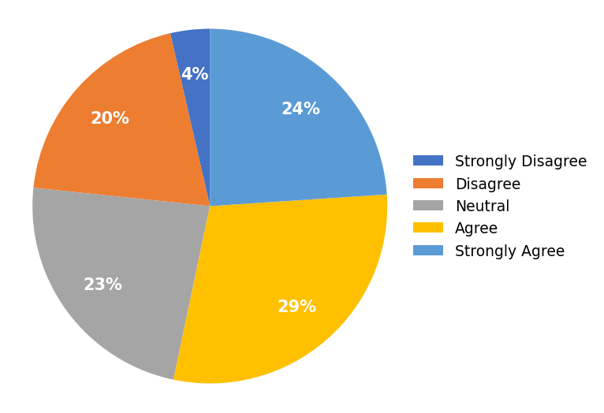

TABLE – 4.12
INCREASE IN OVERALL MONTHLY EXPENSES
S. NO | PARTICULAR | FREQUENCY | PERCENTAGE
1 | Strongly Disagree | 10 | 6%
2 | Disagree | 34 | 20%
3 | Neutral | 60 | 36%
4 | Agree | 46 | 28%
5 | Strongly Agree | 17 | 10%
 | TOTAL | 167 | 100%
INTERPRETATION
The table 4.12 shows that 10% strongly agree, 28% agree, 36% neutral, 20% disagree and 6% strongly disagree. It is found that the majority of the respondents were neutral regarding whether the ease of UPI has increased their overall monthly expenses.
CHART – 4.12
INCREASE IN OVERALL MONTHLY EXPENSES
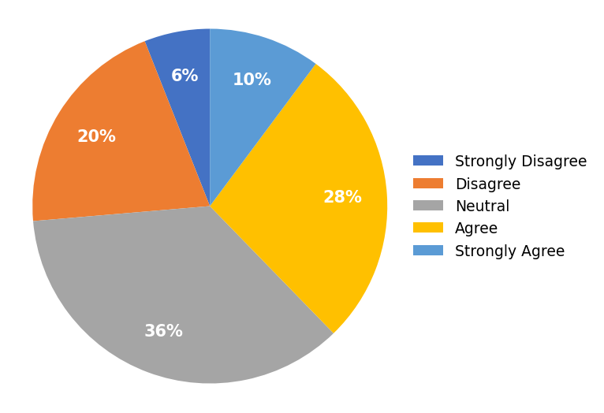

TABLE – 4.13
PAYING DIGITALLY WITHOUT THINKING ABOUT THE AMOUNT
S. NO | PARTICULAR | FREQUENCY | PERCENTAGE
1 | Strongly Disagree | 21 | 13%
2 | Disagree | 34 | 20%
3 | Neutral | 56 | 34%
4 | Agree | 41 | 25%
5 | Strongly Agree | 15 | 9%
 | TOTAL | 167 | 100%
INTERPRETATION
The table 4.13 shows that 9% strongly agree, 25% agree, 34% neutral, 20% disagree and 13% strongly disagree. It is found that the majority of the respondents were neutral regarding whether they often pay digitally without thinking about the amount.
CHART – 4.13
PAYING DIGITALLY WITHOUT THINKING ABOUT THE AMOUNT
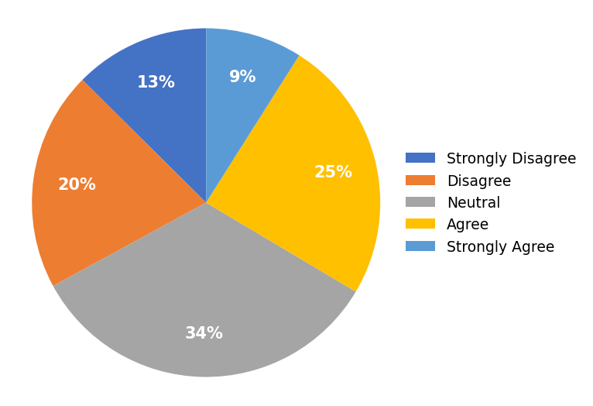

TABLE – 4.14
SHOPPING ONLINE MORE DUE TO UPI
S. NO | PARTICULAR | FREQUENCY | PERCENTAGE
1 | Strongly Disagree | 8 | 5%
2 | Disagree | 22 | 13%
3 | Neutral | 39 | 23%
4 | Agree | 54 | 32%
5 | Strongly Agree | 44 | 26%
 | TOTAL | 167 | 100%
INTERPRETATION
The table 4.14 shows that 26% strongly agree, 32% agree, 23% neutral, 13% disagree and 5% strongly disagree. It is found that the majority of the respondents were agreeing that they shop online more because UPI payment is quick and easy.
CHART – 4.14
SHOPPING ONLINE MORE DUE TO UPI
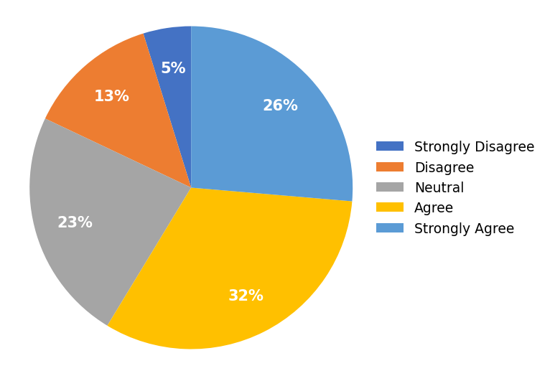

TABLE – 4.15
LOSING THE FEEL OF MONEY WITH UPI
S. NO | PARTICULAR | FREQUENCY | PERCENTAGE
1 | Strongly Disagree | 18 | 11%
2 | Disagree | 39 | 23%
3 | Neutral | 32 | 19%
4 | Agree | 52 | 31%
5 | Strongly Agree | 26 | 16%
 | TOTAL | 167 | 100%
INTERPRETATION
The table 4.15 shows that 16% strongly agree, 31% agree, 19% neutral, 23% disagree and 11% strongly disagree. It is found that the majority of the respondents were agreeing that they lose the feel of money when paying through UPI.
CHART – 4.15
LOSING THE FEEL OF MONEY WITH UPI
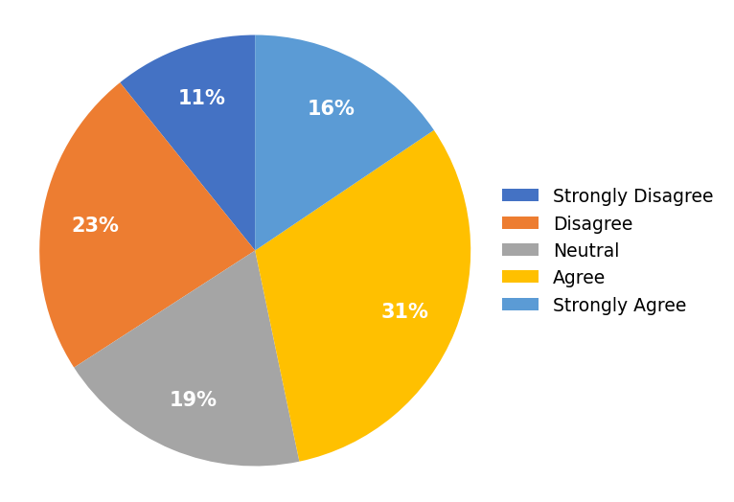

TABLE – 4.16
ABILITY TO SAVE A FIXED AMOUNT EVERY MONTH
S. NO | PARTICULAR | FREQUENCY | PERCENTAGE
1 | Strongly Disagree | 6 | 4%
2 | Disagree | 16 | 10%
3 | Neutral | 34 | 20%
4 | Agree | 60 | 36%
5 | Strongly Agree | 51 | 31%
 | TOTAL | 167 | 100%
INTERPRETATION
The table 4.16 shows that 31% strongly agree, 36% agree, 20% neutral, 10% disagree and 4% strongly disagree. It is found that the majority of the respondents were agreeing that they are able to save a fixed amount every month.
CHART – 4.16
ABILITY TO SAVE A FIXED AMOUNT EVERY MONTH
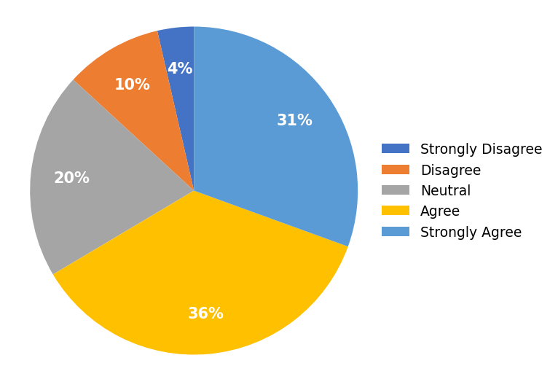

TABLE – 4.17
DIGITAL RECORDS IMPROVING BUDGETING
S. NO | PARTICULAR | FREQUENCY | PERCENTAGE
1 | Strongly Disagree | 3 | 2%
2 | Disagree | 6 | 4%
3 | Neutral | 29 | 17%
4 | Agree | 52 | 31%
5 | Strongly Agree | 77 | 46%
 | TOTAL | 167 | 100%
INTERPRETATION
The table 4.17 shows that 46% strongly agree, 31% agree, 17% neutral, 4% disagree and 2% strongly disagree. It is found that the majority of the respondents were agreeing that UPI helps them keep digital records that improve their budgeting.
CHART – 4.17
DIGITAL RECORDS IMPROVING BUDGETING
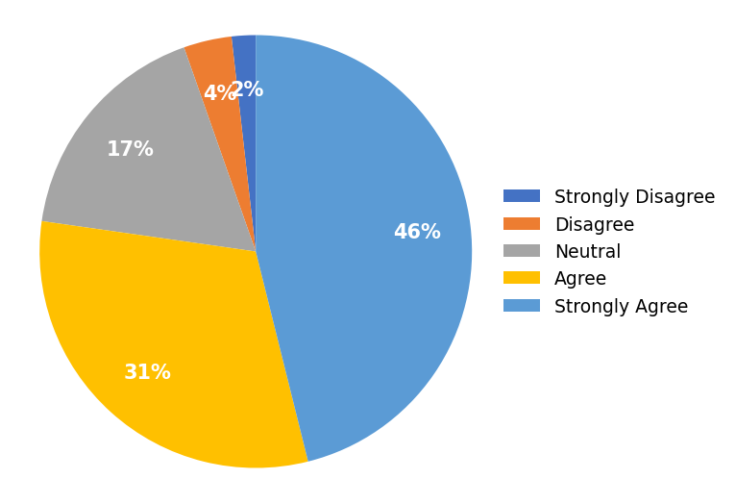

TABLE – 4.18
REVIEWING TRANSACTION HISTORY TO CONTROL EXPENSES
S. NO | PARTICULAR | FREQUENCY | PERCENTAGE
1 | Strongly Disagree | 5 | 3%
2 | Disagree | 25 | 15%
3 | Neutral | 31 | 19%
4 | Agree | 62 | 37%
5 | Strongly Agree | 44 | 26%
 | TOTAL | 167 | 100%
INTERPRETATION
The table 4.18 shows that 26% strongly agree, 37% agree, 19% neutral, 15% disagree and 3% strongly disagree. It is found that the majority of the respondents were agreeing that they review their UPI transaction history to control expenses.
CHART – 4.18
REVIEWING TRANSACTION HISTORY TO CONTROL EXPENSES
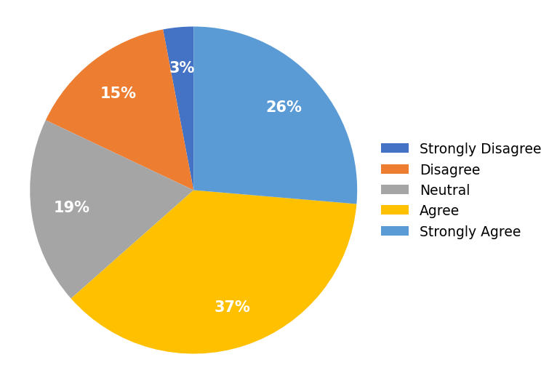

TABLE – 4.19
UPI AND FINANCIAL DISCIPLINE
S. NO | PARTICULAR | FREQUENCY | PERCENTAGE
1 | Strongly Disagree | 8 | 5%
2 | Disagree | 15 | 9%
3 | Neutral | 36 | 22%
4 | Agree | 64 | 38%
5 | Strongly Agree | 44 | 26%
 | TOTAL | 167 | 100%
INTERPRETATION
The table 4.19 shows that 26% strongly agree, 38% agree, 22% neutral, 9% disagree and 5% strongly disagree. It is found that the majority of the respondents were agreeing that UPI has made them more disciplined about their finances.
CHART – 4.19
UPI AND FINANCIAL DISCIPLINE
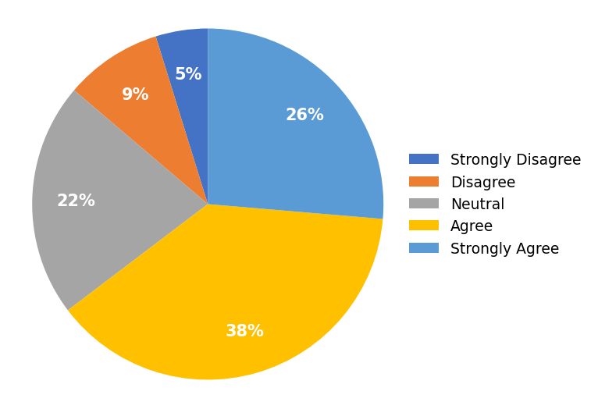

TABLE – 4.20
SETTING A MONTHLY SPENDING LIMIT
S. NO | PARTICULAR | FREQUENCY | PERCENTAGE
1 | Strongly Disagree | 12 | 7%
2 | Disagree | 19 | 11%
3 | Neutral | 37 | 22%
4 | Agree | 62 | 37%
5 | Strongly Agree | 37 | 22%
 | TOTAL | 167 | 100%
INTERPRETATION
The table 4.20 shows that 22% strongly agree, 37% agree, 22% neutral, 11% disagree and 7% strongly disagree. It is found that the majority of the respondents were agreeing that they set a monthly spending limit for themselves.
CHART – 4.20
SETTING A MONTHLY SPENDING LIMIT
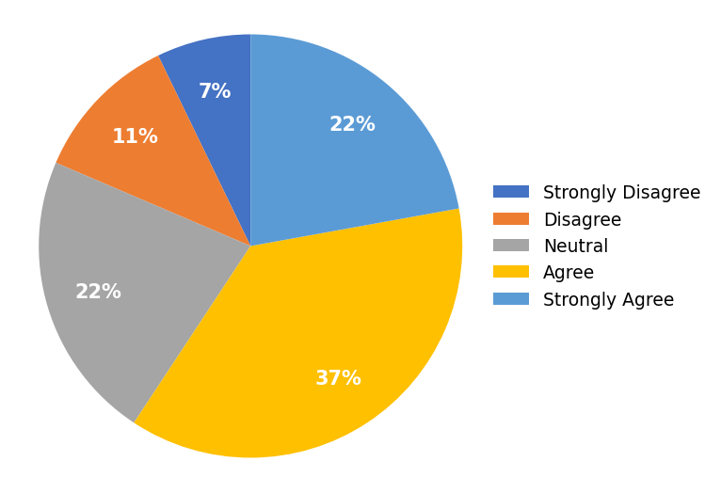

TABLE – 4.21
TRANSFERRING MONEY TO SAVINGS BEFORE SPENDING
S. NO | PARTICULAR | FREQUENCY | PERCENTAGE
1 | Strongly Disagree | 23 | 14%
2 | Disagree | 42 | 25%
3 | Neutral | 40 | 24%
4 | Agree | 42 | 25%
5 | Strongly Agree | 20 | 12%
 | TOTAL | 167 | 100%
INTERPRETATION
The table 4.21 shows that 12% strongly agree, 25% agree, 24% neutral, 25% disagree and 14% strongly disagree. It is found that the majority of the respondents were disagreeing that they transfer money to savings before spending on wants.
CHART – 4.21
TRANSFERRING MONEY TO SAVINGS BEFORE SPENDING
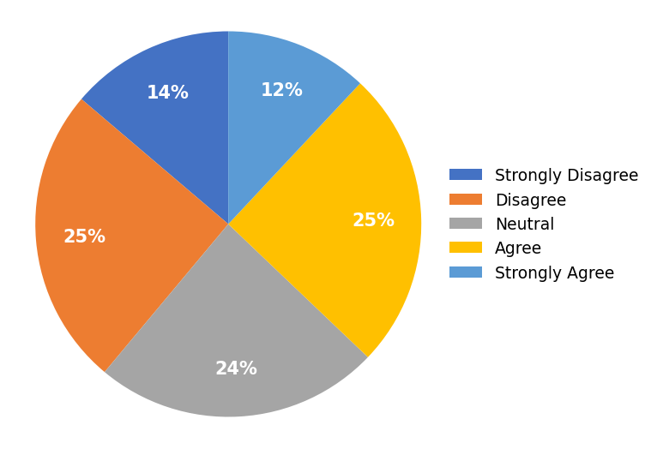

TABLE – 4.22
AVOIDING BORROWING / CASH SHORTAGES
S. NO | PARTICULAR | FREQUENCY | PERCENTAGE
1 | Strongly Disagree | 6 | 4%
2 | Disagree | 10 | 6%
3 | Neutral | 18 | 11%
4 | Agree | 57 | 34%
5 | Strongly Agree | 76 | 46%
 | TOTAL | 167 | 100%
INTERPRETATION
The table 4.22 shows that 46% strongly agree, 34% agree, 11% neutral, 6% disagree and 4% strongly disagree. It is found that the majority of the respondents were agreeing that digital payments help them avoid borrowing or cash shortages.
CHART – 4.22
AVOIDING BORROWING / CASH SHORTAGES
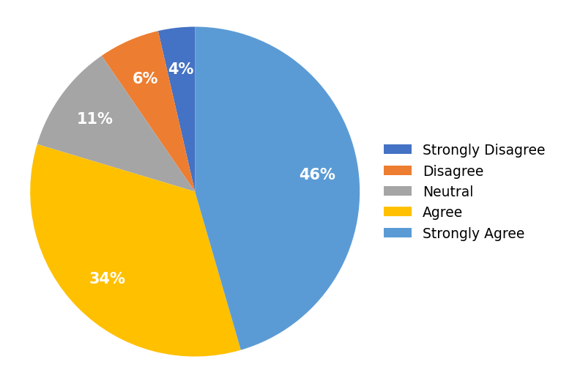

TABLE – 4.23
BETTER PLANNING OF EXPENSES
S. NO | PARTICULAR | FREQUENCY | PERCENTAGE
1 | Strongly Disagree | 9 | 5%
2 | Disagree | 9 | 5%
3 | Neutral | 40 | 24%
4 | Agree | 60 | 36%
5 | Strongly Agree | 49 | 29%
 | TOTAL | 167 | 100%
INTERPRETATION
The table 4.23 shows that 29% strongly agree, 36% agree, 24% neutral, 5% disagree and 5% strongly disagree. It is found that the majority of the respondents were agreeing that they plan their expenses better because of digital transaction records.
CHART – 4.23
BETTER PLANNING OF EXPENSES
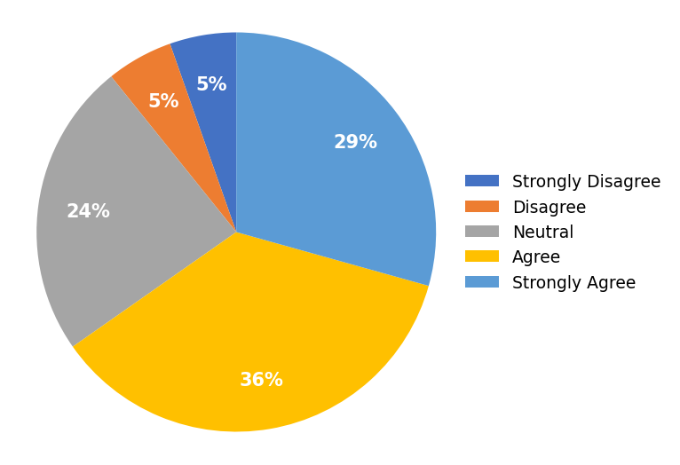

TABLE – 4.24
STABILITY / IMPROVEMENT IN SAVINGS
S. NO | PARTICULAR | FREQUENCY | PERCENTAGE
1 | Strongly Disagree | 3 | 2%
2 | Disagree | 17 | 10%
3 | Neutral | 38 | 23%
4 | Agree | 58 | 35%
5 | Strongly Agree | 51 | 31%
 | TOTAL | 167 | 100%
INTERPRETATION
The table 4.24 shows that 31% strongly agree, 35% agree, 23% neutral, 10% disagree and 2% strongly disagree. It is found that the majority of the respondents were agreeing that their savings have remained stable or improved since using UPI.
CHART – 4.24
STABILITY / IMPROVEMENT IN SAVINGS
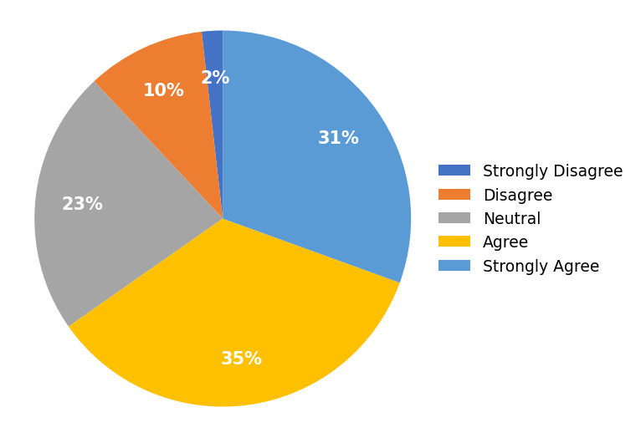

TABLE – 4.25
OVERALL POSITIVE IMPACT OF UPI ON SAVING HABITS
S. NO | PARTICULAR | FREQUENCY | PERCENTAGE
1 | Strongly Disagree | 1 | 1%
2 | Disagree | 5 | 3%
3 | Neutral | 24 | 14%
4 | Agree | 50 | 30%
5 | Strongly Agree | 87 | 52%
 | TOTAL | 167 | 100%
INTERPRETATION
The table 4.25 shows that 52% strongly agree, 30% agree, 14% neutral, 3% disagree and 1% strongly disagree. It is found that the majority of the respondents were agreeing that overall UPI has had a positive impact on their saving habits.
CHART – 4.25
OVERALL POSITIVE IMPACT OF UPI ON SAVING HABITS
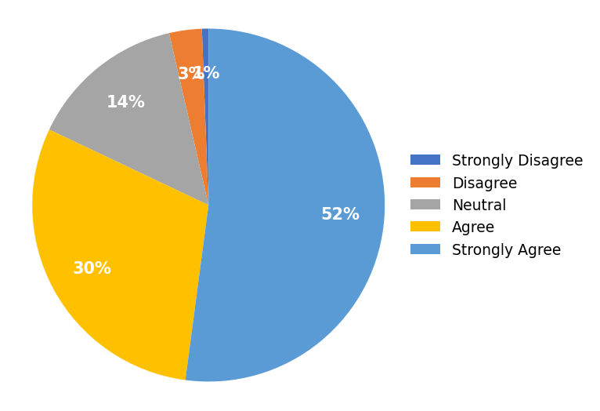

INTERPRETATION BASED ON CHI-SQUARE TEST OF INDEPENDENCE
PROBLEM OF THE STATEMENT
Respondents were asked about their gender and whether using UPI makes them spend more than planned. There were 5 answer choices through a linear scale: Strongly Disagree, Disagree, Neutral, Agree, and Strongly Agree. A test for an association between gender and opinion regarding spending more than planned using the Chi-Square Test of Independence is done. (Use α = 0.05)
HYPOTHESIS
H0: Gender is not associated with the tendency to spend more than planned while using UPI.
H1: Gender is associated with the tendency to spend more than planned while using UPI.
CLUSTERED BAR CHART
One way to visualize the association between two categorical variables is by using a clustered bar chart. The clusters in the chart are determined by the gender groups, while the coloured bars represent the opinion levels regarding spending more than planned while using UPI.
CHART – 4.26
CLUSTERED BAR CHART
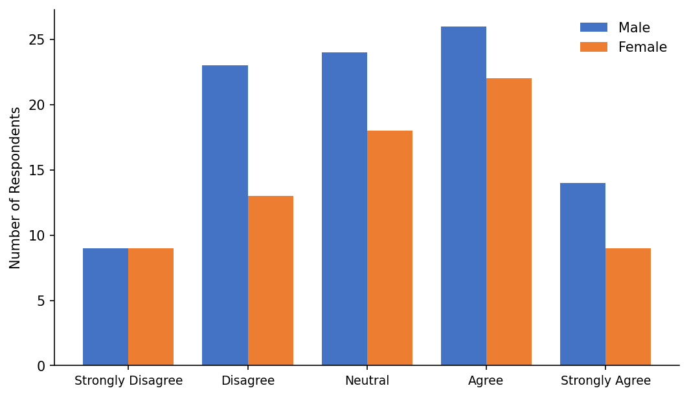

OUTPUT TABLES
The first table is the case processing summary, which tells us the number of valid cases used for analysis. Only cases with no missing values can be used in the test.
Case Processing Summary
 | Valid | Missing | Total
Spend more than planned * Gender | 167 (100.0%) | 0 (0.0%) | 167 (100.0%)
Spend More Than Planned * Gender Crosstabulation
Particulars | Male | Female | Total
Strongly Disagree | 9 | 9 | 18
Disagree | 23 | 13 | 36
Neutral | 24 | 18 | 42
Agree | 26 | 22 | 48
Strongly Agree | 14 | 9 | 23
Total | 96 | 71 | 167
Chi-Square Tests
Test | Value | df | Asymptotic Significance (2-sided)
Pearson Chi-Square | 1.343 | 4 | 0.854
N of Valid Cases | 167
a. 0 cells (0.0%) have an expected count less than 5. The minimum expected count is 7.65.
FINDINGS
➢ The value of the test statistic (Pearson Chi-Square) is 1.343.
➢ The corresponding p-value of the test statistic is 0.854.
➢ The minimum expected cell count is 7.65, and no cell has an expected count less than 5, so the assumption of the test is satisfied.
DECISION AND CONCLUSION
Since the p-value (0.854) is greater than the chosen significance level (α = 0.05), we do not reject the null hypothesis.
Therefore, it is concluded that there is no significant association between gender and the tendency to spend more than planned while using UPI. Based on the results, we can state the following:
No association was found between gender and spending more than planned while using UPI (χ² = 1.343, p = 0.854).

CHAPTER – V
FINDINGS, SUGGESTIONS AND CONCLUSIONS

CHAPTER – V

FINDINGS, SUGGESTIONS AND CONCLUSIONS

5.1 FINDINGS
➢ 57% of the respondents were male and 43% were female.
➢ The sample is dominated by young users, with 81% below 25 years of age.
➢ 44% of the respondents were undergraduates and 43% held professional/master’s qualifications.
➢ A majority of the respondents (65%) earn below Rs.25,000 per month.
➢ Google Pay (46%) and PhonePe (38%) are the most widely used UPI applications.
➢ A majority of the respondents agreed that they use UPI for most of their daily transactions.
➢ A large share of respondents agreed that UPI cashbacks and offers encourage them to spend more.
➢ Many respondents agreed that they shop online more because UPI payment is quick and easy.
➢ A majority of respondents agreed that UPI helps them keep digital records that improve budgeting.
➢ Most respondents agreed that digital payments help them avoid borrowing or cash shortages.
➢ A majority of respondents agreed that overall UPI has had a positive impact on their saving habits.
➢ The chi-square test showed no significant association between gender and the tendency to spend more than planned (χ² = 1.343, p = 0.854).

5.2 SUGGESTIONS
➢ UPI applications should include built-in monthly spending limits and alerts to help users avoid unplanned spending.
➢ Users should regularly review their UPI transaction history to track and control expenses.
➢ Financial-literacy programmes should be introduced for young users to encourage disciplined saving in a cashless environment.
➢ App providers can offer ‘savings nudges’ such as round-up savings and goal-based reminders alongside cashbacks.
➢ Educational institutions can incorporate basic personal-finance modules that address digital spending habits.

5.3 CONCLUSION
In conclusion, the study reveals that UPI is deeply integrated into the daily transactions of respondents and exerts a moderate influence on spending, particularly through cashbacks, online shopping, and small everyday purchases. At the same time, respondents perceive UPI positively in terms of record-keeping and budgeting, reflected in generally high agreement with the saving-related statements.
The chi-square test indicated that the tendency to spend more than planned is not significantly associated with gender, suggesting that the behavioural influence of UPI is broadly uniform across demographic groups. The overall evidence suggests that UPI is a double-edged tool: it enhances convenience and encourages spending, yet also supports financial awareness through digital records. Promoting responsible usage through financial literacy and app-level features is therefore essential for achieving better financial outcomes.

REFERENCES

Agarwal, S., Ghosh, P., Li, J., & Ruan, T. (2018). Digital payments and consumer spending after demonetization in India. Retrieved from https://papers.ssrn.com/sol3/papers.cfm?abstract_id=3641508
Brown, M., Nacht, J., Nellen, T., & Stix, H. (2023). Cashless payments and consumer spending. Retrieved from https://papers.ssrn.com/sol3/papers.cfm?abstract_id=4668928
A study on UPI’s impact on spending behaviour among Indian users (2024). Retrieved from https://arxiv.org/abs/2401.09937
A study on e-wallets and impulse buying among Gen-Y and Gen-Z consumers (2022). Retrieved from https://link.springer.com/article/10.1057/s41270-022-00164-9
A study on sales promotion, FOMO and digital payment methods (2024). Retrieved from https://www.tandfonline.com/doi/abs/10.1080/23311975.2024.2419484
A study on the impact of instant digital transactions on consumer spending (2025). Retrieved from https://www.ijraset.com/research-paper/impact-of-instant-digital-transactions-on-consumer-spending-behaviour
A study on the behavioural impact of digital wallets on modern consumers (2024). Retrieved from https://www.researchgate.net/publication/383360479
A study on determinants of behavioural intention to use digital payment among Indian youngsters (2024). Retrieved from https://www.mdpi.com/1911-8074/17/2/87
A study on UPI as a digital innovation and financial inclusion (2021). Retrieved from https://www.researchgate.net/publication/353016519
A study on cashless transactions among university students (2021). Retrieved from https://pmc.ncbi.nlm.nih.gov/articles/PMC10719559/
A comparative analysis of UPI versus traditional payment methods (2024). Retrieved from https://www.researchgate.net/publication/384286994
An empirical study on consumer perception towards UPI in India (2024). Retrieved from https://link.springer.com/chapter/10.1007/978-3-031-64359-0_13
A study on intention and adoption of e-wallets (2022). Retrieved from https://www.researchgate.net/publication/348518228
A study on sustainable economic development, digital payment and consumer demand (2022). Retrieved from https://www.mdpi.com/1660-4601/19/14/8819
An EY-CII industry report on digital payments in rural and semi-urban India (2024). Retrieved from https://www.ey.com/en_in/newsroom/2024/12
A study assessing the role of UPI in financial inclusion and digital trust (2025). Retrieved from https://www.abacademies.org/articles/assessing-the-role-of-upi-17741.html
A study on the influence of digital wallets on consumer behaviour for sustainable growth (2025). Retrieved from https://link.springer.com/chapter/10.1007/978-981-95-0599-9_8
A study on small-scale merchants’ acceptance of UPI in India (2026). Retrieved from https://www.nature.com/articles/s41599-026-08005-1

ANNEXURE
QUESTIONNAIRE
SECTION A – DEMOGRAPHIC PROFILE
1. Gender
• Male
• Female
2. Age
• Below 25 years
• 25–35 years
• Above 35 years
3. Educational Qualification
• School
• Undergraduate (UG)
• Professional / Masters
4. Monthly Income
• Below Rs.25,000
• Rs.25,000 – Rs.50,000
• Rs.50,000 – Rs.1,00,000
• Above Rs.1,00,000
5. Which UPI app do you use the most?
• Google Pay
• PhonePe
• Paytm
• BHIM
• Others
SECTION B – SPENDING BEHAVIOUR
(1 = Strongly Disagree to 5 = Strongly Agree)
6. I use UPI for most of my daily transactions.
• Strongly Disagree
• Disagree
• Neutral
• Agree
• Strongly Agree
7. Using UPI makes me spend more than I planned.
• Strongly Disagree
• Disagree
• Neutral
• Agree
• Strongly Agree
8. I make more impulse/unplanned purchases because UPI is convenient.
• Strongly Disagree
• Disagree
• Neutral
• Agree
• Strongly Agree
9. I find it harder to track my spending when I use UPI.
• Strongly Disagree
• Disagree
• Neutral
• Agree
• Strongly Agree
10. UPI cashbacks and offers encourage me to spend more.
• Strongly Disagree
• Disagree
• Neutral
• Agree
• Strongly Agree
11. I spend on small things now that I would have skipped with cash.
• Strongly Disagree
• Disagree
• Neutral
• Agree
• Strongly Agree
12. The ease of UPI has increased my overall monthly expenses.
• Strongly Disagree
• Disagree
• Neutral
• Agree
• Strongly Agree
13. I often pay digitally without thinking about the amount.
• Strongly Disagree
• Disagree
• Neutral
• Agree
• Strongly Agree
14. I shop online more because UPI payment is quick and easy.
• Strongly Disagree
• Disagree
• Neutral
• Agree
• Strongly Agree
15. I lose the feel of money when I pay through UPI compared to cash.
• Strongly Disagree
• Disagree
• Neutral
• Agree
• Strongly Agree
SECTION C – SAVING BEHAVIOUR
(1 = Strongly Disagree to 5 = Strongly Agree)
16. I am able to save a fixed amount every month.
• Strongly Disagree
• Disagree
• Neutral
• Agree
• Strongly Agree
17. Using UPI helps me keep digital records that improve my budgeting.
• Strongly Disagree
• Disagree
• Neutral
• Agree
• Strongly Agree
18. I review my UPI transaction history to control my expenses.
• Strongly Disagree
• Disagree
• Neutral
• Agree
• Strongly Agree
19. UPI has made me more disciplined about my finances.
• Strongly Disagree
• Disagree
• Neutral
• Agree
• Strongly Agree
20. I set a monthly spending limit for myself.
• Strongly Disagree
• Disagree
• Neutral
• Agree
• Strongly Agree
21. I transfer money to savings before spending on wants.
• Strongly Disagree
• Disagree
• Neutral
• Agree
• Strongly Agree
22. Digital payments help me avoid borrowing/cash shortages.
• Strongly Disagree
• Disagree
• Neutral
• Agree
• Strongly Agree
23. I plan my expenses better because of digital transaction records.
• Strongly Disagree
• Disagree
• Neutral
• Agree
• Strongly Agree
24. My savings have remained stable or improved since using UPI.
• Strongly Disagree
• Disagree
• Neutral
• Agree
• Strongly Agree
25. Overall, UPI has had a positive impact on my saving habits.
• Strongly Disagree
• Disagree
• Neutral
• Agree
• Strongly Agree

