- Definition
Conversation Schemas in Genesys Cloud enable administrators to define custom conversation attributes and associate these attributes with conversations through the unique conversation ID of each conversation. These attributes allow you to store and retrieve additional business-specific information about a conversation.
Use the conversation schemas UI or Conversation schema management APIs to define schemas and attributes tailored to your business needs.
For example, If we want to retrieve customer conversations based on their type (premium/general), we can create our custom schema with an attribute called ‘customer-type’. Later, we can update this attribute through the Conversation Attribute API and associate it with a conversation, making it easier to fetch conversations using this custom attribute.
Conversation Attribute
A conversation attribute is a piece of information about an interaction. In contrast to participant data, which is linked to individual participants, conversation attributes are created and stored at the conversation level. Administrators can define such custom attributes within a conversation schema and store structured, interaction-specific metadata that is not part of the default conversation model
Limitation
Schema limits
- You can create a maximum of 50 conversation schemas. All active and inactive schemas count toward the limit of 50.
- Once the schema is saved, both the schema and the attributes within the schema cannot be deleted. However, you can inactivate a schema.
- The schema title must be:
Between 1 and 50 Unicode characters.
Special characters and spaces are allowed
Unique within the org for all enabled schemas
- Schemas are immutable. when a schema is updated, a new version is created.
- Enabling and disabling schemas increments the version by one.
- A schema version is required for updates. Flows or scripts are pinned to the schema version that they were built with.

Schema attribute limits
- Each schema can define up to 50 attributes. This limit can be increased via a support request.
- Attributes cannot be deleted or disabled.
- You can edit existing attributes within their defined validation constraints
- Attribute titles must be:
Between 1 and 100 characters,
Special characters and spaces are allowed
Unique within the schema
- When updating attributes you cannot change the core type or key name
- You can change the title as long as it remains unique within the schema.
- Change min/max limits as long as you’re expanding the range, as in you can only raise the maximums and lower the minimums.

- Sample Use case
We built a sample IVR application that contains a menu with the following options:
- Option 1: Insurance Details
- Option 2: Claims
- Option 3: Renew Policy
- Option 4: Others
When a customer selects a menu option, a Data Action is invoked to update a custom attribute. The Data Action receives the Conversation ID and the menu option selected by the customer as inputs.
Later, we can use the Custom Attribute Search API to retrieve conversations based on the selected menu option. For example, if we need a list of Conversation IDs where customers selected the "Insurance Details" option, we can query the custom attribute and filter the results accordingly.

- How we use this Custom Attribute with Data action in Architect flow
Call this DataAction from Architect Flow and pass the values for attribute which is mentioned in conversation schemas.
Example Diagram
Attribute values
PUT request
Conversation Schemas
Data Action
Architect Flow

- Define Custom Attribute in Genesys Console
- Click Menu > Orchestration > Orchestration Assets > Conversation Schemas.
- Click Create Schema. The Create New Conversation Schema page appears.
- Assign a unique name to the schema.
- (Optional) Enter a description.
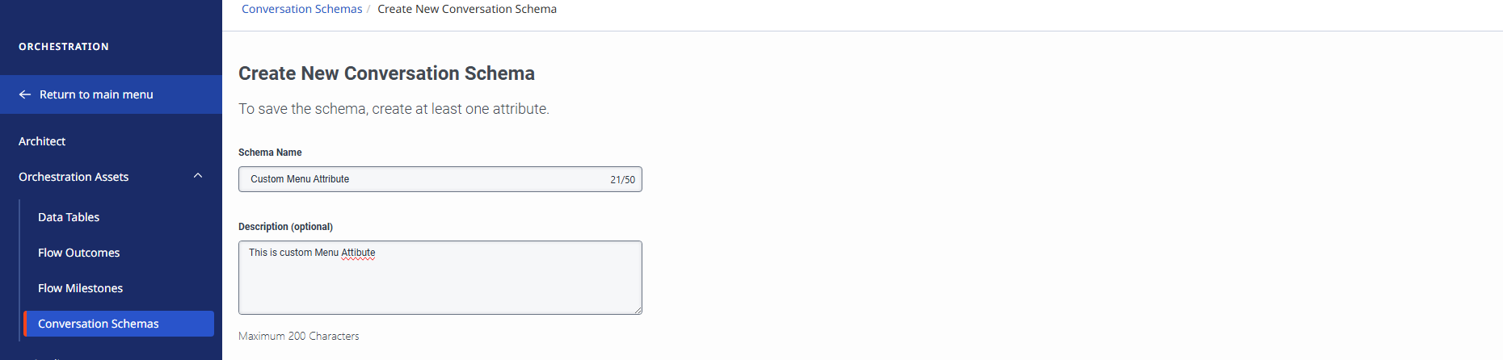
- To add conversation attributes, perform the following steps:
  - Click Add Conversation Attributes.
  - Assign a name for the attribute.
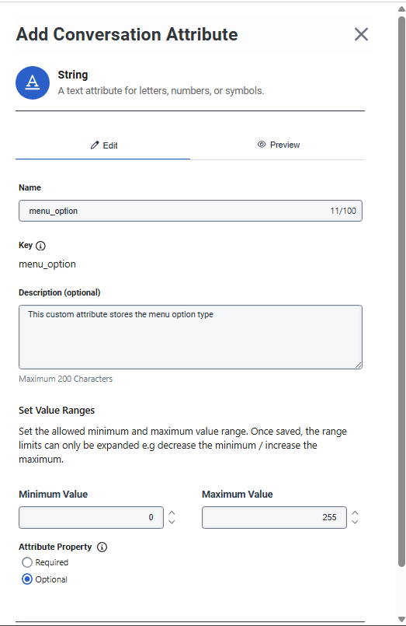
  - Provide a unique key.
  - Add a description.
  - Set the field property such as whether the attribute is mandatory or not.
  - Set the field property such as whether the attribute is unique or not. This condition applies only to the List field type.
  - (Optional) Click the Preview tab to preview your attribute configuration.
  - Click Add.
  - Repeat step 6 to add up to 50 attributes to the schema.
  - Click Save Schema to save the changes or click Cancel to cancel the schema creation.
- Click Save Schema to save the changes or click Cancel to cancel the schema creation.
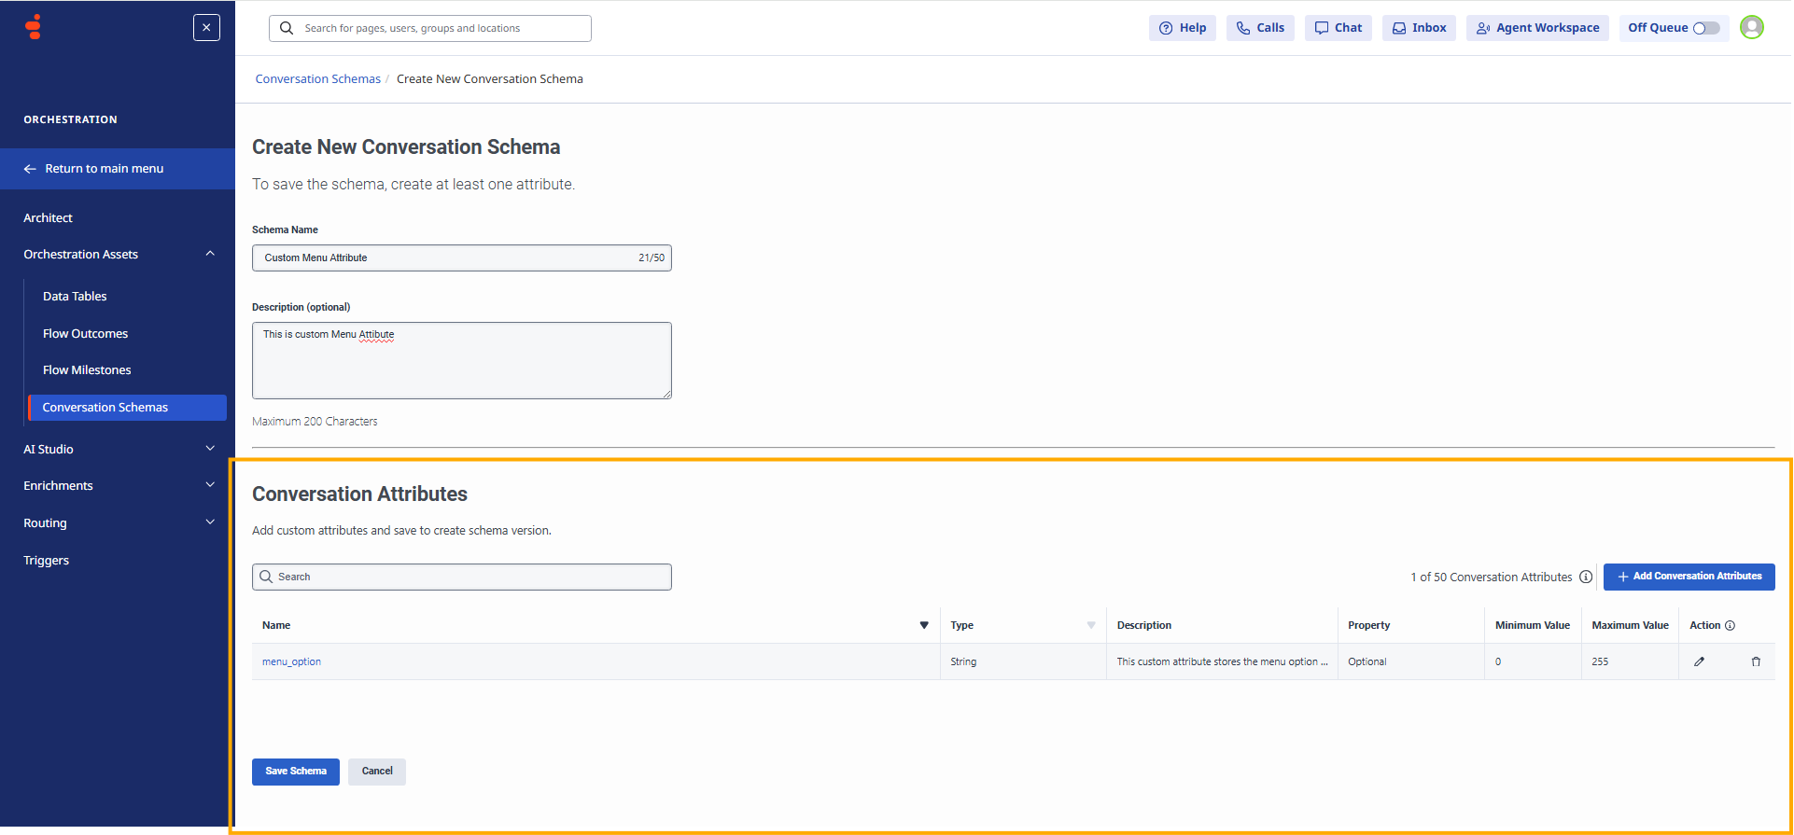

- Configure the Custom Attribute in Genesys Cloud Dataaction
Create Data Action to update the attribute value, This Data Action updates the custom attribute based on conversation ID inside the architect flow
API to update the attribute based on conversation ID
PUT /api/v2/conversations/{conversation-id}/customattributes
Data Action configuration
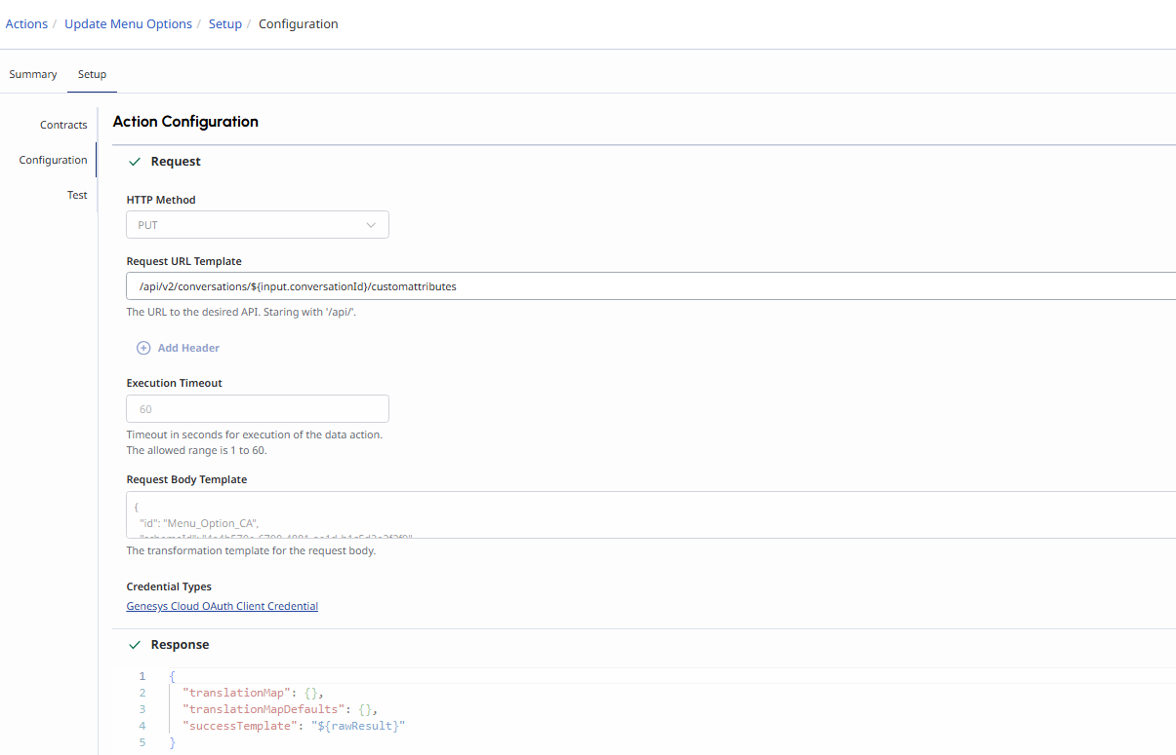
Testing Custom Attribute Data action
We need to provide conversation Id and custom Attribute as input to this Dataaction
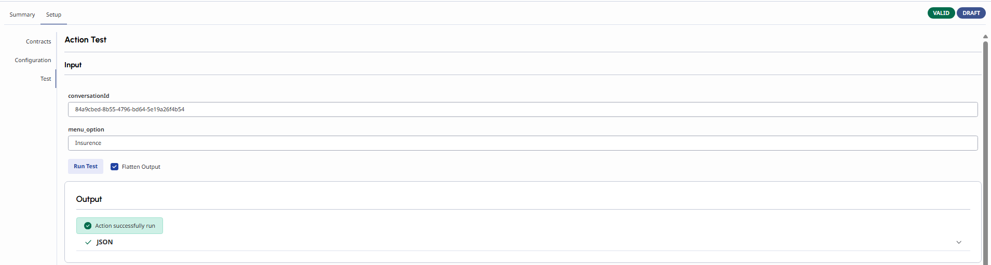

- Built Architect flow to Update the custom Attribute based on menu option
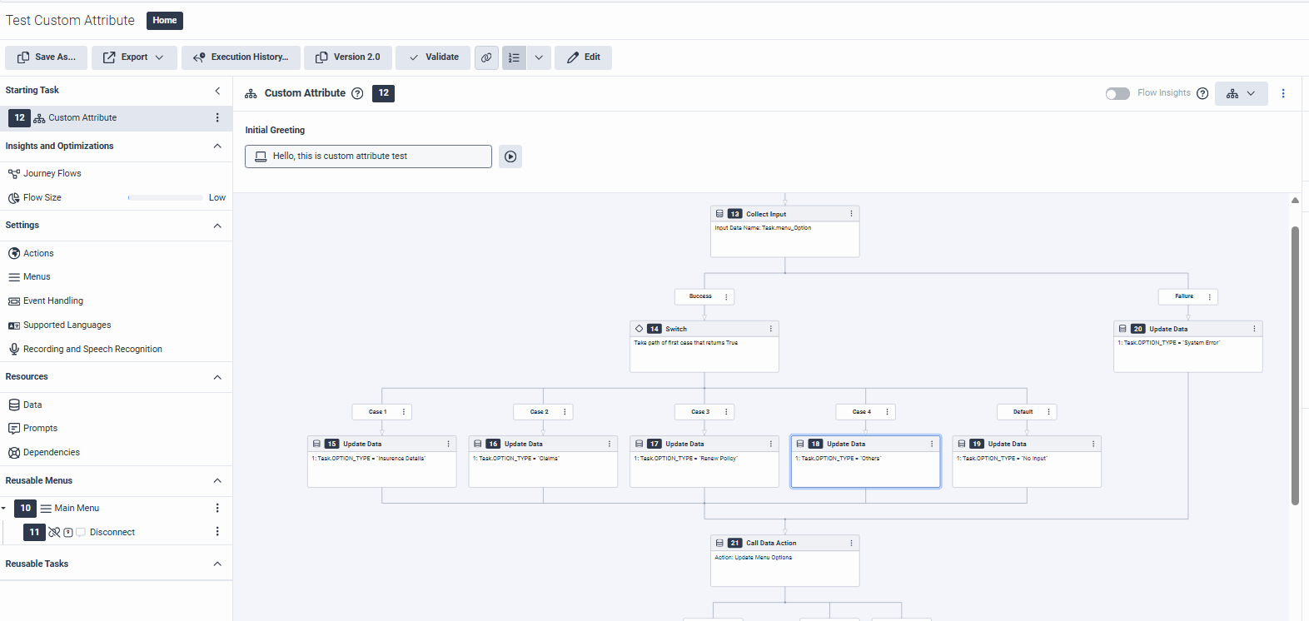

In this Architect flow, I have built a menu using a Collect Input block. Based on the option selected by the user, the value is stored in the Task.Option variable.
This Task.Option value is then passed to a Data Action along with the Conversation ID as a custom attribute.
As a result, the custom attribute is updated at the conversation level. Later, we can query it using the Conversation Custom Attribute Search API.
- Make Test Calls
I made a test call and selected Menu Option 3, "Renew Policy." The Data Action successfully updated the custom attribute for the corresponding Conversation ID.

- Conversation Custom Attribute Search API
In this use case, the Conversation Custom Attribute Search API is used to retrieve a list of conversations associated with the "Renew Policy" menu option.
I used Postman to test this functionality.
API Endpoint
POST https://api.mypurecloud.jp/api/v2/conversations/customattributes/search
Request
In the request, I specified the custom attribute field as "menu_option", which was defined in the schema in Step 4. The attribute value was set to "Renew Policy", which is populated through the IVR using the Task.Option variable based on the menu option selected by the caller.
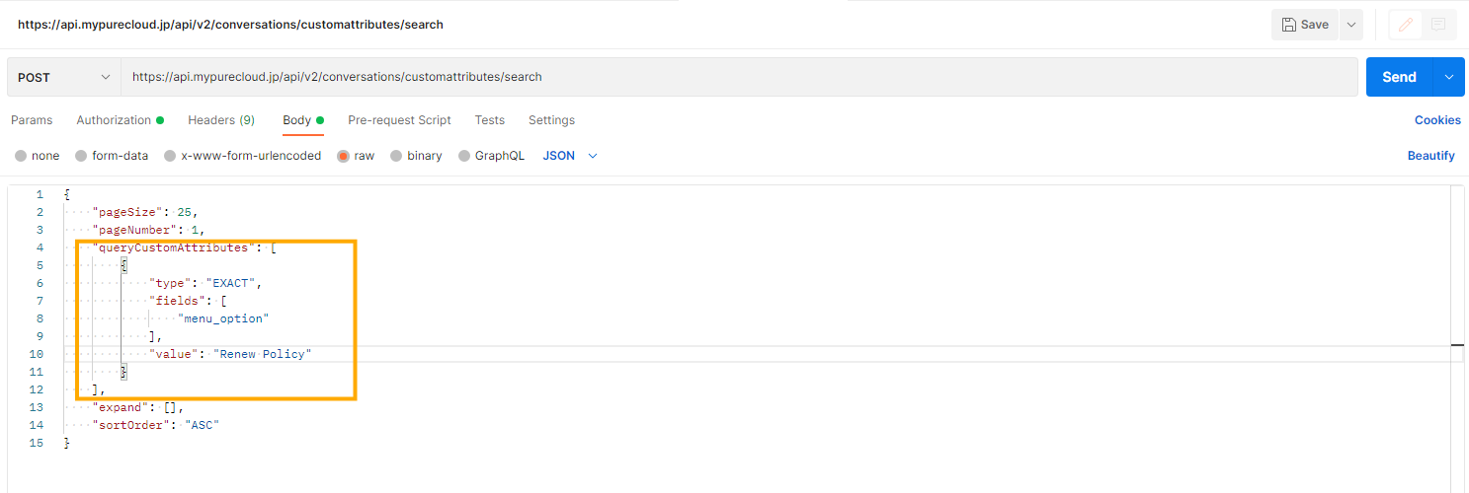
Response
The response returns a list of Conversation IDs associated with the "Renew Policy" menu option.
Since I have currently made only one test call and selected the "Renew Policy" option, the response contains only one Conversation ID.
