Ticketing tool Developing steps

Creating the component

ng g c pages/login

ng g c pages/layout

ng g c pages/department

ng g c pages/parentCategory

ng g c pages/childCategory

ng g c pages/employee

ng g c pages/newTicket

ng g c pages/ticketList

ng g c pages/dasboard

Configuring routes

In **app.route.ts**

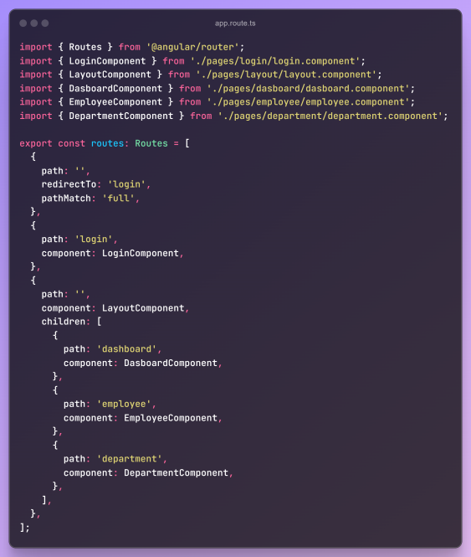

Login will be parent component.

Once we logged in layout will be parent component