April 2, 2021

Chris Cameron
Board of Directors
Morro Bay Bird Festival

Thank you for the opportunity to work with you to provide enhancements as defined by Bob Revel. All the tasks associated with this effort has been completed and this letter is to confirm that I have implemented all functionality that was asked for.

As always, it is my commitment to you all work done by me will be uploaded to the GitHub repository to make it exactly duplicate what is in production on your web site. Other developers may fork (make a copy) or download this repository if changes are to be made. This is a standard process for open source software that is widely supported throughout the industry.

Again, thank you for this opportunity. My invoice for this effort is attached.

Sincerely,
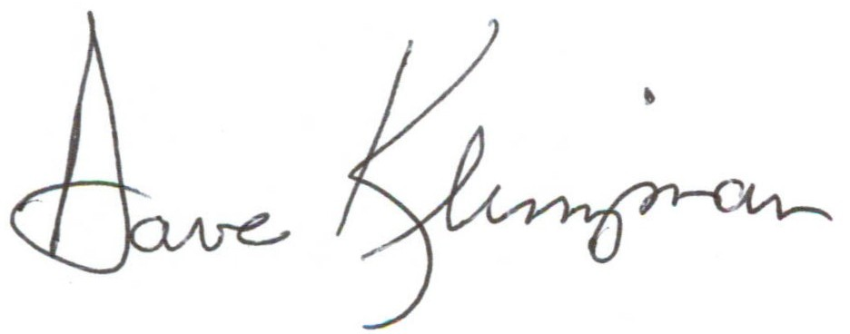

Dave Klinzman
461 Fresno Avenue
Morro Bay, CA 93442

Invoice
April 4, 2021

For work as described:

Description | Hour/Rate | Total
Bobolink support actions as requested;  1. Added 3 new fields into the existing events database table.  2. Duplicated events table to create the new ‘eventsdev’ table for testing an external system.  3. Added 3 new scripts to allow updates to be made to the new ‘eventsdev’ table’ | 8 hours @ $100 per hour | $800
Updates to event scheduling:  1. Updated the event navigation mechanism to improve listing, updating and printing event lists and schedules.  2. Created a new event listing focused on creating a daily schedule of events. | 3 Hours @ $100 per hour | $300
Updated the MBBF backup software resposibory on GitHub. | 1 hour | $0
In-kind donation to the Morro Bay Bird Festival |  | -$300
Balance due: |  | $800

