Event Registration
User Guide
Table of Contents
Overview 2
Registration and Event Scheduling 3
Registration 4
Event Scheduling 5
Scheduling Action Buttons 6
Scheduling Events 6
Modify Agenda 6
Special Attendee 'ALL' 8
Add/Delete Attendees - 9
Administration 10
Administration Portal 10
Main Menu Bar 10
Home Page 11
Financial Menu 11
Payments 11
Current & Pending Exemptions 11
Attendee Invoice 12
Profiles and Attendees 12
Profile Event Summary 12
Update Profile 12
Schedule Events 12
Add New Profile 12
Wipe out an existing profile 12
Dates, Times and Time Periods 12
Dates and Times 13
Time Periods 13
Event Monitor 14

Overview
The Event Registration system is fully integrated with the existing Event Planning System currently used by the Morro Bay Bird Festival to plan and conduct their annual festival.
Effort has been done to create an web application that is compatible with all types of devices including smart phones, tablets as well as desktop systems.

Registration and Event Scheduling
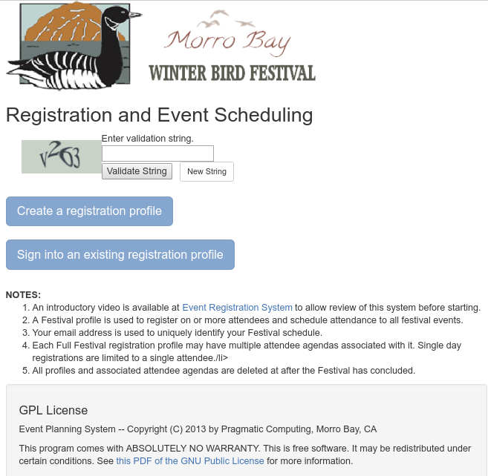
Successful access to the registration system will provide the following page.
Entry of a one-time password must be entered and validated. Once the entry has been completed one of two options can be selected either as a first time user visit or for a return visit to previously created profile.
The profile is created at the beginning of the scheduling process. The profile is identified with a valid email address of the registrant since it is an easily remembered entity and is universally unique to the individual.
Once established, the profile can be revisited by re-entry of the registration profile's associated email address.

Registration
When someone starts the registration process the first step is to create a registration profile that will be associated with the email address entered. This record contains information pertaining to the main registrant as well as other specifics regarding their festival attendance.
The registration profile page is illustrated and explained in the following paragraphs.
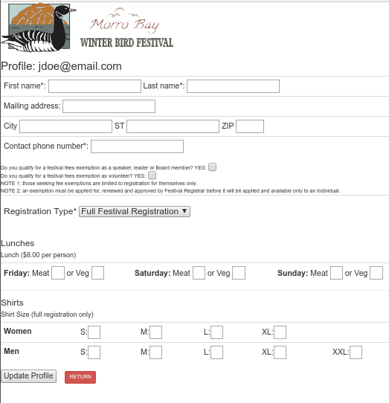
Specific information about the registrant is at the top of the page. Required fields are marked with an '*' specifically the 'First name', 'Last name' and Contacct phone number fields are required to be entered.
The there are several fields that follow the demographic information that are must be entered during the initial entry of the profile.
The registrant may identify themselves as a Speaker, Leader or Board Member (SLBM) or as a festival volunteer if they believe they are qualified. Only one choice can be selected but choosing either will mark the registrant as a potential 'exempt' attendee applying for fee exemption approval by the Festival Registrar. Additionally, the option of choosing the type of festival registration is removed.
An 'exempt' attendee is excused from paying the registration fees for the festival and is limited to a single registration but may register for any event on any day commencing 2 weeks after the start of public registration. Event fees, if any, are added to the profile and must to be paid for by the registrant.
Marking the profile as either an SLBM or volunteer will flag the profile and identify it on reports available to the Festival Registrar. The Registrar will review the exemption request and either approve or deny the request.
An exempt attendee is allowed to create their registration profile but may only modify the initial profile or register for any event on any of the festival days after a 2 weeks grace period has expired following the start of public registration .
If neither of the exemption options are selected the registrant is allowed to select the type of registration for the profile. There are basically 5 types: a full festival registration, a single day for Friday, Saturday or Sunday events, and last day for Monday.
If the registration type selected is 'Full Festival Registration' (the default) an additional 3 attendees can be added to the profile and events scheduled for any festival day. If the registration type is NOT 'Full Festival Registration' then the registrant is limited to a single attendee and limited to only selecting events on the registration day selected.
Following the registration type are options available to select lunches for the day where lunches are appropriate.
Following the lunch section options are shirt selection for any t-shirts that the attnedee might want to include in the profile.
All through the process of creating the profile charges are being calculated and accrued on the profile. All charges will be reflected in the final invoice festival invoice when all events have been scheduled for the profile.
It should be noted that the profile might need to be updated after initial creation to add in addition lunches and/or shirts for attendees that were added after all events have been selected.
The profile is 'locked' when the update of the profile is complete and all events have been selected. This lock is applied during the 'Confirmation and Payment' process when the confirmation button has been clicked. At that time, the only way to change anything on the profile and its associated scheduled events is either by the Registrar unlocking the profile or for the Registrar to make the changes directly.
The implications of totally unlocking the profile is that the Event Monitor (described later) will find the profile and delete all the scheduled events. This might be the desired outcome but should be considered when making changes to the profile.

Event Scheduling
After completion of the registration page, the actions required to schedule events and/or add additional attendees to the festival registration are presented and the profile action page is presented. Clicking the 'Schedule Events' button (1) will allow the events for each day to be listed for selection
The 'Add/Delete Attendee' button (2) provides the ability to add and/or delete additional attendees that will be included in this profile. Each can have their own unique schedule of events.

Clicking the 'Info' icon (3) in the upper right will expand the page and display addition help information regarding the scheduling process.
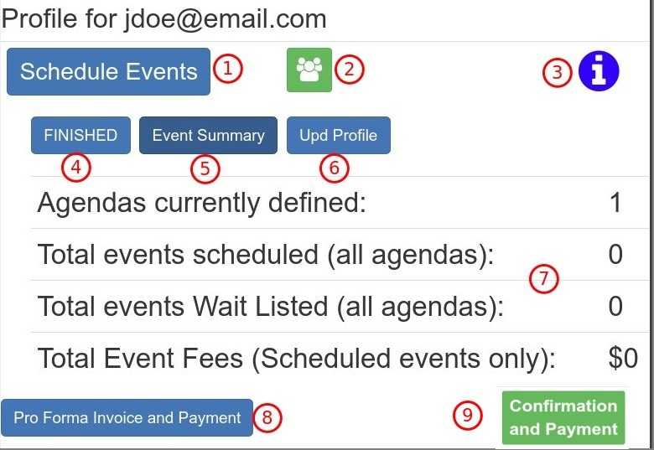
The 'Invoice' button (8) at the bottom will navigate to a page that will summarize all information about the profile and associated attendees. All charges will be detailed and a balance due amount provided.
Items listed in area (7) summarizes the profile. The total number of defined agendas, the total number of events for all agendas, the total number of events that are wait listed and the total event fees for the events currently selected for all attendees.
After the profile has been completed and all events scheduled the 'Confirmation and Payment' button is clicked. This will provide a page that will provide final confirmation of the completed profile and, if confirmed, lock the profile from any further changes. Payment options are presented and notification of the completed registration sent to the Festival Registrar.

Scheduling Action Buttons

The 'Add/Delete Attendee' button (2) is available for the registration type of 'Full Festival Registration' only. It is used to add or delete attendees to the current profile. Registration fees for each added attendee is added to the profiles charges as is any/all charges for fees for selected events.
The 'EXIT' button (4) will save the current profile and associated attendees events(s) and exit the registration system.
The 'Event Summary' button (5) will provide an summary of all events (if any) for all the defined attendees.
The 'Upd Profile' (6) will allow the profile information, initially created when defining the profile, to be updated.
Clicking the 'Info' icon (3) a second time will collapse all this information and revert to the initial display.

Scheduling Events
The following image illustrates is what is presented when entering the scheduling of events. First note that the profile name (1) is presented followed by the 'Done' button at the top (2) and bottom (12) which will return control to the previous page.
The drop down selection list (3) provides the ability to select the festival day for the event list. Changing the day will automatically re-display the registered events for that day (if any). For partial festival registrants only the day that has been registered for will be listed.
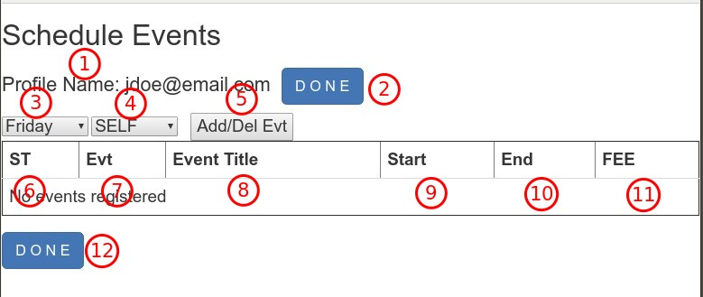
The drop down selection list (4) shows all attendees currently defined. An initial agenda named 'SELF' is automatically created for the registrant who created the profile. Additional attendees may be added to this list by using the add/delete attendee' icon assuming that Full Festival registration has been selected in the profile record. Selection of an day or attendee from either drop down list will automatically display any/all selected events the attendee and day chosen.

Modify Agenda
The use of the 'Add/Del Evt' button (5) will list of ALL events for the selected day and attendee including those already registered. Events may be dropped or added using the associated event's check box. The status column will be updated appropriately assuming that time and capacity checks are passed.
The column headings of the listing are defined as:
- ST (6) – current status of the selected event for this specific profile, agenda and day.
- Evt (7) – The number of the listed event. Note that 100 series number are for Friday events, 200 for Saturday events, 300 for Sunday events and 400 for Monday events.
- Event Title (8) – The description of the event. This is also a link when, if clicked, will display a full description of the event.
- Start (9) – This is that start time of the event using a 24 hour clock notation.
- End (10) – This is the end time of the event using a 24 hour clock notation.
- FEE (11) – The fees for the event (if any).
The 'DONE' button (12) performs the same action as button 2. Both will return the user to the profile page.
After clicking the 'Add/Del Evt' button an additional column is added at the start of the list which contains a check box used to select/deselect specific events for the chosen day and agenda.
When an event is checked a series of validations are performed to determine the appropriate status to provide.
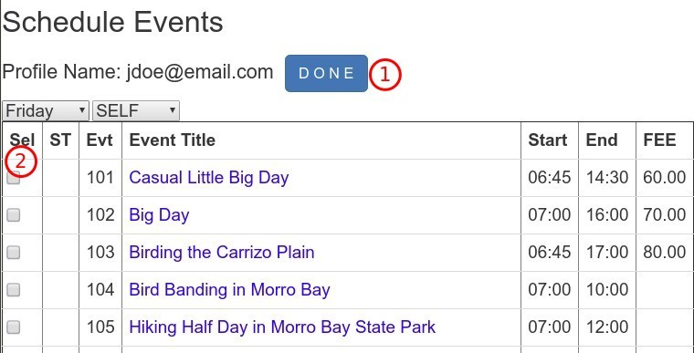
First a check of the start and end times of the newly selected event is compared to any other previously selected events for that day to determine if there are any time conflicts. If so, an advisory error message is displayed and the event is not selected.
If there are no time conflicts a check is then done to make sure that there is attendance capacity available in the event.
If both checks are successfully passed, the status column is updated with 'OK' and the registration for that profile, agenda and day is recorded.
If there are no time conflicts but the maximum capacity for the event has been reached the status is updated to 'WL' and the registration for that profile, agenda and day is recorded as 'wait listed'. The Festival Registrar is responsible for reviewing all events and if/when capacity becomes available for an event with a wait list take appropriate steps of notifications and adjustments to assign attendance from the wait list.
When selecting events pay attention to the end time of an early event compared to a later event's start time to make sure to avoid event time conflicts.
In the case where an event is 'wait listed' a check by the registrant can be done by deselecting the wait listed event and selecting it again. If capacity has become available, the the status will show 'OK' otherwise it will revert to the 'WL' state.
If an event has been reported as 'wait listed' a second event with overlapping times may be selected without a time conflict being reported. It will be assumed that a wait listed event with an overlapping event time-wise will indicate that the wait listed event is preferred. The registrar may change the registration to 'OK' and canceling the second event if space to the original wait listed event becomes available.
There is a special status that can also appear which is created when the Registrar makes a event selection for a specific profile, day and attendee. If the Festival Registrar makes the reservation, there is no time conflict and capacity is available then the status is set to 'OK' (same as if an attendee). However, if the capacity has been exceeded, the Registrar can over-ride the capacity check and register the attendee regardless of capacity limitations. When this is done, the status of the scheduled event is 'AO' signifying that an 'Attendance Override' has been done by the Registrar. NOTE: this action could result in more attendees for a specific event that defined as the event's maximum capacity.
Merely change the day and/or attendee to continue the selection process until the entire festival has been scheduled for all those registered.
These steps can be revisited repeatedly until all changes and agenda have been finalized.
When event selection for this session has been completed clicking the 'DONE' button (1) will return control to the previous page.

Special Attendee 'ALL'
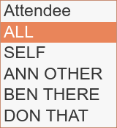
A special item 'ALL' is located in the Attendee list drop down list. When this item is selected all events that are added or deleted are applied to all attendees that are currently listed for the specific day selected (four attendees in the example screen shot.)
All events for all attendees for a specific day are initially listed with 'checked' entries showing the status for that event. The events listed designate ANY event selected by ANY attendee for that day.
Clicking the 'Add/Del Evt' button provides adds the ability to check/un-check individual events. Each event listed has a check box for ANY attendee event those that were individually regisgered. It should be noted that un-checking these events may not be applied to all attendees for the specific day even those selected on an individual basis.
A review of all events for all attendees can be obtained by clicking the 'List All' button.
When selecting an event, if there are any time conflicts with any other events already selected on any attendee for the specific day, the selection will fail for all with an advisory message shown.


Add/Delete Attendees -
This action provides that ability to register additional attendees onto the agenda and schedule events for them. Selection of the 'Add/Del Attendee' icon will produce the following page:
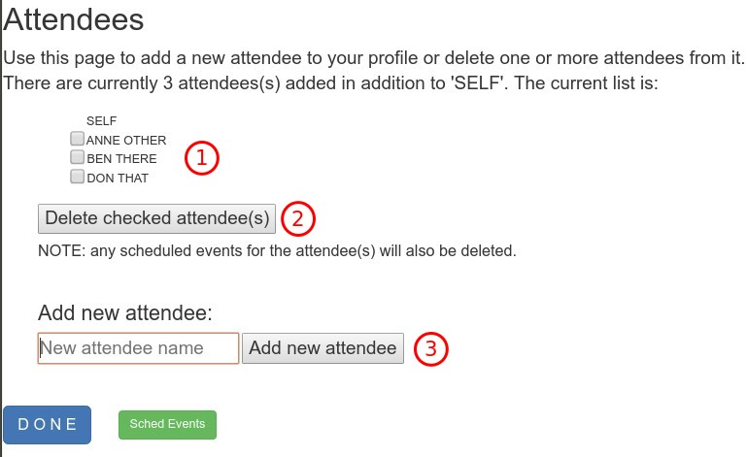
This example shows in the area labeled (1) that 3 attendees in addition to the default 'SELF' have already been added. These names will appear in the attendee list when scheduling events.
All registration and event fees (if any) will be accumulated with the profile.
Selection of the check box for one or more attendees will designate them for deletion if follow by clicking the 'Delete check attendees(s)' button (2). A confirmation message will also allow the action to be reconsidered.
CAUTION: deletion of an attendee will also cause the deletion of all scheduled events for that attendee.
To add a new attendee to the current profile merely supply a unique name and click the 'Add new attendee' button (3).

Administration
Administrative functions allow for the management of the registration and event planning system. All administrator functions center around the main menu that is presented after successfully logging into the administration portal.

Administration Portal
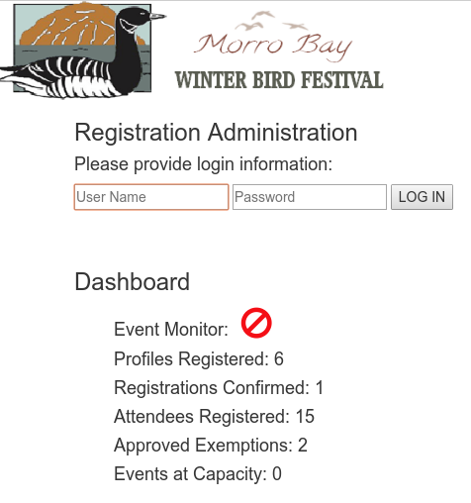
Accessing the administration portal will display the following page. Supplying the user id and password will allow further access.
For convenience a brief overview of the registration system statistics which are provided without logging in. The following definitions explain these fields:
Event Monitor: this icon represents the current status of the Event Monitor. The red barred circle icon indicates that the Event Monitor is INACTIVE. A turning gear icon indicates that the icon is running at 10 minute intervals. Use the Utility menu item (explained later) to manage the Event Monitor.
Profiles Registered: total count of registered profiles.
Registrations Confirmed: total count of registered profiles that have completed their registration process, selected their events and have confirmed these selections.
Attendees Registered the total number of individual attendees that have been registered.
Approved Exemptions: the total number of attendees that have requested for a fees exemption as a volunteer, speaker or Board member and the Registrar has APPROVED.
Events at Capacity: the total number of festival events that have been 'SOLD OUT'.

Main Menu Bar
The main menu bar is presented at the top of each page of the portal. For those menu items that access one of the many registered profiles an 'index' listing of the profiles is presented with a 'Filter' input box at the top. Entry of a string of characters will quickly narrow the listing to only those rows that contain the string entered. The 'Reset' button will clear the Filter input and list all profiles. Usually the first 3 or 4 characters is sufficient to narrow the listing to the target profile. Clicking anywhere on the row of a profile will access the data for the it.
The following shows the main menu bar. An explanation of each function provided.

Home Page
This provides the home page for all administration functions. If provides the same registration system data points previously explained.

Financial Menu
Three actions are provided on this drop down menu.

Payments
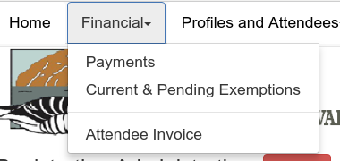
This action item produces an index listing of all registered profiles. E Clicking anywhere on the line will provide a data entry form (as illustrated) to allow entry of a payment amount to be applied to the profile.
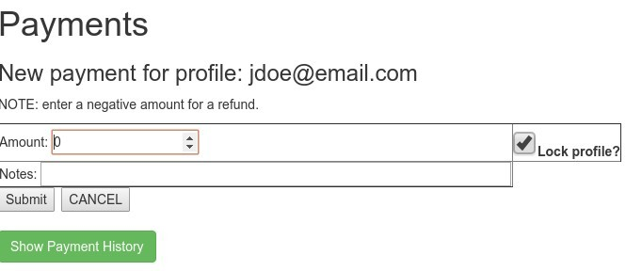
In addition to the amount field, a notes field is provided to allow entry of reference information (check number, last 4 digits of credit card, etc.). The 'Lock Profile?' check box is assumed when adding a payment. However, if there is a reason to do so, the profile may be unlocked. CAUTION: all events have a chance to be released by the Event Monitor if the profile is unlocked.
Use the 'Submit' button to apply the payment to the profile, use 'Cancel' or click the area below the form to hide the payment form.
The payment history for this profile can be obtained by clicking the 'Show Payment History' button.

Current & Pending Exemptions
When completing the profile, the registrant can indicate that they are a speaker, leader or Board Member which qualifies them to be exempted from payment of the Festival registration fees. However, this is must be approved by the Festival Registrar before it is applied.
This function will provide a of all profiles that have applied for ('YES') or have been approved ('APPROVED') for festival fee exemptions. NOTE: all fields can be updated and any change to any field will be applied when the form is submitted. However, of particular note is the check box labeled 'Fee Exemption' followed by a drop down box with three options:
- NO – the registrant has NOT applied to be exempted from Festival fees.
- YES – the registrant IS applying to be exempted from Festival fees.
- APPROVED – the Registrar has reviewed and approved the fee exemption application.
The Registrar will modify this field based on review of the application made by the registrant. Note that this listing will only show those registrant profiles that have either applied for the exemption ('YES') or approved ('APPROVED').
Any invoice that is created uses the 'Fee Exemption' field to apply the fee discount configured using the system parameter 'ExemptPerCent' which is usually 100% but it is configurable.

Attendee Invoice
This function will produce an invoice of all charges that have been applied to the profile selected.

Profiles and Attendees
This group of administrative functions allow for the maintenance of all profile and attendee agendas currently on the database.

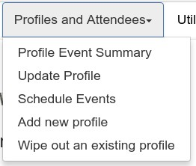
Profile Event Summary
This page will list all events, grouped by attendee, that have been scheduled by all attendees on the profile selected from the index.

Update Profile
This will provide a page that shows all fields defined for the selected profile so that they can be reviewed and/or updated. Any field changed will be applied to the profile if the 'Submit' button is clicked.
This page is identical to the 'Current and Pending Exemptions' update page except that the index to this function lists ALL profiles that have been entered on the database regardless of exemption status.

Schedule Events
This function utilizes the exact same functions provided to the registrant to select events for the profile attendee(s). All functions available are detailed in the explanation of the Event Scheduling section of this document.

Add New Profile
This function allows for the creation of a new profile to be added to the database. Typically, this function would allow the Registrar to create a registration profile and schedule events for someone who does not/can not do so on-line. Once the registration profile is created, use the 'Update Profile' function to supply all information about the registrant and 'Schedule Events' to add attendees and schedule events for the profile.

Wipe out an existing profile
This function will provide the ability to completely delete an profile and all items associated with it including the profile itself, schedule events and payment records (if any.) A confirmation of the action is provided to allow exact determination of the actions outcomes.

Dates, Times and Time Periods
These date parameters, where noted, are defined and maintained by using the menu item 'Utilities → Maintain Users and Dates'. Access to this table is restricted to password access. The initial password is 'raptor' which, if desired, can be redefined by changing the password for the 'RegAdmin' user password once initial access has been done
Date and time formats use the international date/time format of 'YYYY-MM-DD HH:MM' where:
YYYY – is the 4 digit year,
MM – is the 2 digit month (01 = January, 02 = February, 03 = March, etc.)
DD – is the 2 digit day of the month
HH – represents the 2 digit hour of the day using a 24 hour clock notation
(01 = 1:00 AM, 02 = 2:00 AM, …. 22 = 10:00 PM, 23 = 11:00 PM, 00 = 12:00 AM)
MM = represents the 2 digit minutes of the hour.
Care and accuracy should be applied to definition of these values.

Dates and Times
Event Start Date ('eventstart') – this parameter defines the actual date and time of the first day of the Festival. This would usually be set to midnight of the date of the first day.
Registration Start Date ('regstart') – this is the actual date and time the registration is allowed to commence. This date is usually set some time in advance of the actual event start date to allow registrants the opportunity to examine the roster of events and practice the registration process before the actual registration peiod commences.
When appropriate after the 'practice' period has elapsed, the registration start date would be set to the actual registration start date.
Registration for festival event is blocked for all users until after the date and time defined for 'regstart'.
Registraton End Date ('regend') - this is the date and time when registration closes for the current festival.

Time Periods
Time periods are estblished for various functions defined within the system.
Exemption Attendee Block – this is a two week block out period based on the 'regstart' date and time. It is established to prevent volunteers, leaders and speakers from registering for events before the paying attendees have had a chance to make their preferred selections. Exempt attendees are forgiven payment of event registration fees but are expected to not take up space for highly sought events until the block period has expired.
Event Registration Hold – this is the system defined period of 30 minutes that allows the registrant/attendee to confirm their attendance and registration for their selected events. The 30 minute period starts with the time of the last event selected for their agenda. This time out is enforced by the Event Monitor which runs in the background every 10 minutes. When the Event Monitor finds that 30 or more minutes as elapse since the last event was scheduled, all scheduled events are 'released'. The registrant can prevent this by confirming their attendance to the festival after registration and event selection.

Event Monitor
Events are scheduled by the registrant using the interface outlined in the preceding sections. Each selected event is added to the registrant's profile with a date and time stamp in addition to the other information regarding the event.
A utility called the 'Event Monitor' is provided to prevent registrants from selecting events and then abandoning the profile blocking others from selecting those events. The event monitor checks the length of time that an event may be 'reserved' by the registrant. This 'expiration' period is enforced by the event monitor. If a profile does not have an event added within the expiration period all scheduled events are deleted from the profile.
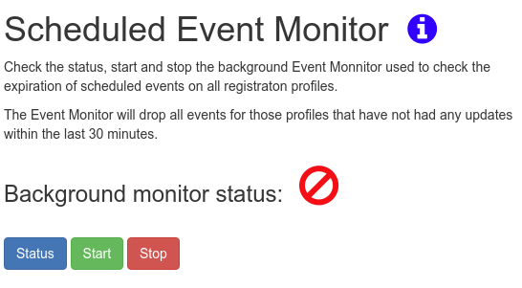
All actions of the event monitor are logged and available for review. The event monitor log can be reviewed 3 different ways: the last 5 events are displayed when the monitor status button is clicked, a special 'event monitor log' is available on the 'Utilities' menu which will isolate the event monitor activities and list them in reverse chronological order (the latest first), and finally a complete listing of all system log entries also available in the 'Utilities' menu. The the case of the last 2 a date and time can be selected for both the start and end of the logging period of interest.
Running the Event Monitor effectively means that a registrant may select the roster of events they would like to attend and are provided a 30 minute window during which the registrant must confirm their intention to pay by clicking the 'Confirmation and Payment' button. The Registrar can run periodic reports that will provide a listing of those that have not paid their registration fees and can optonally release those scheduled events if warranted.
The event monitor is started by the administrator from the 'Utilities' menu and runs as a background program every 10 minutes from the time of initiation. An indicator on the admin home page as well as the event monitor page itself provides running status of the event monitor. The event monitor can be started, stopped or its status checked as well.

