October 23, 2016

Jean Fanselow, President
Board of Directors
Morro Bay Bird Festival

Thank you for the opportunity to work with you with an update to your event planning system. All the tasks associated with this effort has been completed and this letter is to confirm that I have delivered all functionality that was to be provided.

As a part of these deliverables, all work product associated with this effort has been uploaded into a public source code repository. This provides the organization access to everything that was done in conjunction with the design and development of this system as well as provide a back up to this work.

This repository may be accessed using the URL of: https://github.com/klinzmandr/MBBFEvents

The entire repository may be downloaded as a zip file which will contain all elements comprising the event planning system as it exists on your web service. This includes all PHP code used as well as all SQL scripts that were used to load the initial database.

As always, it is my commitment to you that any future work done by me will be uploaded to this repository to make it exactly duplicate what is in production on your web site. Other developers may fork (make a copy) or download this repository if changes are to be made. This is a standard process for open source software that is widely supported throughout the industry.

Again, thank you for this opportunity. My invoice for this effort is attached.

Sincerely,
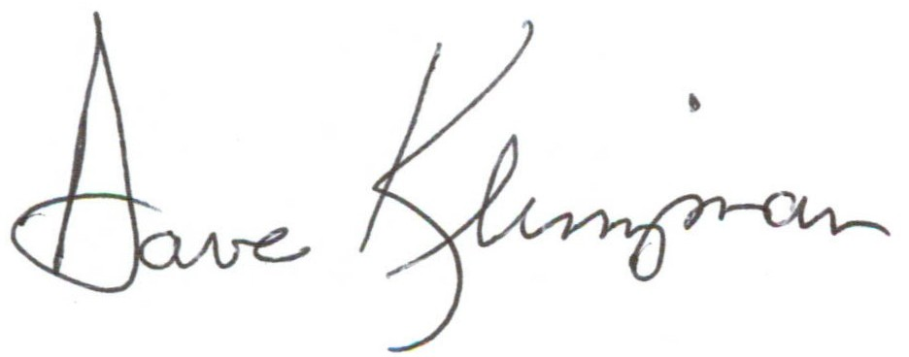

Dave Klinzman
461 Fresno Avenue
Morro Bay, CA 93442

Invoice

October 23, 2017

For work as described:
Description | Hour/Rate | Total
For tasks performed as per emails of April 12 and September 25, 2017 | 23 hours @ $100 per hour | $2,300
Update the document repository software | 6 hours @ $100 per hour | $0
In-kind donation to the Morro Bay Bird Festival | 13 hours @ $100 per hour | -$1,300
Balance due: |  | $1,000

Thank you for the opportunity to work with you.

Please send payment to:

D. Klinzman
461 Fresno Avenue
Morro Bay, CA 93442

