Event Planning System
User Guide

Introduction
The Event Planning System (EPS) was developed for the Morro Bay Bird Festival to support the annual event planning process for developing their annual 4 day calendar of events.
Access to this system is done by referencing the URL of: http://mbbfbirdfestival.org/mbbfevents
This URL will provide the initial login page where an authorized user id and password may be entered. All access requires a unique user id so that individual actions may be logged for security and accountability.
In some pages additional password security is requested in order to limit use of special administrative functions to those with the knowledge of the implications of the action being requested. The passwords for these functions are administered in the same way as other user id's which is discussed in a later section. The user identification portion of these are fixed and should not be changed. However, the password can be adjusted if/when necessary.

Login and Navigation
Supply a valid user id and password to log into the system. After successful login, all pages of the system is available from the menu bar fixed at the top of each page.
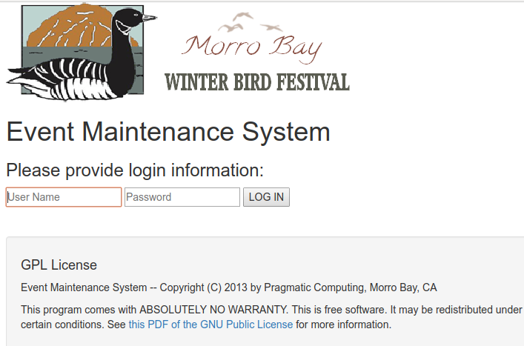
Clicking the menu bar selection will (usually) result in a drop down selection list of other menu choices associated with it. s
All menu items are grouped to be logically associated with the menu selection item. For example, all activites assoicated with creation, update or deletion of events is under the 'Events' item. Also included are all the reports available about Events in the sub-menu.
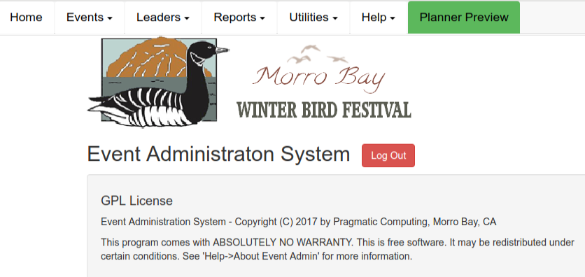
After successful login the 'Home' page of the system is displayed. Return to this page at any time by merely clicking the 'Home' menu item.

Events
The heart of the system is the ability to create, update, duplicate and/or delete activities and leaders that comprise the annual calendar of events.
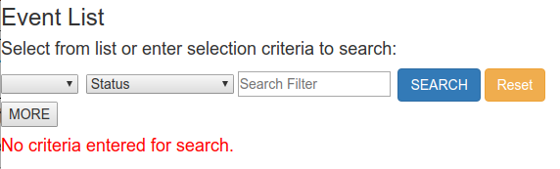
After successful login, the menu bar is displayed at the top of the page. Clicking these selections will cause various actions to happen related to the menu item selected. For example, the menu item Events → Search/List' provides the following page.
Printing the currently listed events can be done by selecting the 'Print Last List' menu item will print all details for all events listed in the current search results list. The Add New Event item will add a NEW event to the current program of events as explained in the following paragraphs. Clicking the 'Home' button will return you to the Home Page.
Event navigation starts with the listing of one or more events in the search results list. This is done by choosing the criteria used for the search. The selection criteria is cumulative. In other words, each additional search criteria selected will typically reduce the number of items in the selection list.
Selection of any event in the search results listing will produce a event detail page showing all details for that specific event in editable fields. Changes may be made to any field and applied. The page is checked to make sure all changes are saved before a different page is displayed.
The 'Reset' button will set all criteria to their initial values of NULL or empty. The 'List All' menu item will produce a complete listing of all events in the current calendar of events EXCEPT those that have an 'Event Status' of 'Delete' discussed in a later section.

Event List Navigation
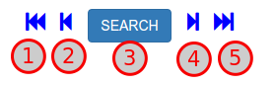
Navigation within the search result listing is accomplished by use of the 'arrow' buttons at the top, center of the event update page. From the event currently being displayed, these buttons will function as follows:
- Display the page for the first event in the current search result list.
- Display the previous event to the current in the search result list.
- Return to the Event Search page to create a new search list (or click the Event → Search Events menu item).
- Display the next event from the the current in the search result list.
- Display the page of the last event in the current search result list.

Action Icons
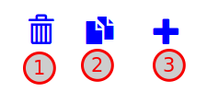
There are additional 'action' icons displayed on each event detail page that are defined for the CURRENTLY displayed event. They are:
- Delete the event currently displayed. This action permanently deletes the event from the database. This action can not be reversed. A confirmation dialog is displayed to make sure this action is intentional.
- Duplicate the event currently displayed. This action will make an exact copy of the event in its entirety using the NEW trip number that is solicited. After the new duplicated event is displayed, it is recommended that it's day, start time, end time and other associated distinguishing information be applied. A re-sequencing of all events for a specific day may be necessary if duplicate trip numbers have been created for that day as a result of using this action.
- Add a new event to the calendar. This action creates a new, blank event record with the trip number set to 999 the Event Title set to '**New Event**'and the 'Trip Status' set to 'Delete'. These are the same actions as done by selecting the 'Events → Add New Event' menu item.
These values are easily updated on the page displayed after the add. If the new event is not updated at that time it may be found at any time by merely searching for all events with the search 'Status' field set to 'Delete'.

Editing Events
All fields of an event may be updated. Some fields are restricted to the contents of a selection list. Selection lists are managed using the administrative tools provided. Review this user guide in the Utilities section for information about maintaining selection lists.
Time fields are entered using a time 'picker' and the leader fields are prompted with a 'type ahead' function consisting of the names of all 'active' leaders currently registered in the Leader database.
One field of special note is the 'Trip Status' field and specifically the status of 'Delete' contained in it. Special handling of this status has been devised to allow events to be 'parked'. This simply means that the event is not going to appear in any listing or report if their status has been marked as 'Delete'.
When an event's trip status is changed to 'Delete' three things are changed in the event record:
- The trip number is changed to '999',
- The trip status field is updated to 'Delete', and
- Leader fields are all erased.
All other information about the event remains unchanged.
A listing of all 'parked' events may be obtained by creating a search results list with the 'Status' field set to 'Delete'.
An event may be re-used ('un-parked') by merely changing the 'Trip' number and the 'Trip Status' fields. Other distinguishing fields such as the event day, start time, end time, etc. would also, probably, be modified as well.
It should be noted that moving an event from 'parked' into the calendar of events may cause duplication of existing trip numbers on specific days. This can easily be detected by creating a search results listing and/or doing a 're-sequence' of the events for that specific day.
If an event is to be permanently deleted from the database in its entirety, then the event should be displayed and the 'Delete' action icon on the event's page clicked. Merely changing an event's Event Status field to 'Delete' does NOT delete it from the database.

Multi-event Handling
There is often the case where the same event is offered more than once a day or on more than one day. In this case this is the recommended sequence of steps to 'clone' events.
- Create the first in the sequence of events. Set the 'Multi-Event' flag to 'Y' and create and enter a UNIQUE code into the 'Multi Event Code(s)' field for the events. This code should be alphanumeric and not contain spaces and separated from other codes (if there is more than one) with a comma. This unique code can then be used as the 'Search Events' search string to list this event and all its eventual clones. It is NOT recommended to number these since the unique event code on all will quickly group them in a search results list.
- After saving the changes, duplicate the event providing a new Trip number.
- In the duplicated event specifically change the day, start time and end time of the new event as well as any other appropriate fields leaving the Multi Event Code(s) unchanged.
- Repeat steps 2 and 3 for each cloned event needed.
- For future access to this group of events enter the 'Multi Event Code(s)' assigned to all of them in the Search string field of the event search page. Pre-planned codes developed and used for this multi-event use will greatly enhance future maintenance of these events as a group.

Leader Maintenance
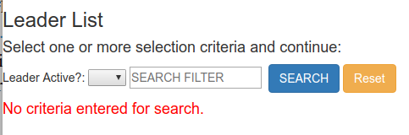
Maintenance of the leader records largely mimic that of events. The search results page is produced when the main menu item 'Leaders' is clicked. It works similarly to that for events but the selection criteria is limited to merely list leaders that are 'active' vs 'inactive.'
Use the menu item 'Leaders → Add New Leader' to create a new leader record.
Of particular note is the first and last name fields of the leader record. These two fields are used to create the 'type ahead' list used in the Event update page. NOTE: A leader record MUST exist before the name will appear in the leader list for any of the leader fields of the event records.
However, it is not mandatory that a leader record exist for a leader name. As a matter of good housekeeping, it is recommended that a leader record be created BEFORE a leader's name be utilized in an event record.

Reports
A series of reports have been developed to support the development and maintenance of the calendar of events. Most all reports are self documenting. This simply means that the report has an explanatory description provided when the report is initially selected.
All reports have been created to be displayed as a web page, printed as a hard copy page, and/or saved as a PDF file (Chrome is the recommended browser for doing this.) Extraneous buttons, headings, etc. are eliminated in the printer output of a web report page and pagination is done where appropriate.
Most all reports have been created to allow the results to be exported to a spreadsheet. This may be accomplished using one of two possible methods:
- highlight all report lines displayed (including the headers) and copy/paste them into an open, empty spreadsheet program like OpenOffice/LibreOffice Calc, MSExcel, Google Doc spreadsheet, etc..
- Click the 'DOWNLOAD AS CSV FILE' link to download a text file formatted as a comma separated values (CSV) file to subsequently open using a spreadsheet program.

Utilities
The utilities menu contains special programs needed to maintain or monitor the entire system. Some of these utilities require an added, special password to control the security and usage of these functions. These passwords are all maintained in 'User Administration' utility.

List Maintenance
All drop down selection lists utilized in the EPS have been created in such a way as to allow changes to them without the need for changing the programs that use them. All lists are maintained as free form text boxes. The lines that begin with double slash marks ('//') are considered as comments and ignored as are all blank lines.
Drop down lists are created by using the HTML '<option>' tag. A group of these tags comprise the 'list' of options presented when the drop down selection field is selected in the update form. The '<option>' tag consists of two basic parts: the 'value' portion and the 'prompt' portion. The prompt portion is what is displayed in the drop down selection list visible to the user. The value portion is what is provided to the program and recorded in the database for that selection. The format is:
<option value='XXXXX'>ZZZZZ</option>
where 'XXXXX is the value of the selection and 'ZZZZZ' is the prompt.
The contents of the various lists are made available for editing when that list is selected from the choices provided in the utility.
Most all lists are formated exactly the same with exception of the 'Sites' list. In this particular list the site's location code is also specified separated by a colon (':') from the site name. Care must be taken with this list since the site code is automatically isolated and entered into the event record as a part of selecting that site. Not having a site code specified or having one which is duplicated on another site would not be a good thing.
Any change made to the list will not be permanent until the 'SAVE UPDATES' button is clicked after which the updated list is displayed again.
CAUTION: CHANGING THE CONTENTS OF A SPECIFIC LIST DOES NOT CHANGE ANY EVENT DATA VALUE ALREADY RECORDED ON THE DATABASE.

Usage Log Browsers
All database activity is logged in the database for each user. There are two log browsers provided both using a date range to isolate specific actions based on dates and times. One provides a detailed listing of specific actions undertaken by every user. The second provides summary information about page usage.

User Administration
Administration of the systems users is done with the menu selection 'User Administration' of the utilities menu. This will prompt for an additional password which is initially set to 'raptor'. Once access to this facility is accomplished this password may be changed.
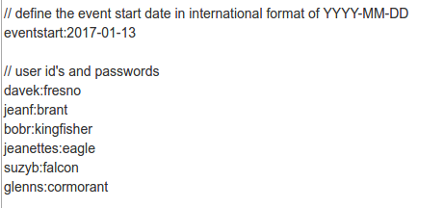
The administrative tasks are accomplished by editing as free form text. The initial lines of the text merely explain that lines that start with double slash marks ('//') are considered comment lines and, along with blank lines, are ignored.
The first line of interest defines the event start date for the event calendar. This must be specified in YYYY-MM-DD format.
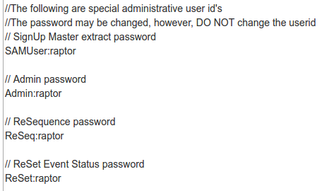
Users are identified using a unique character string for each user followed by a password with a colon (':') separating them (as illustrated.) This definition must begin on a single line with nothing following it.
Any new users added should be tested before providing the user id and password to them to ensure they work.
The second portion of the same file contains special user ids and associated passwords used by other utilities of the system.
The password portion of these entries (the character string following the colon (':') character) may be changed as security requires.
CAUTION: DO NOT CHANGE THE USER ID PORTION OR IT WILL MAKE THAT FUNCTION UNAVAILABLE.

Re-sequencing Events of a Day
For identification purposes, each event has a unique sequential number assigned known as a 'Trip' number for the specific festival day it is to occur on. As the planning process proceeds, new events are added and existing events are rescheduled. This will often result in duplicated trip numbers being assigned to events. This is resolved by using this utility.
First the utility selects all events with the status of 'New' or 'Retain' for the selected day. These are then sorted by start time and then end time within start time. Finally these events are sequentially renumbered depending on the day where the 100 series is for Friday, 200 for Saturday, 300 for Sunday and 400 for Monday.
Re-sequencing may be needed if the day, start time or end time is modified on any event since changes to these fields may result in a change of the sequence order. Listing and reviewing the trip numbers for all the events for a single day will quickly identify if this utility needs to be run.
The results report will report the old sequence number as well as the new sequence numbers that has been assigned.

Reset Trip Status
This facility is normally used to commence the development of a new calendar of events for a new annual festival.
This utility has been provided to allow the status field for all events to be set to 'UNDER CONSIDERATON'. This action would also normally be accompanied by the setting of the event start date for the new calendar in the 'User Administration' utility.
It is recommended that all events for the prior festival be backed up in some form before this function is used.

Validate Database
This utility examines each event record and applies a series of business rules to determine if the event has any obvious omissions or errors.
Rules applied to each event:
- Event has a site code.
- Event has at least the first leader identified
- All leaders identified for event are 'registered'.
- Event has a start time.
- Event has an end time.
- Event 'Fee Required' is YES and a FEE amount is specified.
- Event 'Multi-event' is YES and a multi-code is specified.
- Event 'Transport Required' is YES and transportation is specified
- Event has 'Max Attendees' specified.
- Event has a experience level specified.
A resulting report is created reporting any exceptions to these rules.

SignUp Masters Extract
On-line reservations is supported by an external vendor. This utility creates a special file and makes it available for downloading to this reservations vendor.
This utility creates a new window/tab and is capable of running in a 'stand-alone' mode. This would allow the URL of:
http://www.morrobaybirdfestival/mbbrevents/sumextract.php
There is a special 'usage' password required for security purposes so that access and control of this function can be managed via the user administration utility.
Two methods are available for making the registration information available.
- Allow the registration vendor to run the utility using the URL provided plus the password provided and downloading the file produced, and
- Running the utility and then download and send the file produced to the registration vendor as an attachment to an email message.
File Format Information
The format of the file produced is a text file in a modified comma separated variable (CSV) format. All fields required by the vendor is provided in the format needed. These fields are separated from one another using the vertical bar ('|') or 'pipe' character. The registration vendor is able to import this file, separate the fields using this character and initialize all the needed data into their database.

Planner Review
A special button is provided on the menu bar to allow review of all events using the same planner review program that is provided on the web site to those wanting to attend the event. This provides a way to cross check all pertinent event information used by attendees when planning their weekend activity roster.

Leader Review Feature
It is often desirable to enable the review of events and demographic information by the leader directly. This is provided for by a using a function provided at the URL of:
http://morrobaybirdfestival.net/mbbfevents/lead
The user must supply the one-time password provided plus their unique email address to access the page.
The reply page displayes all events that the leader has been assigned as well as all information that has been provided to event staff that will be published concerning them and the events they are associated with.
Event leaders as supplied the email addresses of all leaders by using the report ''Leaders → Leader Reports → Leader Info Report” and clicking the 'Show/Hide Email Addresses' button. Alternatively, the email address can be directly obtained by displaying the leader information for that specific leader.
It should be noted that it is necessary for all leaders to have different, unique email addresses for this feature to work properly. A leader that has a duplicate email address shared with another will prevent either leader from displaying their information .
END

