Mem/Contact TAB
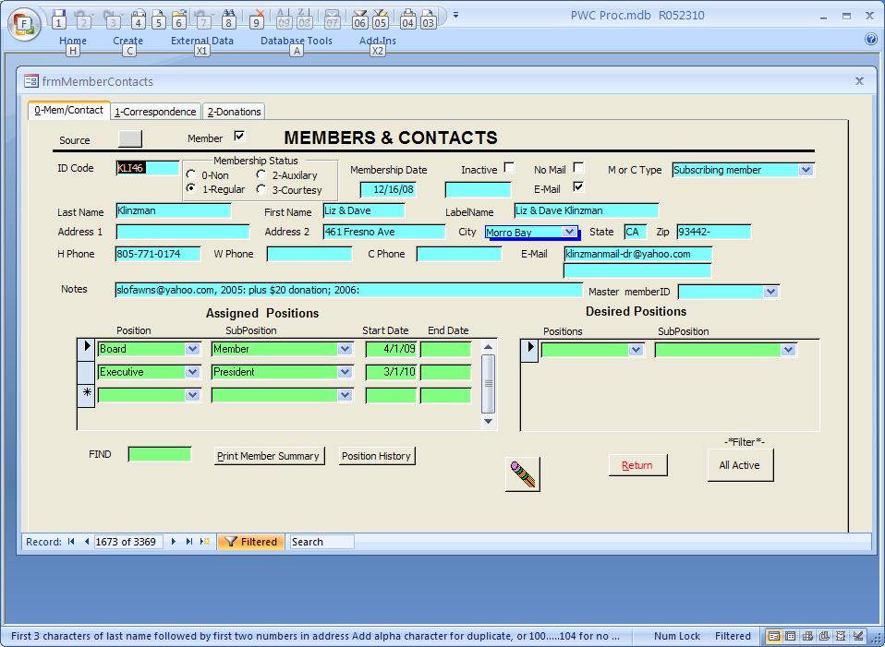

Correspondence TAB

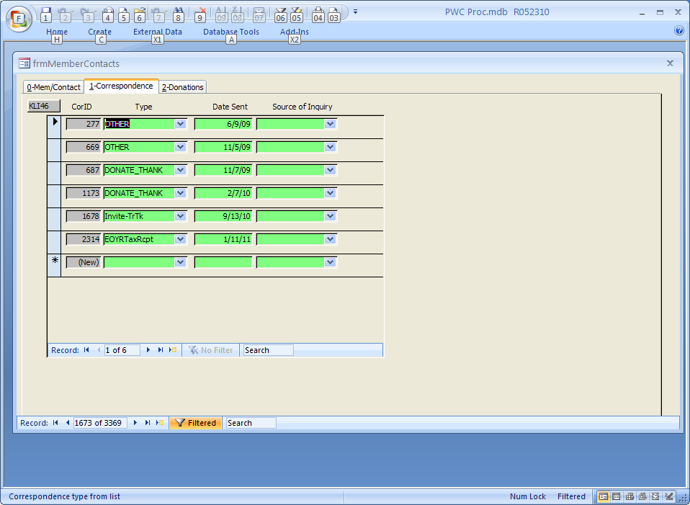

Donations TAB

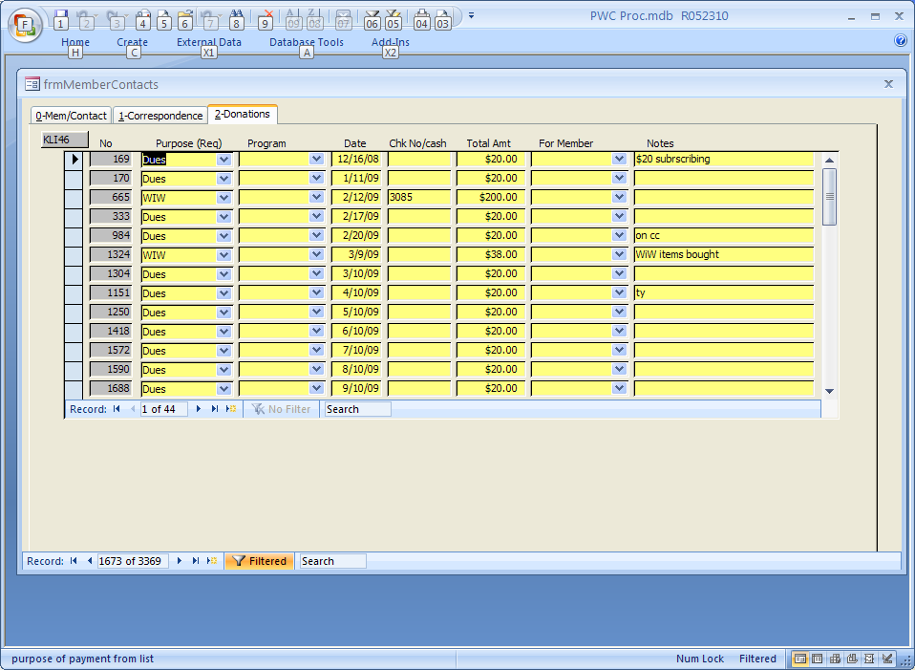

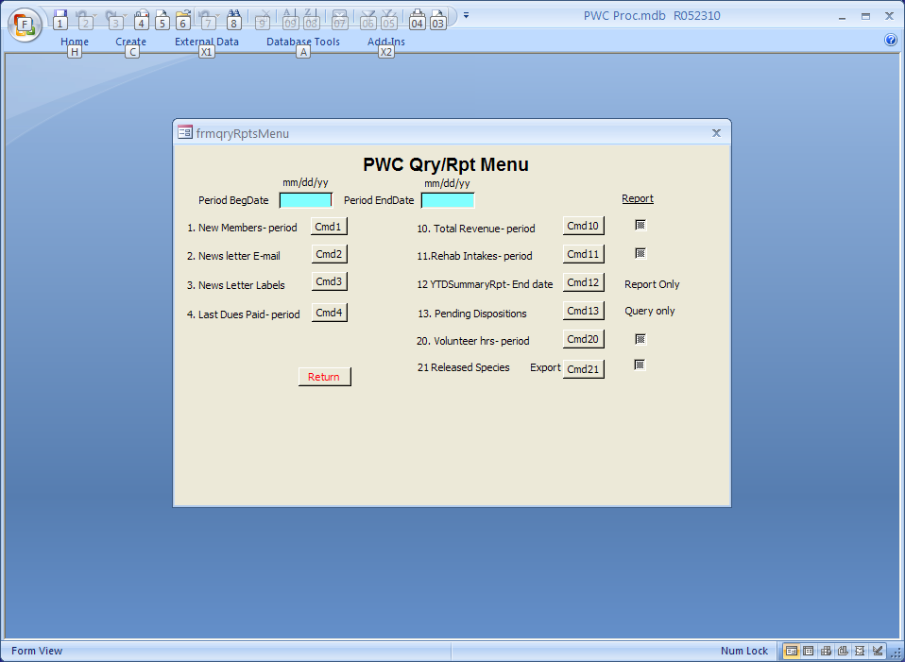

ztblMCType
Member Type (Code) | Description of Member Type | Usage
COMPANY | Merchant, Business or other Company type | B
DIGNITARY | Govt and Chamber Reps | M
Donor | Donor | B
IND_OR_FAM | Individual or Family | B
LIFETIME | Lifetime member -one time $500 donation | M
ORG | Organization e.g.non profit ; Gov Agencyr | B
PROSPECTS | Board Prospects | M
RESCUER | Rescuer of animals | B
SR_STUDNT | Full-time Student or Senior over 65 | M
SUBSCR | Subscribing member | B
VET | Veterinarian | B
VOL | Volunteer | M

Vol: Last Date Served
Text0 | Text1 | TMCID | LastSvc | LastOfVolHrs | NameLabel1stline | EmailAddress1 | HomePhone
Tuesday, August 30, 2011 | 1:53:28 PM | JEN12 | 7/10/10 | 4.00 | Virginia Jensen | ginijude@live.com | (805) 534-9901
Tuesday, August 30, 2011 | 1:53:28 PM | GRA12A | 10/27/10 | 4.00 | Angel Graham | angel.graham@sbcglobal.net | (805) 927-5970
Tuesday, August 30, 2011 | 1:53:28 PM | GOO45 | 1/2/11 | 2.50 | Elizabeth Goodenough
Tuesday, August 30, 2011 | 1:53:28 PM | WEL15 | 5/20/11 | 4.25 | Alice Welchert | alicewelchert@ymail.com | (805) 428-7355
Tuesday, August 30, 2011 | 1:53:28 PM | Kra24 | 5/31/11 | 10.00 | Laura Kramer | laurakramer01@gmail.com | (805) 462-1148
Tuesday, August 30, 2011 | 1:53:28 PM | STA28 | 6/5/11 |  | Jeff Stabler | stabe74@gmail.com
Tuesday, August 30, 2011 | 1:53:28 PM | COW35 | 6/20/11 | 4.00 | Evans Lowan | cadiscovery@prodigy.net | (805) 471-6953

