**Instructions to build and the run the application**

1. Set up a local SQL server 2017 or above
2. Change the connection strings in “**appsettings.json**”, “**appsettings.Development.json**”, “**appsettings.Staging.json**” and” **appsettings.Production.json**” of the project, “HawesAndCurtis.Api”. Please refer the below picture.

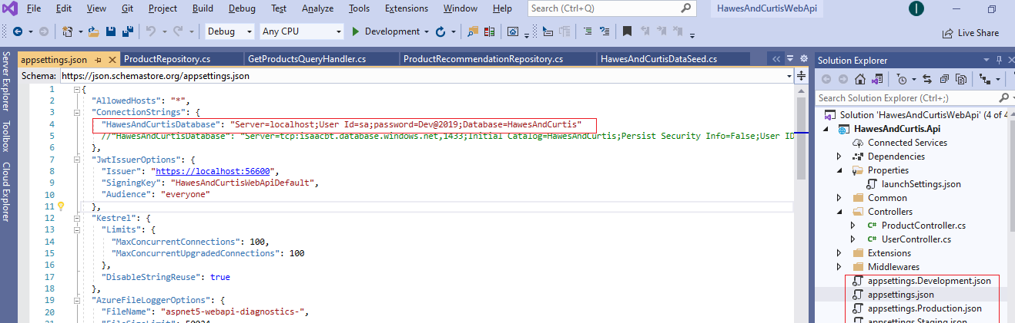

1. **Build and run the project.**
2. **Open a command prompt and navigate to the folder “AngularClient”**
3. **Run the command “npm install”. Ensure al node packages are installed**
4. **Run the command “ng serve -o”. This will open the application in Browser with url - http://localhost:3000/**
5. **Click on the menu link “STORE”**
6. **Select the first shirt, with name, “Cutaway Collar Non-Iron Twill Shirt - White”. Rest of the shirts do not have product recommendations in the database.**