StockMaster
Inventory & Order Management System

CS 305 - Advanced Java
Individual Semester Project
UNYT | Spring 2026

Author: Klisard Muca
Instructor: Ndricim Ferko
Submission: Week 14

Table of Contents

1. Introduction 3
2. Architecture & Design 3
2.1 Package Structure 3
2.2 Layered Flow 3
2.3 Domain Model (Entity Relationships) 3
2.4 Key Design Decisions 4
3. Feature Mapping (R1–R10) 5
R1 — Collections Framework 5
R2 — Generics 5
R3 — Lambda Expressions & Functional Programming 5
R4 — Stream API 5
R5 — Concurrency / Multithreading 6
R6 — JDBC / Database 6
R7 — JPA / ORM 7
R8 — RESTful Web Services 7
R9 — Design Patterns 7
R10 — Exception Handling 8
3.11 Requirement Summary 8
4. Challenges & Solutions 9
4.1 LazyInitializationException during JSON serialization 9
4.2 Preventing concurrent overselling of stock 9
5. Conclusion 9
6. AI Disclosure 10

1. Introduction
StockMaster is a back-end application for managing the inventory and order workflow of a retail business. It allows staff to register suppliers, catalogue products, track stock across multiple warehouses, and place customer orders with automatic stock deduction and discount handling. The application is exposed entirely as a RESTful web service built with Spring Boot, and persists its data in a PostgreSQL relational database.
I chose the inventory-and-orders domain because it maps naturally and non-trivially onto every requirement of the course. A real store must hold different kinds of data in different collection types, calculate aggregate figures over large product lists, prevent two simultaneous orders from overselling the same item, persist rich relationships between orders and the products they contain, and expose all of this over a clean HTTP API. Rather than bolting features on artificially, the domain itself motivates each advanced Java feature covered in CS 305.
The system is organised in clear layers — entities, repositories, services, controllers — plus dedicated packages for design patterns, concurrency, and direct JDBC reporting. The sections that follow describe the architecture, map each of the ten technical requirements (R1–R10) to its implementation with code excerpts, discuss the main technical challenges encountered, and reflect on the outcome.

2. Architecture & Design

2.1 Package Structure
The codebase follows a conventional layered Spring Boot architecture. Each package has a single, well-defined responsibility:
com.stockmaster
.entity JPA entities (Product, Supplier, Order, OrderItem, Warehouse)
.enums OrderStatus
.repository Spring Data JPA repositories (+ base.Repository<T>)
.dto PagedResult<T>, StockReportDto, OrderRequest
.exception custom exceptions + GlobalExceptionHandler
.pattern builder / strategy / observer
.concurrency WarehouseStockChecker
.jdbc ReportingRepository (direct JDBC)
.service ProductService, OrderService, SupplierService, WarehouseService
.controller Product / Order / Supplier / Warehouse REST controllers

2.2 Layered Flow
A request flows from a REST controller, into a service that holds the business logic, down to a repository that talks to the database. Cross-cutting concerns are isolated: discount algorithms live in the pattern.strategy package, low-stock alerting in pattern.observer, parallel stock checks in concurrency, and SQL reporting in jdbc. This separation keeps each class small and makes the requirement-to-code mapping in Section 3 straightforward.
HTTP Client → Controller → Service → Repository / JDBC → PostgreSQL

2.3 Domain Model (Entity Relationships)
The five entities form the following relationships, all mapped with JPA annotations:
- Supplier 1 — N Product: a supplier provides many products (@OneToMany / @ManyToOne).
- Order 1 — N OrderItem: an order contains many line items, cascaded and orphan-removed.
- OrderItem N — 1 Product: each line item references a product and snapshots its price at order time.
- Warehouse holds a Map<String, Integer> of SKU → quantity via @ElementCollection.
The UML class diagram below summarises the model:
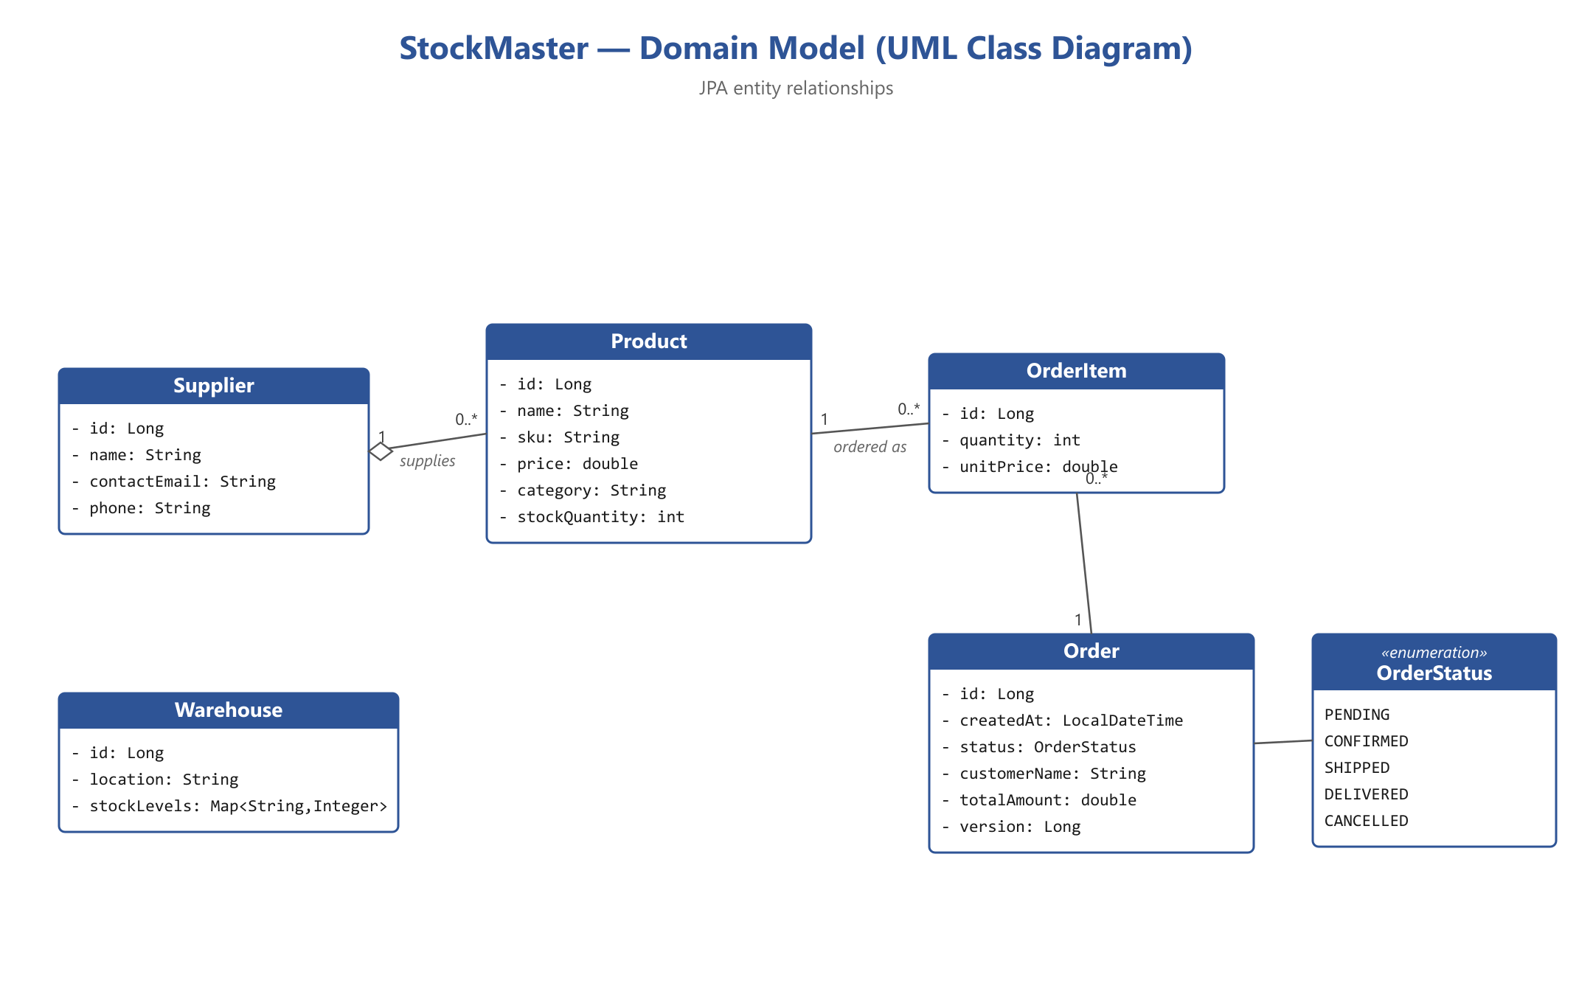
Figure 1 — StockMaster domain model (JPA entity relationships).

2.4 Key Design Decisions
- ReentrantLock over synchronized: a fair ReentrantLock guards stock deduction, preventing two concurrent orders from overselling while avoiding thread starvation.
- @Version optimistic locking: concurrent modifications of the same Order are detected at commit time instead of silently overwriting.
- TreeMap for grouping: category grouping returns a TreeMap so results are deterministically sorted, unlike a HashMap.
- Direct JDBC alongside JPA: multi-table JOIN and GROUP BY reports are expressed in raw SQL, sharing the same HikariCP pool as JPA.
- Three design patterns: Builder assembles orders safely, Strategy makes discounts pluggable, Observer decouples low-stock alerts.

3. Feature Mapping (R1–R10)
Each requirement below is shown with its location in the source and a representative code excerpt.

R1 — Collections Framework
Location: ProductService, Warehouse, StockEventPublisher, OrderService.
Three distinct collection types are used, each chosen for its use case: ArrayList for ordered lists, HashMap for O(1) key lookup, and TreeMap for sorted grouping.
// TreeMap keeps categories sorted alphabetically (HashMap would not)
public TreeMap<String, List<Product>> groupByCategory() {
return productRepository.findAll().stream()
.collect(Collectors.groupingBy(
Product::getCategory, TreeMap::new, Collectors.toList()));
}
// Warehouse: HashMap for fast SKU -> quantity lookup
private Map<String, Integer> stockLevels = new HashMap<>();

R2 — Generics
Location: repository.base.Repository<T>, dto.PagedResult<T>, ProductService.mapProducts.
A generic base repository interface, a generic paginated result wrapper, and a generic method parameterised over both input and output types.
// Generic class - reusable pagination envelope
public class PagedResult<T> {
private final List<T> content;
// ...
}
// Generic method - maps products to any type R via a Function
public <R> List<R> mapProducts(Function<Product, R> mapper) {
return productRepository.findAll().stream()
.map(mapper).collect(Collectors.toList());
}

R3 — Lambda Expressions & Functional Programming
Location: ProductService (Predicate, Function, Comparator), GlobalExceptionHandler.
Functional interfaces are used in several distinct places, including caller-supplied predicates for flexible filtering.
// Predicate<Product> supplied by the caller, applied with a Stream
public List<Product> findByPredicate(Predicate<Product> filter) {
return productRepository.findAll().stream()
.filter(filter)
.collect(Collectors.toList());
}
// Comparator via method reference for sorted paging
.sorted(Comparator.comparing(Product::getName))

R4 — Stream API
Location: ProductService, OrderService.
Streams are used with both intermediate operations (filter, map, sorted) and terminal operations (collect, reduce, sum, groupingBy).
// mapToDouble + reduce: total value of all inventory
public double calculateTotalInventoryValue() {
return productRepository.findAll().stream()
.mapToDouble(p -> p.getPrice() * p.getStockQuantity())
.reduce(0.0, Double::sum);
}
// filter + mapToDouble + sum: revenue from delivered orders
orderRepository.findAll().stream()
.filter(o -> o.getStatus() == OrderStatus.DELIVERED)
.mapToDouble(Order::getTotalAmount).sum();

R5 — Concurrency / Multithreading
Location: concurrency.WarehouseStockChecker (ExecutorService + Future), OrderService (ReentrantLock), Order (@Version).
Warehouses are queried in parallel using a fixed thread pool; each check is a Callable whose result is collected via Future with a timeout. Stock deduction is serialised with a fair ReentrantLock to guarantee thread safety.
private final ExecutorService executorService =
Executors.newFixedThreadPool(4);
for (Warehouse warehouse : warehouses) {
Callable<String> task = () -> {
Integer onHand = warehouse.getStockLevels().getOrDefault(sku, 0);
return onHand >= requiredQty ? warehouse.getLocation() : null;
};
futures.add(executorService.submit(task));
}
String location = future.get(5, TimeUnit.SECONDS);
// OrderService: only one thread at a time may read-then-write stock
stockLock.lock();
try {
// validate + deduct stock + build order
} finally {
stockLock.unlock(); // always released
}

R6 — JDBC / Database
Location: jdbc.ReportingRepository.
Reporting queries use direct JDBC with PreparedStatement (preventing SQL injection), try-with-resources for automatic resource closing, and meaningful SQLException handling.
try (Connection conn = dataSource.getConnection();
PreparedStatement ps = conn.prepareStatement(sql)) {
ps.setInt(1, threshold); // bound parameter - safe
try (ResultSet rs = ps.executeQuery()) {
while (rs.next()) {
dto.setProductName(rs.getString("name"));
// ...
}
}
} catch (SQLException e) {
throw new RuntimeException("... SQLState=" + e.getSQLState(), e);
}

R7 — JPA / ORM
Location: entity package + 4 Spring Data repositories.
Five entities are mapped with JPA annotations covering identity generation, relationships, enum persistence, optimistic locking, and element collections.
@Entity @Table(name = "orders")
public class Order {
@Id @GeneratedValue(strategy = GenerationType.IDENTITY)
private Long id;
@Enumerated(EnumType.STRING)
private OrderStatus status;
@Version private Long version; // optimistic locking
@OneToMany(mappedBy = "order", cascade = CascadeType.ALL,
orphanRemoval = true)
private List<OrderItem> items = new ArrayList<>();
}

R8 — RESTful Web Services
Location: controller package (4 controllers).
Each resource exposes full CRUD through Spring MVC, returning ResponseEntity with appropriate HTTP status codes and JSON bodies.
@RestController
@RequestMapping("/api/products")
public class ProductController {
@PostMapping
public ResponseEntity<Product> create(@RequestBody Product product) {
Product created = productService.createProduct(product);
return ResponseEntity
.created(URI.create("/api/products/" + created.getId()))
.body(created);
}
@DeleteMapping("/{id}")
public ResponseEntity<Void> delete(@PathVariable Long id) { ... }
}

R9 — Design Patterns
Location: pattern.builder, pattern.strategy, pattern.observer.
Three Gang-of-Four patterns are applied in meaningful contexts:
- Builder (OrderBuilder) — assembles an Order with a variable number of line items and validates invariants in build(), so an Order can never exist in a partial state.
- Strategy (DiscountStrategy with None/Percentage/Flat) — the discount algorithm is chosen at runtime in the controller, leaving OrderService untouched when new discount types are added (Open/Closed Principle).
- Observer (StockObserver / StockEventPublisher) — when stock drops below threshold, the publisher notifies all observers (logging, email) without knowing what they do.
// Strategy chosen at runtime from the request
DiscountStrategy strategy = switch (type.toUpperCase()) {
case "PERCENTAGE" -> new PercentageDiscountStrategy(value);
case "FLAT" -> new FlatDiscountStrategy(value);
default -> new NoDiscountStrategy();
};

R10 — Exception Handling
Location: exception package.
Custom exceptions distinguish recoverable business conditions from programming errors. InsufficientStockException is deliberately checked (extends Exception), forcing callers to handle it; the others are unchecked. A @RestControllerAdvice translates each to a clean JSON response with the correct status code. There are no empty catch blocks anywhere.
// Checked: insufficient stock is a recoverable business condition
public class InsufficientStockException extends Exception { ... }
@RestControllerAdvice
public class GlobalExceptionHandler {
@ExceptionHandler(InsufficientStockException.class)
public ResponseEntity<Map<String,Object>> handle(...) {
return build(HttpStatus.CONFLICT, ex.getMessage());
}
}

3.11 Requirement Summary
Req | Feature | Primary Location
R1 | Collections | ProductService, Warehouse, StockEventPublisher
R2 | Generics | Repository<T>, PagedResult<T>, mapProducts()
R3 | Lambda / Functional | ProductService (Predicate, Function, Comparator)
R4 | Stream API | ProductService, OrderService
R5 | Concurrency | WarehouseStockChecker, OrderService, Order@Version
R6 | JDBC | jdbc.ReportingRepository
R7 | JPA / ORM | entity package + 4 JpaRepository interfaces
R8 | REST | controller package (4 controllers)
R9 | Design Patterns | Builder, Strategy, Observer
R10 | Exception Handling | exception package + GlobalExceptionHandler

4. Challenges & Solutions

4.1 LazyInitializationException during JSON serialization
Problem. The Product entity references its Supplier with a lazy @ManyToOne association. After disabling Open-Session-In-View, requests to GET /api/products crashed with org.hibernate.LazyInitializationException: could not initialize proxy — no Session. The controller returned successfully, but when Jackson serialized the response it tried to read product.supplier.name after the Hibernate session had already closed, so the lazy proxy could not load.
Solution. I analysed the trade-off between eager and lazy fetching. Switching everything to eager loading would solve the symptom but cause unnecessary joins and the classic N+1 problem. Instead I kept lazy fetching for efficiency and re-enabled spring.jpa.open-in-view=true, which holds the persistence context open through view rendering so the serializer can safely initialise the proxy. I also added @JsonIgnoreProperties on the inverse sides of relationships to break the bidirectional serialization cycle (Order ↔ OrderItem, Supplier ↔ Product). This resolved the crash while preserving lazy loading everywhere else.

4.2 Preventing concurrent overselling of stock
Problem. Stock deduction is a read-then-write sequence: read the current quantity, check it is sufficient, then subtract. If two order requests for the same product run on different threads at the same time, both can read the same starting quantity and both succeed — driving stock negative and overselling the item.
Solution. I serialised the critical section in OrderService.placeOrder with a fair ReentrantLock(true), acquired before validation and released in a finally block so it is never leaked even on exception. I chose ReentrantLock over a synchronized block because the fair-ordering mode prevents thread starvation under load and the lock object makes the intent explicit. As a second line of defence at the persistence layer, the Order entity carries a @Version field for optimistic locking, so concurrent modifications of the same order are detected at commit time rather than silently overwriting each other.

5. Conclusion
Building StockMaster brought the individual topics of CS 305 together into a single coherent system. The most valuable lesson was seeing how the advanced features interlock in practice: generics make the repository and pagination code reusable, the Stream API turns reporting logic into a few readable lines, the design patterns keep the order workflow extensible, and the concurrency utilities make the difference between a correct and an incorrect system under load. Debugging the LazyInitializationException in particular forced me to understand how the JPA persistence context, lazy proxies, and JSON serialization actually interact rather than treating the framework as a black box.
Given more time I would add automated tests with JUnit and Mockito (especially a concurrency test that fires many simultaneous orders to prove the lock prevents overselling), introduce DTOs for every response to fully decouple the API from the entity model, and add Spring Security to protect the write endpoints. Overall the project meets all ten technical requirements with meaningful, non-trivial usage, runs correctly against PostgreSQL, and is structured so that each requirement can be located and explained on demand.

6. AI Disclosure
In accordance with Section 6 of the project description, I disclose the following use of AI tools.
Tool used: an AI coding assistant (Claude).
How it was used:
- Generating the initial Spring Boot project scaffold and boilerplate (entity getters/setters, repository interfaces, controller method stubs).
- Explaining concepts and suggesting which design patterns and collection types best fit each part of the domain.
- Helping diagnose the LazyInitializationException and the concurrent-overselling design, including the trade-offs discussed in Section 4.
- Drafting and formatting portions of this written report.
What is my own work and understanding: I designed the application domain and feature plan, reviewed and verified every line of generated code, ran and debugged the application against PostgreSQL, and can explain any part of the implementation on demand. The architectural decisions (ReentrantLock vs. synchronized, lazy vs. eager fetching, direct JDBC alongside JPA) reflect my own analysis. AI-assisted text in this report has been reviewed and edited to reflect my own understanding, and is kept to a supporting role rather than replacing my own writing.

