Algebra_COVID_plots

Kevin Little

3/27/2020

## Table and Plot of U.S. Deaths

knitr::kable(data_use)

|  |  |  |  |  |  |  |  |  |  |  |  |  |
| --- | --- | --- | --- | --- | --- | --- | --- | --- | --- | --- | --- | --- |
| dateRep | day | month | year | cases | deaths | countriesAndTerritories | geoId | countryterritoryCode | popData2018 | deaths_nudge | log_count_deaths | serial_day |
| 2020-03-01 | 1 | 3 | 2020 | 3 | 1 | United_States_of_America | US | USA | 327167434 | 1 | 0.0000000 | 1 |
| 2020-03-02 | 2 | 3 | 2020 | 20 | 1 | United_States_of_America | US | USA | 327167434 | 1 | 0.0000000 | 2 |
| 2020-03-03 | 3 | 3 | 2020 | 14 | 4 | United_States_of_America | US | USA | 327167434 | 4 | 0.6020600 | 3 |
| 2020-03-04 | 4 | 3 | 2020 | 22 | 3 | United_States_of_America | US | USA | 327167434 | 3 | 0.4771213 | 4 |
| 2020-03-05 | 5 | 3 | 2020 | 34 | 2 | United_States_of_America | US | USA | 327167434 | 2 | 0.3010300 | 5 |
| 2020-03-06 | 6 | 3 | 2020 | 74 | 1 | United_States_of_America | US | USA | 327167434 | 1 | 0.0000000 | 6 |
| 2020-03-07 | 7 | 3 | 2020 | 105 | 2 | United_States_of_America | US | USA | 327167434 | 2 | 0.3010300 | 7 |
| 2020-03-08 | 8 | 3 | 2020 | 95 | 3 | United_States_of_America | US | USA | 327167434 | 3 | 0.4771213 | 8 |
| 2020-03-09 | 9 | 3 | 2020 | 121 | 4 | United_States_of_America | US | USA | 327167434 | 4 | 0.6020600 | 9 |
| 2020-03-10 | 10 | 3 | 2020 | 200 | 5 | United_States_of_America | US | USA | 327167434 | 5 | 0.6989700 | 10 |
| 2020-03-11 | 11 | 3 | 2020 | 271 | 2 | United_States_of_America | US | USA | 327167434 | 2 | 0.3010300 | 11 |
| 2020-03-12 | 12 | 3 | 2020 | 287 | 2 | United_States_of_America | US | USA | 327167434 | 2 | 0.3010300 | 12 |
| 2020-03-13 | 13 | 3 | 2020 | 351 | 10 | United_States_of_America | US | USA | 327167434 | 10 | 1.0000000 | 13 |
| 2020-03-14 | 14 | 3 | 2020 | 511 | 7 | United_States_of_America | US | USA | 327167434 | 7 | 0.8450980 | 14 |
| 2020-03-15 | 15 | 3 | 2020 | 777 | 10 | United_States_of_America | US | USA | 327167434 | 10 | 1.0000000 | 15 |
| 2020-03-16 | 16 | 3 | 2020 | 823 | 12 | United_States_of_America | US | USA | 327167434 | 12 | 1.0791812 | 16 |
| 2020-03-17 | 17 | 3 | 2020 | 887 | 16 | United_States_of_America | US | USA | 327167434 | 16 | 1.2041200 | 17 |
| 2020-03-18 | 18 | 3 | 2020 | 1766 | 23 | United_States_of_America | US | USA | 327167434 | 23 | 1.3617278 | 18 |
| 2020-03-19 | 19 | 3 | 2020 | 2988 | 42 | United_States_of_America | US | USA | 327167434 | 42 | 1.6232493 | 19 |
| 2020-03-20 | 20 | 3 | 2020 | 4835 | 0 | United_States_of_America | US | USA | 327167434 | NA | NA | 20 |
| 2020-03-21 | 21 | 3 | 2020 | 5374 | 110 | United_States_of_America | US | USA | 327167434 | 110 | 2.0413927 | 21 |
| 2020-03-22 | 22 | 3 | 2020 | 7123 | 80 | United_States_of_America | US | USA | 327167434 | 80 | 1.9030900 | 22 |
| 2020-03-23 | 23 | 3 | 2020 | 8459 | 131 | United_States_of_America | US | USA | 327167434 | 131 | 2.1172713 | 23 |
| 2020-03-24 | 24 | 3 | 2020 | 11236 | 119 | United_States_of_America | US | USA | 327167434 | 119 | 2.0755470 | 24 |
| 2020-03-25 | 25 | 3 | 2020 | 8789 | 211 | United_States_of_America | US | USA | 327167434 | 211 | 2.3242825 | 25 |
| 2020-03-26 | 26 | 3 | 2020 | 13963 | 249 | United_States_of_America | US | USA | 327167434 | 249 | 2.3961993 | 26 |
| 2020-03-27 | 27 | 3 | 2020 | 16797 | 246 | United_States_of_America | US | USA | 327167434 | 246 | 2.3909351 | 27 |

#extend data table by one week  
buffer <- 7  
  
p0 <- ggplot(data=data_use,aes(x=dateRep,y=deaths))+  
 theme_bw()+  
 geom_point(size=rel(2.0),colour="blue")+  
 geom_line()+  
 labs(title="U.S.Daily New Deaths", caption="Source: https://ourworldindata.org/coronavirus-source-data, 27 Mar 2020")+  
 xlab("Date")+  
 xlim(min(data_use$dateRep),max(data_use$dateRep)+buffer)  
  
print(p0)

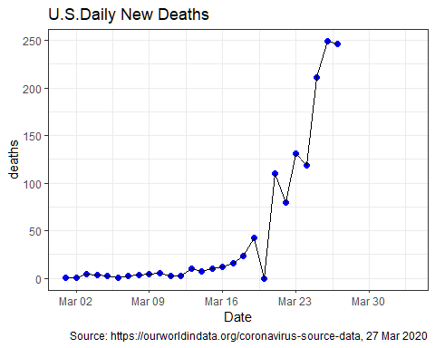

## Linear Fit

This is the linear fit

lm_out <- lm(data=data_use,data_use$log_count_deaths ~ data_use$serial_day)  
#check plot  
p1<- ggplot(data=data_use,aes(x=serial_day,y=log_count_deaths))+  
 theme_bw()+  
 geom_point()+  
 geom_line()  
   
p2 <- p1+ geom_smooth(method=lm)  
print(p2)

## `geom_smooth()` using formula 'y ~ x'

## Warning: Removed 1 rows containing non-finite values (stat_smooth).

## Warning: Removed 1 rows containing missing values (geom_point).

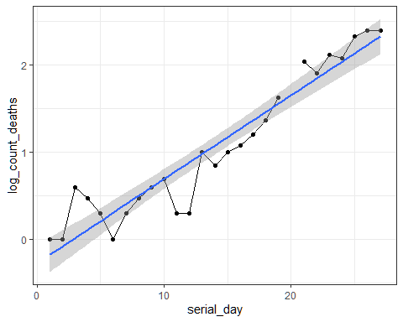

#intercept  
lm_out$coefficients[1]

## (Intercept)   
## -0.2700875

#slope  
lm_out$coefficients[2]

## data_use$serial_day   
## 0.09621738

## Exponential limits

cchart_df <- data.frame(data_use[!is.na(data_use$log_count_deaths),c("dateRep","serial_day")],  
 lm_out$residuals,c(NA,diff(lm_out$residuals)),lm_out$fitted.values)  
  
  
  
AvgMR <- mean(abs(cchart_df$lm_out.residuals))  
cchart_df$UCL <- lm_out$fitted.values+2.66*mean(AvgMR,na.rm=TRUE)  
cchart_df$LCL <- lm_out$fitted.values-2.66*mean(AvgMR,na.rm=TRUE)  
  
#buffer with buffer days beyond max date  
buffer_serial_day <- seq(from=max(cchart_df$serial_day)+1,to=max(cchart_df$serial_day)+buffer,by=1)  
predicted_value <- lm_out$coefficients[1]+ lm_out$coefficients[2]*buffer_serial_day  
buffer_dates <- seq.Date(from=max(cchart_df$dateRep)+1,to=max(cchart_df$dateRep)+buffer,by="day")  
buffer_df <- cbind.data.frame(buffer_dates,  
 buffer_serial_day,  
 rep(NA,buffer),  
 rep(NA,buffer),  
 predicted_value,  
 predicted_value +2.66*mean(AvgMR,na.rm=TRUE),  
 predicted_value - 2.66*mean(AvgMR,na.rm=TRUE))  
  
names(buffer_df) <- names(cchart_df)  
  
  
df_out <- rbind(cchart_df,buffer_df)  
  
df_out$predict <- 10^df_out$lm_out.fitted.values  
df_out$UCL_anti_log <- 10^df_out$UCL  
df_out$LCL_anti_log <- 10^df_out$LCL  
  
p3 <- p0 + geom_line(data=df_out,aes(x=dateRep,y=predict),linetype="solid",colour="red")+  
 geom_line(data=df_out,aes(x=dateRep,y=UCL_anti_log),linetype="dotted")+  
 geom_line(data=df_out,aes(x=dateRep,y=LCL_anti_log),linetype="dotted")  
  
print(p3)

