**ARCHITECTURAL DESIGN**

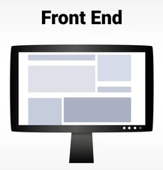

**Server**

**Browser(client)**

**Collect data**

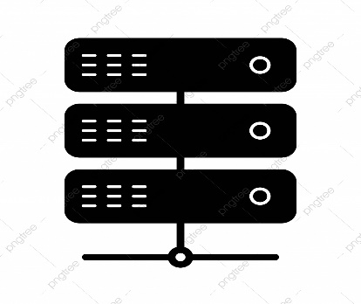

**Request**

**Display Results**

**Response**

**Client**

**HTML-JavaScript-CSS-REACT**

Node.js-Express

**Response**

**Request**

**Database**

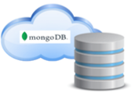

**Mongo DB Atlas**