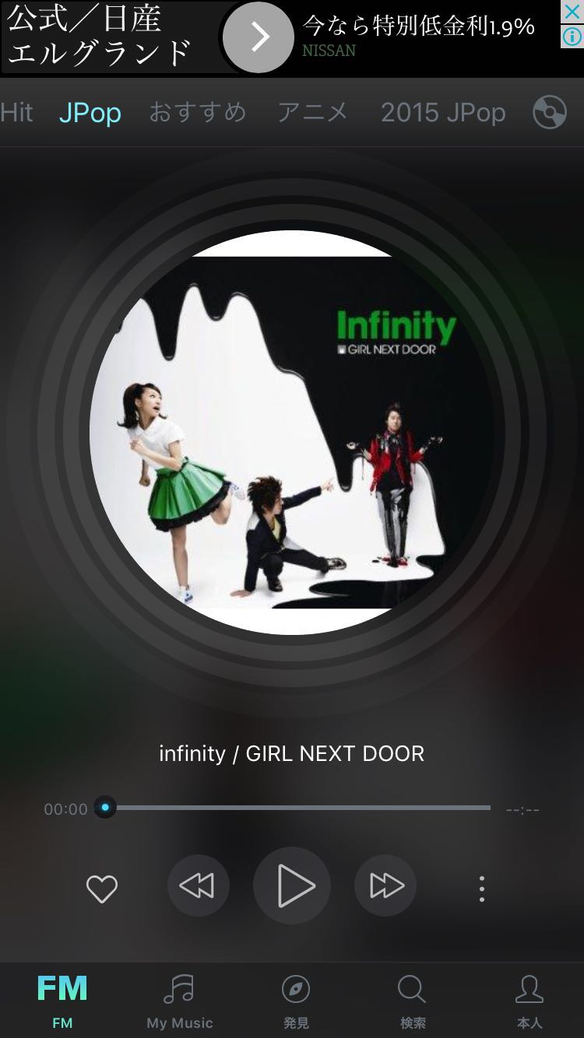

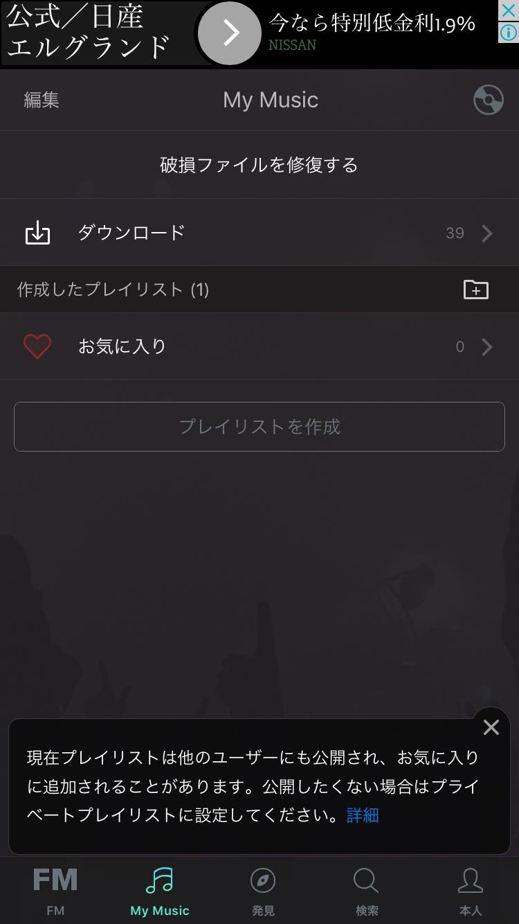

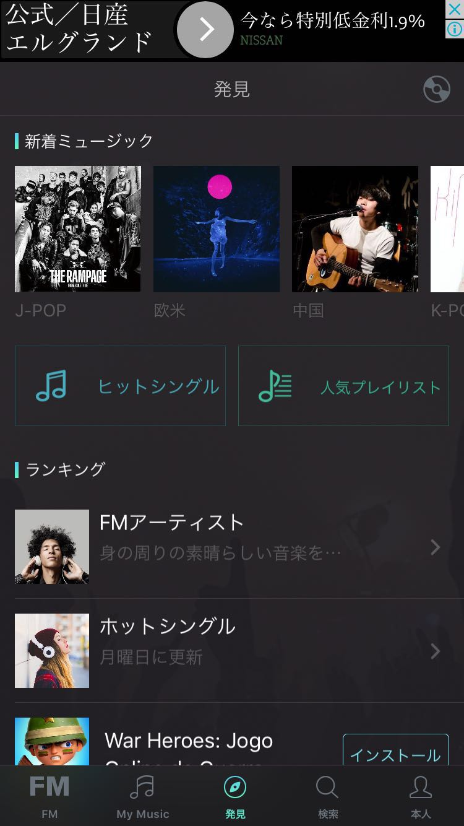

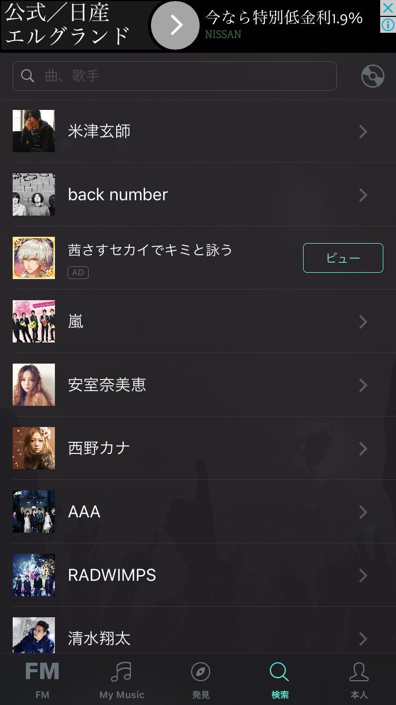

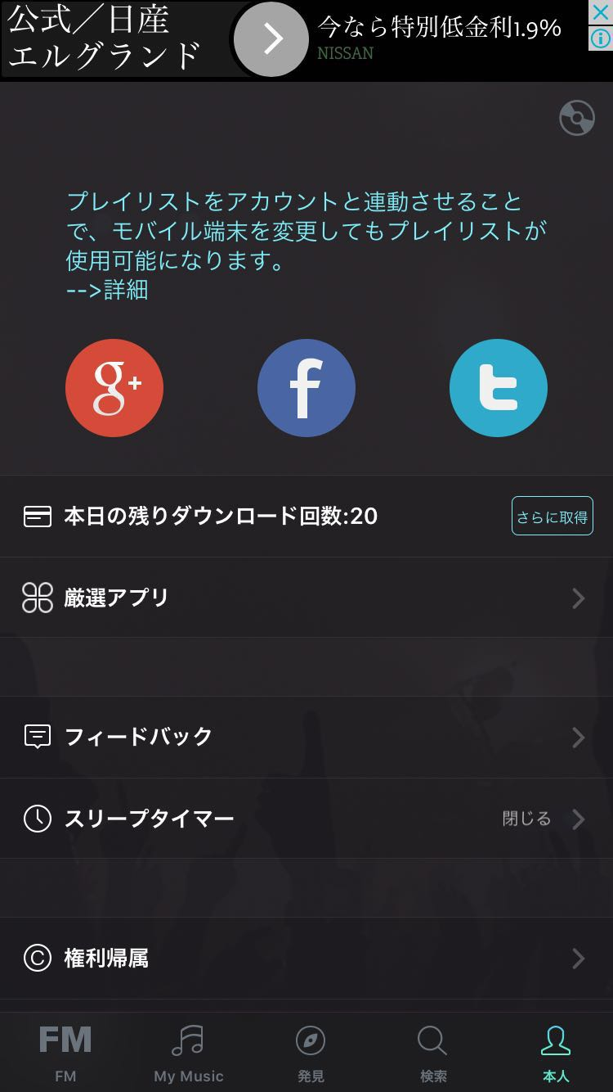

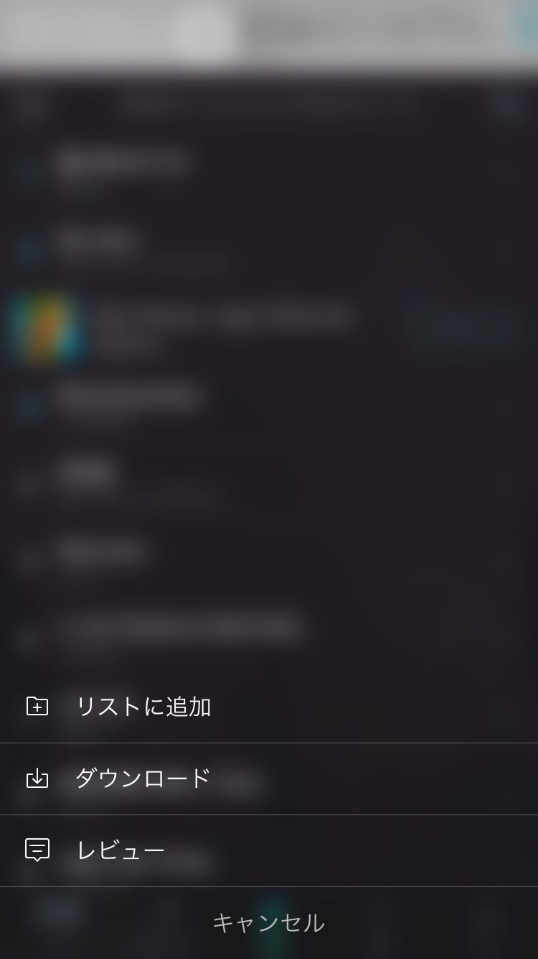

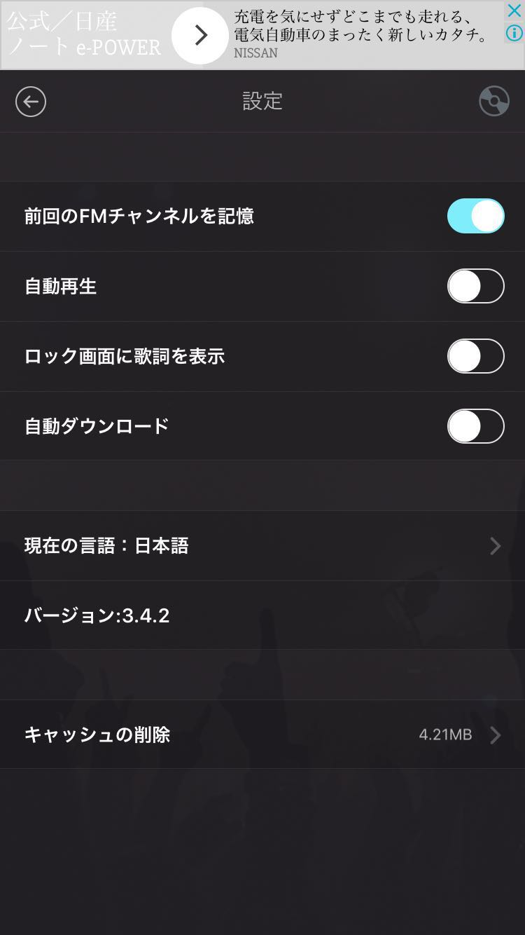

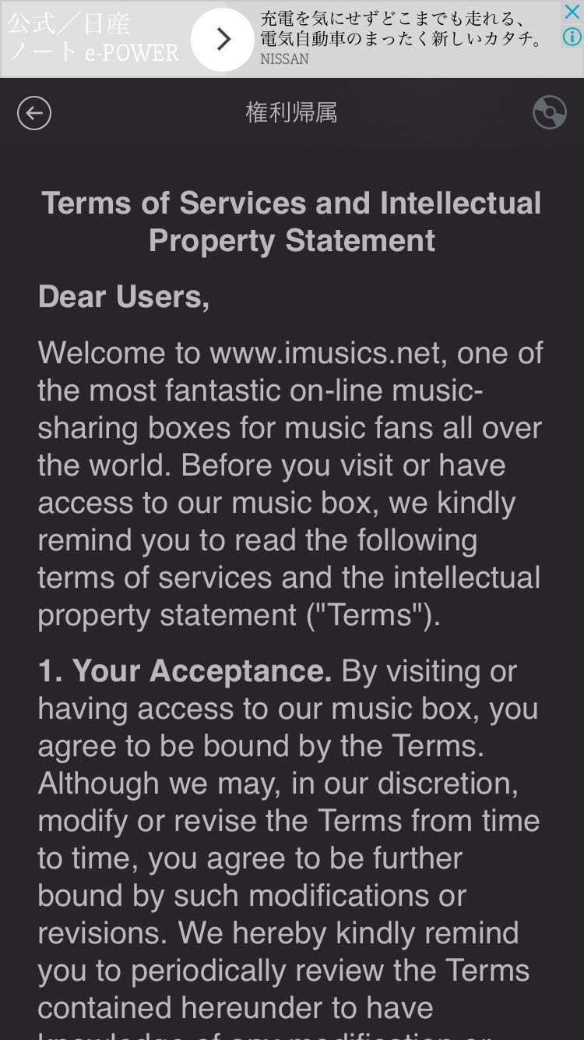

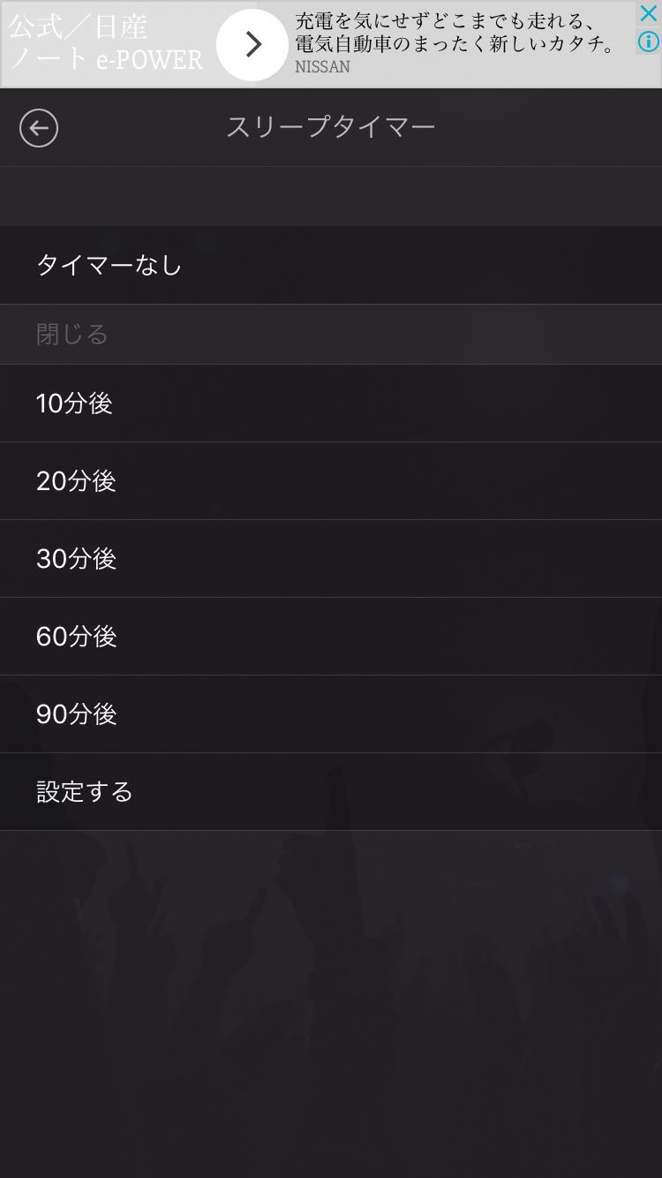

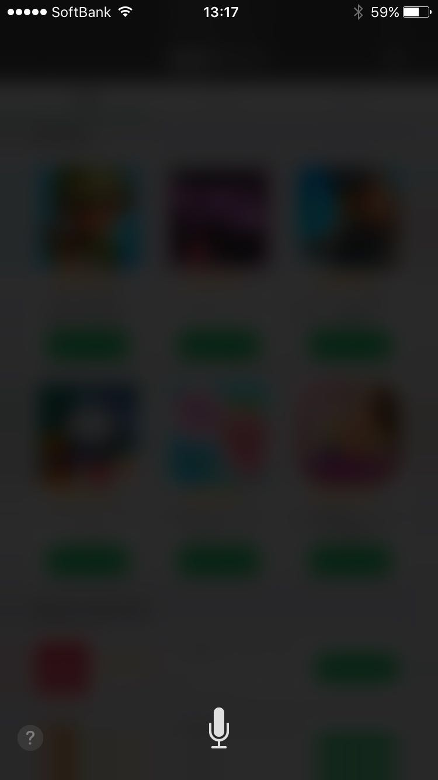

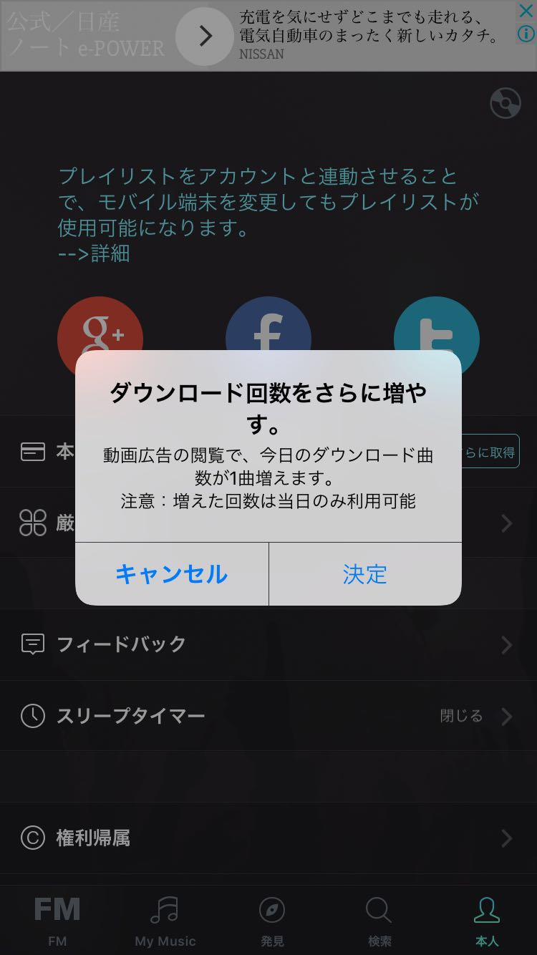

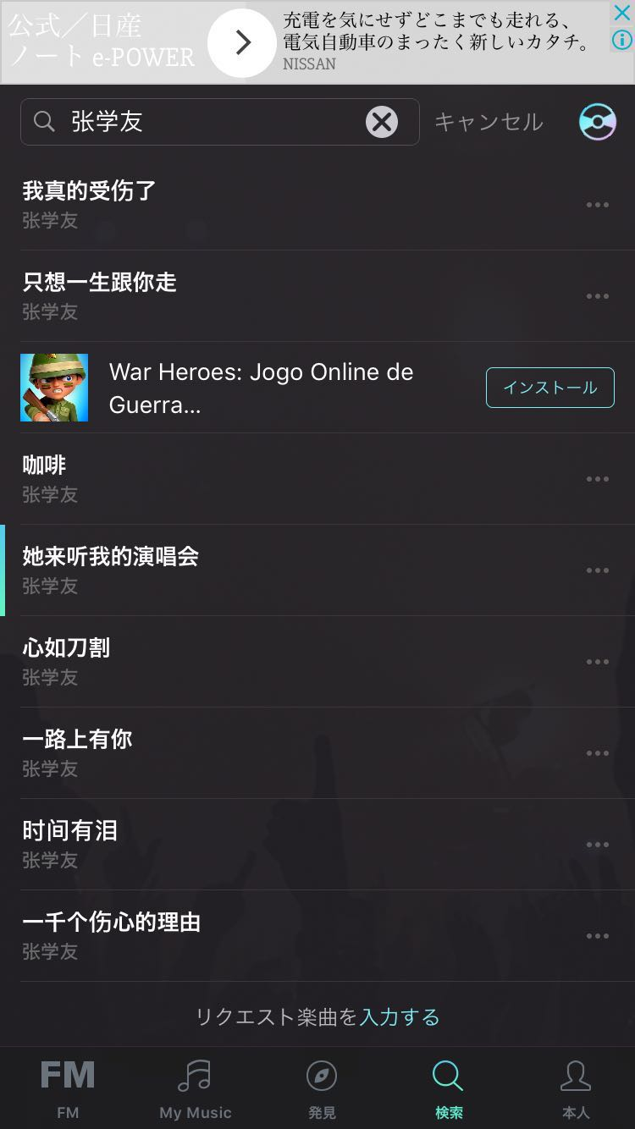

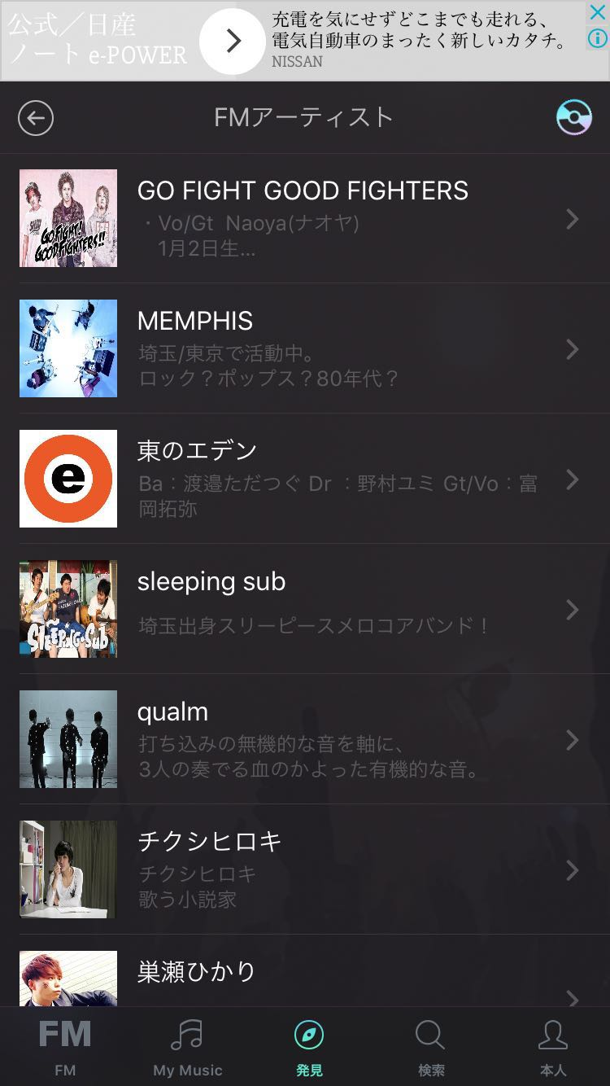

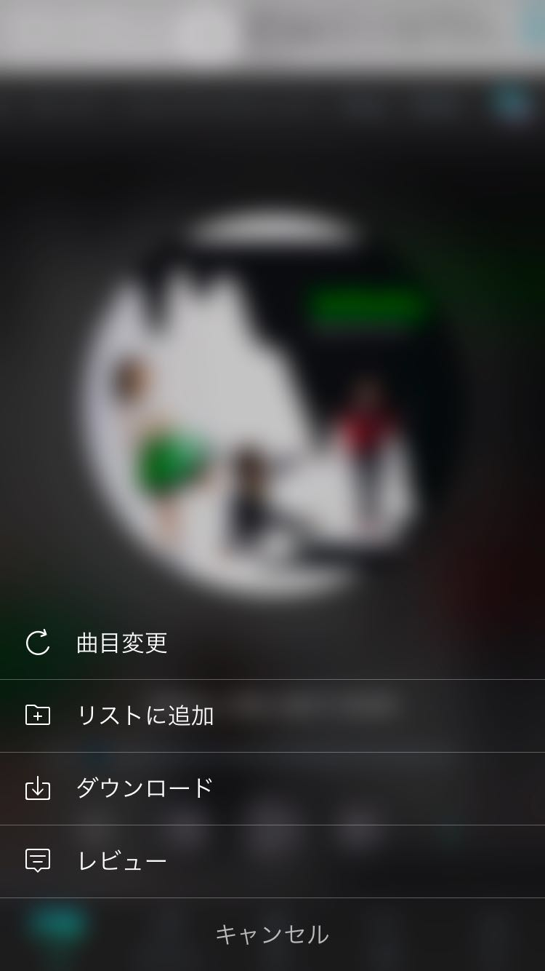

应用结构

应用包括”FM”、我的音乐、发现、搜索、我5个栏目。

FM：

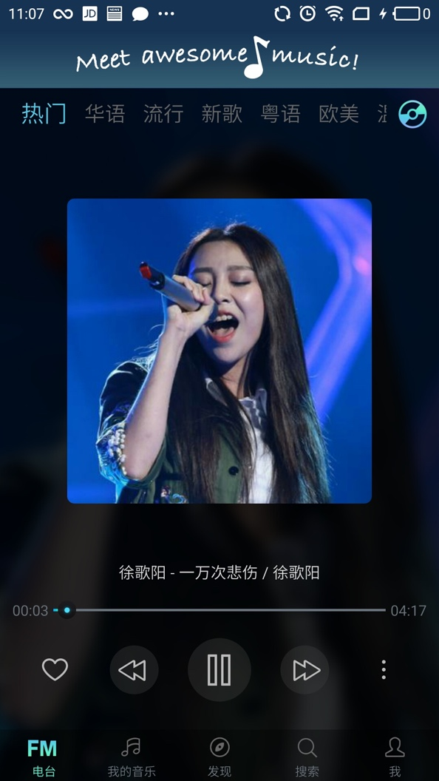

FM是播放音乐的界面，正在播放的音乐在该界面展示。上部的榜单信息从如下的请求中获取：

https://theinfoapps.com/myfm/category/list/zh-hans/?os_api=22&osv=5.1&device_type=PRO%205&client_id=&dpi=480&device_manufacturer=Meizu&carrier=&e=ZAdvY47XDMn0QzuwEW5BeA%0A&install_id=&fmek=d4cec0bdeccd321061552d3e&rom=1495870962&jb=false&v=3.1.7&lang=zh&ac=WiFi&sig_hash=61%3A71%3A7B%3AF9%3A0D%3A81%3A05%3A58%3A3D%3A41%3ABF%3A5A%3A96%3A1F%3A42%3ABE%3A05%3A0E%3ABF%3A96&channel=GOOGLE_PLAY&android_id=&appname=MusicFM&carrier_code=&appid=net.imusic.android.musicfm&version_code=16&unique_device_id=15114233380020693v3.1.7&osn=meizu_PRO5&timezone=8&fmev=bc3f405a5f6748b1070297f8e5bd7bff&country=CN&channel_lang=zh-hans&resolution=1920x1080&device_brand=Meizu&phonetype=android&r=18e0bc&model=ull_arm64-v8a_armeabi-v7a_armeabi

{

"status": "1",

"data": {

"channels": [

{

"source": "4",

"name": "热门",

"id": "2048"

},

{

"source": "4",

"name": "华语",

"id": "10001"

}

]

}

}

点击某个榜单时，从如下地址获取榜单中歌曲信息：

https://theinfoapps.com/myfm/category/2048/?os_api=22&osv=5.1&device_type=PRO%205&client_id=&dpi=480&device_manufacturer=Meizu&carrier=&e=ZAdvY47XDMn0QzuwEW5BeA%0A&install_id=&fmek=d4cec0bdeccd321061552d3e&rom=1495870962&jb=false&v=3.1.7&lang=zh&ac=WiFi&sig_hash=61%3A71%3A7B%3AF9%3A0D%3A81%3A05%3A58%3A3D%3A41%3ABF%3A5A%3A96%3A1F%3A42%3ABE%3A05%3A0E%3ABF%3A96&channel=GOOGLE_PLAY&android_id=&appname=MusicFM&carrier_code=&appid=net.imusic.android.musicfm&version_code=16&unique_device_id=15114233380020693v3.1.7&osn=meizu_PRO5&timezone=8&fmev=bc3f405a5f6748b1070297f8e5bd7bff&country=CN&channel_lang=zh-hans&resolution=1920x1080&device_brand=Meizu&phonetype=android&r=06af24&model=ull_arm64-v8a_armeabi-v7a_armeabi

{

"status": "1",

"data": [

{

"share_uri": "/share/play/?sid=C2D4A1C216860B3222D535631E1D9844",

"lyricURL": "http://cdn.letusmusictogether.com/lyric/bc/5569f6ddfc384286360ac624ff24b1.lrc",

"ori_coverURL": "http://cdn.letusmusictogether.com/image/08/e554f5074bcfae684f201d08d2ccd3.jpg",

"title": "팔레트",

"url": "http://cdn.letusmusictogether.com/music/db/5d88dbab581e98679e9f23240783c0.mp3",

"coverURL": "http://cdn.letusmusictogether.com/image/08/e554f5074bcfae684f201d08d2ccd3.jpg",

"song_id_ext": "C2D4A1C216860B3222D535631E1D9844",

"artist": "IU",

"copyright_type": 1,

"flag": 0,

"source": {},

"length": 217,

"mv": {

"region_allowed": "",

"dislikes": 19087,

"published_at": "2017-04-21 09:00:05",

"likes": 639919,

"mtime": "2017-11-22 08:26:15",

"duration": "00:03:39",

"id": 90305485,

"title": "[MV] IU(아이유) _ Palette(팔레트) (Feat. G-DRAGON)",

"views": 62213374,

"language_id": 0,

"comments": 32205,

"source": 0,

"description": "[MV] IU(아이유) _ Palette(팔레트) (Feat. G-DRAGON)\n\n*English subtitles are now available. :D\n(Please click on 'CC' button or activate 'Interactive Transcript' function)\n\n:: Get the new album on : http://smarturl.it/iupalette\n\n▶1theK FB : http://www.facebook.com/1theK\n▶1theK TW : https://twitter.com/1theK\n▶1theK G+ : https://plus.google.com/+1theK",

"embeddable": 1,

"is_active": 1,

"cover_image": "https://i.ytimg.com/vi/d9IxdwEFk1c/mqdefault.jpg",

"is_public": 1,

"y_video_id": "d9IxdwEFk1c",

"fm_mv_active": 1,

"ctime": "2017-04-22 08:06:26",

"rate": 60411,

"region_blocked": "",

"review_info": ""

},

"uploader": "",

"sid": 2600413,

"cdn_coverURL": "http://cdn.letusmusictogether.com/image/08/e554f5074bcfae684f201d08d2ccd3.jpg",

"other_sources": []

},

]

}

默认显示第一个分类的第一首歌曲，只显示，不播放。

在任何界面选择播放某一首歌曲时，播放的信息展示在FM界面中。