**Karl Louie Tuazon**

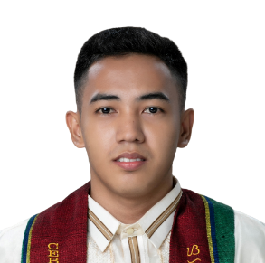 San Fernando, Cebu



karllouieflorestuazon@gmail.com



09917591627



https://github.com/klltzn



<https://karllouietuazon.000webhostapp.com/>



**PROFESSIONAL SUMMARY**

As a dedicated, hardworking and reliable person, I am seeking for a challenging opportunity where I can use my skills for the growth of the organization and myself.

**EXPERIENCE**

**Computer Technician Intern | Nabscomputer System | November 2022 – June 2023**

* Assemble and troubleshoot a PC/computer.
* Deliver some computer stocks.
* Installing a license software or free-trial software and Reformatting a PC/Laptop.

**EDUCATION**

**Tertiary**

August 2023

Bachelor of Industrial Technology Major in Computer Technology

Cebu Technological University

**Secondary**

July 2019

Science, Technology, Engineering and Mathematics Strand

Dalaguete National High School

**TECHNICAL SKILLS**

* Programming (C#, Python, JavaScript)
* Hardware troubleshooting, repair and maintenance
* Assembling a computer set
* Knowledge at web development (HTML, CSS, JavaScript, PHP, SQL)
* Basic knowledge in Photoshop
* Basic knowledge in web development framework (Bootstrap, React, Node.js, .NET)

**SOFT SKILLS**

* Problem-solving
* Critical Thinking
* Openness to Criticism
* Adaptability
* Decision-making
* Organizational
* Teamwork

**CERTIFICATIONS**

* Theoretical Understanding of HTML | Sololearn | 2021
* Theoretical Understanding and Practical Understanding of Introduction to JavaScript | Sololearn | 2023
* Theoretical Understanding and Practical Understanding of JavaScript Intermediate | Sololearn | 2023
* Theoretical Understanding and Practical Understanding of Python | Sololearn | 2023

**REFERENCES**

* Kim Martin a senior software developer who taught me Windows Forms and Web Forms in C#.