Review of the Literature on Oyster Bed Microbial Communities

Kelly Miller

2025-02-07

# Introduction to the microbial world

Microorganisms are the unsung heroes of primary production, though the narrative usually centers on plants. They work on a scale we cannot see, but the effects of their cumulative efforts are impossible to miss; half of the oxygen in each breath we take has been produced by oceanic microbes (Pomeroy et al., n.d.). Take a breath. (Thanks microbes!)

Let’s start with the three domains of life: Bacteria, Archaea, and Eukarya. In biological classification (*i.e.*, domain, phylum, class, order, family, genus, and species), domain is the broadest level of distinction. Humans belong to Eukarya, along with plants, fungi, and many microbial species whose cells contain membrane-bound nuclei. In contrast, Bacteria and Archaea are exclusively microbial, and exclusively prokaryotic.

The microbial world holds incredible biodiversity and functional diversity. As humans, our genus (*Homo*) contains our species, *Homo sapiens*, and extinct relatives like *Homo erectus*. Compare this to the bacterial genus *Streptococcus*, which includes species that ferment milk into cheese and yogurt, live in soil, populate and help regulate human organ systems, and can cause infections like strep throat and scarlet fever–all within one genus of bacteria.

## Microbial Metabolism: Cross-Feeding and the Nitrogen Cycle

Instead of performing metabolic pathways from start to finish–like the way our digestive systems pass food from mouth to esophagus to stomach to small intestine, etc. –microorganisms rely on each other to achieve comparable processes. These interactions in microbial communities are known as **handoffs or metabolic cross-feeding**. Cumulatively, they make up **intermediate microbial pathways**. A prime example of microbial handoffs is denitrification (Figure 1), a key step in the nitrogen cycle, and one that is performed by sediment microbial communities within oyster farms. In denitrification, nitrate (NO3-) is converted to nitrite (NO2-) which is converted to nitric oxide (NO) and then to nitrous oxide (N2O) and finally to dinitrogen (N2) (Figure 1).

Each microorganism in this pathway has a specific enzyme that catalyzes one step in the sequence. Dr. Lawrence Pomeroy described this microbial community behavior as an “external digestive process” that benefits motile bacteria (Pomeroy et al., n.d.). Dr. Farooq Azam simplified it even further, calling microbial communities the “ultimate swimming stomachs” (Pomeroy et al., n.d.).

Denitrification results in the removal of nitrogen from the system, occurring when N2 gas (a very stable, non-reactive form of nitrogen due to the triple bond between the two nitrogen molecules) bubbles up and is released into the atmosphere–where it naturally makes up nearly 80% of the air we breathe (“The Atmosphere | National Oceanic and Atmospheric Administration,” n.d.). In a world where greenhouse gas emissions resulting from human activity are knocking environmental equilibrium off balance, the storage of nitrogen as diatoms is especially vital now. When in more volatile forms (NOx), nitrogen compounds have the potential to form nitrous oxide, a greenhouse gas three hundred times more potent than carbon dioxide (“Why Laughing Gas Is a Growing Climate Problem,” n.d.).

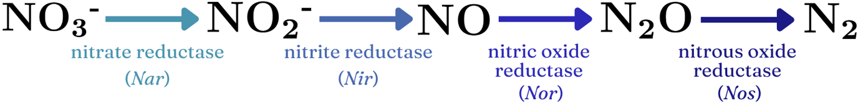

## The Microbial Loop: Energy Flow in Ecosystems

While the traditional depiction of the food chain is a pyramid with plants at the base, topped by primary, secondary, and tertiary consumers, much of the available energy in our food webs derives from microbes. This microbial-driven energy flow is called the **microbial loop**. It begins with **primary production** performed by photosynthetic bacteria—either **bacterioplankton**, which are bacteria and archaea that drift through the water column (Pomeroy et al., n.d.), or **periphyton**, which are attached to submerged surfaces like sediments and aquatic plants. These microbes use sunlight energy (and sometimes heat energy—in a process known as **chemosynthesis**) to form organic compounds, just as terrestrial plants do (Pomeroy et al., n.d.). Bacterioplankton and periphyton’s biomass–built by performing photosynthesis/chemosynthesis–then fuels the rest of the ecosystem. One food chain looks like this: bacterioplankton are consumed by microflagellates (<0.002 mm), which are in turn eaten by ciliates like *Paramecium* (~0.02-0.2 mm). These ciliates are then preyed upon by copepods (1-2 mm) and mid-size animal plankton called mesozooplankton (0.2-20 mm). All of this occurs before fish larvae enter the food web as predators, linking microbial production to larger organisms.

However, the microbial loop can be short-circuited by **filter-feeders** like oysters and krill, which capture microorganisms en masse as they pump seawater through their gills. Regardless of whether or not the full microbial loop has occured, it is closed by the microbes involved in decomposition, when they break down decaying organisms and detritus. This process releases essential nutrients into the water column, where they can be reabsorbed by bacterioplankton.

## It’s a Microbial World

Microbes are diverse, abundant, and essential to life on Earth. Their community interactions cycle nutrients, regulate ecosystems, and sustain food webs. Therefore, when we discuss the factors shaping ecological systems—whether nutrient cycling, energy flow, or ecosystem stability—we must recognize that the true drivers of biological processes are microorganisms.

It’s a microbial world—we’re just living in it.

# Introduction to oyster farming

Oyster aquaculture has been practiced globally since ancient times, when oysters were part of the Greek, Roman, and Chinese diets. (Botta et al. 2020). In the last two hundred years, overharvesting and coastal development activities (ex. dredging) have decimated reefs. More than “85% of oyster reefs have been lost globally, and less than 1% of wild populations remain in many locations” (Ray and Fulweiler 2021).

Today, many coastal communities are trying to build back their oyster populations. As the ecological consequences of industrial and agricultural production become increasingly evident, responsible oyster aquaculture has emerged as part of a reimagined, more sustainable food system. Unlike traditional agriculture, oyster farming does not require land or freshwater resources–and can even provide ecological benefits. These benefits include improved water quality, habitat creation for marine species, and storm surge protection (Stevens et al. 2024).

# Theory #1: Oysters enhance the biodiversity and composition of microbial communities in the seafloor.

Oysters are filter feeders, capable of filtering ~50 gallons of seawater per day. As water passes through their gills, they obtain algae and large plankton. This organic matter is either ingested and eventually excreted as feces–or rejected, encased in mucus, and deposited into the sediment as pseudofeces. Oyster biodeposition promotes a sediment environment that is rich in carbon (C), nitrogen (N), phosphorous (P), and silicon (Si), and contains trace metals like iron (Fe), molybdenum (Mo) and copper (Cu) (Ray and Fulweiler 2021).

By… Nitrogen and carbon content increase impacts community composition

By adding trace metals to marine sediments, oysters promote biodiverse microbial communities (Feinman et al. 2018) . Bacteria with the *Nar* gene might only be able to perform nitrate reduction in an environment with molybedenum, as “nitrate reductase requires a Molybdenum protein co-factor”(Stevens et al. 2024). Likewise for bacteria with the *Nos* gene: “nitrous oxide reductase requires Cu for reducing nitrous oxide (N2O) to N2” (Stevens et al. 2024).

**description for the pic I actually want to use: “relative abundances of bacterial phyla in RefSeq-annotated RNA transcripts from control and 7 yr sites” (source = Stevens)**

### \textcolor{red}{+ pg 292 fig 5, stevens paper?}

## Microbial communities found in oyster bed sediment

Based on sampling from Ninigret Pond–a coastal lagoon in Rhode Island–some of the most dominant bacterial phyla that showed a drastic increase in abundance from control to farmed sites were *Proteobacteria*, *Thermotogae*, and *Spirochaetes* (Stevens et al. 2024). Per the same study, 141 genera exhibited differential abundance between control and farmed site samples. 124 of those genera, including *Firmicutes*, *Deltaproteobacteria*, and *Epsilonproteobacteria*, were more abundant at the farmed sites (Stevens et al. 2024). Some genera were less abundant at the farmed sites–like *Alphaproteobacteria* and *Gammaproteobacteria* (Stevens et al. 2024). While the abundance of microbes was higher at farmed sites than control sites, the community composition did not appear drastically different in modelling by phyla. And, while there was some uniformity between the relative abundance of the various phyla from control sites, the farmed sites showed less agreement–particularly in the relative abundance of *Firmicutes* (Stevens et al. 2024).

One bacterial genus that increased in richness as a result of oyster farming was *Vibrio* (Feinman et al. 2018). Some species of *Vibrio* are associated with food-borne illnesses stemming from seafood ingestion (Feinman et al. 2018). However, Feinman et. al, 2018 found that *Vibrio* present were not the pathogenic strains; there was insufficient evidence that the *Vibrio* richness increase from oyster farming was harmful to human health (Feinman et al. 2018).

Factors varying between oyster beds affect the influence oyster farming has on sediment microbial communities. The Feinman et al. study found that oyster stocking density (loosely versus tightly packed oyster farms) accounted for more of the variability in sediment microbial community composition between samples than did the location of the samples (intertidal versus subtidal range), though the paper did not find a direct connection(Feinman et al. 2018). Whether on-bottom methods or tray farming had been used–meaning the oyster colony was on a tray suspended in the water, instead of having contact with the sediments– impacted sediment microbial community composition, but less so than stocking density or location (Feinman et al. 2018).

firmicutes picture

# Theory #2: Oysters stimulate increased denitrification by sediment microbiota.

Oyster sediment microbes boost the cycling and recycling of nitrogen, phosphorous, and silicon in the water column (Ray and Fulweiler 2021). As agricultural and industrial production load freshwater and marine systems with these nutrients in the form of fuel, fertilizer, and waste run-off, nutrient cycling is critical to mitigating eutrophication. While an overabundance of nitrogen and phosphorous causes phytoplankton overgrowth and harmful algal blooms, the long-term result is anoxia–conditions in which very few organisms from the original, oxygenic ecosystem can survive. This is where oyster bed microbes come into play: “Stimulation of sediment denitrification and denitrification in oysters can permanently remove excess N from coastal systems, reducting the impact of eutrophication” (Ray and Fulweiler 2021).

While oysters themselves have denitrifying microbes in their microbiomes, sediments may have a greater impact on nitrogen cycling. While 17/45 studies in a meta-analysis by Ray & Fulweiler (2021) reported fluxes from oysters, 31/45 reported fluxes from sediments(Ray and Fulweiler 2021).

Where

Here’s the pathway: nutrient loading on aquatic system - probably from anthropogenic activity.

Then, this stimulates an increase in the abundance of many photosynthetic organisms, like cyanobacteria. All the time, decaying matter and detritus is falling through the water column in the form of marine snow. When oysters “catch” plankton and other microbes and algae, they are pulled out from the water column, boosting water clarity. The seafloor is, ideally covered in decay and also microbes. It is a place of regeneration, of recycling. When sediment microbes take in nitrogen paired with organic material (usually it will be in the form of ammonia or urea, although neither of those are organics?? But are they just with carbon anyway?) microbes break the bonds between nitrogen and hydrogen, returning hydrogen to the water column? At some points, our nitrogens in the process of denitrification are paired with oxygens but the oxygens are eventually returned to the water column. Close to the end of the process of denitrification, nitrous oxide is created. Nitrous oxide is a harmful greenhouse gas, however, the amounts released from sediment denitrification are very small. The Fulweiler meta-analysis suggests that the amount of nitrous oxide released is negligible. This would be a good place to put the Ray and Fulweiler nutrient flux diagram

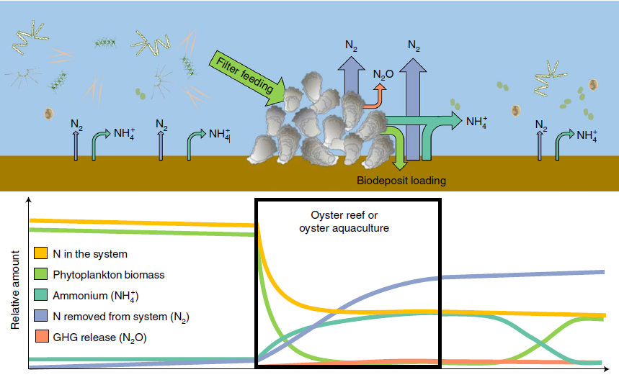

Oyster poop microbes remineralize unstable nitrogen compounds (urea, ammonia, nitrate, nitrite, nitric oxide, nitrous oxide), returning them to the water column as N2.

Diatom nitrogen makes up like 70% of our atmosphere and gas rises so a lot of the N2 is recycled back into the air. Kind of cool that we are all breathing matter that had its energy spent and has been recycled billions of time. From death back unto life, or something like that.

So to sum it up, oyster sediment bacteria improve water quality and combat eutrophication. Now I am realizing that I need to learn more about how they actually combat eutrophication and mitigate global warming. I think I’ve mentioned sequestering, but do they really sequester? Maybe I’m getting carbon cycle and nitrogen cycle confused.

* “sediments beneath oysters return significantly more NH4+ to the water column than bare sediments” (Ray and Fulweiler 2021), pg. 2, 1st col, oysters have highly-variable effect on NOx fluxes between studies, in contrast
* ““oysters also have a strong effect on sediment phosphate regeneration” (Ray and Fulweiler 2021), si unclear
* check pg 3z - effect on primary production. promote nitrogen recycling, but add back to system? How does this combat denitrification?
* Seems that oysters do not have a net positive ability related to sequestering carbon. Installing oyster aquacutlutre initially increases sediment CO2 and CH4 release, before returning to baseline. This is good compared to more typical forms of raising protein because for example, cow corn monoculture releases hella GHGs from soils. But there are limited studies on the impact of oyster aquacutluutre on GHG emissions. I am left wondering about the strength of the one study discussed in the Ray paper. Also, do oysters themselves release GHGs?* Are there other pieces of oyster awauculture that release GHGs? Restoration projects are underway; should they be?
* *Omg. Discussed in next paragraph. pg 4 column 2 of ray and fulweiler

# Trade-offs

Denitrification by sediment microbes is an intermediate, and therefore leaky process. Before nitrates and nitrites (NOx groups) are fully reduced to N2, they become **nitrous oxide** molecules (a potent greenhouse gas), some of which escape into the atmosphere. This happens on a much smaller scale than anthropogenic greenhouse gas emission, but it is still happening. The paper that

**increasing dinoflagellate growth**

# Conclusion - next steps

From my review of the literature on oyster sediment microbial communities, I have formed the thoughts to guide my own research:

1. Is there a significant difference in the biodiversity of microbial communities in control versus oyster sediments based on my dataset?
2. How pronounced is the impact of denitrifying microbes in these communities? With trade-offs like an increase in dinoflagellate growth and the release of nitrous oxide to consider, it is important to weigh the value of the nutrient cycling performed by oyster sediment microbes.

Sediment microbial communities are one factor to be considered in an evaluation of oysters’ impact on the environment.

## Citations

Botta, Robert, Frank Asche, J. Scott Borsum, and Edward V. Camp. 2020. “A Review of Global Oyster Aquaculture Production and Consumption.” *Marine Policy* 117: 103952. https://doi.org/<https://doi.org/10.1016/j.marpol.2020.103952>.

Feinman, Sarah G., Yuna R. Farah, Jonathan M. Bauer, and Jennifer L. Bowen. 2018. “The Influence of Oyster Farming on Sediment Bacterial Communities.” *Estuaries and Coasts* 41 (3): 800–814. <https://doi.org/10.1007/s12237-017-0301-7>.

Pomeroy, Lawrence R., Peter J. leB Williams, Farooq Azam, and John E. Hobbie. n.d. “The Microbial Loop | Oceanography.” <https://tos.org/oceanography/article/the-microbial-loop>.

Ray, Nicholas E., and Robinson W. Fulweiler. 2021. “Meta-Analysis of Oyster Impacts on Coastal Biogeochemistry.” *Nature Sustainability* 4 (3): 261–69. <https://doi.org/10.1038/s41893-020-00644-9>.

Stevens, Joshua T. E., Nicholas E. Ray, Alia N. Al-Haj, Robinson W. Fulweiler, and Priyanka Roy Chowdhury. 2024. “Oyster Aquaculture Enhances Sediment Microbial Diversity: Insights from a Multi-Omics Study.” *Aquaculture Environment Interactions* 16 (December): 283–301. <https://doi.org/10.3354/aei00484>.

“The Atmosphere | National Oceanic and Atmospheric Administration.” n.d. <https://www.noaa.gov/jetstream/atmosphere>.

“Why Laughing Gas Is a Growing Climate Problem.” n.d. <https://news.stanford.edu/stories/2020/10/laughing-gas-growing-climate-problem>.