**DATA SCIENCE WITH R PROGRAMMING**

*1.Bar Chart:*

library(ggplot2)

workout <- c(300,250,200,180,70)

names(workout) <- c("Cardio","Strength Training","Yoga", "Group Classes","Swimming")

barplot(workout, main="Workout Preferences", xlab="Workout Type", ylab="Number of Members", col="cyan")

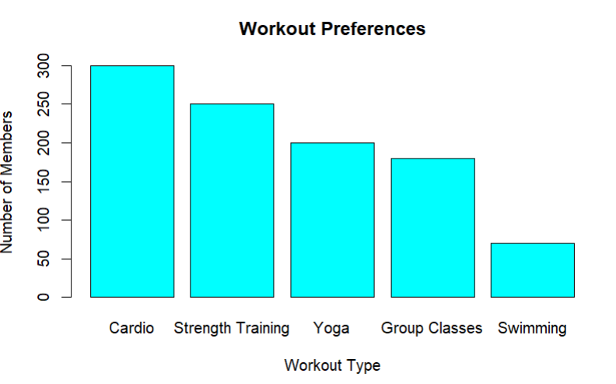

*2.Histogram:*

age_gr <- c("18-25 years", "26-35 years", "36-45 years", "46-55 years", "56+ years")

customer_co <- c(200, 180, 150, 120, 70)

age_data <- data.frame(Age_Gr = age_gr, Customers = customer_co)

hist(age_data$Customers, breaks = c(0, 50, 100, 150, 200), col = "Red",

xlab = "Number of Customers", ylab = "Frequency",

main = "Age Distribution in Shopping Mall")

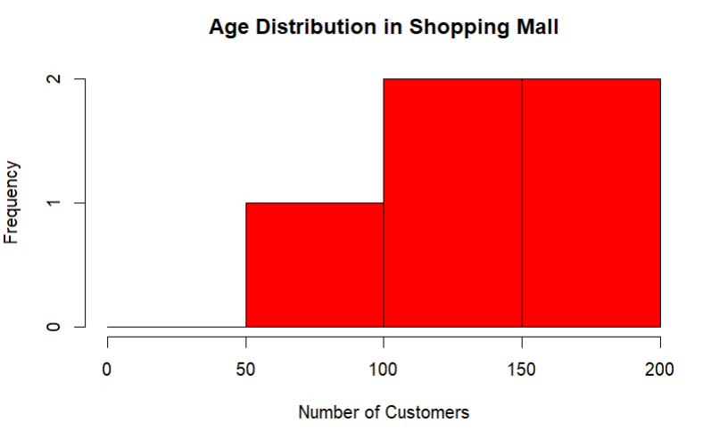

*3.Boxplot:*

dep <- c("Marketing", "Finance", "IT", "Operations", "Other")

salary_ranges <- list(

Marketing = c(50000, 80000),

Finance = c(60000, 90000),

IT = c(70000, 100000),

Operations = c(55000, 85000),

Sales = c(65000, 95000)

)

salary_data <- data.frame(Department = rep(dep, each = 100),

Salary = unlist(lapply(salary_ranges, function(range) {

sample(seq(range[1], range[2], by = 1000), 100, replace = TRUE)

})))

boxplot(Salary ~ Department, data = salary_data, col = "blue",

xlab = "Department", ylab = "Salary",

main = "Salary Distribution Across Departments")

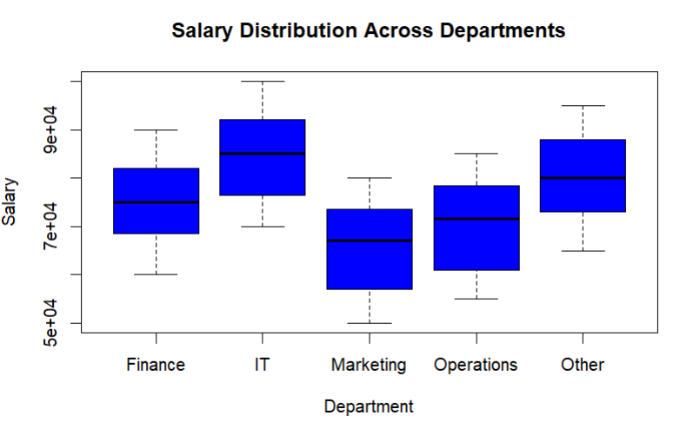

*4.Line Chart:*

cost=c(100000,110000,95000,120000,105000,115000)

plot(cost,type='o',xlab='month',ylab='cost',col='blue')

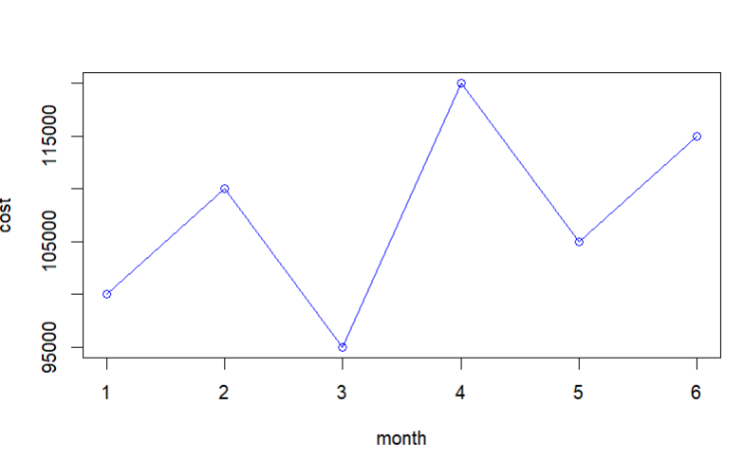

*5. Scatter Plot:*

sleep=c(7,6,8,6.5,7.5)

prod=c(80,75,90,78,85)

plot(sleep,prod,ylab='productivity',main='the relationship between hours of sleep and productivity')

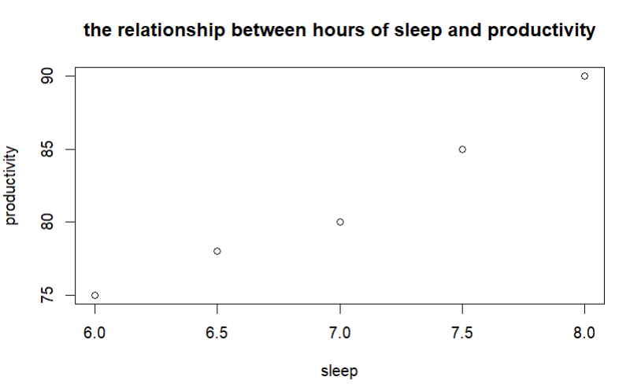

*6.Bar Chart(mtcars database):*

data(mtcars)

average_mpg <- tapply(mtcars$mpg, mtcars$cyl, mean)

barplot(average_mpg,

main = "Average MPG by Car Model",

xlab = "No.of Cylinders",

ylab = "Average MPG",

col = "purple",

border = "green")

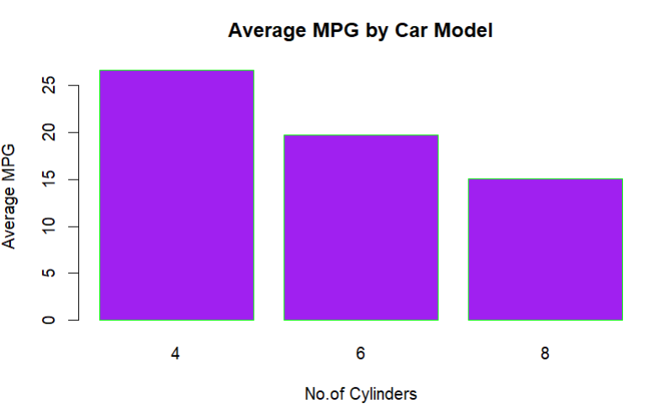

*7.Histogram (iris dataset):*

data(iris)

sepal_lengths <- iris$Sepal.Length

hist(sepal_lengths, main = "Distribution of Sepal Lengths", xlab = "Sepal Length", ylab = "Frequency")

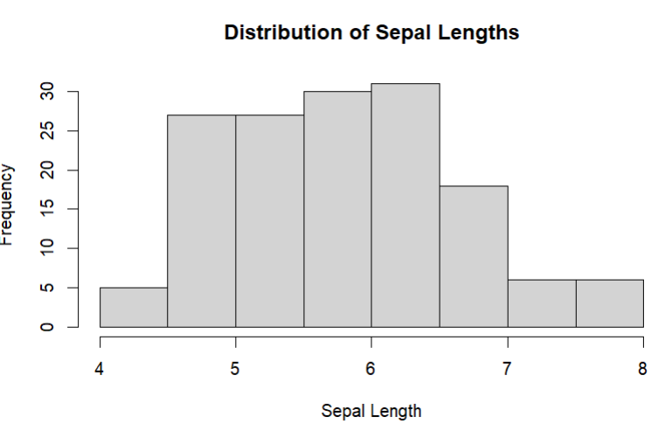

*8.Line Chart (AirPassenger dataset):*

data(AirPassengers)

plot(AirPassengers, type = "o", main = "Trend in Monthly Passenger Counts", xlab = "Year", ylab = "Passenger Count")

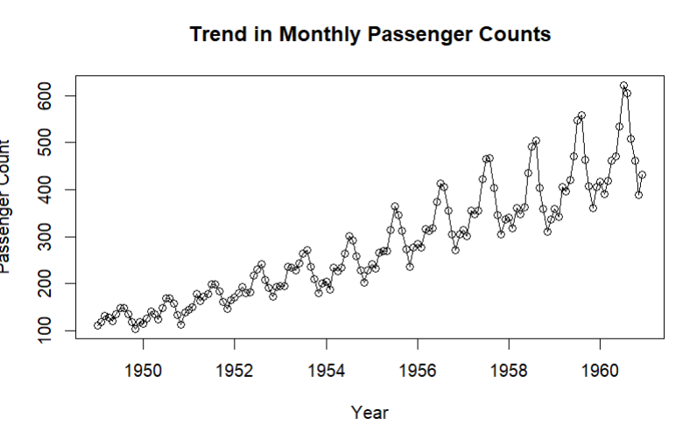

*9. Probability Distribution:*

lambda <- 27

x <- 20

probability <- 1 - ppois(x - 1, lambda)

cat("a) Probability of having 20 or more cars:", probability, "\n")

random_numbers <- runif(19, min = 4, max = 5)

cat("b) 19 random numbers between 4 and 5:", random_numbers, "\n")

rate <- 2

time <- 2

probability_2_wheeler <- ppois(1, rate * time)

cat("c) Probability of 2-wheeler vehicles passing in less than two minutes:", probability_2_wheeler, "\n")

mean_score <- 92

std_dev <- 25.2

score_cutoff <- 80

probability_students_80_or_more <- pnorm(score_cutoff, mean = mean_score, sd = std_dev, lower.tail = FALSE) * 100

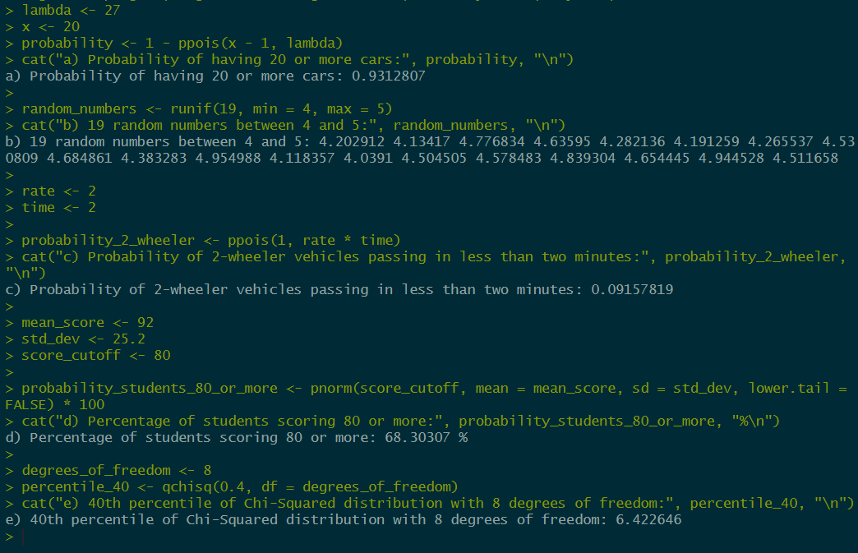

*10. Measures of Tendency and Dispersion:*

x <- c(300,310,290,320,330,300,310,330,340,320)

range(x)

sd(x)

var(x)

install.packages("moments")

library(moments)

reaction_times <- c(300, 310, 290, 320, 330, 300, 310, 330, 340, 320)

range_reaction <- max(reaction_times) - min(reaction_times)

std_dev_reaction <- sd(reaction_times)

var_reaction <- var(reaction_times)

print(paste("Reaction Times: Range =", range_reaction,

"Standard Deviation =", std_dev_reaction,

"Variance =", var_reaction))

completion_times <- c(15, 18, 20, 25, 22, 17, 21, 19, 24, 23)

mean_completion <- mean(completion_times)

median_completion <- median(completion_times)

mode_completion <- as.numeric(names(which.max(table(completion_times))))

skewness_completion <- skewness(completion_times)

kurtosis_completion <- kurtosis(completion_times)

print(paste("Completion Times: Mean =", mean_completion,

"Median =", median_completion,

"Mode =", mode_completion,

"Skewness =", skewness_completion,

"Kurtosis =", kurtosis_completion))

