NAME Arjun M
UNIQUE ID E0222054
YEAR II
TERM T2
DEPARTMENT B. Tech CSE (CYS & IoT)
COURSE CODE CSE 240
COURSE NAME DATA SCIENCE WITH R

Vectors
- Create a numeric vector number with values 3, 7, 2, 8, and 5. Print the vector.

n = c(3,7,2,8,5)
print(n)

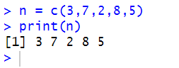

- Calculate the sum of the values in the numbers vector using sum(). Print the result.

n = c(1,2,3)
sum(n)

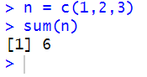

- Calculate the mean of the values in the numbers vector using mean(). Print the result.

n = mean(c(1,2,3))
print(n)

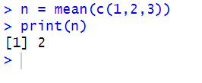

- Create a character vector colors with values "red," "blue," "green," "red," and "yellow." Print the vector.

n = c("Red","Blue","Green","Red","Yellow")
print(n)

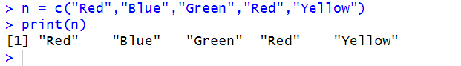

- Find the unique values in the colors vector using unique(). Print the unique values.

n = c("Red","Blue","Green","Red","Yellow")
print(unique(n))

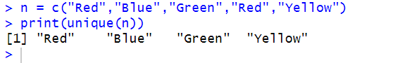
Numeric Vectors
- Create a numeric vector grade with values 85, 90, 78, 92, and 88. Print the vector.

g = c(85,90,78,92,88)
print(g)

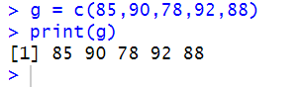

- Find the mean,median,standard deviation,variance,min and max of the vector grades.

g = mean(c(85,90,78,92,88))
print(g)

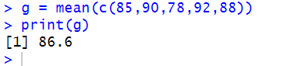

g = median(c(85,90,78,92,88))
print(g)

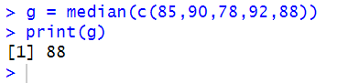

g = sd(c(85,90,78,92,88))
print(g)

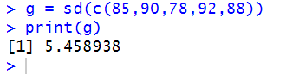

g = var(c(85,90,78,92,88))
print(g)

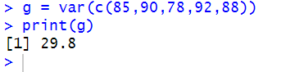

g = min(c(85,90,78,92,88))
print(g)

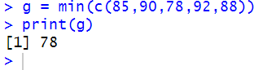

g = max(c(85,90,78,92,88))
print(g)

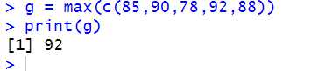

- Sort the grades vector in ascending order using sort(). Print the sorted vector.

g = sort(c(85,90,78,92,88))
print(g)

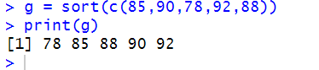

- Reverse the order of the grades vector using rev(). Print the reversed vector.

g = rev(c(85,90,78,92,88))
print(g)

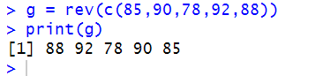

- Create a sequence of numbers from 1 to 10 using seq() and assign it to a variable sequence. Print the sequence.

s = seq(1,10)
print(s)

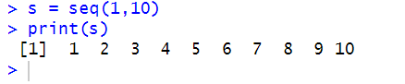

- Repeat the sequence vector three times using rep(). Print the repeated sequence.

r = rep(s,3)
print(r)

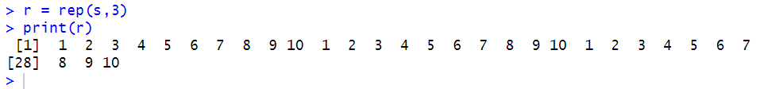
Character Vectors
- Create a character vector fruits with values "apple," "banana," and "orange." Print the vector.

f = c("Apple","Banana","Orange")
print(f)

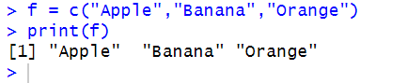

- Sort the fruits vector in alphabetical order using sort(). Print the sorted vector.

f = sort(c("Banana","Orange","Apple"))
print(f)

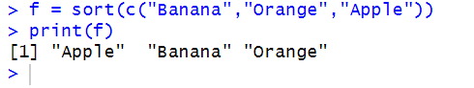

- Create a sequence of characters from "A" to "E" using seq(). Print the sequence.

c = LETTERS[seq(1:5)]
print(c)

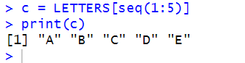

- Repeat the sequence of characters in "A B C D E" three times using rep(). Print the repeated sequence.

c = rep(c,3)
print(c)

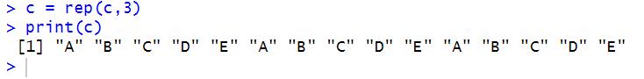

- Find the unique values in the fruits vector using unique(). Print the unique values.

f = c("Apple","Banana","Orange","Apple")
print(unique(f))

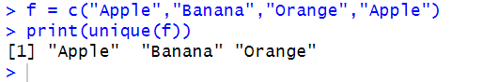
Boolean Vectors
- Create a boolean vector logical_values with values TRUE, FALSE, TRUE, TRUE, and FALSE. Print the vector.

b = c(TRUE,FALSE,TRUE,TRUE,FALSE)
print(b)

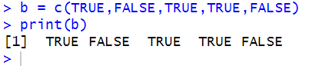

- Find the unique values in the logical_values vector using unique(). Print the unique values.

b = c(TRUE,FALSE,TRUE,TRUE,FALSE)
print(unique(b))

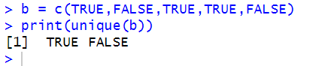
List
- Write a R program to convert a given list to vector.

s = list("Arjun",5)
res = unlist(s)
print(res)

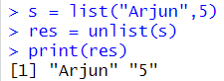

- Write a R program to merge two given lists into one list.

l1 = list("A",1)
l2 = list("B",2)
res = append(l1,l2)
print(res)

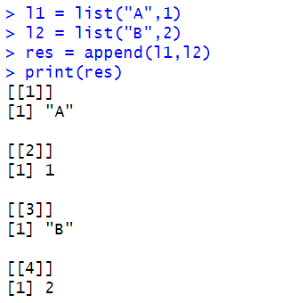

Factor
- Write a R program to extract the five of the levels of factor created from a random sample from the LETTERS (Part of the base R distribution.)

l = sample(LETTERS, 10, replace = TRUE)
f = factor(l)
res = levels(f)[1:5]
cat(res)

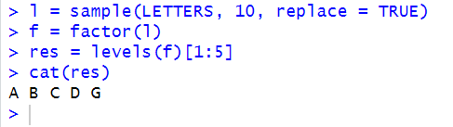

- Write a R program to create an ordered factor from data consisting of the names of months.

month = c("January","February","March","April","May","June","July","August","September","October","November","December")
res = factor(month , ordered = TRUE , levels = month.name)
cat(res)

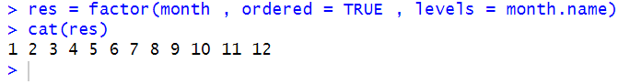

Matrix

- Create a 3x4 matrix with values from 1 to 12 using the range function.

m = matrix(1:12 , nrow = 3 , ncol = 4 , byrow = TRUE)
print(m)

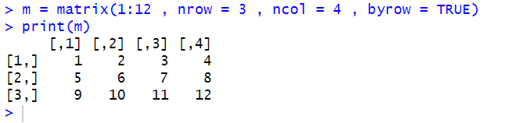

- Generate a 2x3 matrix using two vectors in R.

v1 = c(1,2,3)
v2 = c(4,5,6)
res = matrix(c(v1,v2) , nrow = 2 , ncol = 3 , byrow = TRUE)
print(res)

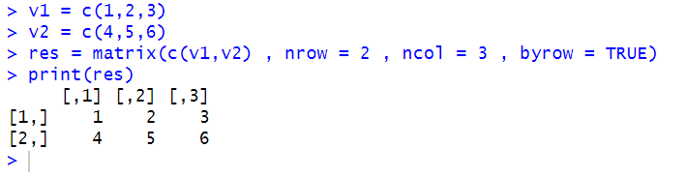

- Construct a 4x4 matrix with specified diagonal values of 1,2, 3, and 4.

v = c(1,2,3,4)
res = diag(v)
print(res)

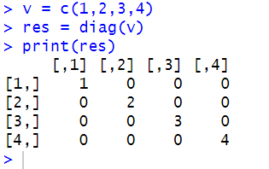

- Change the column names to 'X1', 'X2', 'X3', 'X4' and row names to 'Row1', 'Row2', 'Row3', 'Row4'.

dimnames(res) = list(c("ROW 1","ROW 2","ROW 3","ROW 4"),c("X1","X2","X3","X4"))
print(res)

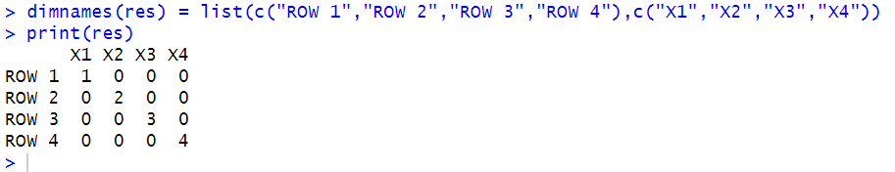

- Delete the second column from the matrix created in question1.

m = matrix(1:12 , nrow = 3 , ncol = 4 , byrow = TRUE)
m = m[,-2]
print(m)

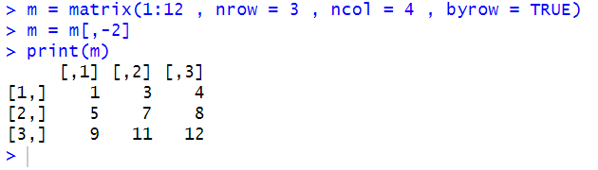

- Remove the third row from the matrix created in question 2.

m = matrix(1:12 , nrow = 3 , ncol = 4 , byrow = TRUE)
m = m[-3,]
print(m)

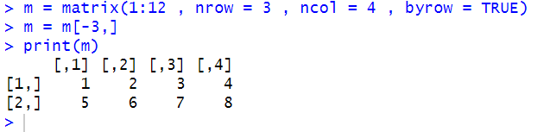

- Perform element-wise multiplication on the matrix created in question 3 by a scalar value of 2.

v = c(1,2,3,4)
res = diag(v)
print(res*2)

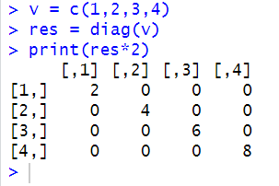

Array

- Write a R program to create an array using four given columns, three given rows, and two given tables and display the content of the array.

arr = array(1:24 , dim = c(3, 4, 2))
print(arr)

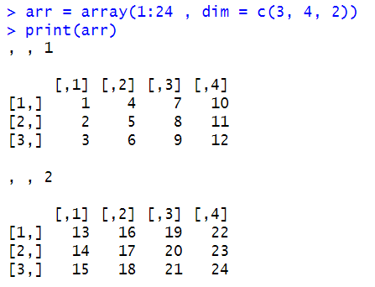

- Write a R program to create an array of two 3x3 matrices each with 3 rows and 3 columns from two given two vectors. Print the second row of the second matrix of the array and the element in the 3rd row and 3rd column of the 1st matrix.

v1 = c(1,2,3,4,5,6,7,8,9)
v2 = c(10,11,12,13,14,15,16,17,18)
m1 = matrix(c(v1), byrow = TRUE)
m2 = matrix(c(v2), byrow = TRUE)
arr = array(c(m1,m2),dim = c(3,3,2))
print(arr)
a = arr[2,,2]
print(a)
b = arr[3,3,1]
print(b)

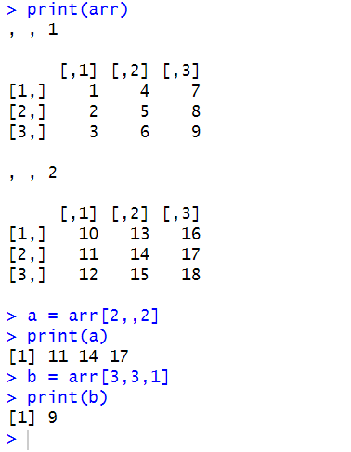

Data Frame

- Create a dataframe based on students details(name,age,score)
How to access elements in dataframe
How to add column attribute in df
Mean and sum of the score
Structure of data frame
summary of dataframe
How to add row attribute
How to delete particular row or column

df = data.frame(
Name = c("A","B","C"),
Age = c(17,19,18),
Score = c(93,85,90)
)
print(df)

df$Name[1]

Gender = c("M","F","M")
df = cbind(df,Gender)

sum(df$Score)
mean(df$Score)
structure(df)
summary(df)

r = data.frame(Name = "D", Age = 19, Score = 95, Gender = "M")
df = rbind(df,r)

df = df[-2,]
df = df[,-3]

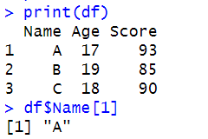

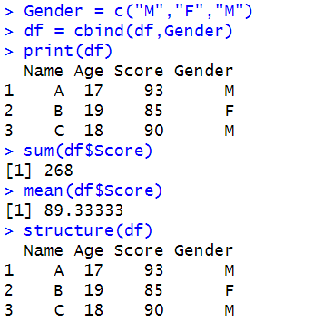

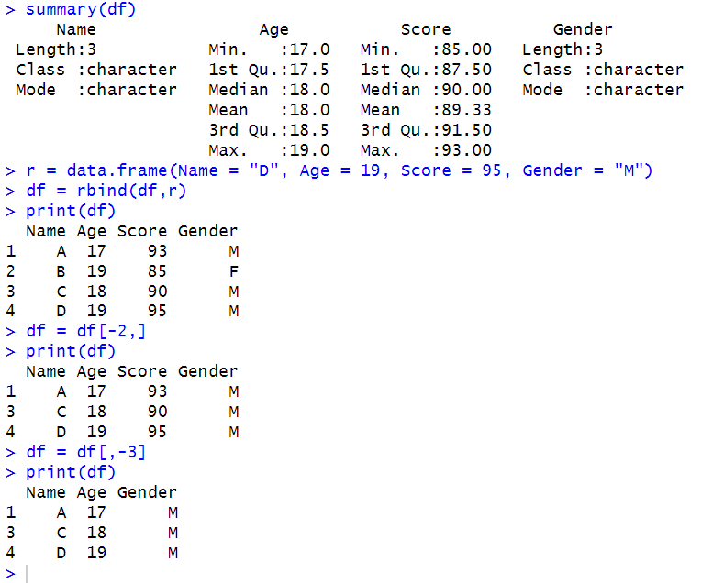

Conditional Statements

- Check whether given number is odd or even

a = as.numeric(readline("Enter the number : "))
if(a%%2==0){
print("EVEN")
}else{
print("ODD")
}

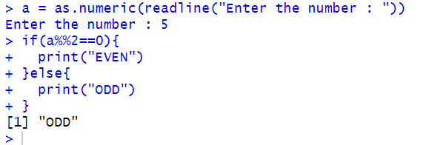

- Check Whether the given number is positive or negative

a = as.numeric(readline("Enter the number : "))
if(a>0){
print("POSITIVE")
}else{
print("NEGATIVE")
}

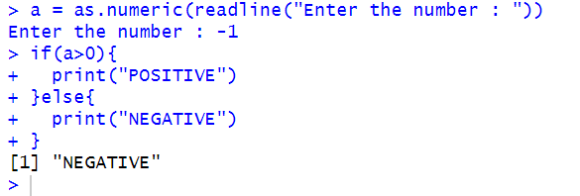

- Get Employee Name and Basic Pay from user and Calculate Net Pay based on
    - Basic pay < 2000 => netpay= basicpay*0.2
    - Basic pay > 2000 and <4000 => netpay= basicpay*0.4
    - Basic pay > 4000 => netpay= basicpay*0.6

name = readline("Enter your name : ")
basicpay = as.numeric(readline("Enter your salary : "))
if(basicpay<2000){
netpay = 0.2*basicpay
}else if(basicpay>=2000 && basicpay<=4000){
netpay = 0.4*basicpay
}else{
netpay = 0.6*basicpay
}

print(name)
print(netpay)
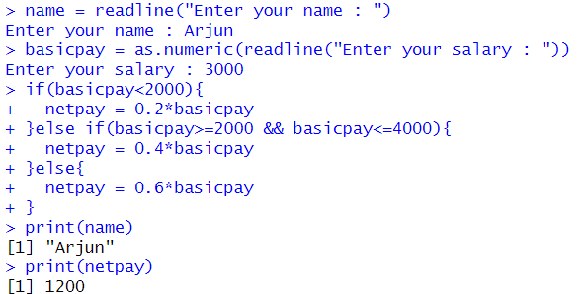

Switch Case

- Print month for the corresponding numbers 1-jan,2-feb

month = as.numeric(readline("Enter the month no : "))
switch(month,
"1"={print("JAN")},
"2"={print("FEB")},
"3"={print("MAR")},
"4"={print("APR")},
"5"={print("MAY")},
"6"={print("JUN")},
"7"={print("JUL")},
"8"={print("AUG")},
"9"={print("SEP")},
"10"={print("OCT")},
"11"={print("NOV")},
"12"={print("DEC")},"NO MATCH")

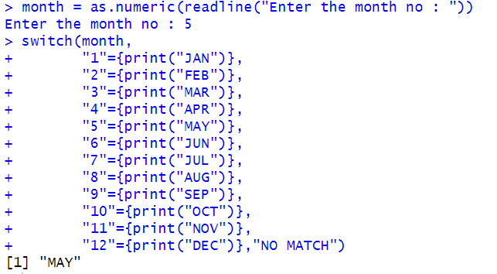

- Basic Calculator

o = readline("Enter the operator : ")
n1 = as.numeric(readline("Enter the first no : "))
n2 = as.numeric(readline("Enter the second no : "))
switch(o,
"+"={res=n1+n2
print(res)},
"-"={res=n1-n2
print(res)},
"*"={res=n1*n2
print(res)},
"/"={res=n1/n2
print(res)},"NO MATCH")

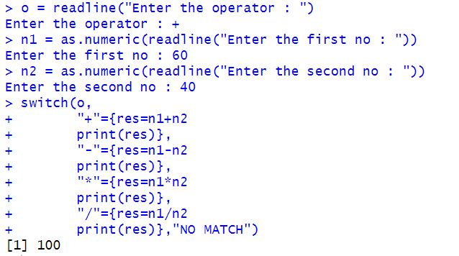

For Loop
1) Using for-loop increment the value of vector by 2

v = c(1,2,3,4,5)
for(i in v){
print(i+2)
}

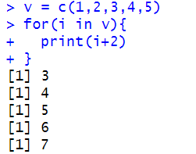
2) Using for-loop given year is a leap year or not

yr = c(2000:2010)
for(i in yr){
if((i%%4==0 && i%%100!=0)||i%%400==0){
print("YES")
}else{
print("NO")
}
}

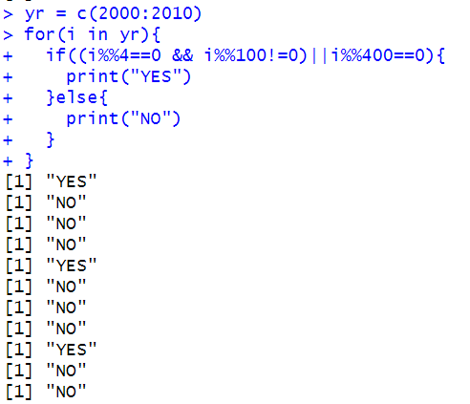
3) Using for-loop traverse through list , matrix , array

l = list("Arjun",5)
for(i in l){
print(i)
}

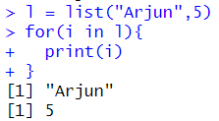

While Loop

- Find the factorial of a number using while loop

w = as.numeric(readline())
fact = 1
i = 1
while(i<=w){
fact = fact*i
i = i+1
}
print(fact)

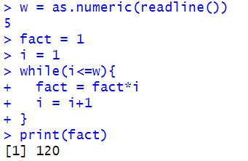

- Generation of fibonacci series

n = 8
f = numeric(n)
f[1] = 0
f[2] = 1

for(i in 3:n) {
f[i] = f[i - 1] + f[i - 2]
}

print(f)

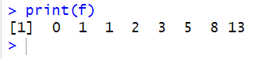

- Check whether it is Armstrong number or not

a = as.numeric(readline("Enter the number : "))
n1 = a
sum = 0
while(n1>0){
r = n1%%10
sum = sum + (r*r*r)
n1 = n1%/%10
}
if(sum == a){
print("Amstrong no")
}else{
print("Not a amstrong no")
}

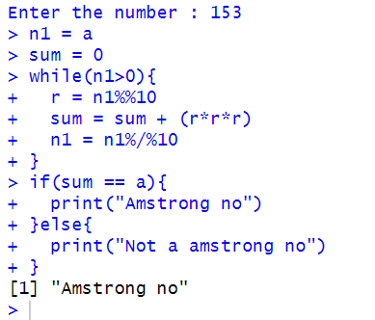

- Find the sum of the digits of a number and product of digits of a number

n = as.numeric(readline("Enter the number : "))
temp = n
sum = 0
while(n>0){
digit = n %% 10
sum = sum + digit
n = n %/% 10
}
print(sum)

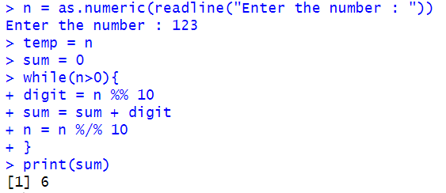

n = as.numeric(readline("Enter the number : "))
temp = n
pro = 1
while(n>0){
digit = n %% 10
pro = pro * digit
n = n %/% 10
}
print(pro)

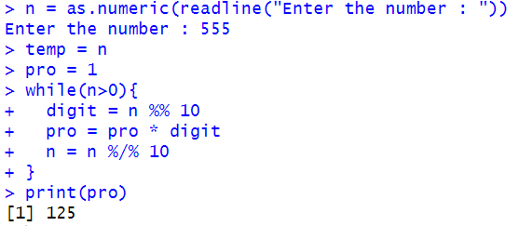

- Find the sum of square of digits of a number

n = as.numeric(readline("Enter the number : "))
temp = n
sum = 0
while(n>0){
digit = n %% 10
sum = sum + (digit*digit)
n = n %/% 10
}
print(sum)

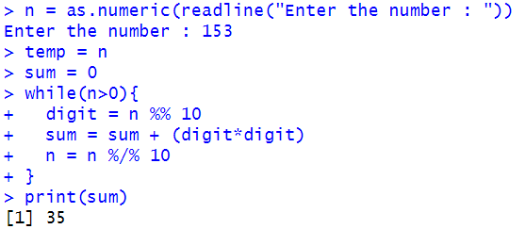

- Find the largest and smallest digits of the given number

n = 305621
l = 0
s = 0
while (n>0){
digit = n %% 10
l = max(l,digit)
s = min(s,digit)
n = n %/% 10
}
print(l)
print(s)

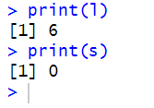
Function

- Write a function to calculate factorial of a number and Fibonacci series

fibonacci = function(n) {
f = numeric(n)
f[1] = 0
f[2] = 1
for (i in 3:n){
f[i] = f[i - 1] + f[i - 2]
}
return(f)
}

n = 8
result = fibonacci(n)
print(result)

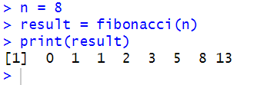

factorial = function(n) {
if (n == 0 || n == 1) {
return(1)
} else {
return(n * factorial(n - 1))
}
}

n = 5
result = factorial(n)
print(result)

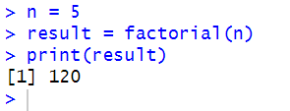

- Write a function to calculate sum of two numbers
  - Function with argument and without return value

sum = function(a,b){
print(a+b)
}
sum(60,40)

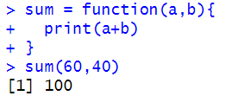

  - Function without argument and without return value

sum = function(a = 60 , b = 40){
print(a+b)
}
sum()

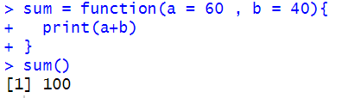

  - Function without argument and with return value

sum = function(a = 60 , b = 40){
return(a+b)
}
sum()

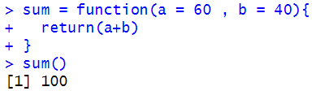

  - Function with argument and with return value

sum = function(a,b){
return(a+b)
}
sum(60,40)

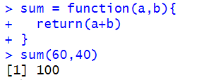

- Write a R Program that gets radius of Circle as an input from the user and uses a function called calculate area that takes the radius of a circle as an argument and returns the area of the circle.

area = function(r){
a = 3.14*r*r
return(a)
}
area(as.numeric(readline("Enter the radius : ")))

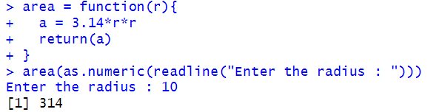

Class and objects

- Write a R program to print student Marksheet using Classes and objects
Attributes: Name,ID,DS,DAA,JAVA
Methods: calculate average(),display()

setClass("student" , slots = c(sname = "character", id = "numeric" , ds = "numeric" , daa = "numeric" , java = "numeric"))
s2 = new("student")
setGeneric("getData",function(object){
standardGeneric("getData")
})

setGeneric("display",function(object){
standardGeneric("display")
})

setMethod("getData","student",
function(object)
{
object@sname = readline("Enter your name : ")
object@id = as.numeric(readline("Enter your ID : "))
object@ds = as.numeric(readline("Enter your DS mark : "))
object@daa = as.numeric(readline("Enter your DAA mark : "))
object@java = as.numeric(readline("Enter your JAVA mark : "))
return(object)
})
s2 = getData(s2)
setMethod("display","student",
function(object)
{
print(object@sname)
print(object@id)
average = (object@ds + object@daa + object@java)/3
print(average)
})
display(s2)

