

|  |  |  |
| --- | --- | --- |
| **Name** | **:** | M ARJUN |
| **Unique ID** | **:** | E0222054 |
| **Year** | **:** | II |
| **Term** | **:** | T1 |
| **Department** | **:** | B. Tech CSE (CyS & IoT) |
| **Faculty Name** | **:** | Dr. Rajalakshmi S |
| **Academic Year** | **:** | 2023-2024 |

**1)Write a JavaScript to find maximum of three numbers (prompt the numbers from the user**

**Code:**

const prompt = require("prompt-sync")();

let n1 = prompt('Enter First number: ')

let n2 = prompt('Enter Second number: ')

let n3 = prompt('Enter Third number: ')

if(n1>n2&&n1>n3){

    console.log(`${n1} is greatest`)

}

else if(n2>n1&&n2>n3){

    console.log(`${n2} is greatest`)

}

else{

    console.log(`${n3} is greatest`)

}

**OUTPUT:**

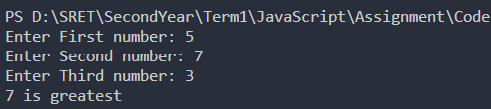

**2)** **Write a function in JavaScript to compute simple interest (prompt the principal p, year y and rate of interest r from the user)**

**Code:**

*//simple intrest = pnr/100*

const prompt = require('prompt-sync')()

let res=0;

let p = prompt('Enter the principal amount: ')

let n = prompt('Enter no. of years: ')

let r = prompt('Enter the rate of intrest: ')

function simpleIntrest(p,n,r){

    return (p*n*r)/100

}

res=simpleIntrest(p,n,r)

console.log("Simple intrest is: ",res)

**OUTPUT:**

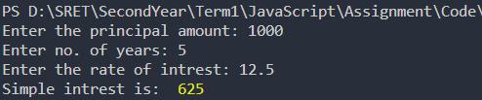

**3)** **Predict the output:**

**A)**

**Code:**

function Sample() {

    var x = 5;

    var x = 10;

    console.log(x);

    let y = 15;

*//    let y = 20;*

}

    Sample ();

*//the output of the statement presnt in d is 10*

*// redeclaration of let is not possible*

**OUTPUT:**



**B)**

**Code:**

function Sample1() {

    var x = 10;

    if (true) {

    let x = 20;

    console.log(x);

    }

    console.log(x);

    }

    Sample1();

*// //the output of the statement presnt in e and g is 20,10*

**OUTPUT:**



**4)** **Create an object called cart with the items as key and price as value**

**Apple 120**

**Banana 50**

**Orange 100**

**Kiwi 150**

**Dragon Fruit 200**

**Iterate through the object and print key together with value. Calculate the total price**

**of the fruits and store in a variable called BillAmount.**

**Code:**

let cart = {

    Apple: 120,

    Banana: 50,

    Orange: 100,

    Kiwi: 150,

    DragonFruit: 200

}

for(let i in cart){

    console.log(i," : ",cart[i])

}

function bill(cart){

    let total=0;

    for(let i in cart){

        total+=cart[i]

    }

    return total

}

console.log("Total amount to be paid by the customer is: ",bill(cart))

**OUTPUT:**

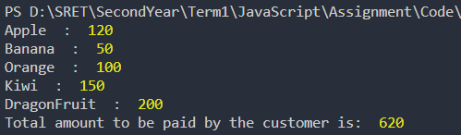

**5)** **Design a html form that accepts Name from the user. When the user clicks the button ClickMe, it should invoke the function Greetings in JavaScript which should display “Hello, Welcome User”**

**Code:**

<!DOCTYPE html>

<html>

<head>

    <title>Q5</title>

</head>

<body>

    <form>

        <label>Name</label>

        <input type="text" name="name" id="name">

        <input type="button" name="ClickMe" value="ClickMe" onclick="Greetings()">

    </form>

    <script type="text/javascript", language="javascript">

        function Greetings(){

            var name = document.getElementById("name").value;

            alert("Hello, Welcome "+name);

        }

    </script>

</body>

</html>

**OUTPUT:**

