

|  |  |  |
| --- | --- | --- |
| **Team Members** | **:** | ARJUN |
| **Unique ID** | **:** | E0222054 |
| **Year** | **:** | I |
| **Term** | **:** | T3 |
| **Department** | **:** | B. Tech CSE (CyS & IoT) |
| **Faculty Name** | **:** | Dr. Shiyamala Gowri G |
| **Academic Year** | **:** | 2022-2023 |

**Question1: IP Address of your computer**

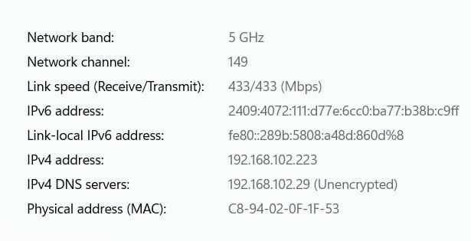

**Question2: Explore https://www.submarinecablemap.com/ website and submit your views**

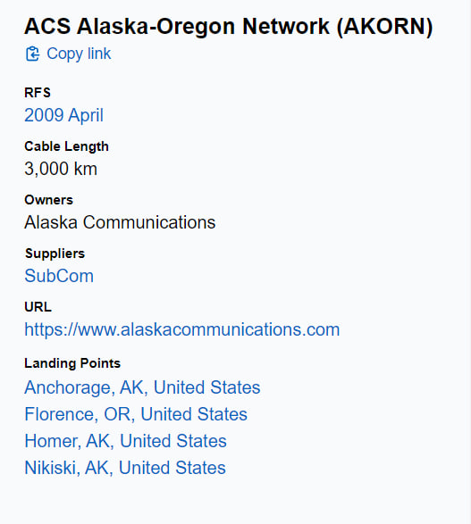

**Question3: Edit your name on SRET Website (Placed students link)**

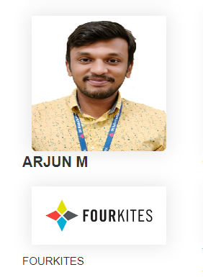

**Question4: Edit any product name on any of the online shopping websites.**

