

|  |  |  |
| --- | --- | --- |
| **Name** | **:** | ARJUN |
| **Unique ID** | **:** | E0222054 |
| **Year** | **:** | I |
| **Term** | **:** | T3 |
| **Department** | **:** | B. Tech CSE (CyS & IoT) |
| **Faculty Name** | **:** | Dr. Shiyamala Gowri G |
| **Academic Year** | **:** | 2022-2023 |

Q1.CSS Selectors

1.Element Selector

<!DOCTYPE html>

<html lang="en">

<head>

    <meta charset="UTF-8">

    <meta http-equiv="X-UA-Compatible" content="IE=edge">

    <meta name="viewport" content="width=device-width, initial-scale=1.0">

    <title>Css using element</title>

    <link rel="stylesheet" href="element.css">

</head>

<body>

    <p>

        This is a paragraph tag

    </p>

    <p>

        Styling for the paragraph tag is done by elementing

    </p>

</body>

</html>

p{color:blue;

    font-size: 10px;

    font-family:'Times New Roman', Times, serif ;

    background-color: aqua;

}

OUTPUT:

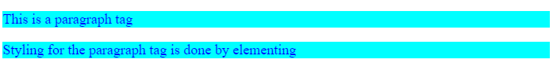

2.ID Selector

<!DOCTYPE html>

<html lang="en">

<head>

    <meta charset="UTF-8">

    <meta http-equiv="X-UA-Compatible" content="IE=edge">

    <meta name="viewport" content="width=device-width, initial-scale=1.0">

    <title>Css using id</title>

    <link rel="stylesheet" href="id.css">

</head>

<body>

    <p>

        This is a paragraph tag

    </p>

    <p id="para">

        Styling for the paragraph tag is done using id

    </p>

</body>

</html>

#para{

    color:blue;

    font-size: 10px;

    font-family:'Times New Roman', Times, serif ;

    background-color: aqua;

}

OUTPUT:

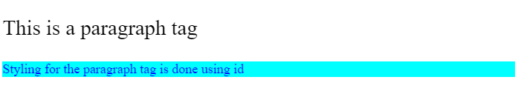

3.Classname Selector

<!DOCTYPE html>

<html lang="en">

<head>

    <meta charset="UTF-8">

    <meta http-equiv="X-UA-Compatible" content="IE=edge">

    <meta name="viewport" content="width=device-width, initial-scale=1.0">

    <title>Css using ClassName</title>

    <link rel="stylesheet" href="class.css">

</head>

<body class="bdy">

    <p>

        This is a paragraph tag

    </p>

    <p class="para">

        Styling for the paragraph tag is done using class name

    </p>

</body>

</html>

.bdy{background-color: darkmagenta;}

.para{font-size: 50px;

color: burlywood;}

OUTPUT:

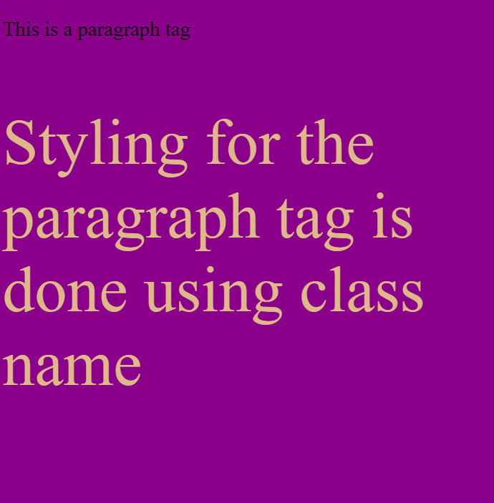

4.Univ Selector

<!DOCTYPE html>

<html lang="en">

<head>

    <meta charset="UTF-8">

    <meta http-equiv="X-UA-Compatible" content="IE=edge">

    <meta name="viewport" content="width=device-width, initial-scale=1.0">

    <title>Css with Universal selector</title>

    <link rel="stylesheet" href="univ.css">

</head>

<body>

    <h1>

        heading1

    </h1>

    <h4>

        heading4

    </h4>

    <p>

        Working on universal selectors in CSS

    </p>

    <p>This is an Paragraph tag</p>

</body>

</html>

* {

    color: brown;

    background-color: cadetblue;

    font-family: Arial, Helvetica, sans-serif;

    text-align: justify;

}

OUTPUT:

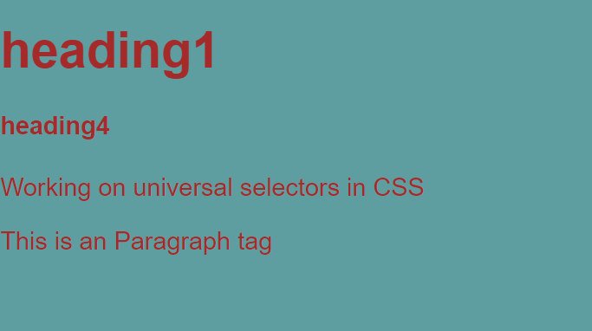

5.Group Selector

<!DOCTYPE html>

<html lang="en">

<head>

    <meta charset="UTF-8">

    <meta http-equiv="X-UA-Compatible" content="IE=edge">

    <meta name="viewport" content="width=device-width, initial-scale=1.0">

    <title>Grouping elements for css</title>

    <link rel="stylesheet" href="group.css">

</head>

<body>

    <h1>

        Heading1

    </h1>

    <h2>

        Heading2

    </h2>

    <h3>

        Heading3

    </h3>

</body>

</html>

h1,h2,h3{

    color:blue;

    font-size: 10px;

    font-family:'Times New Roman', Times, serif ;

    background-color: aqua;

}

OUTPUT:

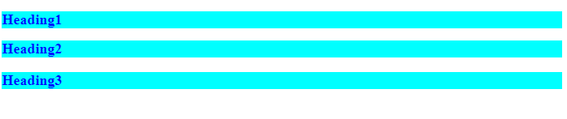

Q2.Inline Internal and External CSS

<!DOCTYPE html>

<html lang="en">

<head>

    <link rel="stylesheet" href="style4.css">

    <style>

        p

        {

            color: coral;

        }

    </style>

    <meta charset="UTF-8">

    <meta http-equiv="X-UA-Compatible" content="IE=edge">

    <meta name="viewport" content="width=device-width, initial-scale=1.0">

    <title>CSS</title>

</head>

<body>

    <!--INLINE CSS-->

    <h1 style = "color:aqua">WEB DESIGNING</h1>

    <!--INTERNAL CSS-->

    <p>HTML</p>

    <!--EXTERNAL CSS-->

    <h4>CSS</h4>

</body>

</html>

h4

{

    background-color: burlywood;

    color: white;

}

OUTPUT:



Q3.Colour Background Borders

<!DOCTYPE html>

<html lang="en">

<head>

    <style>

        p

        {

            color: hotpink;

            border: 3px solid black;

            padding: 30px;

            text-align: justify;

            background-color: bisque;

        }

    </style>

    <meta charset="UTF-8">

    <meta http-equiv="X-UA-Compatible" content="IE=edge">

    <meta name="viewport" content="width=device-width, initial-scale=1.0">

    <title>COLORS BG AND MARGINS</title>

</head>

<body>

    <p>Earth is the third planet from the Sun and the only place known in the universe where life has originated and found habitability. While Earth may not contain the largest volumes of water in the Solar System, only Earth sustains liquid surface water, extending over 70.8% of the Earth with its ocean, making Earth an ocean world. Earth's polar regions currently retain most of all other water with large sheets of ice covering ocean and land, dwarfing Earth's groundwater, lakes, rivers and atmospheric water.</p>

</body>

</html>

OUTPUT:

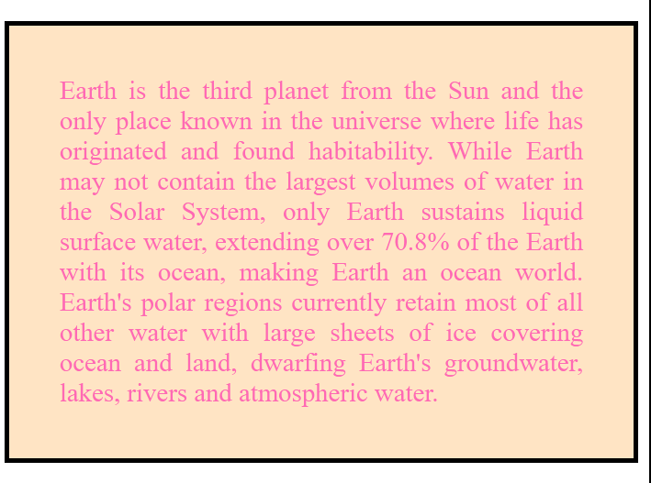

4.Box Model

<!DOCTYPE html>

<html lang="en">

<head>

    <style>

        p

        {

            border: 3px solid black;

            padding: 20px;

            margin: 100px;

        }

    </style>

    <meta charset="UTF-8">

    <meta http-equiv="X-UA-Compatible" content="IE=edge">

    <meta name="viewport" content="width=device-width, initial-scale=1.0">

    <title>BOX MODEL</title>

</head>

<body>

    <p>Earth is the third planet from the Sun and the only place known in the universe where life has originated and found habitability. While Earth may not contain the largest volumes of water in the Solar System, only Earth sustains liquid surface water, extending over 70.8% of the Earth with its ocean, making Earth an ocean world. Earth's polar regions currently retain most of all other water with large sheets of ice covering ocean and land, dwarfing Earth's groundwater, lakes, rivers and atmospheric water.</p>

</body>

</html>

OUTPUT:

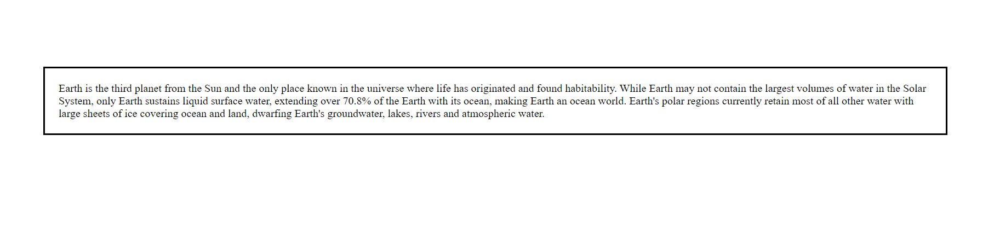

5.Table List and Link

<!DOCTYPE html>

<html lang="en">

<head>

    <meta charset="UTF-8">

    <meta http-equiv="X-UA-Compatible" content="IE=edge">

    <meta name="viewport" content="width=device-width, initial-scale=1.0">

    <title>TABLE LIST LINK</title>

</head>

<body>

    <h3>Unordered Lists</h3>

    <ul type = "square">

        <li>WEB DESIGN</li>

        <li>ADV PYTHON</li>

        <li>CALCULUS</li>

        <li>PHYSICS</li>

    </ul>

    <h3>Ordered Lists</h3>

    <ol type = "I">

        <li>WEB DESIGN</li>

        <li>ADV PYTHON</li>

        <li>CALCULUS</li>

        <li>PHYSICS</li>

    </ol>

    <h3>Description Lists</h3>

    <dl>

        <dt>PYTHON</dt><br>

        <dd>- Interpreted Language</dd>

        <dt>C</dt><br>

        <dd>- Compiler Language</dd>

        <br>

    </dl><br><br>

    <table border = "2" bgcolor = "aqua" cellpadding = "6" cellspacing = "5">

        <caption><b>List of Union Territories</b></caption>

        <thead>

            <th>NO</th>

            <th>UNION TERRITORY</th>

            <th>CAPITAL</th>

            <th>YEAR OF EST</th>

        </thead>

        <tbody>

            <tr>

                <td>1</td>

                <td>Andaman</td>

                <td>Port Blair</td>

                <td>1949</td>

            </tr>

            <tr>

                <td>2</td>

                <td>Jammu and Kashmir</td>

                <td>Srinagar</td>

                <td>1955</td>

            </tr>

            <tr>

                <td>3</td>

                <td>Lakshadweep</td>

                <td>Kavaratti</td>

                <td>1953</td>

            </tr>

        </tbody>

    </table><br><br>

    <a href = "https://www.google.co.in/" target="_blank">CLICK ME !</a>

</body>

</html>

OUTPUT:

