M2A6 - CSS DISPLAY FLOAT POSITION AND NAVIGATION PROPERTIES

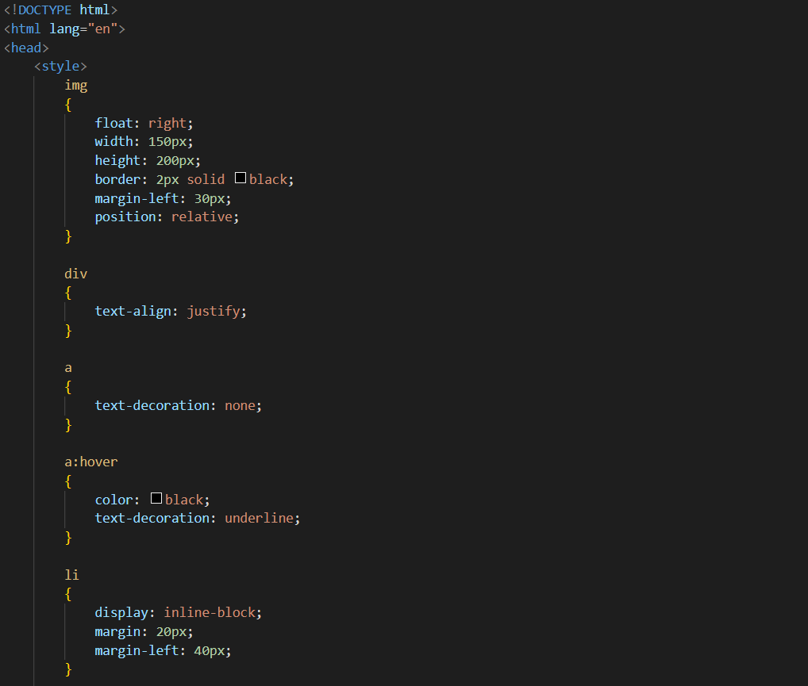

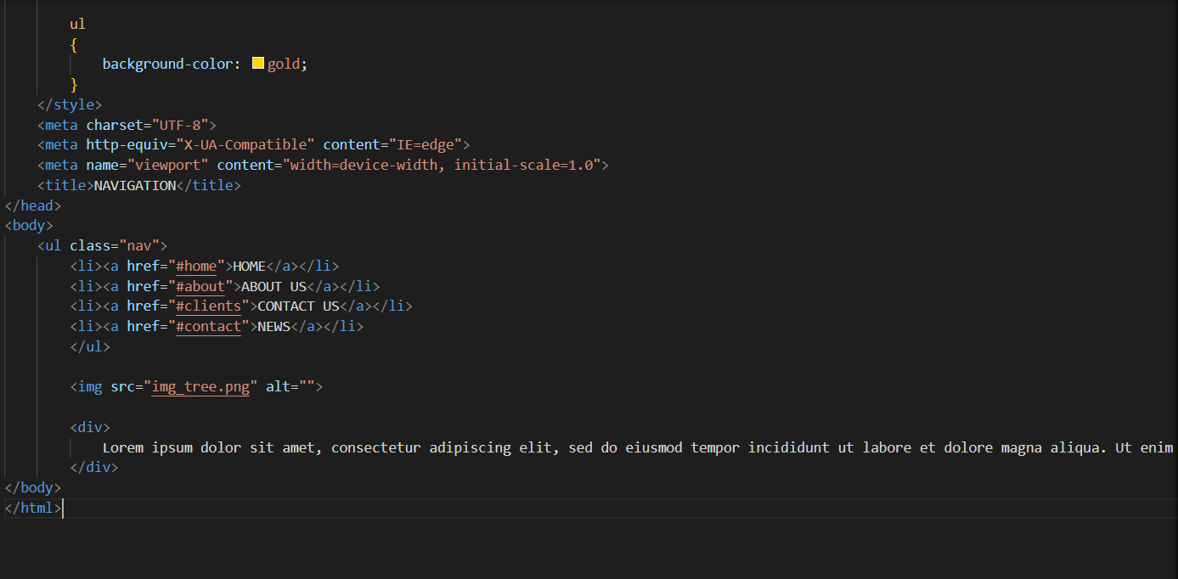

OUTPUT

