Detection & Classification of Glaucoma using Fundus Images

**Model 1:**

Dataset link - <https://cvit.iiit.ac.in/projects/mip/drishti-gs/mip-dataset2/Dataset_description.php>

The dataset consists of a total of 101 images. These have been divided into 50 training and 51 testing images. All the images have been marked by 4 eye experts with varying clinical experience. All images were collected at Aravind eye hospital, Madurai

Image Dimension - 2896 X 1944 pixels

The dataset is annotated with Optic Disc (OD), Optic Cup (OC) boundaries and Cup to disc Ratio (CDR) Values.

UNET Model is trained with a fundus image and Optic Dick, Optic cup masks.

It gives accuracy of 89% for 50 images in test, Jaccard Score (IOU) of 0.81.

**How it works:**

* User will be able to upload any fundus image of any size and proportion
* UNET Model will extract cup, disk boundaries
* Based on boundaries values, CDR will be calculated and if the value is greater than 0.5, the class would be glaucomatic or if it lesser than 0.5 it would show as a health fundus images

**Model 2:**

Dataset link - <https://www.adcis.net/en/third-party/messidor/>

The 1200 eye fundus color numerical images of the posterior pole of the Messidor database were acquired by 3 ophthalmologic departments using a color video 3CCD camera mounted on a Topcon TRC NW6 non-mydriatic retinograph with a 45 degree field of view. Images were captured using 8 bits per color plane at 1440*960, 2240*1488 or 2304*1536 pixels.

Resnet 18 weights are used for training the model transfer learning with some layers changed (Transfer Learning) - <https://pytorch.org/hub/pytorch_vision_resnet/>

Results

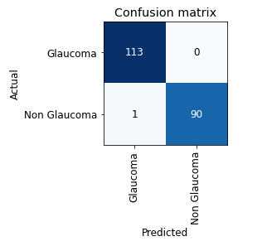

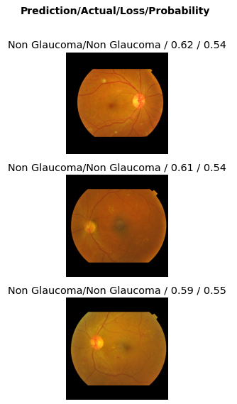

|  |  |  |  |  |
| --- | --- | --- | --- | --- |
| **epoch** | **train_loss** | **valid_loss** | **error_rate** | **roc_auc_score** |
| 0 | 0.553327 | 0.160508 | 0.058824 | 0.995332 |
| 1 | 0.491702 | 0.044486 | 0.014706 | 0.999417 |
| 2 | 0.399362 | 0.175142 | 0.058824 | 0.999903 |

|  |  |  |  |  |  |
| --- | --- | --- | --- | --- | --- |
| **average_precision_score** | **precision_score** | **accuracy** | **recall_score** | **f1_score** | **time** |
| 0.994658 | 1 | 0.941176 | 0.868132 | 0.929412 | 03:58 |
| 0.999272 | 0.988889 | 0.985294 | 0.978022 | 0.983425 | 05:28 |
| 0.999881 | 1 | 0.941176 | 0.868132 | 0.929412 | 05:28 |