Kenneth Mui

[klmui@wisc.edu](mailto:klmui@wisc.edu)

CS 407

4/22/20

Lab 9 Sensors Write-up

1. For smoothing, I used exponentially weighted moving average (EWMA) with an alpha of 0.9. After trying simple moving average and EWMA with an alpha of 0.1, I decided to use EWMA with an alpha of 0.9 since it gave me a graph with minimal “bumps.” I have attached WALKING.csv, TURN.csv, and WALKING_AND_TURNING.csv to this submission. Columns K through S in each file contain the EWMA values. If you plan to run the scripts provided, please download the Excel sheets attached to this submission and place them in the same directory as the scripts since the scripts depend on the EWMA values calculated in those Excel sheets. Here are the graphs for EWMA accel_z, gyro_z, and mag_z.

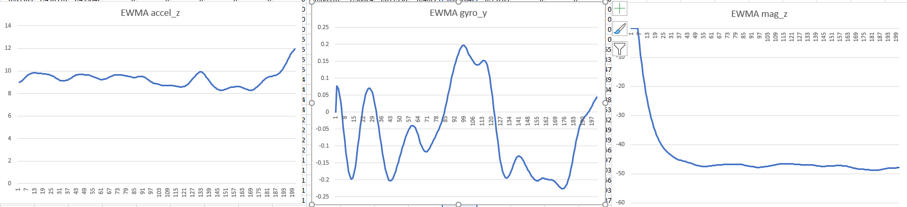

1. I have attached my algorithm for finding the number of steps in WALKING.csv and WALK_AND_TURNING.csv. I wrote the algorithm in Python using Jupyter Notebooks. To run the script, run Steps.ipynb and look at the second cell to get the number of steps in WALKING.csv and look at the third cell to get the number of steps in WALKING_AND_TURNING.csv. I have attached pictures of the output below. To calculate the number of steps, I decided to use the EWMA accel_z values since those values should correspond to the phone bouncing up and down due to walking. Therefore, I used a Python library called scipy to find the number of peaks. To reduce the number of peaks found, I set the distance between two peaks to be at least 104 data points apart since I don’t think people can walk more than 2 steps in one second (200 data points = 1 second). The number of steps ended up corresponding with the number of peaks I counted in the corresponding graphs. Also, given the number of seconds in the data samples, the results seemed reasonable. As shown below, the number of steps for WALKING.csv is 36 and the number of steps for WALKING_AND_TURNING.csv is 78.

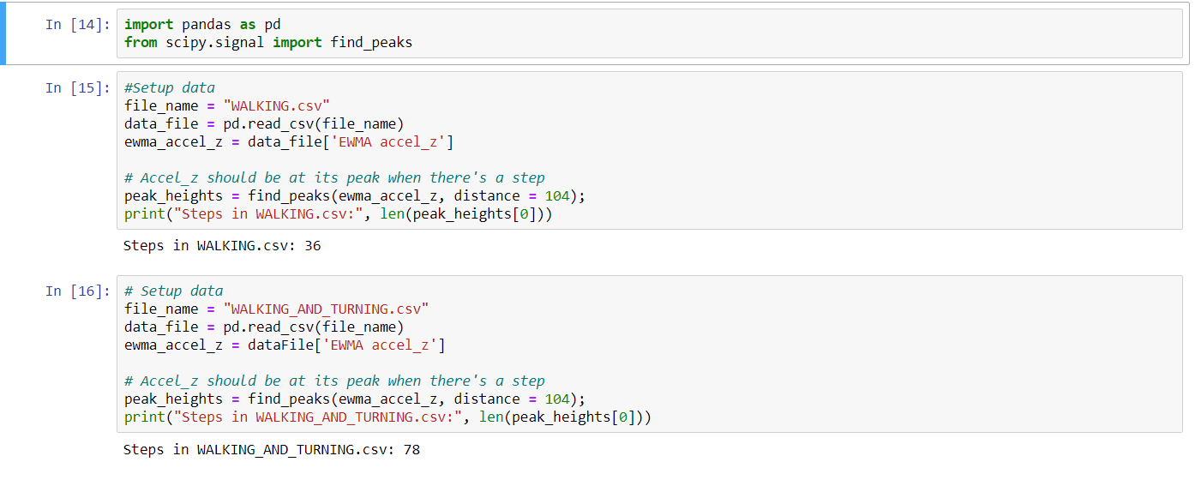

1. I have attached my algorithm for finding the number turns in TURNING.csv and WALK_AND_TURN.csv. I also wrote this algorithm in Python using Jupyter Notebooks. Run Turns.ipynb and look at cells 2 and 3 to see the number of clockwise and counterclockwise turns in TURNING.csv. I decided to use the EWMA gyro_z values since the phone was turned while face-up on a surface. Looking at the gyro_z graph of TURNING.csv, I deduced that a value of about 4 was a 90-degree clockwise turn and a value of about -4 was a 90-degree counterclockwise turn. So, my algorithm finds all the peeks and local minimums in both csv files and compares their values to 4 and -4. Like part 2 of this write-up, I had to specify a minimum distance between two peeks to eliminate peeks that are close too close to each other. For TURNING.csv, I got 4 90-degree clockwise turns and 4 90-degree counterclockwise turns. For WALKING_AND_TURNING.csv, I noticed that the minimums of the graph were about -2 and -4. As a result, I concluded that -2 corresponded to a 45-degree counterclockwise turn and -4 corresponded to a clockwise turn. I ended up with 0 clockwise turns and 4 counterclockwise turns for WALKING_AND_TURNING. The results all matched up with the number of peaks in the gyro_z graphs.

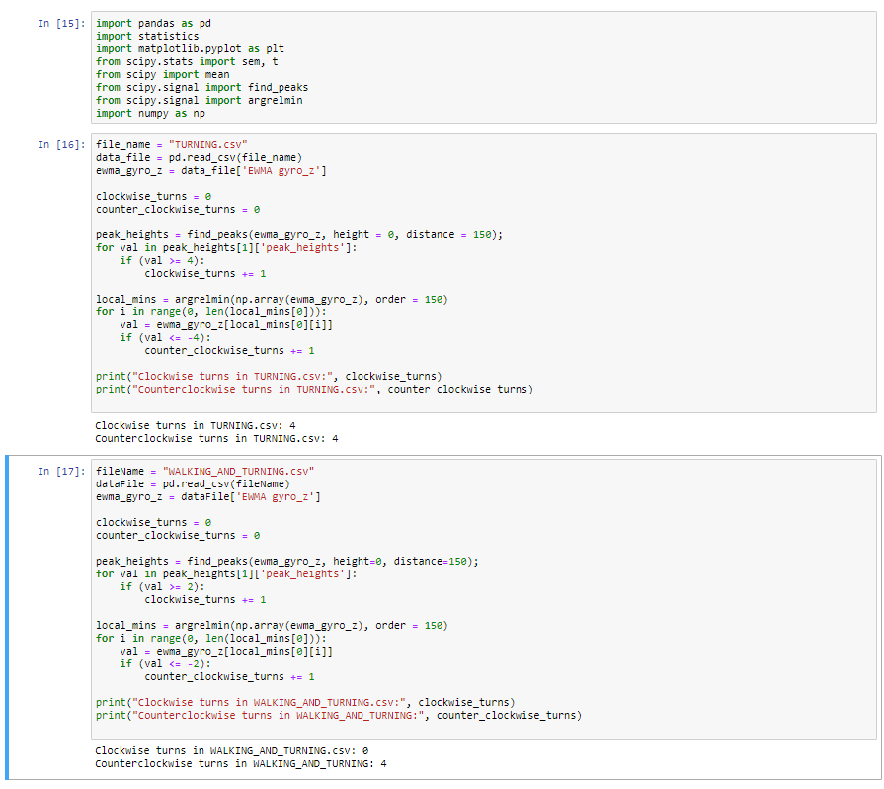

1. Here is the algorithm and output for WALKIN­G_AND_TURNING.csv. The person holding the phone took 21 steps, took a 45-degree counterclockwise turn, 15 steps, a 90-degree counterclockwise turn, 18 steps, a 45-degree counterclockwise turn, 15 steps, a 45-degree counterclockwise turn, and 9 steps.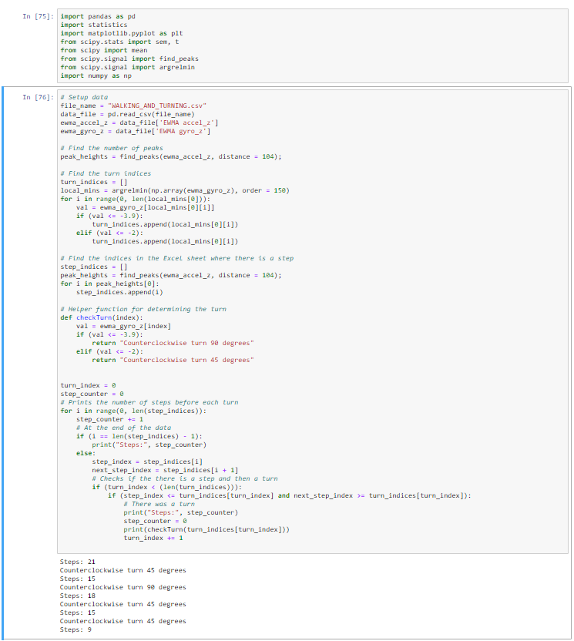

Here is the corresponding plot.

