1.Creating IAM user (with out access)
Make sure that you are creating a user called "ajay"
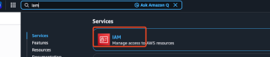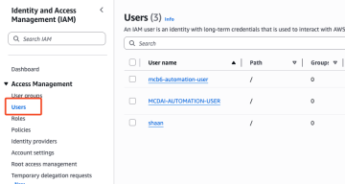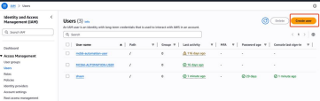
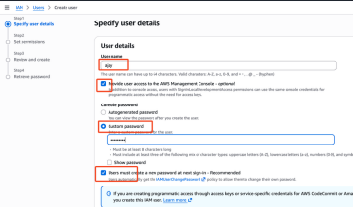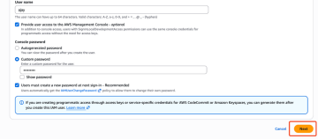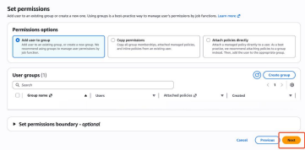
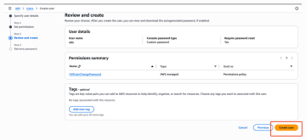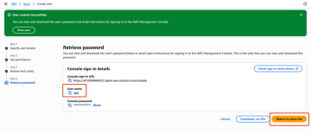
Devops/Cloud Platform team will create your user account like above, once they are done with creating your account they will share the username, password, 12 digit account id so that user ajay can login to the account and verify his access
How do we get 12 digit id
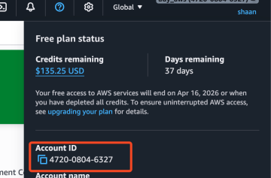
2.Verify user access
User ajay will login to verify his access using below
Note: Take private/incognito window or take a sperate browser. https://aws.amazon.com/
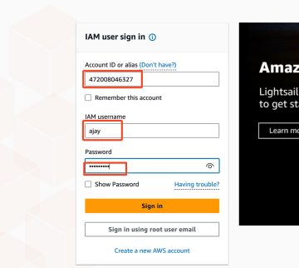
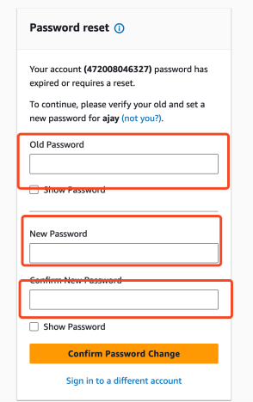
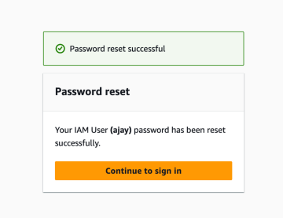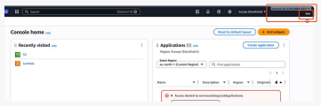
If you observe above, this user ajay is a dummy user. He don't have any access Let's test his access
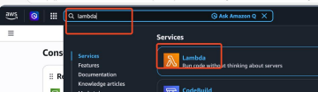
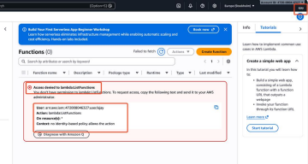In simple ajay user is a dummy user where don't have any access t o

