3. Working with groups
Create a group:
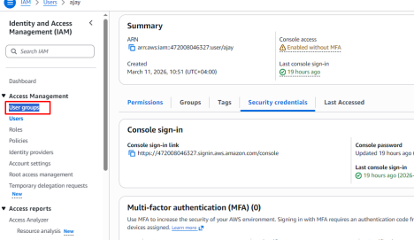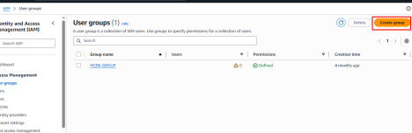
DVS Technologies | Website: www.dvstechnologies.in | Mobile: 8892499499, 9632558585
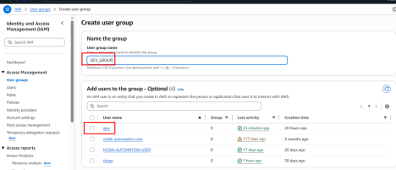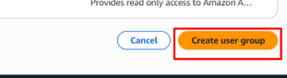
verify if our user ajay is having ECR permissions or not
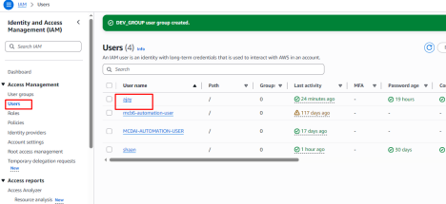DVS Technologies | Website: www.dvstechnologies.in | Mobile: 8892499499, 9632558585
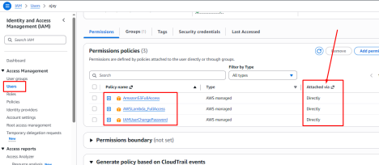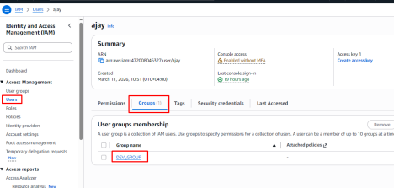
DVS Technologies | Website: www.dvstechnologies.in | Mobile: 8892499499, 9632558585
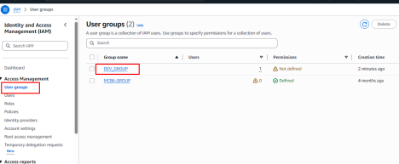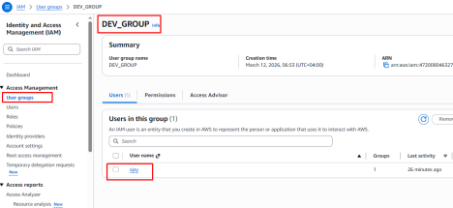
DVS Technologies | Website: www.dvstechnologies.in | Mobile: 8892499499, 9632558585
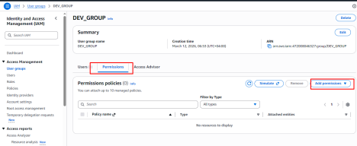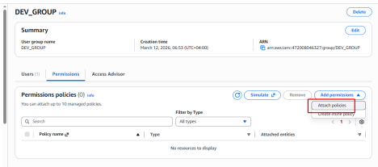
DVS Technologies | Website: www.dvstechnologies.in | Mobile: 8892499499, 9632558585
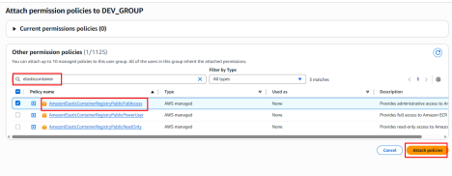Final verification:
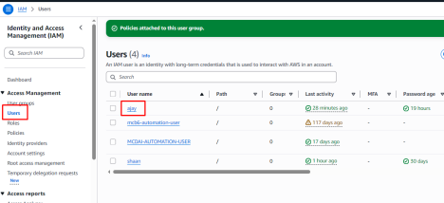DVS Technologies | Website: www.dvstechnologies.in | Mobile: 8892499499, 9632558585
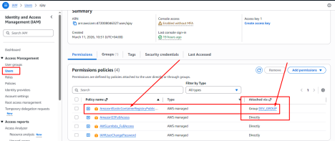DVS Technologies | Website: www.dvstechnologies.in | Mobile: 8892499499, 9632558585

